Calendar of Events
Dec 07 Heidelberg League @ 7:00 p.m.
Dec 10 Confirmation Classes @ 4:45 to 6:30 p.m.
Consistory Meeting @ 7:00 p.m.
Dec 11 Prayer Group @ 12 Noon
Dec 14 3rd Sunday of Advent
Prayer Time for Service @ 8:30 a.m.
Sunday School Classes @ 9:15 a.m.
Praise Music @ 10:15 a.m.
Worship Service @ 10:30 a.m.
w/Holy Communion
Program Practice @ 12 Noon to 2:00 p.m.
M/O Care Center Service @ 2:00 p.m.
Dec 15 Men’s Christian Fellowship @ 7:00 p.m.
Upcoming Special Music
Sunday, Dec. 14 - Holy Communion
Sunday, Dec. 21 - Jay & Sharyl Herrboldt

Announcements
Women’s Bible Study: Our next Bible Study will be “One in a Million” by Priscilla Shirer. This will be a 7-week DVD/Workbook led Bible Study. The study will begin on Wed., Jan. 7th, and will be held at 9:30 a.m. & 6:00 p.m. Please sign the sheet in the Narthex if you plan to attend and also to have your workbook ordered.
Christmas Caroling: We will plan to meet at the church on Sunday, Dec. 21st at 4PM to go caroling in Menno. Everyone is welcome to join! After caroling we will come back to the church for some chili soup, other goodies and fellowship & games! Please sign the sheet in the Narthex if you plan to attend.
Poinsettias: During the Advent Season we have the opportunity to place poinsettias in the sanctuary in memory of loved ones. Let the church office know who your plant is in memory of.
Flower Committee: We are looking for individuals willing to place the flowers in the sanctuary before our Sunday worship services. Please sign the sheet in the Narthex if you are willing to help.
Inclement Weather: We are in the time of year when weather conditions may affect our ability to have worship services. If services need to be canceled, we will attempt to notify the congregation through the Prayer Chain, the Sunday School Phone Tree, and the Church Website. If you have questions, please contact the church or Pastor Mike’s cell phone. Thanks!

Salem Reformed Church – Who Are We?
We believe the Bible to be the inspired, inerrant, infallible Word of God in its original manuscripts. It is our supreme authority in all matters of doctrine and practice. We are affiliated with the Conservative Congregational Christian Conference.

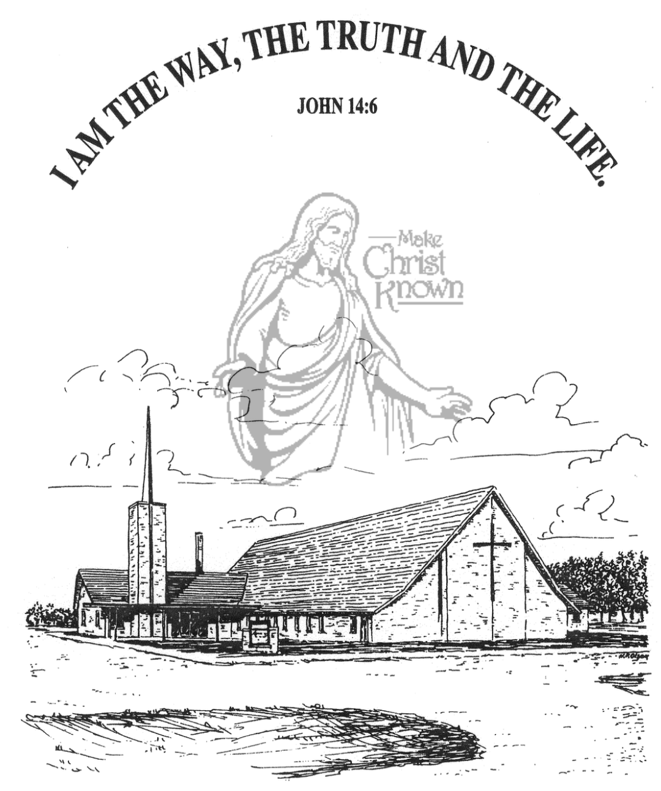
Sunday, December 07, 2025

Salem Reformed Church
Menno, South Dakota

..3

SALEM REFORMED CHURCH
Menno, South Dakota

Rev. Michael Hecht Pastor
Marina Schaeffer Pianist

10:30 AM – Worship Service December 07, 2025
Second Sunday of Advent

Meditation: “In the sixth month, God sent the angel Gabriel to Nazareth, a town in Galilee, to a virgin pledged to be married to a man named Joseph, a descendant of David. The virgin’s name was Mary. The angel went to her and said, “Greetings, you who are highly favored! The Lord is with you.’ Mary was greatly troubled at His words and wondered what kind of greeting this might be. But the angel said to her, ‘Do not be afraid, Mary, you have found favor with God. You will be with Child and give birth to a Son, and you are to give Him the name Jesus. He will be great and will be called the Son of the Most High. The Lord God will give Him the throne of His father David, and He will reign over the house of Jacob forever; His kingdom will never end.’ Luke 1:26-33 NIV

Prelude Music and #10 Praise Book
Ringing of the Bell
Welcome / Announcements
Opening Prayer
Lighting of the Advent Wreath
Audrey Mudder and Joanna Fergen
*Hymn: #277 “Hark! the Herald Angels Sing”
Sharing of Joys and Concerns
Our Time of Offering Psalm 50:1 AMP
*Doxology sung on page #815
*Lord’s Prayer debts and debtors
Kingdom Kids: “PEACE”
Special Music: “Noel” sung by Natasha & Naomi Auch
The Holy Scriptures
Isaiah 9:1-7
Large Print NIV 1984 Edition, pg. 1072
Sermon: “Mighty God!”
*Hymn: #281 “What Child Is This?”
*Benediction:
Postlude
(*denotes standing for those able)
The congregation will be ushered out after the Benediction
Youth Ushers: Madison Schaeffer, Ashlyn Derby, Elly Fischer

Office Hours for Pastor Hecht
Tuesday – Friday: 8:00 AM to Noon (Church Office)
Afternoons: Visitation or Church Office
Church: (605) 387-5334 Parsonage: (605) 387-2855
Pastor Mike’s Cell #: (605) 660-1803
Church Web Page: salemreformedchurch.com

Opportunities
Greeters Today: Jerry & Joan Nusz
Greeters December 14th: Robert & Elaine Balogh
Greeters December 21st:
Sunday Prayer Time: 8:30 a.m.
Sunday School Classes: 9:15 a.m.
Praise Music: 10:15 a.m.
Worship Service: 10:30 a.m.

Announcements
Welcome: We extend a warm welcome to our visiting guests this morning. Please sign our guest book in the Narthex. We ask God’s blessing upon you and we pray that you will return and worship with us again soon.
Soup Kitchen: We would like to thank everyone for attending the annual Soup Kitchen. The committee would like to express their heartfelt appreciation for your gift of time, food donations, and financial support. We thank you for making this event a success! If you would like to serve on the committee next year please contact a committee member: Deb Schmidt or Mick Huber.
Christmas Program Lunches/Practices: Please remember to bring what you signed up for! Lunches will be served on Sundays, Dec. 7th & 14th. Lunch coordinators are Chandra van Zyl, Katie Huber, and Kristin Heckenlaible. Thanks so Much for helping in this way! **The last practice will be Sun., Dec. 21st during the Sunday School Hour. This practice will also include the Pre-School Class.
Hannah Mettler Missionary: Hannah is the granddaughter of Jeff & Linda Nusz. She serves full-time as a missionary with YWAM (Youth With a Mission). Hannah will be leading a mission team of 15 to Vietnam in January. Her funding need is $3,000. We will place a special offering plate in the back of the sanctuary TODAY, for those desiring to give. Please make checks to Salem Reformed Church. Thank You!
Sunday Offerings: Please note that we have an Offering Box/Pulpit at the back of the Sanctuary for people to place their tithes and offerings in during our worship services.

