Calendar of Events
Dec 29 to Jan 06 Pastor Mike/Ann on Vacation
Jan 04 Sanctity of Human Life Sunday
Prayer Time for Service @ 8:30 a.m.
Sunday School Classes @ 9:15 a.m.
Praise Music @ 10:15 a.m.
Worship Service @ 10:30 a.m.
Jan 05 Men’s Christian Fellowship @ 7:00 p.m.
Jan 07 Women’s Bible Study @ 9:30 a.m. & 6:00 p.m.
Confirmation Classes @ 4:45 – 6:30 p.m.
FCA at Menno Gym @ 7:30 p.m.
Jan 08 Prayer Group @ 12 Noon
Upcoming Special Music
Sunday, Jan. 04 - Available
Sunday, Jan. 11 - Available

Announcements
Coffee Hour: We are looking for a few volunteers to bring 2 dozen goodies for Coffee Hour on Sunday, January 18th. Please sign the sheet in the Narthex if you are able to help.
Pastor’s Vacation: Pastor Mike/Ann will be on vacation from December 29th through January 6th. Please contact the church office or one of the Consistory Members for special needs.
Annual Reports: If you are responsible for completing a report for our Annual Meeting, please have it turned into the church office by Friday, January 9, 2026. You may also email your report to the office at: salemref2@goldenwest.net
Women of the Church Business Meeting: The W.O.C. Annual Business Meeting will be held after church, Sun., Jan. 18th.
Annual Meeting: The Annual Meeting of the Congregation is scheduled for Sunday, January 25, 2026 @ 12:30 p.m. The snow date is set for Sun., Feb.1st at the same time.
Women’s Bible Study: Our next Bible Study will be “One in a Million” by Priscilla Shirer. This will be a 7-week DVD/Workbook led Bible Study. The study will begin on Wed., Jan. 7th, and will be held at 9:30 a.m. & 6:00 p.m. Please sign the sheet in the Narthex if you plan to attend and also to have your workbook ordered.
Confirmation/High School Trip: We will plan to go Ice Skating in Yankton on Sunday, January 11th, leaving immediately after church. The cost of skating has been covered by a very generous individual! Lunch will be provided after the skating is over.

Salem Reformed Church – Who Are We?
We believe the Bible to be the inspired, inerrant, infallible Word of God in its original manuscripts. It is our supreme authority in all matters of doctrine and practice. We are affiliated with the Conservative Congregational Christian Conference.

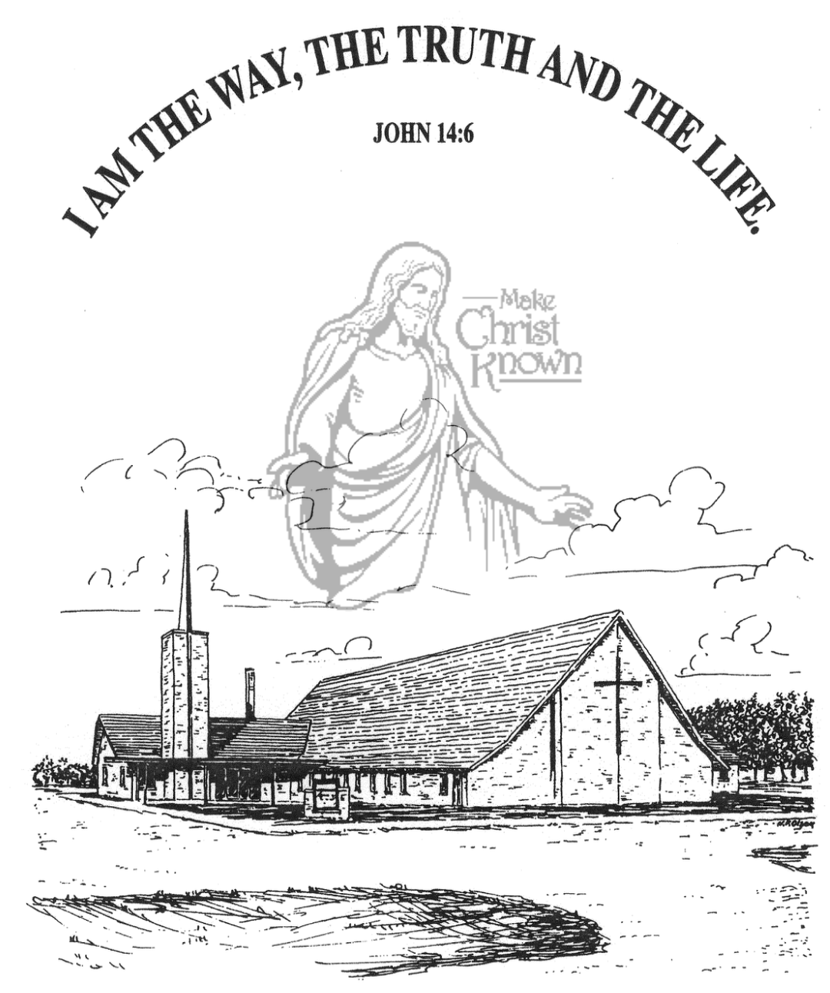
Sunday, December 28, 2025

Salem Reformed Church
Menno, South Dakota

..3

SALEM REFORMED CHURCH
Menno, South Dakota

Rev. Michael Hecht Pastor
Joan Nusz Pianist

10:30 AM – Worship Service December 28, 2025
First Sunday after Christmas

Meditation: “This is what Isaiah son of Amoz saw concerning Judah and Jerusalem: In the last days the mountain of the LORD’s temple will be established as chief among the mountains; it will be raised above the hills, and all nations will stream to it. Many peoples will come and say, ‘Come, let us go up to the mountain of the LORD, to the house of the God of Jacob. He will teach us His ways, so that we may walk in His paths.’ The law will go out from Zion, the word of the LORD from Jerusalem. He will judge between the nations and will settle disputes for many peoples. They will beat their swords into plowshares and their spears into pruning hooks. Nation will not take up sword against nation, nor will they train for war anymore.’ Isaiah 2:1-4 NIV

Prelude Music and #32 Praise Book Joan Nusz
Ringing of the Bell
Welcome / Announcements / Opening Prayer
*Hymn: #288 “We Three Kings”
Sharing of Joys and Concerns
Our Time of Offering Psalm 127:3-5 NIV
*Doxology sung on page #815
*Lord’s Prayer debts and debtors
Baptism: Sage Nicholas Crisafulli & Leilani Cynthia Storms
Questions of Candidates / Congregational Assent
Education Committee Pledge Kevin Holzwarth
Congregational Song: “Jesus Loves You”
Kingdom Kids: “The Candy Cane” by Emily Guthmiller
Hymn: #254 “Isn’t He”
The Holy Scriptures
Revelation 20:1-10
Large Print NIV 1984 Edition, pg. 1936
Sermon: “He Shall Reign Forever!”
*Hymn: #372 “Our God Reigns”
*Benediction:
Postlude (*denotes standing for those able)
The congregation will be ushered out after the Benediction
Youth Ushers: Madison Schaeffer, Ashlyn Derby, Elly Fischer

Office Hours for Pastor Hecht
Tuesday – Friday: 8:00 AM to Noon (Church Office)
Afternoons: Visitation or Church Office
Church: (605) 387-5334 Parsonage: (605) 387-2855
Pastor Mike’s Cell #: (605) 660-1803
Church Web Page: salemreformedchurch.com

Opportunities
Greeters Today: Larry & Connie Kirschenman
Greeters January 04th: Dave & Peg Walloch
Greeters January 11th: Donna Friesen & Jef Poma-Sanchez
Sunday Prayer Time: 8:30 a.m.
Sunday School Classes: 9:15 a.m.
Praise Music: 10:15 a.m.
Worship Service: 10:30 a.m.

Announcements
Welcome: We extend a warm welcome to our visiting guests this morning. Please sign our guest book in the Narthex. We ask God’s blessing upon you and we pray that you will return and worship with us again soon.
Congratulations: We rejoice with the Family of Sage Crisafulli and Leilani Storms on their baptisms today. Their parents are Braden and Ivana Storms. We extend a warm welcome to all of their family and friends who may be present today!
Sunday School Classes: Sunday School Classes will RESUME next Sunday, January 4th at the regular time of 9:15 a.m.
Taking Down of the Greens: The CE Committee will be taking down the Christmas Tree and Greens next Sun., Jan. 4th after our worship service. Others are welcome to help.
Christmas Eve Offering: The offering received on Christmas Eve was $6,805.00. This will be divided equally between the Abbott House, Swan Lake Christian Camp, and Healing Hope Ministries. We praise the Lord for such generous giving!
Christmas Day Offering: The offering received on Christmas Day was $4,560.00, and will be given to the M/O Care Center to assist with on-going needs as determined by the Board of Directors and the Administration.
Sanctity of Human Life Sunday: We will be celebrating this special day on Sun., Jan. 4th, with a guest speaker from the Alpha Center in Sioux Falls. The offering received that day will go to the Pro-Life Ministry of the Alpha Center.
Sunday Offerings: Please note that we have an Offering Box/Pulpit at the back of the Sanctuary for people to place their tithes and offerings in during our worship services.

