Calendar of Events
Dec 24 Christmas Eve Program @ 7:00 p.m.
Dec 25 Christmas Day Worship @ 10:00 a.m.
Dec 28 **No Sunday School Classes Today
Prayer Time for Service @ 9:30 a.m.
Prelude Music @ 10:15 a.m.
Worship Service @ 10:30 a.m.
w/Baptisms of Leilani Cynthia Storms and
Sage Crisafulli
Dec 29 to Jan 06 Pastor Mike/Ann on Vacation
Jan 04 Sanctity of Human Life Sunday
Prayer Time for Service @ 8:30 a.m.
Sunday School Classes @ 9:15 a.m.
Praise Music @ 10:15 a.m.
Worship Service @ 10:30 a.m.
Upcoming Special Music
Wednesday, Dec. 24 - Caden Fischer
Thursday, Dec. 25 - Available
Sunday, Dec. 28 - Available

Announcements
Special Thanks: Thanks to Chandra van Zyl, Kristin Heckenlaible, and Katie Huber for coordinating and serving the lunches for the Christmas Program Practices!
Annual Reports: If you are responsible for completing a report for our Annual Meeting, please have it turned into the church office by Friday, January 9, 2026. You may also email your report to the office at: salemref2@goldenwest.net
Women of the Church Business Meeting: The W.O.C. Annual Business Meeting will be held after church, Sun., Jan. 18th.
Annual Meeting: The Annual Meeting of the Congregation is scheduled for Sunday, January 25, 2026 @ 12:30 p.m. The snow date is set for Sun., Feb.1st at the same time.
Women’s Bible Study: Our next Bible Study will be “One in a Million” by Priscilla Shirer. This will be a 7-week DVD/Workbook led Bible Study. The study will begin on Wed., Jan. 7th, and will be held at 9:30 a.m. & 6:00 p.m. Please sign the sheet in the Narthex if you plan to attend and also to have your workbook ordered.
Flower Committee: We are looking for individuals willing to place the flowers in the sanctuary before our Sunday worship services. Please sign the sheet in the Narthex if you are willing to help.

Salem Reformed Church – Who Are We?
We believe the Bible to be the inspired, inerrant, infallible Word of God in its original manuscripts. It is our supreme authority in all matters of doctrine and practice. We are affiliated with the Conservative Congregational Christian Conference.

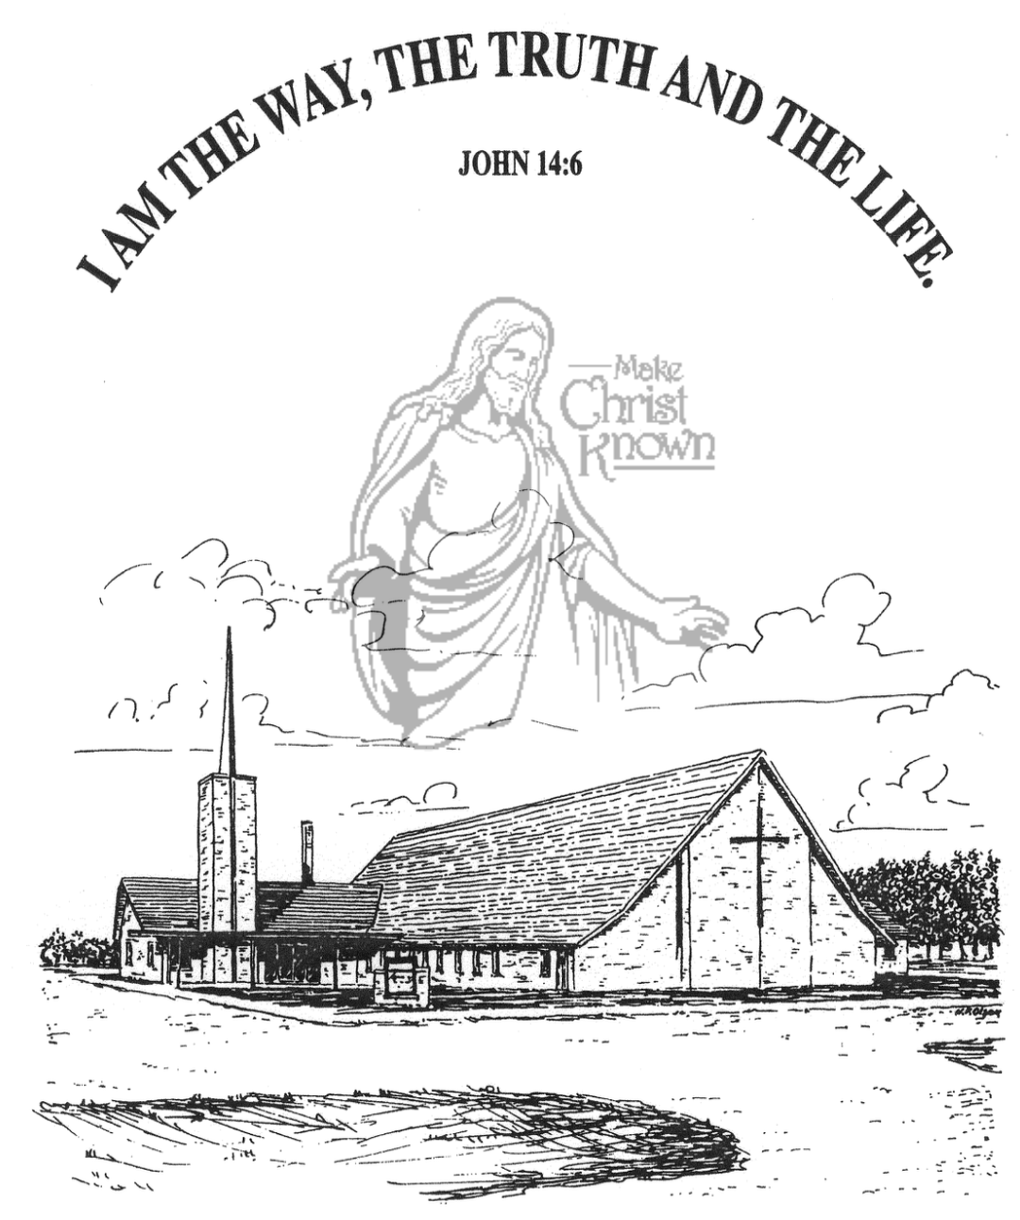
Sunday, December 21, 2025

Salem Reformed Church
Menno, South Dakota

..3

SALEM REFORMED CHURCH
Menno, South Dakota

Rev. Michael Hecht Pastor
Cindy Herrboldt Organist

10:30 AM – Worship Service December 21, 2025
Fourth Sunday of Advent

Meditation: “But now in Christ Jesus you who once were far away have been brought near through the blood of Christ. For He Himself is our PEACE, who has made the two one and has destroyed the barrier, the dividing wall of hostility, by abolishing in His flesh the law with its commandments and regulations. His purpose was to create in Himself one new man out of the two, thus making peace, and in this one body to reconcile both of them to God through the cross, by which He put to death their hostility. He came and preached PEACE to you who were far away and PEACE to those who were near. For through Him we both have access to the Father by one Spirit. Consequently, you are no longer foreigners and aliens, but fellow citizens with God’s people and members of God’s household.” Ephesians 2:13-19 NIV

Prelude Music Duets Cindy & Sharyl Herrboldt
Ringing of the Bell
Welcome / Announcements
Opening Prayer
Lighting of the Advent Wreath
Trent Crick and Andrew Nusz
*Hymn: #278 “Angels We Have Heard on High”
Sharing of Joys and Concerns
Our Time of Offering Luke 2:13,14 NIV
*Doxology sung on page #815
*Apostles’ Creed see words on screen
Kingdom Kids: “LOVE”
Special Music: “The Sweetest Gift” by Jay & Sharyl Herrboldt
The Holy Scriptures
Isaiah 9:1-7
Large Print NIV 1984 Edition, pg. 1072
Sermon: “Prince of Peace!”
*Hymn: #258 “Go, Tell It on the Mountain”
*Benediction:
Postlude (*denotes standing for those able)
The congregation will be ushered out after the Benediction
Youth Ushers: Madison Schaeffer, Ashlyn Derby, Elly Fischer

Office Hours for Pastor Hecht
Tuesday – Friday: 8:00 AM to Noon (Church Office)
Afternoons: Visitation or Church Office
Church: (605) 387-5334 Parsonage: (605) 387-2855
Pastor Mike’s Cell #: (605) 660-1803
Church Web Page: salemreformedchurch.com

Opportunities
Greeters Today: Lee & Dianne Herrboldt
Greeters December 24th: Steve & Sheri Preszler
Greeters December 25th: Carl & Linda Zeeb
Greeters December 28th:
Sunday Prayer Time: 8:30 a.m.
Sunday School Classes: 9:15 a.m.
Praise Music: 10:15 a.m.
Worship Service: 10:30 a.m.

Announcements
Welcome: We extend a warm welcome to our visiting guests this morning. Please sign our guest book in the Narthex. We ask God’s blessing upon you and we pray that you will return and worship with us again soon.
Sunday School Classes: We will NOT be having Sunday School Classes on Sun., Dec. 28th. Church will be at the regular time of 10:30 a.m. **Sunday School Classes will RESUME on Sun., January 4th at the regular time of 9:15 a.m.
Christmas Eve Program: The Children should be at church by 6:30-6:40 PM. The High School Youth should be here by 6:30 PM. Thanks to Directors Cindy Herrboldt/Natasha Auch.
Christmas Caroling: We will plan to meet at the church TODAY at 4PM to go caroling in Menno. Everyone is welcome to join! After caroling we will come back to the church for some chili soup, other goodies, and fellowship & games! Sign the sheet in the Narthex if you plan to attend.
Christmas Eve Offering: Our Christmas Eve Program and Candle Light Service is at 7 PM, on December 24th. The offering received will be divided equally between the Abbott House in Mitchell, Swan Lake Christian Camp near Viborg, and Healing Hope Ministries near Alcester.
Christmas Day Offering: Our Christmas Day Offering will be given to the M/O Care Center to assist with on-going needs. Our worship service will be at 10 AM on Christmas morning.
Sunday Offerings: Please note that we have an Offering Box/Pulpit at the back of the Sanctuary for people to place their tithes and offerings in during our worship services.

