Calendar of Events
Dec 14 M/O Care Center Service @ 2:00 p.m.
Dec 15 Men’s Christian Fellowship @ 7:00 p.m.
Dec 17 FCA at Menno Gym @ 7:30 p.m.
Dec 18 Prayer Group @ 12 Noon
Dec 21 4th Sunday of Advent
Prayer Time for Service @ 8:30 a.m.
Christmas Program Practice @ 9:15 a.m.
Prelude Music @ 10:15 a.m.
Worship Service @ 10:30 a.m.
CE Comm. Fills Sacks @ 11:45 a.m.
Christmas Caroling @ 4:00 p.m.
Dec 24 Christmas Eve Program @ 7:00 p.m.
Dec 25 Christmas Day Worship @ 10:00 a.m.
Dec 28 No Sunday School Classes Today
Prayer Time for Service @ 9:30 a.m.
Prelude Music @ 10:15 a.m.
Worship Service @ 10:30 a.m.
w/Baptism of Leilani Cynthia Storms
Upcoming Special Music
Thursday, Dec. 25 - Available
Sunday, Dec. 28 - Available

Announcements
Sunday School Classes: Please note – We will not be having Sunday School on Dec. 28th. Classes will resume on Jan. 4th.
Women’s Bible Study: Our next Bible Study will be “One in a Million” by Priscilla Shirer. This will be a 7-week DVD/Workbook led Bible Study. The study will begin on Wed., Jan. 7th, and will be held at 9:30 a.m. & 6:00 p.m. Please sign the sheet in the Narthex if you plan to attend and also to have your workbook ordered.
Flower Committee: We are looking for individuals willing to place the flowers in the sanctuary before our Sunday worship services. Please sign the sheet in the Narthex if you are willing to help.
Inclement Weather: We are in the time of year when weather conditions may affect our ability to have worship services. If services need to be canceled, we will attempt to notify the congregation through the Prayer Chain, the Sunday School Phone Tree, and the Church Website. If you have questions, please contact the church or Pastor Mike’s cell phone. Thanks!

Salem Reformed Church – Who Are We?
We believe the Bible to be the inspired, inerrant, infallible Word of God in its original manuscripts. It is our supreme authority in all matters of doctrine and practice. We are affiliated with the Conservative Congregational Christian Conference.

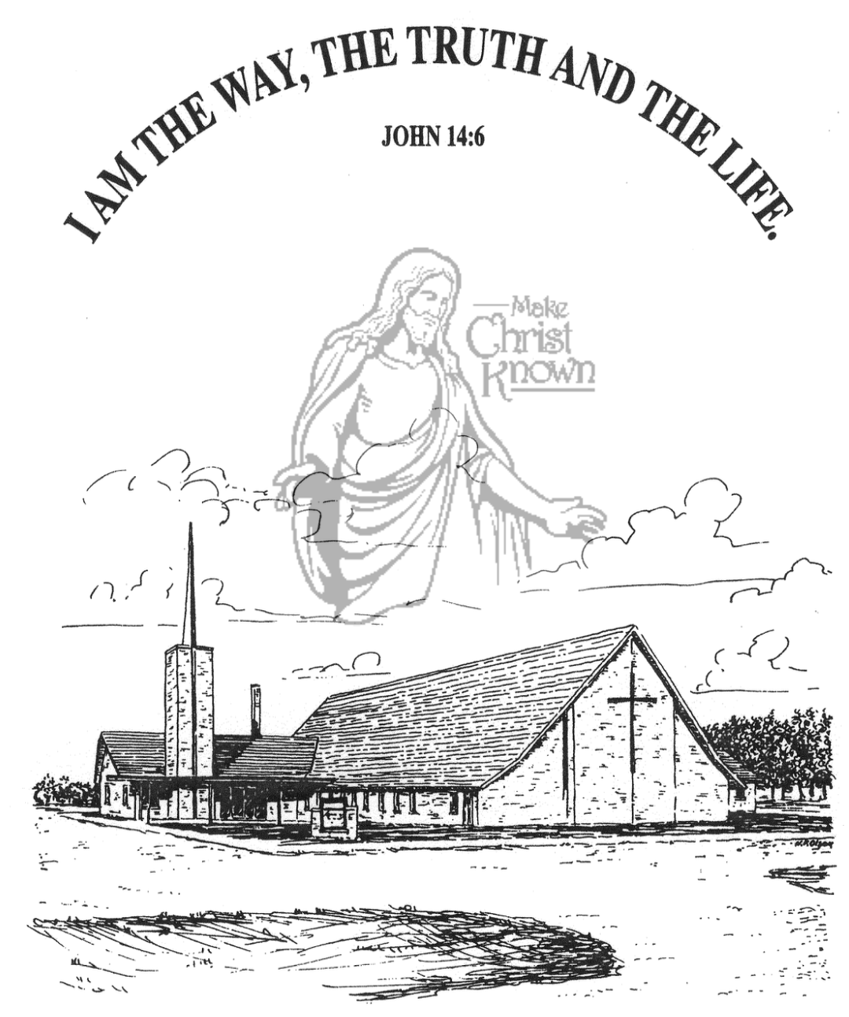
Sunday, December 14, 2025

Salem Reformed Church
Menno, South Dakota

..3

SALEM REFORMED CHURCH
Menno, South Dakota

Rev. Michael Hecht Pastor
Jennifer Herrboldt Pianist

10:30 AM – Worship Service December 14, 2025
Third Sunday of Advent

Meditation: “He was in the world, and though the world was made through Him, the world did not recognize Him. He came to that which was His own, but His own did not receive Him. Yet to all who received Him, to those who believed in His Name, He gave the right to become children of God – children born not of natural descent, nor of human decision or a husband’s will, but born of God. The Word became flesh and made his dwelling among us. We have seen His glory, the glory of the One and Only, who came from the Father, full of grace and truth.” John 1:10-14 NIV

Prelude Music and #140 Praise Book
Ringing of the Bell
Welcome / Announcements
Opening Prayer
Lighting of the Advent Wreath
Ivana Schaeffer and Savanah Wielenga
*Hymn: #259 “Angels, from the Realms of Glory”
Sharing of Joys and Concerns
Our Time of Offering Isaiah 40:28 NIV
*Doxology sung on page #815
*Lord’s Prayer debts and debtors
Kingdom Kids: “JOY”
Hymn: #262 “Away in a Manger”
The Holy Scriptures
Isaiah 9:1-7
Large Print NIV 1984 Edition, pg. 1072
Sermon: “Everlasting Father!”
Prayer of Confession
#132 “How Deep the Father’s Love” (praise book)
#287 “A Communion Hymn for Christmas”
Sacrament of Holy Communion
*Hymn: #270 “Joy to the World!”
*Benediction:
Postlude
(*denotes standing for those able)
The congregation will be ushered out after the Benediction
Youth Ushers: Madison Schaeffer, Ashlyn Derby, Elly Fischer

Office Hours for Pastor Hecht
Tuesday – Friday: 8:00 AM to Noon (Church Office)
Afternoons: Visitation or Church Office
Church: (605) 387-5334 Parsonage: (605) 387-2855
Pastor Mike’s Cell #: (605) 660-1803
Church Web Page: salemreformedchurch.com

Opportunities
Greeters Today: Robert & Elaine Balogh
Greeters December 21st: Lee & Dianne Herrboldt
Greeters December 24th: Steve & Sheri Preszler
Greeters December 25th: Carl & Linda Zeeb
Sunday Prayer Time: 8:30 a.m.
Sunday School Classes: 9:15 a.m.
Praise Music: 10:15 a.m.
Worship Service: 10:30 a.m.

Announcements
Welcome: We extend a warm welcome to our visiting guests this morning. Please sign our guest book in the Narthex. We ask God’s blessing upon you and we pray that you will return and worship with us again soon.
Holy Communion: We at Salem Reformed Church recognize an open communion table. All are welcome to partake of the bread and wine and accept the gift of grace that God offers to us through Jesus Christ, our Savior and Lord. **The inner most ring of the communion tray contains grape juice. All other rings contain wine.
Christmas Program Lunches/Practices: Lunch coordinators are Chandra van Zyl, Katie Huber, and Kristin Heckenlaible. Thanks so Much for helping in this way! **The last practice will be Sun., Dec. 21st during the Sunday School Hour. This practice will also include the Pre-School Class.
Christmas Caroling: We will plan to meet at the church on Sunday, Dec. 21st at 4PM to go caroling in Menno. Everyone is welcome to join! After caroling we will come back to the church for some chili soup, other goodies and fellowship & games! Sign the sheet in the Narthex if you plan to attend.
Annual Reports: If you are responsible for completing a report for our Annual Meeting, please have it turned into the church office by Friday, January 9, 2026. You may also email your report to the office at: salemref2@goldenwest.net
Sunday Offerings: Please note that we have an Offering Box/Pulpit at the back of the Sanctuary for people to place their tithes and offerings in during our worship services.

