Calendar of Events
Nov 02 M/OCC Worship Service @ 2:00 p.m.
Heidelberg League Meet at @ 5:30 p.m.
Nov 03 Men’s Christian Fellowship @ 7:00 p.m.
Nov 04 M/O Ministerial Meeting @ 11:30 a.m.
Nov 05 Women’s Bible Study @ 9:30 a.m. & 6:00 p.m.
Confirmation Classes @ 4:45 to 6:30 p.m.
FCA at Menno Gym @ 7:30 p.m.
Nov 06 Prayer Group @ 12 Noon
Nov 09 Prayer Time for Service @ 8:30 a.m.
Sunday School Classes @ 9:15 a.m.
Praise Music @ 10:15 a.m.
Worship Service @ 10:30 a.m.
w/Coffee Hour Following
Men Standing Together @ 5:00 p.m.
Upcoming Special Music
Sunday, Nov. 09 - Junior Choir
Sunday, Nov. 16 - Men’s Quartet

Announcements
Bethany Food Pantry: Our church youth group will be sponsoring a Food Drive for the Bethany Food Pantry in Freeman. This will start TODAY, and go thru Sun., Nov. 9th. In addition to non-perishable food items, you may also bring personal care items such as tooth paste, shampoo, deodorant, tooth brushes, laundry detergent. Winter caps, gloves and scarves are also welcome. Items may be placed in the box in the Social Hall.
Christmas Eve Program Director: BIG THANKS to Cindy Herrboldt, who will be directing our Christmas Eve Program this year! Please let Cindy know if your children (Ages 3 Years Old through 8th Grade) will not be present for the program this year. It would be nice to know ASAP. Cindy’s cell number is (605) 660-5251.
Christmas Program Lunches: Please sign the list in the Social Hall for food items or monetary donations needed for the lunches served before our Christmas Program Practices. Lunches will be served on Sundays, Nov. 30th, Dec. 7th & 14th. Lunch coordinators are Chadra van Zyl, Katie Huber, and Kristin Heckenlaible. Thanks so Much for helping in this way!

Salem Reformed Church – Who Are We?
We believe the Bible to be the inspired, inerrant, infallible Word of God in its original manuscripts. It is our supreme authority in all matters of doctrine and practice. We are affiliated with the Conservative Congregational Christian Conference.

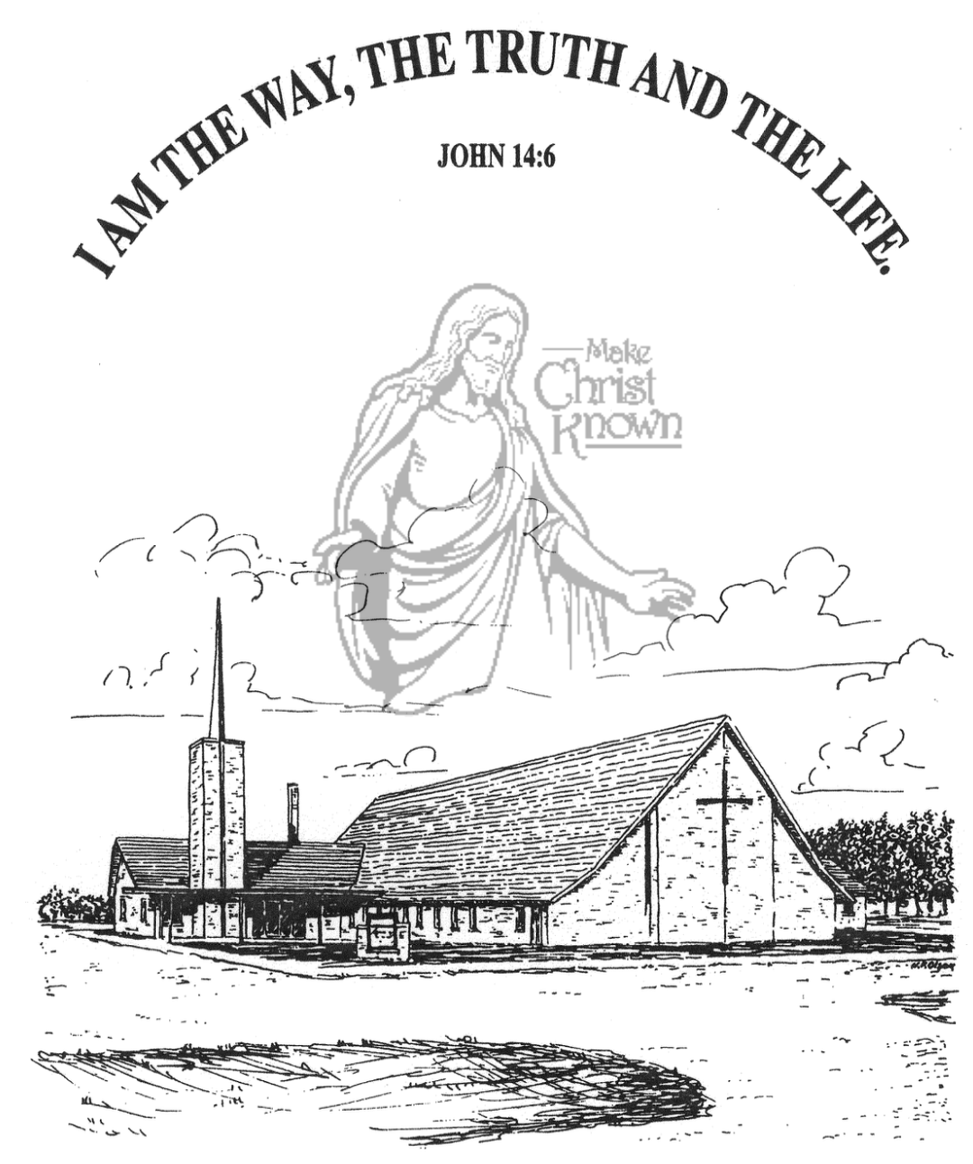
Sunday, November 02, 2025

Salem Reformed Church
Menno, South Dakota

..3

SALEM REFORMED CHURCH
Menno, South Dakota

Rev. Michael Hecht Pastor
Sharyl Herrboldt Pianist

10:30 AM – Worship Service November 02, 2025
Twenty-first Sunday after Pentecost

Meditation: “Therefore, there is now no condemnation for those who are in Christ Jesus, because through Christ Jesus the law of the Spirit of life set me free from the law of sin and death. For what the law was powerless to do in that it was weakened by the sinful nature, God did by sending His own Son in the likeness of sinful man to be a sin offering. And so He condemned sin in sinful man, in order that the righteous requirements of the law might be fully met in us, who do not live according to the sinful nature but according to the Spirit. Those who live according to the sinful nature have their minds set on what that nature desires; but those who live in accordance with the Spirit have their minds set on what the Spirit desires. Romans 8:1-5 NIV

Praise Music: #38, #121, #40, #54, #56, #43
Ringing of the Bell
Welcome / Announcements
Opening Prayer
*Hymn: #147 “How Great Thou Art”
Sharing of Joys and Concerns
Our Time of Offering Romans 6:11,12 AMP
*Doxology sung on page #815
*Lord’s Prayer debts and debtors
Kingdom Kids: “Christ Lives In Me!”
Hymn: #633 “Open Our Eyes Lord”
The Holy Scriptures
Galatians 2:11-21
Large Print NIV 1984 Edition, pg. 1811
Sermon: “Crucified With Christ!”
*Hymn: #575 “Leaning on the Everlasting Arms”
*Benediction:
*Prayer for Our Nation: “God Bless America”
Postlude
(*denotes standing for those able)
The congregation will be ushered out after the Benediction
Youth Ushers: Brockton Kocourek, Micah Goehring,
Corwin Schaeffer, Jefrey Poma-Sanchez
Office Hours for Pastor Hecht
Tuesday – Friday: 8:00 AM to Noon (Church Office)
Afternoons: Visitation or Church Office
Church: (605) 387-5334 Parsonage: (605) 387-2855
Pastor Mike’s Cell #: (605) 660-1803
Church Web Page: salemreformedchurch.com

Opportunities
Greeters Today: Brian & Steph Mehlhaf
Greeters November 09th
Sunday Prayer Time: 8:30 a.m.
Sunday School Classes: 9:15 a.m.
Praise Music: 10:15 a.m.
Worship Service: 10:30 a.m.

Announcements
Welcome: We extend a warm welcome to our visiting guests this morning. Please sign our guest book in the Narthex. We ask God’s blessing upon you and we pray that you will return and worship with us again soon.
Parsonage Basement Open House: The congregation is invited to see the remodeled parsonage basement next Sunday, November 9th. You can come after church or coffee hour until 1:00 p.m. to check it out. It is well done!
Junior Choir: The Junior Choir (Grades 4-8) will be singing in church on Sunday, November 9th! Please have your children here by 9:15 a.m. on Sunday mornings for practice. Thanks!
Sound Crew Help: We are looking for a few more people (High School and older) to help with running the Sound, the Projector, and the Video recording of our services.
Men Standing Together: Sun., Nov. 9th @ 5PM at church. Supper will be provided. Gene VanZee, from Platte, will be our Guest Speaker. Middle School/High School young men are also welcome. Sign the sheet in the Narthex if attending.
Coffee Hour: We are looking for volunteers to bring two dozen goodies for Coffee Hour on Sunday, Nov 9. Please sign the sheet in the Narthex if you are able to help.
M/OCC Bingo Sign-Up: November is our turn to help with Bingo at M/OCC. This will happen each Friday at 2:00 pm. Please sign the sheet in the Narthex if you are able to help.
Special Thanks: Special Thanks to Jennifer Herrboldt for placing the flowers in the sanctuary during October!
Sunday Offerings: Please note that we have an Offering Box/Pulpit at the back of the Sanctuary for people to place their tithes and offerings in during our worship services.

