Calendar of Events
Dec 01 Men’s Christian Fellowship @ 7:00 p.m.
Dec 02 M/O Ministerial at Roosters @ 11:30 a.m.
Dec 03 Confirmation Classes @ 4:45 to 6:30 p.m.
FCA at Menno Gym @ 7:30 p.m.
Dec 04 Prayer Group @ 12 Noon
Dec 06 Soup Kitchen/Bake Sale @ 11 a.m. to 7 p.m.
Dec 07 2nd Sunday of Advent
Prayer Time for Service @ 8:30 a.m.
Sunday School Classes @ 9:15 a.m.
Praise Music @ 10:15 a.m.
Worship Service @ 10:30 a.m.
Program Practice @ 12 Noon to 1:45/2 p.m.
Heidelberg League @ 7:00 p.m.
Upcoming Special Music
Sunday, Dec. 07 - Natasha & Naomi Auch
Sunday, Dec. 14 - Holy Communion

Announcements
Heidelberg League Bake Sale: The High School Youth will be hosting a Bake Sale at the Soup Kitchen on Sat., Dec. 6th. Parents of the youth will be providing baked goods for sale. Others from the congregation are also welcome to donate baked items to the youth group. Donations go towards the youth ministry of our church and their activities throughout the year.
Hannah Mettler Missionary: Hannah is the granddaughter of Jeff & Linda Nusz. She serves full-time as a missionary with YWAM (Youth With a Mission). Hannah will be leading a mission team of 15 to Vietnam in January. Her funding need is $3,000. We will place an offering plate in the back of the sanctuary on Sunday, December 7th, for those desiring to give.
Poinsettias: During the Advent Season we have the opportunity to place poinsettias in the sanctuary in memory of loved ones. Let the church office know who your plant is in memory of.
Old Fashioned Christmas Service: At Our Savior’s Lutheran (The Stone Church) on Sat., December 6th @ 7PM.
Flower Committee: We are looking for individuals willing to place the flowers in the sanctuary before our Sunday worship services. Please sign the sheet in the Narthex if you are willing to help.
Special Thanks: Special Thanks to Jane & Gary Gramkow for placing the flowers in the sanctuary during November!

Salem Reformed Church – Who Are We?
We believe the Bible to be the inspired, inerrant, infallible Word of God in its original manuscripts. It is our supreme authority in all matters of doctrine and practice. We are affiliated with the Conservative Congregational Christian Conference.

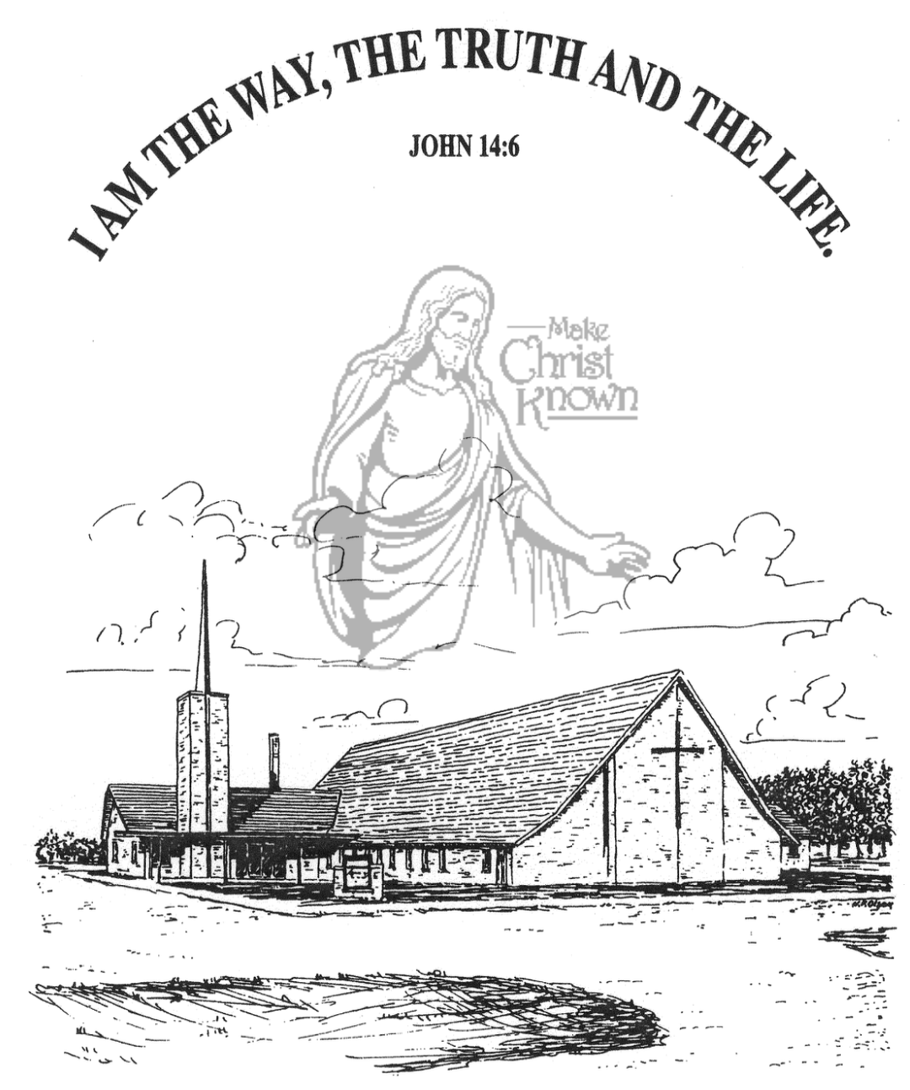
Sunday, November 30, 2025

Salem Reformed Church
Menno, South Dakota

..3

SALEM REFORMED CHURCH
Menno, South Dakota

Rev. Michael Hecht Pastor
Sharyl Herrboldt Pianist

10:30 AM – Worship Service November 30, 2025
First Sunday of Advent

Meditation: “A shoot will come up from the stump of Jesse; from His root a Branch will bear fruit. The Spirit of the LORD will rest on Him – the Spirit of wisdom and of understanding, the Spirit of counsel and of power, the Spirit of knowledge and of the fear of the LORD – and He will delight in the fear of the LORD. He will not judge by what He sees with His eyes, or decide by what He hears with His ears; but with righteousness He will judge the needy, with justice He will give decisions for the poor of the earth. He will strike the earth with the rod of His mouth; with the breath of His lips He wills lay the wicked. Righteousness will be His belt and faithfulness the sash around His waist.” Deuteronomy 32:1-6 NIV

Praise Music: #1, #5, #144, #3, #43
Ringing of the Bell
Welcome / Announcements
Opening Prayer
Lighting of the Advent Wreath
Raelynn Taylor and Savanah Wielenga
*Hymn: #245 “O Come, O Come, Emmanuel”
Sharing of Joys and Concerns
Welcome of New Members – Bryce Herrboldt, Lexi Wieneke, Arliss Wenzel, Ella & Diana Auch, Eileen Kasper
Our Time of Offering Isaiah 9:2 NIV
*Doxology sung on page #815
*Apostles’ Creed see words on screen
Kingdom Kids: “HOPE”
Hymn: #118 “His Name Is Wonderful”
The Holy Scriptures
Isaiah 9:1-7
Large Print NIV 1984 Edition, pg. 1072
Sermon: “Wonderful Counselor!”
*Hymn: #244 “Come, Thou Long-Expected Jesus”
*Benediction:
Postlude (*denotes standing for those able)
The congregation will be ushered out after the Benediction
Youth Ushers: Brockton Kocourek, Micah Goehring,
Corwin Schaeffer, Jefrey Poma-Sanchez
Office Hours for Pastor Hecht
Tuesday – Friday: 8:00 AM to Noon (Church Office)
Afternoons: Visitation or Church Office
Church: (605) 387-5334 Parsonage: (605) 387-2855
Pastor Mike’s Cell #: (605) 660-1803
Church Web Page: salemreformedchurch.com

Opportunities
Greeters Today: Earl & Teresa Neuharth
Greeters December 7th: Jerry & Joan Nusz
Greeters December 14th: Robert & Elaine Balogh
Sunday Prayer Time: 8:30 a.m.
Sunday School Classes: 9:15 a.m.
Praise Music: 10:15 a.m.
Worship Service: 10:30 a.m.

Announcements
Welcome: We extend a warm welcome to our visiting guests this morning. Please sign our guest book in the Narthex. We ask God’s blessing upon you and we pray that you will return and worship with us again soon.
Thanksgiving Eve Service: The offering received for the M.O.R.E. Committee on Thanksgiving Eve was $6,929.00! We Praise the Lord for such generous gifts to share with others!
Hanging of the Greens: Special Thanks to the CE Comm. and their Families, and others who helped with putting up the Christmas Tree and Decorations last Wednesday evening! It is Beautiful! Jesus is the Light of the World!
Soup Kitchen: The Soup Kitchen is scheduled for Saturday, Dec. 6th, from 11AM to 7PM. Please remember to invite your friends and family to this fundraiser! If you have any questions, please contact Deb Schmidt or Mick Huber.
Christmas Program Lunches/Practices: Please remember to bring what you signed up for! Lunches will be served on Sundays, Nov. 30th, Dec. 7th & 14th. Lunch coordinators are Chandra van Zyl, Katie Huber, and Kristin Heckenlaible. Thanks so Much for helping in this way! **The last practice will be Sun., Dec. 21st during the Sunday School Hour. This practice will also include the Pre-School Class.
Human Services Center Gifts: The W.O.C. are sponsoring a donation drive for Christmas Gifts for the residents at HSC. The deadline to bring donations is TODAY, Nov. 30th.
Sunday Offerings: Please note that we have an Offering Box/Pulpit at the back of the Sanctuary for people to place their tithes and offerings in during our worship services.

