Calendar of Events
Nov 23 Olivet Church Chili Cook-Off @ 7PM (Old Gym)
Nov 26 Women’s Bible Study @ 9:30 a.m.
No Confirmation Classes Today
Thanksgiving Eve Service @ 7:00 p.m.
Nov 30 1st Sunday of Advent
Prayer Time for Service @ 8:30 a.m.
Sunday School Classes @ 9:15 a.m.
Praise Music @ 10:15 a.m.
Worship Service @ 10:30 a.m.
Program Practice @ 12 Noon to 1:45 p.m.
Dec 01 Men’s Christian Fellowship @ 7:00 p.m.
Upcoming Special Music
Sunday, Nov. 30 - Available
Sunday, Dec. 07 - Available

Announcements
Homebound Visitation: We are looking for ladies to volunteer during the month of December to visit our homebound and elderly. Please sign the sheet in the Narthex if you are willing to participate in these visits.
Christmas Program Lunches: Please sign the list in the Social Hall for food items or monetary donations needed for the lunches served before our Christmas Program Practices. Lunches will be served on Sundays, Nov. 30th, Dec. 7th & 14th. Lunch coordinators are Chandra van Zyl, Katie Huber, and Kristin Heckenlaible. Thanks so Much for helping in this way!
Soup Kitchen: Please take time to stop by the Social Hall today after the service to pick up your work schedule for the Soup Kitchen. If you have any questions, a committee member will be present to assist you. The Soup Kitchen will be held on Saturday, December 6th from 11AM to 7PM. The High School Youth will also be having a Bake Sale Fund Raiser.
Poinsettias: During the Advent Season we have the opportunity to place poinsettias in the sanctuary in memory of loved ones. Please contact the florist of your choice if you desire to place a plant this year. The 1st Sunday of Advent is November 30th.
Special Thanks: Special Thanks to Jane & Gary Gramkow for placing the flowers in the sanctuary during November!

Salem Reformed Church – Who Are We?
We believe the Bible to be the inspired, inerrant, infallible Word of God in its original manuscripts. It is our supreme authority in all matters of doctrine and practice. We are affiliated with the Conservative Congregational Christian Conference.

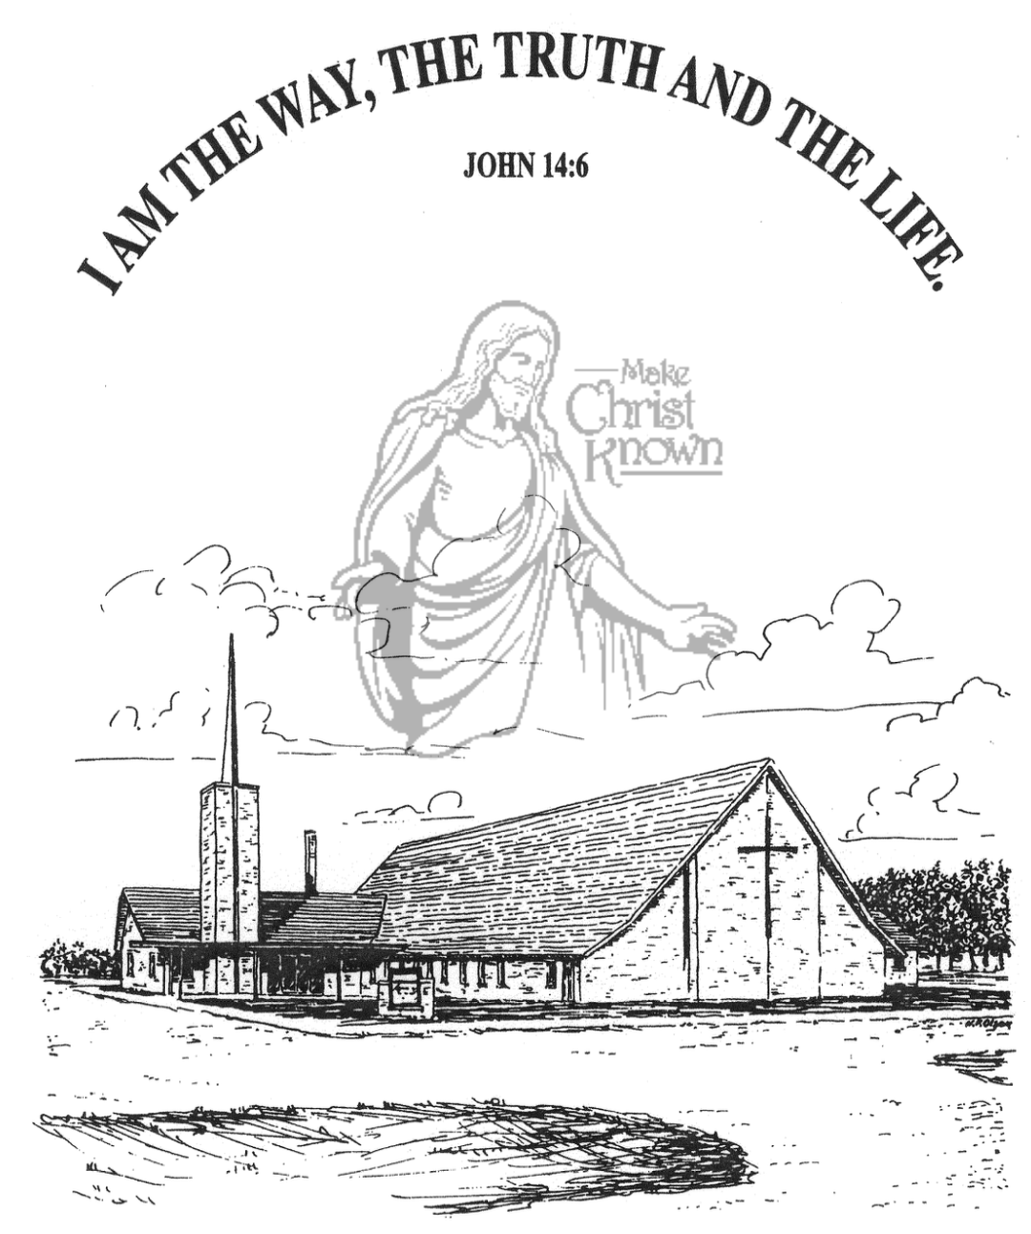
Sunday, November 23, 2025

Salem Reformed Church
Menno, South Dakota

..3

SALEM REFORMED CHURCH
Menno, South Dakota

Rev. Michael Hecht Pastor
Cindy Herrboldt Organist

10:30 AM – Worship Service November 23, 2025
Twenty-fourth Sunday after Pentecost

Meditation: “And Moses recited the words of this song from beginning to end in the hearing of the whole assembly of Israel: ‘Listen, O heavens, and I will speak; hear, O earth, the words of my mouth. Let my teaching fall like rain and my words descend like dew, like showers on new grass, like abundant rain on tender plants. I will proclaim the name of the LORD. Oh, praise the greatness of our God! He is the Rock, His works are perfect, and all His ways are just. A faithful God who does no wrong, upright and just is He. They have acted corruptly toward Him; to their shame they are no longer His children, but a warped and crooked generation. Is this the way you repay the LORD, O foolish and unwise people? Is He not your Father, your Creator, who made you and formed you?’ Deuteronomy 32:1-6 NIV

Praise Music: #45, #31, #57, #96, #21, #32
Ringing of the Bell
Welcome / Announcements
Opening Prayer
*Hymn: #90 “Joyful, Joyful, We Adore Thee”
Sharing of Joys and Concerns
Our Time of Offering I Thessalonians 5:16-18 NIV
*Doxology sung on page #815
*Lord’s Prayer debts and debtors
Kingdom Kids: “Thanksgiving Top 10 List”
Hymn: #101 “All People That on Earth Do Dwell”
The Holy Scriptures
Deuteronomy 8:1-20
Large Print NIV 1984 Edition, pg. 287
Sermon: “Praise the Lord Your God!”
*Hymn: #705 “It Is Well with My Soul”
*Benediction:
*Prayer for Our Nation: “God Bless America”
Postlude (*denotes standing for those able)
The congregation will be ushered out after the Benediction
Youth Ushers: Brockton Kocourek, Micah Goehring,
Corwin Schaeffer, Jefrey Poma-Sanchez
Office Hours for Pastor Hecht
Tuesday – Friday: 8:00 AM to Noon (Church Office)
Afternoons: Visitation or Church Office
Church: (605) 387-5334 Parsonage: (605) 387-2855
Pastor Mike’s Cell #: (605) 660-1803
Church Web Page: salemreformedchurch.com

Opportunities
Greeters Today: Daniel & Nicole Schaeffer
Greeter November 26th: Shirley Mettler
Greeters November 30th: Earl & Teresa Neuharth
Sunday Prayer Time: 8:30 a.m.
Sunday School Classes: 9:15 a.m.
Praise Music: 10:15 a.m.
Worship Service: 10:30 a.m.

Announcements
Welcome: We extend a warm welcome to our visiting guests this morning. Please sign our guest book in the Narthex. We ask God’s blessing upon you and we pray that you will return and worship with us again soon.
Thanksgiving Eve Service: This Service will be Wed. Nov. 26th at 7 PM. The offering received will be given to the M.O.R.E. Committee (Menno/Olivet Resources for the Elderly) to purchase gift certificates for those in need of a holiday meal.
Hanging of the Greens: The CE Comm. will plan to set up the Christmas Tree & Decorations following the Thanksgiving Eve Service. Other helpers are always welcome to assist!
Operation Christmas Child: THANK YOU to all who participated in filling a shoe box for a needy child in another part of our world! We received a total of 113 shoe boxes this year. Praise the Lord! (Last year was 75 shoe boxes.)
Sound Crew Help: We are looking for a few more people (High School and older) to help with running the Sound, the Projector, and the Video recording of our services.
Human Services Center Gifts: The W.O.C. are sponsoring a donation drive for Christmas Gifts for the residents at HSC. A list of acceptable gifts is available by the donation box in the Social Hall. The deadline to bring donations is Sun., Nov. 30th.
Sunday Offerings: Please note that we have an Offering Box/Pulpit at the back of the Sanctuary for people to place their tithes and offerings in during our worship services.

Thanksgiving Eve Service @ 7:00 PM
Wednesday, November 26th

