Calendar of Events
Nov 16 Heidelberg League (Social Hall) @ 7:00 p.m.
Nov 17 Men’s Christian Fellowship @ 7:00 p.m.
Nov 18 W.O.C. Program at Care Center @ 2:00 p.m.
Nov 19 Women’s Bible Study @ 9:30 a.m. & 6:00 p.m.
4-O’s Women in Social Hall @ 11:30 a.m.
Confirmation Classes @ 4:45 to 6:30 p.m.
FCA at Menno Gym @ 7:30 p.m.
Nov 20 Prayer Group @ 12 Noon
Nov 23 Prayer Time for Service @ 8:30 a.m.
Sunday School Classes @ 9:15 a.m.
Praise Music @ 10:15 a.m.
Worship Service @ 10:30 a.m.
Nov 26 Thanksgiving Eve Service @ 7:00 p.m.
Upcoming Special Music
Sunday, Nov. 23 - Available
Sunday, Nov. 26 - Available

Announcements
Homebound Visitation: We are looking for ladies to volunteer during the month of December to visit our homebound and elderly. Please sign the sheet in the Narthex if you are willing to participate in these visits.
Christmas Program Lunches: Please sign the list in the Social Hall for food items or monetary donations needed for the lunches served before our Christmas Program Practices. Lunches will be served on Sundays, Nov. 30th, Dec. 7th & 14th. Lunch coordinators are Chandra van Zyl, Katie Huber, and Kristin Heckenlaible. Thanks so Much for helping in this way!
Soup Kitchen: Please take time to stop by the Social Hall today after the service to pick up your work schedule for the Soup Kitchen. If you have any questions, a committee member will be present to assist you. The Soup Kitchen will be held on Saturday, December 6th from 11AM to 7PM. The High School Youth will also be having a Bake Sale Fund Raiser.
Poinsettias: During the Advent Season we have the opportunity to place poinsettias in the sanctuary in memory of loved ones. Please contact the florist of your choice if you desire to place a plant this year. The 1st Sunday of Advent is November 30th.

Salem Reformed Church – Who Are We?
We believe the Bible to be the inspired, inerrant, infallible Word of God in its original manuscripts. It is our supreme authority in all matters of doctrine and practice. We are affiliated with the Conservative Congregational Christian Conference.

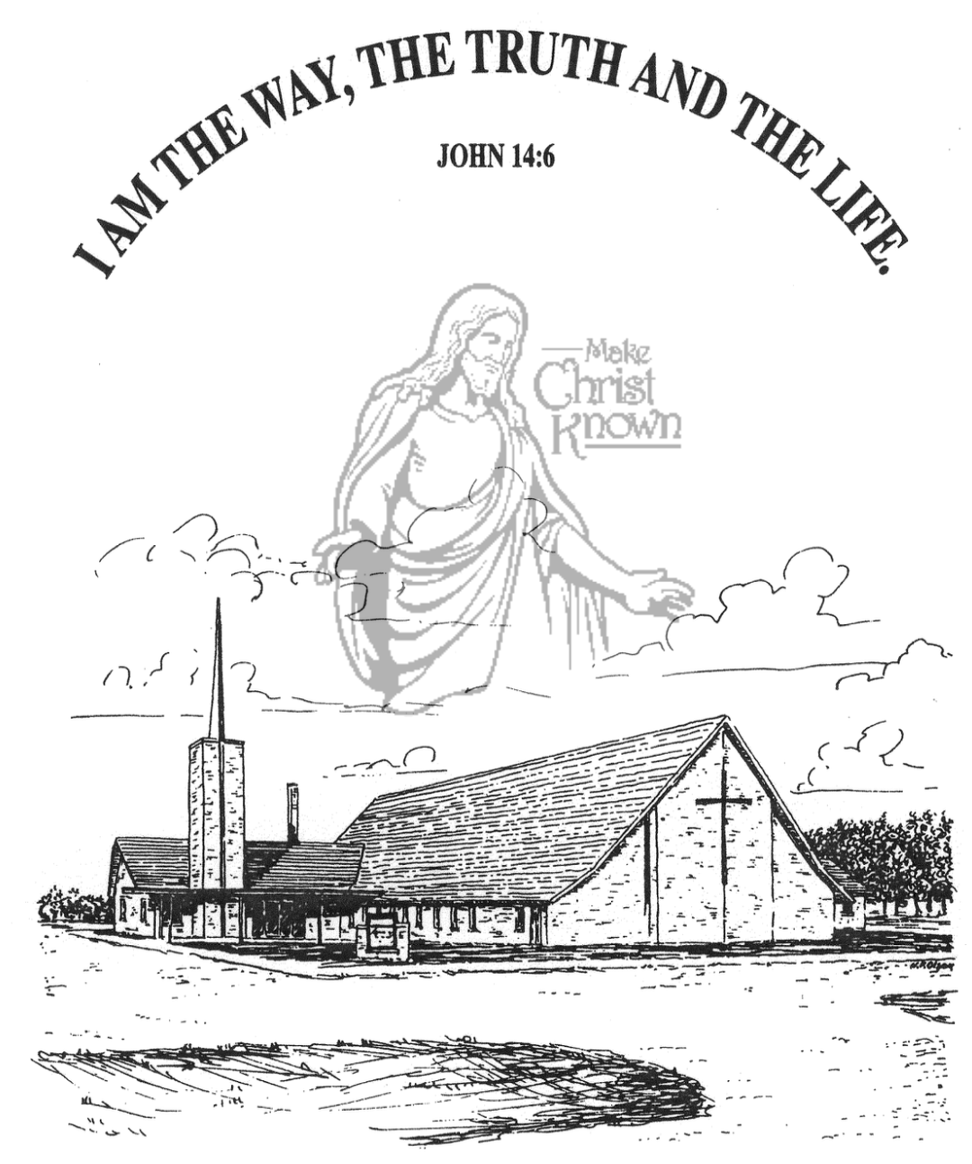
Sunday, November 16, 2025

Salem Reformed Church
Menno, South Dakota

..3

SALEM REFORMED CHURCH
Menno, South Dakota

Rev. Michael Hecht Pastor
Jennifer Herrboldt Pianist

10:30 AM – Worship Service November 16, 2025
Twenty-third Sunday after Pentecost

Meditation: “How lovely is Your dwelling place, O LORD Almighty! My soul yearns, even faints, for the courts of the LORD; my heart and my flesh cry out for the living God. Even the sparrow has found a home, and the swallow a nest for herself, where she may have her young – a place near Your altar, O LORD Almighty, my King and my God. Blessed are those who dwell in Your house; they are ever praising You. . . . Better is one day in Your courts than a thousand elsewhere; I would rather be a doorkeeper in the house of my God than dwell in the tents of the wicked. For the LORD God is a sun and shield; the LORD bestows favor and honor; no good thing does He withhold from those whose walk is blameless. O LORD Almighty, blessed is the man who trusts in You.” Psalm 84:1-4, 10-12 NIV

Praise Music: #86, #91, #83, #116, #23
Ringing of the Bell
Welcome / Announcements
Opening Prayer
*Hymn: #63 “All Creatures of Our God and King”
Sharing of Joys and Concerns
Our Time of Offering II Corinthians 9:10,11 NIV
*Lord’s Prayer sung on page #631
*Apostles’ Creed see words on screen
Kingdom Kids: “Through the Deep Water”
Special Music: “Thy Word” by the Men’s Quartet
The Holy Scriptures
Psalm 61:1-8 NKJ
Large Print NIV 1984 Edition, pg. 897
Sermon: “Lead Me to the Rock!”
*Hymn: #18 “Let’s Just Praise the Lord”
*Benediction:
*Prayer for Our Nation: “God Bless America”
Postlude (*denotes standing for those able)
The congregation will be ushered out after the Benediction
Youth Ushers: Brockton Kocourek, Micah Goehring,
Corwin Schaeffer, Jefrey Poma-Sanchez
Office Hours for Pastor Hecht
Tuesday – Friday: 8:00 AM to Noon (Church Office)
Afternoons: Visitation or Church Office
Church: (605) 387-5334 Parsonage: (605) 387-2855
Pastor Mike’s Cell #: (605) 660-1803
Church Web Page: salemreformedchurch.com

Opportunities
Greeters Today: Robert & Elaine Balogh
Greeters November 23rd:
Greeter November 26th: Shirley Mettler
Sunday Prayer Time: 8:30 a.m.
Sunday School Classes: 9:15 a.m.
Praise Music: 10:15 a.m.
Worship Service: 10:30 a.m.

Announcements
Welcome: We extend a warm welcome to our visiting guests this morning. Please sign our guest book in the Narthex. We ask God’s blessing upon you and we pray that you will return and worship with us again soon.
W.O.C. Program: The W.O.C. will be hosting the program at M/OCC on Thurs., Nov. 18th @ 2PM. Please sign the sheet in the Narthex if you are able to come and help.
Thanksgiving Eve Service: This Service will be Wed. Nov. 26th at 7 PM. The offering received will be given to the M.O.R.E. Committee (Menno/Olivet Resources for the Elderly) to purchase gift certificates for those in need of a holiday meal.
Hanging of the Greens: The CE Comm. will plan to set up the Christmas Tree and Decorations following the Thanksgiving Eve Service. Other helpers are always welcome to stay and assist!
Sound Crew Help: We are looking for a few more people (High School and older) to help with running the Sound, the Projector, and the Video recording of our services.
Human Services Center Gifts: The W.O.C. are sponsoring a donation drive for Christmas Gifts for the residents at HSC. A list of acceptable gifts is available by the donation box in the Social Hall. The deadline to bring donations is Sun., Nov. 30th.
M/OCC Bingo Sign-Up: November is our turn to help with Bingo at M/OCC. This will happen each Friday at 2:00 pm. Please sign the sheet in the Narthex if you are able to help.
Sunday Offerings: Please note that we have an Offering Box/Pulpit at the back of the Sanctuary for people to place their tithes and offerings in during our worship services.

