Calendar of Events
Nov 09 Men Standing Together @ 5:00 p.m.
Nov 11 Veterans Day Program at School @ 2:00 p.m.
Nov 12 Women’s Bible Study @ 9:30 a.m. & 6:00 p.m.
Confirmation Classes @ 4:45 to 6:30 p.m.
Consistory Meeting @ 7:00 p.m.
Nov 13 Prayer Group @ 12 Noon
Nov 16 Prayer Time for Service @ 8:30 a.m.
Sunday School Classes @ 9:15 a.m.
Praise Music @ 10:15 a.m.
Worship Service @ 10:30 a.m.
Heidelberg League @ 7:00 p.m.
Nov 17 Men’s Christian Fellowship @ 7:00 p.m.
Upcoming Special Music
Sunday, Nov. 16 - Men’s Quartet
Sunday, Nov. 23 - Available

Announcements
Bethany Food Pantry: THANKS to everyone who donated items for the Bethany Food Pantry! You are a blessing to so many!
Veterans Day Program: The National Honor Society will present a Veterans Day Celebration on Tues, Nov. 11th at 2PM in the Menno New Gym. All are invited to attend as we honor those who have served!
Homebound Visitation: We are looking for ladies to volunteer during the month of December to visit our homebound and elderly. Please sign the sheet in the Narthex if you are willing to participate in these visits.
Christmas Program Lunches: Please sign the list in the Social Hall for food items or monetary donations needed for the lunches served before our Christmas Program Practices. Lunches will be served on Sundays, Nov. 30th, Dec. 7th & 14th. Lunch coordinators are Chandra van Zyl, Katie Huber, and Kristin Heckenlaible. Thanks so Much for helping in this way!
Soup Kitchen: We would like to remind you to sign up to work at the annual soup kitchen and for providing donations. Please stop by the Social Hall today if you have not had the opportunity to volunteer for the event. This event is not possible without the help of wonderful, giving women like yourselves. We appreciate your generous gifts of time and food donations!

Salem Reformed Church – Who Are We?
We believe the Bible to be the inspired, inerrant, infallible Word of God in its original manuscripts. It is our supreme authority in all matters of doctrine and practice. We are affiliated with the Conservative Congregational Christian Conference.

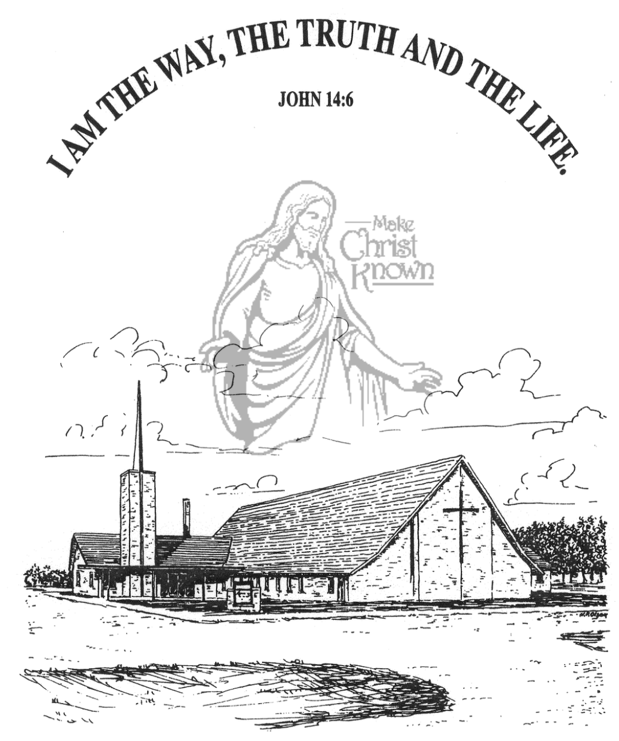
Sunday, November 09, 2025

Salem Reformed Church
Menno, South Dakota

..3

SALEM REFORMED CHURCH
Menno, South Dakota

Rev. Michael Hecht Pastor
Marina Schaeffer Pianist

10:30 AM – Worship Service November 09, 2025
Twenty-second Sunday after Pentecost

Meditation: “Blessed is the nation whose God is the LORD, the people He chose for His inheritance. From heaven the LORD looks down and sees all mankind; . . . . No king is saved by the size of his army; no warrior escapes by his great strength. A horse is a vain hope for deliverance; despite all its great strength it cannot save. But the eyes of the LORD are on those who fear Him, on those whose hope is in His unfailing love, to deliver them from death and keep them alive in famine. We wait in hope for the LORD; He is our help and our shield. In Him our hearts rejoice, for we trust in His holy name. May Your unfailing love rest upon us, O LORD, even as we put our hope in You.”
Psalm 33:12,13, 16-22 NIV

Praise Music: #14, #123, #111, #120
Ringing of the Bell
Welcome / Announcements
Opening Prayer
*Hymn: #79 “My Jesus, I Love Thee”
Sharing of Joys and Concerns
Our Time of Offering Psalm 34:1-3 NIV
*Doxology sung on page #815
*Apostles’ Creed see words on screen
Kingdom Kids: “Picking Up Pennies”
Special Music: “Unashamed” by Junior Choir (Grade 4-8)
The Holy Scriptures
Psalm 46:1-11
Large Print NIV 1984 Edition, pg. 885
Sermon: “A Very Present Help”
*Hymn: #133 “Whom Shall I Fear?” (praise book)
*Benediction:
*Prayer for Our Nation: “God Bless America”
Postlude
(*denotes standing for those able)
The congregation will be ushered out after the Benediction
Youth Ushers: Brockton Kocourek, Micah Goehring,
Corwin Schaeffer, Jefrey Poma-Sanchez
Office Hours for Pastor Hecht
Tuesday – Friday: 8:00 AM to Noon (Church Office)
Afternoons: Visitation or Church Office
Church: (605) 387-5334 Parsonage: (605) 387-2855
Pastor Mike’s Cell #: (605) 660-1803
Church Web Page: salemreformedchurch.com

Opportunities
Greeters Today: Jim & Deb Christensen
Greeters November 16th Robert & Elaine Balogh
Sunday Prayer Time: 8:30 a.m.
Sunday School Classes: 9:15 a.m.
Praise Music: 10:15 a.m.
Worship Service: 10:30 a.m.

Announcements
Welcome: We extend a warm welcome to our visiting guests this morning. Please sign our guest book in the Narthex. We ask God’s blessing upon you and we pray that you will return and worship with us again soon.
Parsonage Basement Open House: The congregation is invited to see the remodeled parsonage basement TODAY! You can come after church or coffee hour until 1:00 p.m. to check it out. Thanks to all who have helped on this project!
Coffee Hour: Please join us in the Social Hall after church today for a time of fellowship, while enjoying coffee and desserts. This is a chance to get better acquainted!
Sound Crew Help: We are looking for a few more people (High School and older) to help with running the Sound, the Projector, and the Video recording of our services.
Men Standing Together: TODAY @ 5PM at church. Supper will be provided. Gene VanZee, from Platte, will be our Guest Speaker. Middle School/High School young men are also welcome. Sign the sheet in the Narthex if attending.
Human Services Center Gifts: The W.O.C. are sponsoring a donation drive for Christmas Gifts for the residents at HSC. A list of acceptable gifts is available by the donation box in the Social Hall. The deadline to bring donations is Sun., Nov. 30th.
M/OCC Bingo Sign-Up: November is our turn to help with Bingo at M/OCC. This will happen each Friday at 2:00 pm. Please sign the sheet in the Narthex if you are able to help.

Sunday Offerings: Please note that we have an Offering Box/Pulpit at the back of the Sanctuary for people to place their tithes and offerings in during our worship services.

