**Calendar of Events**

Oct 05 Heidelberg League @ 7:00 p.m.

Oct 06 Men’s Christian Fellowship @ 7:30 p.m.

Oct 07 M/O Ministerial Mtg at Roosters @ 11:30 a.m.

Oct 08 Women’s Bible Study @ 9:30 a.m. & 6:00 p.m.

Confirmation Classes @ 4:45 to 6:30 p.m.

Consistory Meeting @ 7:30 p.m.

Oct 09 Prayer Group @ 12 Noon

Oct 12 Prayer Time for Service @ 8:30 a.m.

Sunday School Classes @ 9:15 a.m.

Praise Music @ 10:15 a.m.

Worship Service @ 10:30 a.m.

**Upcoming Special Music**

Sunday, Oct. 12 - Available

Sunday, Oct. 19 - Tyler Ulmer

**Announcements**

**Ark Encounter Bus Tour:** Please contact Cindy Herrboldt if you are interested in a bus tour going to the Ark & Creation Museums in Kentucky on July 21-25, 2026. **(See the October Salem Spire for more details.)**

**Weekend to Remember:** Here is a wonderful way to invest in your marriage! This is a 2 ½ day getaway that equips couples with practical tools and resources. It is scheduled for Nov. 14-16, 2025 in Sioux Falls. Check out their website for more information: [*www.familylife.com*](http://www.familylife.com)

**Sound Crew Help:** We are looking for a few more people (High School and older) to help with running the Sound, the Projector, and the Video recording of our services. Please contact Joanie Handel, Ken Stepanek or the church office if interested.

**Men Standing Together:** This is scheduled for Sunday Evening, November 9th in our Social Hall. Supper will be provided. Please watch the church bulletin for more details.

**Christmas Eve Program Director:** BIG THANKS to Cindy Herrboldt, who will be directing our Christmas Eve Program this year! Please let Cindy know if your children **(Ages 3 Years Old through 8th Grade)** will not be present for the program this year. It would be nice to know ASAP. Cindy’s cell number is (605) 660-5251.

**Salem Reformed Church – Who Are We?**

**We believe the Bible to be the inspired, inerrant, infallible Word of God in its original manuscripts. It is our supreme authority in all matters of doctrine and practice. We are affiliated with the Conservative Congregational Christian Conference.**

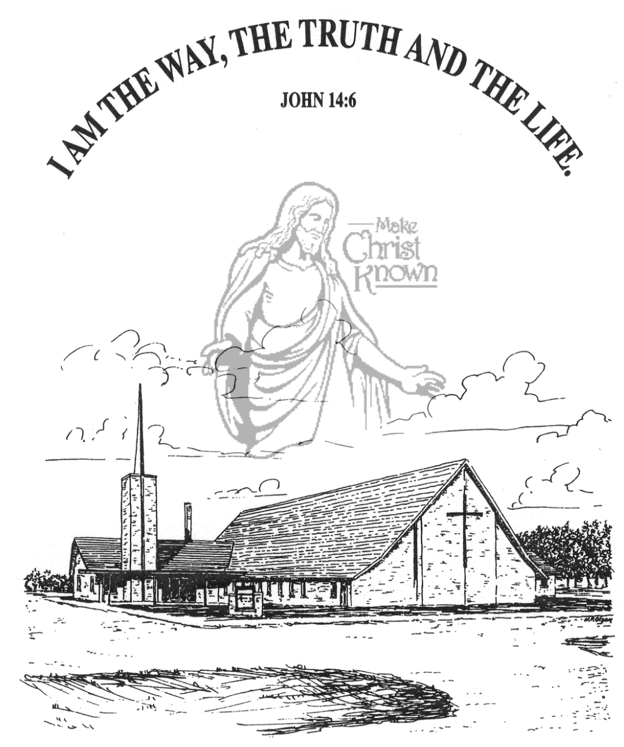

**Sunday, October 05, 2025**

**Salem Reformed Church**

**Menno, South Dakota**

..3

**SALEM REFORMED CHURCH**

Menno, South Dakota

Rev. Michael Hecht Pastor

Marina Schaeffer Pianist

10:30 AM – Worship Service October 05, 2025

Seventeenth Sunday after Pentecost

**Meditation:** *“Now, brothers, I want to remind you of the gospel I preached to you, which you received and on which you have taken your stand. By this gospel you are saved, if you hold firmly to the word I preached to you. Otherwise, you have believed in vain. For what I received I passed on to you as of first importance: that Christ died for our sins according to the Scriptures, that He was buried, that He was raised on the third day according to the Scriptures, and that He appeared to Peter, and then to the Twelve. . . . and last of all He appeared to me also, as to one abnormally born.”*  I Corinthians 15:1-5, 8 NIV

**Praise Music:** #93, #126, #49, #150

**Ringing of the Bell**

**Welcome / Announcements**

**Opening Prayer**

**\*Hymn:** #21 “O For a Thousand Tongues to Sing”

**Sharing of Joys and Concerns**

**Our Time of Offering**  I John 1:8,9 NIV

**\*Doxology** sung on page #518

**\*Lord’s Prayer** debts and debtors

**Kingdom Kids:** “The Savior’s Happy Meal”

**Hymn:** #387 “Holy Spirit, Thou Art Welcome”

**The Holy Scriptures**

Galatians 1:11-24

Large Print NIV 1984 Edition, pg. 1810

**Sermon: “Preaching Jesus Among the Gentiles”**

**Prayer of Confession**

#308 “There is a Redeemer”

#124 “Jesus Messiah” (praise book)

**Sacrament of Holy Communion**

**\*Hymn:** #120 “10,000 Reasons”

**\*Benediction:**

**\*Prayer for Our Nation:** “God Bless America”

**Postlude** (*denotes standing for those able)

The congregation will be ushered out after the Benediction

Youth Ushers: Amanda Rames, Ashlynn Fergen, Briley Cross

**Office Hours for Pastor Hecht**

Tuesday – Friday: 8:00 AM to Noon (Church Office)

Afternoons: Visitation or Church Office

Church: (605) 387-5334 Parsonage: (605) 387-2855

Pastor Mike’s Cell #: (605) 660-1803

Church Web Page: ***salemreformedchurch.com***

**Opportunities**

Greeters Today: David & Jennifer Herrboldt

Greeters October 12th:

Sunday Prayer Time: 8:30 a.m.

Sunday School Classes: 9:15 a.m.

Praise Music: 10:15 a.m.

Worship Service: 10:30 a.m.

**Announcements**

**Welcome:** We extend a warm welcome to our visiting guests this morning. Please sign our guest book in the Narthex. We ask God’s blessing upon you and we pray that you will return and worship with us again soon.

**Holy Communion:** We at Salem Reformed Church recognize an open communion table. All are welcome to partake of the bread and wine and accept the gift of grace that God offers to us through Jesus Christ, our Savior and Lord. **The inner most ring of the communion tray contains grape juice. All other rings contain wine.

**Heidelberg League:** The High School Youth will be meeting at church THIS EVENING at 7:00 PM.

**Mission Fest Service:** Mission Fest is on Sunday, October 19th. Our guest speaker will be Ali Farhadi. He will be sharing Sunday AM & PM! Ali was born into a Muslim family in the Islamic Republic of Iran. His family immigrated to the United States in 1989. Over the next two decades, Ali heard the witness of the Gospel from many believers, and was brightly saved in 2010. Ali and Veronika share the Good News of Jesus to Muslims in the USA and beyond! The offering has been designated as follows: 90% to the Ministry of Ali/Veronika, and 10% given to the FCA at Menno High School.

**\*NOTE:** The Consistory and Spouses will host a Pot Luck Dinner following the service. Please stay and enjoy the meal!

**Cherub Choir:** The Cherub Choir (3 yrs. old – 3rd Grade) will be singing in church on Sunday, October 26th!

**Sunday Offerings:** Please note that we have an Offering Box/Pulpit at the back of the Sanctuary for people to place their tithes and offerings in during our worship services.