Calendar of Events
Oct 29 Women’s Bible Study @ 9:30 a.m. & 6:00 p.m.
4-O’s Women Meet at Church @ 11:30 a.m.
Confirmation Classes @ 4:45 to 6:30 p.m.
Oct 30 Prayer Group @ 12 Noon
Nov 01 Daylight Savings Time Ends/Set Clocks Back!
Nov 02 Prayer Time for Service @ 8:30 a.m.
Sunday School Classes @ 9:15 a.m.
Praise Music @ 10:15 a.m.
Worship Service @ 10:30 a.m.
M/OCC Worship Service @ 2:00 p.m.
Heidelberg League Meet at @ 5:30 p.m.
Nov 03 Men’s Christian Fellowship @ 7:00 p.m.
Nov 04 M/O Ministerial Meeting @ 11:30 a.m.
Upcoming Special Music
Sunday, Nov. 02 - Available
Sunday, Nov. 09 - Junior Choir

Announcements
M/OCC Open House & Bingo Fundraiser – TODAY: Come check out all the updates/additions at the nursing home! Open House 1:00-2:00, Community Worship 2:00-2:30, followed by Bingo from 2:30-4:30. $10 per card – play all day.
Bethany Food Pantry: Our church youth group will be sponsoring a Food Drive for the Bethany Food Pantry in Freeman. This will start TODAY, and go thru Sun., Nov. 9th. In addition to non-perishable food items, you may also bring personal care items such as tooth paste, shampoo, deodorant, tooth brushes, laundry detergent. Winter caps, gloves and scarves are also welcome. Items may be placed in the box in the Social Hall.
Christmas Eve Program Director: BIG THANKS to Cindy Herrboldt, who will be directing our Christmas Eve Program this year! Please let Cindy know if your children (Ages 3 Years Old through 8th Grade) will not be present for the program this year. It would be nice to know ASAP. Cindy’s cell number is (605) 660-5251.
M/OCC Bingo Sign-Up: November is our turn to help with Bingo at M/OCC. This will happen each Friday at 2:00 pm. Please sign the sheet in the Narthex if you are able to help.

Salem Reformed Church – Who Are We?
We believe the Bible to be the inspired, inerrant, infallible Word of God in its original manuscripts. It is our supreme authority in all matters of doctrine and practice. We are affiliated with the Conservative Congregational Christian Conference.

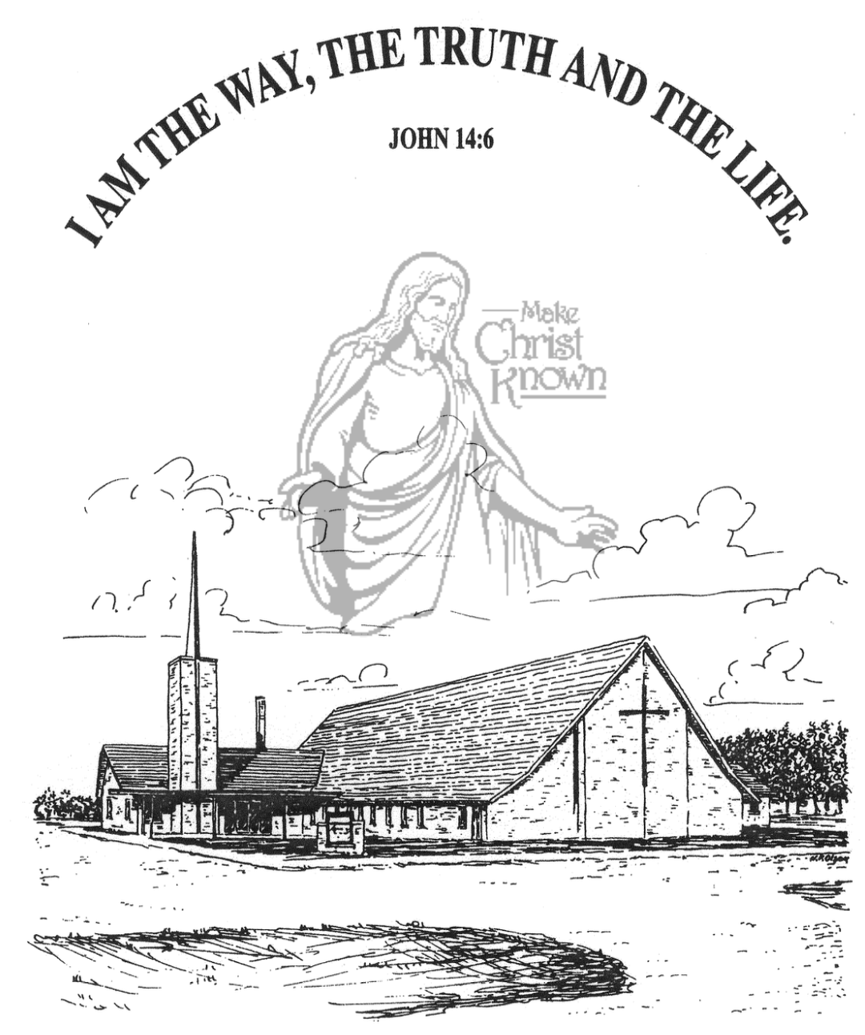
Sunday, October 26, 2025

Salem Reformed Church
Menno, South Dakota

..3

SALEM REFORMED CHURCH
Menno, South Dakota

Rev. Michael Hecht Pastor
Joan Nusz Pianist

10:30 AM – Worship Service October 26, 2025
Reformation Sunday

Meditation: Heidelberg Catechism Question #60 – How are you right with God?
Answer: “Only by true faith in Jesus Christ! Even though my conscience accuses me of having grievously sinned against all God’s commandments and of never having kept any of them, and even though I am still inclined toward all evil, nevertheless, without my deserving it at all, out of sheer grace, God grants and credits to me the perfect satisfaction, righteousness, and holiness of Christ, as if I had never sinned or been a sinner, as if I had been as perfectly obedient as Christ was obedient for me. All I need to do is accept this gift of God with a believing heart.”

Praise Music: #88, #53, #60, #24, #762
Ringing of the Bell
Welcome / Announcements
Opening Prayer
*Hymn: #151 “A Mighty Fortress Is Our God”
Sharing of Joys and Concerns
Our Time of Offering Isaiah 9:2,3 NIV
*Doxology sung on page #815
*Apostles’ Creed see words on screen
Special Music: “My God” and “Father Abraham”
(sung by the Cherub Choir – Ages 3yrs thru 3rd Grade)
Kingdom Kids: “Christ In Me” by Emily Guthmiller
Hymn: #62 “Blessed Be the Lord God Almighty”
The Holy Scriptures
Galatians 2:11-21
Large Print NIV 1984 Edition, pg. 1811
Sermon: “The Truth of the Gospel”
*Hymn: #330 “Are You Washed in the Blood?”
*Benediction:
*Prayer for Our Nation: “God Bless America”
Postlude
(*denotes standing for those able)
The congregation will be ushered out after the Benediction
Youth Ushers: Amanda Rames, Ashlynn Fergen, Briley Cross
Office Hours for Pastor Hecht
Tuesday – Friday: 8:00 AM to Noon (Church Office)
Afternoons: Visitation or Church Office
Church: (605) 387-5334 Parsonage: (605) 387-2855
Pastor Mike’s Cell #: (605) 660-1803
Church Web Page: salemreformedchurch.com

Opportunities
Greeters Today: Ken & Ramona Bittner
Greeters November 02nd Brian & Steph Mehlhaf
Sunday Prayer Time: 8:30 a.m.
Sunday School Classes: 9:15 a.m.
Praise Music: 10:15 a.m.
Worship Service: 10:30 a.m.

Announcements
Welcome: We extend a warm welcome to our visiting guests this morning. Please sign our guest book in the Narthex. We ask God’s blessing upon you and we pray that you will return and worship with us again soon.
Daylight Savings Time Ends: Remember to set your clocks BACK 1 Hour this coming Saturday evening, November 1st.
Mission Fest Offering: The total amount given for the Mission Fest Offering last Sunday was $11,156.00. We Praise the Lord for such generous giving to these missions! The Menno FCA received 10% = $1,115.60; and Ali/Veronika Farhadi received 90% = 10,040.40. To God Be the Glory!
Junior Choir: The Junior Choir (Grades 4-8) will be singing in church on Sunday, November 9th! Please have your children here by 9:15 a.m. on Sunday mornings for practice. Thanks!
Sound Crew Help: We are looking for a few more people (High School and older) to help with running the Sound, the Projector, and the Video recording of our services.
Men Standing Together: Sun., Nov. 9th @ 5PM at church. Supper will be provided. Gene VanZee, from Platte, will be our Guest Speaker. Middle School/High School young men are also welcome. Sign the sheet in the Narthex if attending.
Coffee Hour: We are looking for volunteers to bring two dozen goodies for Coffee Hour on Sunday, Nov 9. Please sign the sheet in the Narthex if you are able to help.
CE Committee Meeting: The Christian Education Committee will plan to meet after church TODAY!
Sunday Offerings: Please note that we have an Offering Box/Pulpit at the back of the Sanctuary for people to place their tithes and offerings in during our worship services.

