Calendar of Events
Oct 19 Mission Fest & Youth Group @ 7:00 p.m.
Oct 20 Men’s Christian Fellowship @ 7:30 p.m.
Oct 22 Women’s Bible Study @ 9:30 a.m. & 6:00 p.m.
Confirmation Classes @ 4:45 to 6:30 p.m.
Oct 23 Prayer Group @ 12 Noon
Oct 26 Prayer Time for Service @ 8:30 a.m.
Sunday School Classes @ 9:15 a.m.
Praise Music @ 10:15 a.m.
Worship Service @ 10:30 a.m.
CE Committee Mtg. @ 11:45 a.m.
M/OCC Open House @ 1:00 p.m.
Upcoming Special Music
Sunday, Oct. 26 - Cherub Choir
Sunday, Nov. 02 - Available

Announcements
Bethany Food Pantry: Our church youth group will be sponsoring a Food Drive for the Bethany Food Pantry in Freeman. This will start next Sun., Oct. 26th thru Sun., Nov. 9th. In addition to non-perishable food items, you may also bring personal care items such as tooth paste, shampoo, deodorant, tooth brushes, laundry detergent. Winter caps, gloves and scarves are also welcome. Items may be placed in the box in the Social Hall.
Christmas Eve Program Director: BIG THANKS to Cindy Herrboldt, who will be directing our Christmas Eve Program this year! Please let Cindy know if your children (Ages 3 Years Old through 8th Grade) will not be present for the program this year. It would be nice to know ASAP. Cindy’s cell number is (605) 660-5251.
M/OCC Bingo Sign-Up: November is our turn to help with Bingo at M/OCC. This will happen each Friday at 2:00 pm. Please sign the sheet in the Narthex if you are able to help.
Coffee Hour Coordinators: We are looking for 1 or 2 couples willing to host our monthly Coffee Hour after church, starting in January. BIG THANKS to Allen & Carrie Dyk who have hosted this for the last several years. Please contact the Dyk’s if you have questions about this. Please contact the church office if you are willing to host these monthly events.

Salem Reformed Church – Who Are We?
We believe the Bible to be the inspired, inerrant, infallible Word of God in its original manuscripts. It is our supreme authority in all matters of doctrine and practice. We are affiliated with the Conservative Congregational Christian Conference.

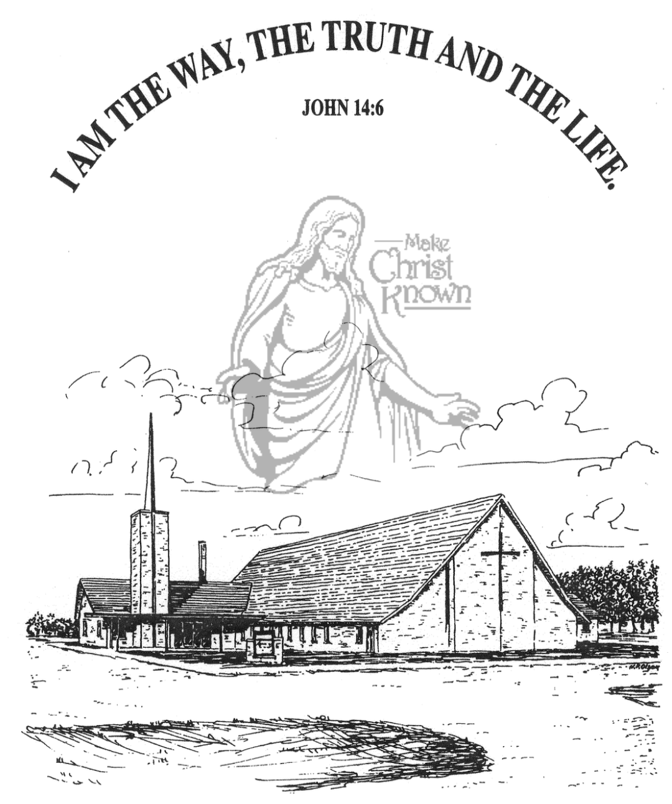
Sunday, October 19, 2025

Salem Reformed Church
Menno, South Dakota

..3

SALEM REFORMED CHURCH
Menno, South Dakota

Rev. Michael Hecht Pastor
Cindy Herrboldt Organist

10:30 AM – Worship Service October 19, 2025
Nineteenth Sunday after Pentecost

Meditation: “That if you confess with your mouth, ‘Jesus is Lord,’ and believe in your heart that God raised Him from the dead, you will be saved. For it is with your heart that you believe and are justified, and it is with your mouth that you confess and are saved. As the Scripture says, ‘Anyone who trusts in Him will never be put to shame.’ For there is no difference between Jew and Gentile – the same Lord is Lord of all and richly blesses all who call on Him, for, ‘Everyone who calls on the name of the Lord will be saved.’ How, then, can they call on the One they have not believed in? And how can they believe in the One of whom they have not heard? And how can they hear without someone preaching to them? And how can they preach unless they are sent? As it is written, ‘How beautiful are the feet of those who bring good news!” Romans 10:9-15 NIV

Praise Music: #66, #19, #28, #45, #32, #12
Ringing of the Bell
Welcome / Announcements
Opening Prayer
*Hymn: #45 “Crown Him with Many Crowns”
Sharing of Joys and Concerns
Our Time of Offering Romans 1:16,17 NIV
*Doxology sung on page #815
*Lord’s Prayer debts and debtors
Kingdom Kids: “No More Mail? ? ?”
Special Music: “In Christ Alone” sung by Tyler Ulmer
The Holy Scriptures
Selected Verses from Romans
Large Print NIV 1984 Edition, pg. 1747
Sermon: “The Roman Road” shared by Ali Farhadi
*Hymn: #372 “Our God Reigns”
*Benediction:
*Prayer for Our Nation: “God Bless America”
Postlude (*denotes standing for those able)
The congregation will be ushered out after the Benediction
Youth Ushers: Amanda Rames, Ashlynn Fergen, Briley Cross
Office Hours for Pastor Hecht
Tuesday – Friday: 8:00 AM to Noon (Church Office)
Afternoons: Visitation or Church Office
Church: (605) 387-5334 Parsonage: (605) 387-2855
Pastor Mike’s Cell #: (605) 660-1803
Church Web Page: salemreformedchurch.com

Opportunities
Greeters Today: Robert & Elaine Balogh
Greeters October 26th:
Sunday Prayer Time: 8:30 a.m.
Sunday School Classes: 9:15 a.m.
Praise Music: 10:15 a.m.
Worship Service: 10:30 a.m.

Announcements
Welcome: We extend a warm welcome to our visiting guests this morning. Please sign our guest book in the Narthex. We ask God’s blessing upon you and we pray that you will return and worship with us again soon.
Mission Fest Service: A Special Welcome to Ali & Veronika Farhadi, as they are here to share during our Mission Fest Services! Ali will be sharing again this evening at 7PM! The offering today will be designated as follows: 90% to the Ministry of Ali/Veronika, and 10% given to the FCA at Menno High School. EVERYONE is invited to stay and enjoy a Pot Luck Meal after our service this morning!
Cherub & Junior Choirs: The Cherub Choir (3 yrs. old – 3rd Grade) will be singing in church on Sunday, October 26th! The Junior Choir (Grades 4-8) will be singing in church on Sunday, November 9th! Please have your children here by 9:15 a.m. on Sunday mornings for practice. Thanks!
Sound Crew Help: We are looking for a few more people (High School and older) to help with running the Sound, the Projector, and the Video recording of our services. Contact Joanie Handel, Ken Stepanek or the church office if interested.
Men Standing Together: Sun., Nov. 9th @ 5PM at church. Supper will be provided. Gene VanZee, from Platte, will be our Guest Speaker. Middle School/High School young men are also welcome. Sign the sheet in the Narthex if attending.
CE Committee Meeting: The Christian Education Committee will plan to meet next Sunday, Oct. 26th, after church.
Sunday Offerings: Please note that we have an Offering Box/Pulpit at the back of the Sanctuary for people to place their tithes and offerings in during our worship services.

