Calendar of Events
Oct 15 Women’s Bible Study @ 9:30 a.m. & 6:00 p.m.
Confirmation Classes @ 4:45 to 6:30 p.m.
FCA at Menno Gym @ 7:30 p.m.
Oct 16 Prayer Group @ 12 Noon
Oct 19 Mission Fest Sunday!
Prayer Time for Service @ 8:30 a.m.
Sunday School Classes @ 9:15 a.m.
Praise Music @ 10:15 a.m.
Worship Service @ 10:30 a.m.
w/Pot Luck Dinner Following
Evening Mission Fest Service @ 7:00 p.m.
Oct 20 Men’s Christian Fellowship @ 7:30 p.m.
Upcoming Special Music
Sunday, Oct. 19 - Tyler Ulmer
Sunday, Oct. 26 - Cherub Choir

Announcements
Ark Encounter Bus Tour: Please contact Cindy Herrboldt if you are interested in a bus tour going to the Ark & Creation Museums in Kentucky on July 21-25, 2026. Please let Cindy Herrboldt know if you plan to go on this trip, even if you have already signed the original sheet.
Weekend to Remember: Here is a wonderful way to invest in your marriage! This is a 2 ½ day getaway that equips couples with practical tools and resources. It is scheduled for Nov. 14-16, 2025 in Sioux Falls. Check out their website for more information: www.familylife.com
Christmas Eve Program Director: BIG THANKS to Cindy Herrboldt, who will be directing our Christmas Eve Program this year! Please let Cindy know if your children (Ages 3 Years Old through 8th Grade) will not be present for the program this year. It would be nice to know ASAP. Cindy’s cell number is (605) 660-5251.
Coffee Hour Coordinators: We are looking for 1 or 2 couples willing to host our monthly Coffee Hour after church, starting in January. BIG THANKS to Allen & Carrie Dyk who have hosted this for the last several years. Please contact the Dyk’s if you have questions about this. Please contact the church office if you are willing to host these monthly events.

Salem Reformed Church – Who Are We?
We believe the Bible to be the inspired, inerrant, infallible Word of God in its original manuscripts. It is our supreme authority in all matters of doctrine and practice. We are affiliated with the Conservative Congregational Christian Conference.

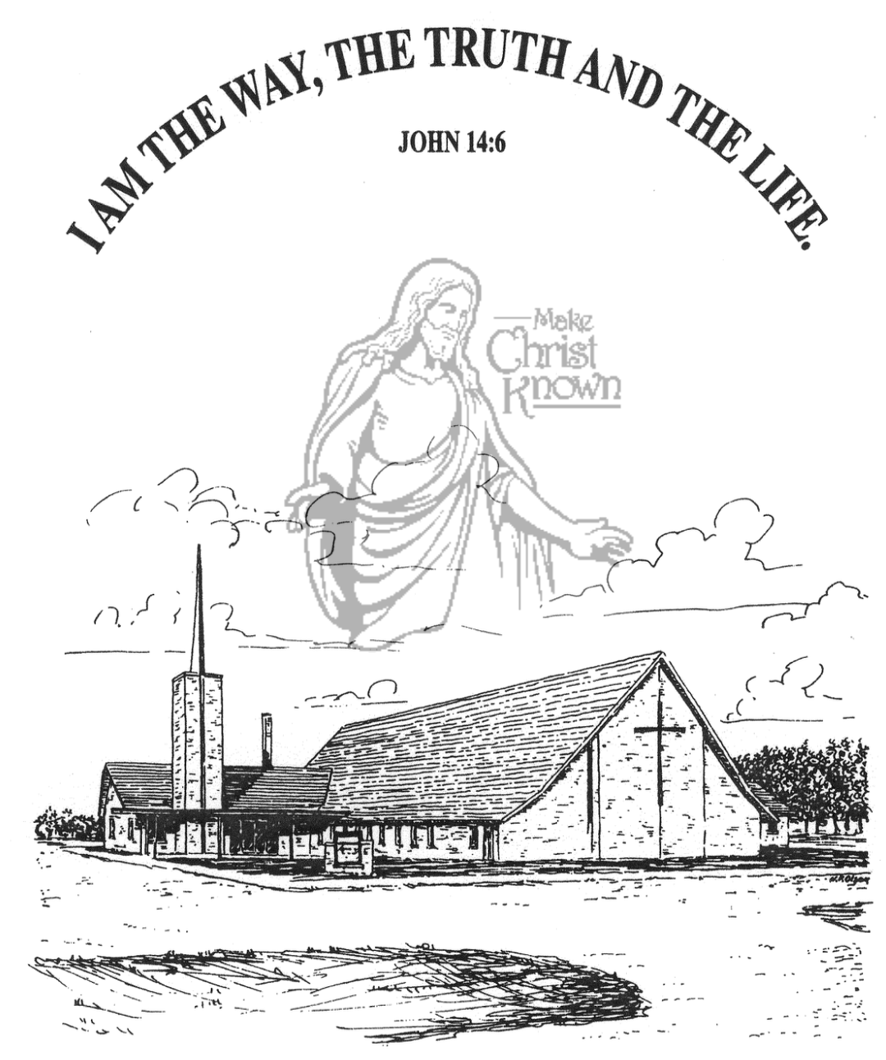
Sunday, October 12, 2025

Salem Reformed Church
Menno, South Dakota

..3

SALEM REFORMED CHURCH
Menno, South Dakota

Rev. Michael Hecht Pastor
Jennifer Herrboldt Pianist

10:30 AM – Worship Service October 12, 2025
Eighteenth Sunday after Pentecost

Meditation: “The apostles and elders, your brothers, To the Gentile believers in Antioch, Syria and Cilicia: Greetings! We have heard that some went out from us without our authorization and disturbed you, troubling your minds by what they said. So we all agreed to choose some men and send them to you with our dear friends Barnabas and Paul – men who have risked their lives for the name of our Lord Jesus Christ. Therefore we are sending Judas and Silas to confirm by word of mouth what we are writing. It seemed good to the Holy Spirit and to us not to burden you with anything beyond the following requirements: You are to abstain from food sacrificed to idols, from blood, from the meat of strangled animals and from sexual immorality. You will do well to avoid these things.” The Council at Jerusalem Acts 15:23-29 NIV

Praise Music: #82, #131, #118, #140
Ringing of the Bell
Welcome / Announcements
Opening Prayer
*Hymn: #139 “Great Is Thy Faithfulness”
Sharing of Joys and Concerns
Our Time of Offering Romans 8:1,2 NIV
*Lord’s Prayer sung on page #631
*Apostles’ Creed see words on screen
Kingdom Kids: “The Gospel in a Nutshell”
Hymn: #520 “The Longer I Serve Him”
The Holy Scriptures
Galatians 2:1-10
Large Print NIV 1984 Edition, pg. 1810
Sermon: “Cruise Ship or Battle Ship?”
*Hymn: #543 “Til the Storm Passes By”
*Benediction:
*Prayer for Our Nation: “God Bless America”
Postlude (*denotes standing for those able)
The congregation will be ushered out after the Benediction
Youth Ushers: Amanda Rames, Ashlynn Fergen, Briley Cross
Office Hours for Pastor Hecht
Tuesday – Friday: 8:00 AM to Noon (Church Office)
Afternoons: Visitation or Church Office
Church: (605) 387-5334 Parsonage: (605) 387-2855
Pastor Mike’s Cell #: (605) 660-1803
Church Web Page: salemreformedchurch.com

Opportunities
Greeters Today: Michael & Stephanie Wagner
Greeters October 19th: Robert & Elaine Balogh
Sunday Prayer Time: 8:30 a.m.
Sunday School Classes: 9:15 a.m.
Praise Music: 10:15 a.m.
Worship Service: 10:30 a.m.

Announcements
Welcome: We extend a warm welcome to our visiting guests this morning. Please sign our guest book in the Narthex. We ask God’s blessing upon you and we pray that you will return and worship with us again soon.
Mission Fest Service: Mission Fest is on Sunday, October 19th. Our guest speaker will be Ali Farhadi. He will be sharing Sunday AM & PM! Ali was born into a Muslim family in the Islamic Republic of Iran. His family immigrated to the United States in 1989. Over the next two decades, Ali heard the witness of the Gospel from many believers, and was brightly saved in 2010. Ali and Veronika share the Good News of Jesus to Muslims in the USA and beyond! The offering has been designated as follows: 90% to the Ministry of Ali/Veronika, and 10% given to the FCA at Menno High School.
*NOTE: The Consistory and Spouses will host a Pot Luck Dinner following the service. Please stay and enjoy the meal!
Cherub Choir: The Cherub Choir (3 yrs. old – 3rd Grade) will be singing in church on Sunday, October 26th!
Sound Crew Help: We are looking for a few more people (High School and older) to help with running the Sound, the Projector, and the Video recording of our services. Contact Joanie Handel, Ken Stepanek or the church office if interested.
Men Standing Together: This is scheduled for Sunday Evening, November 9th in our Social Hall. Supper will be provided. Please watch the church bulletin for more details.

Sunday Offerings: Please note that we have an Offering Box/Pulpit at the back of the Sanctuary for people to place their tithes and offerings in during our worship services.

