**Calendar of Events**

Sept 07 Heidelberg League Youth @ 7:00 p.m.

Sept 10 Women’s Bible Study @ 9:30 a.m. & 6:00 p.m.

Confirmation Classes @ 4:45 to 6:30 p.m.

Consistory Meeting @ 7:30 p.m.

Sept 11 Prayer Group @ 12 Noon

Sept 14 Prayer Time for Service @ 8:30 a.m.

Sunday School Classes @ 9:15 a.m.

Praise Music @ 10:15 a.m.

Worship Service @ 10:30 a.m.

w/Baptism of Nash Keith Miller

Sept 15 Men’s Christian Fellowship @ 7:30 p.m.

**Upcoming Special Music**

Sunday, Sept 14 - Available

Sunday, Sept 21 - Available

**Announcements**

**High School Youth:** The High School Youth will meet TONIGHT @ 7 p.m. in the Social Hall.

**Potato Topper Supper:** You are invited to the Friedens Reformed Church, Tripp, SD, on Wed., Sept. 17th, for this event.

They serve from 5-8 p.m. Free-will donations are accepted.

**Meals-on-Wheels:** Our church will be delivering meals during the month of SEPTEMBER. Please remember the days that you signed up to deliver these meals. They should be picked up at M/OCC at 11:20 AM. Thanks for blessing others.

**S.S. Class Helpers Needed:** We are looking for 1 more helper in each of these classes: K/1st Class and 2/3rd Grade Class. We have found the lead teachers; we are looking for helpers. Contact Kevin Holzwarth or call the church office if you are interested. Thanks!

**Ark Encounter Bus Tour:** We are taking names of people, from our congregation, who would have interest in a bus tour going to the Ark & Creation Museums on July 21-25, 2026. **(See the Salem Spire for more details.)**

**Weekend to Remember:** Here is a wonderful way to invest in your marriage! This is a 2 ½ day getaway that equips couples with practical tools and resources. It is scheduled for Nov. 14-16, 2025 in Sioux Falls. Check out their website for more information: *www.familylife.com*

**Salem Reformed Church – Who Are We?**

**We believe the Bible to be the inspired, inerrant, infallible Word of God in its original manuscripts. It is our supreme authority in all matters of doctrine and practice. We are affiliated with the Conservative Congregational Christian Conference.**

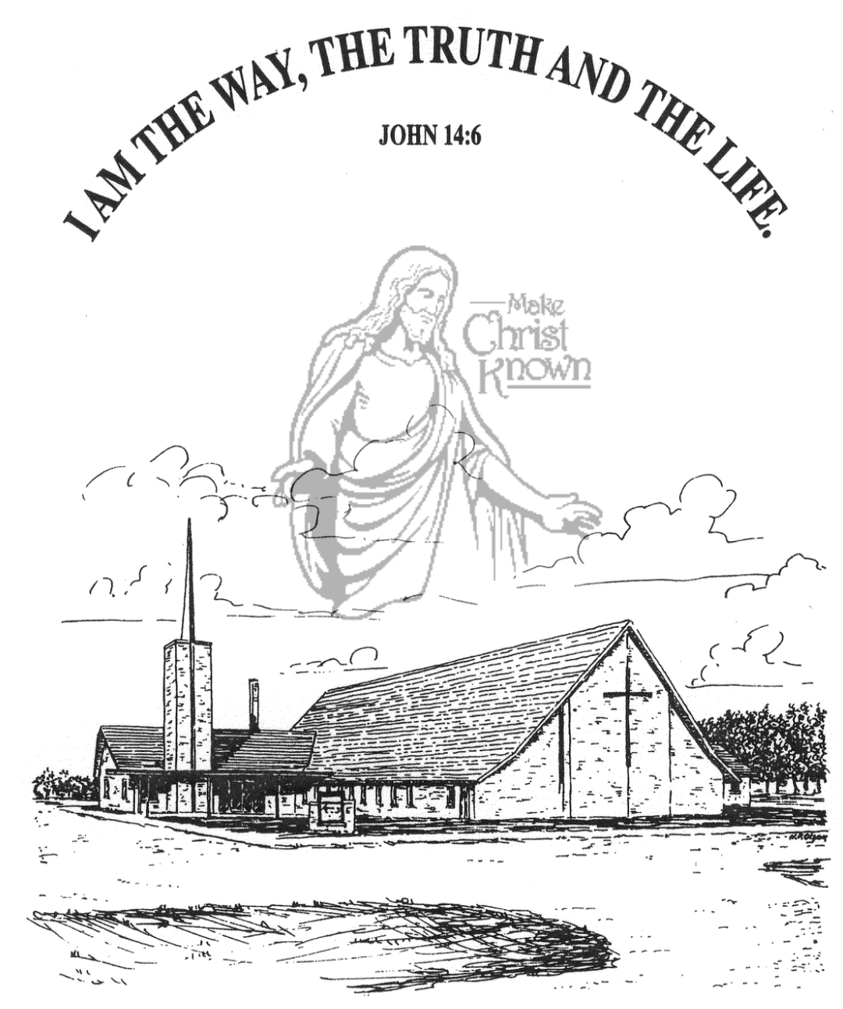

**Sunday, September 07, 2025**

**Salem Reformed Church**

**Menno, South Dakota**

..3

**SALEM REFORMED CHURCH**

Menno, South Dakota

Rev. Michael Hecht Pastor

Jennifer Herrboldt Pianist

10:30 AM – Worship Service September 07, 2025

Thirteenth Sunday after Pentecost

**Meditation:** *“Children, obey your parents in the Lord, for this is right. ‘Honor your father and mother’ – which is the first commandment with a promise – ‘that it may go well with you and that you may enjoy long life on the earth.’ Fathers, do not exasperate your children; instead, bring them up in the training and instruction of the Lord.”*

Ephesians 6:1-4 NIV

**Praise Music:** #48, #70, #72, #143, #16

**Ringing of the Bell**

**Welcome / Announcements**

**Opening Prayer**

**\*Hymn:** #210 “Praise to the Lord, the Almighty”

**Sharing of Joys and Concerns**

**Our Time of Offering**  II Timothy 1:5 NIV

**\*Lord’s Prayer** sung on page #631

**\*Apostles’ Creed** see words on screen

**Presentation of Sunday School Teachers**

**Responsive Reading – taken from Romans 12:3-8**

**Covenant / Prayer of Affirmation**

**Hymn:** “Lord, We Bring to You Our Children”

**Presentation Of:** by Katie Huber, Asst. S.S. Superintendent

**ESV Children’s Bibles - 2nd Grade**

**Heidelberg Catechism - 4th Grade**

**Egermeier’s Bible Story Book - 6th Grade**

**The Holy Scriptures**

I Samuel 17

Large Print NIV 1984 Edition, pg. 445

**Sermon/Skit: “David and Goliath – Then and Now”**

**\*Hymn:** #353 “Victory in Jesus”

**\*Benediction:**

**\*Prayer for Our Nation:** “God Bless America”

**Postlude**

(*denotes standing for those able)

The congregation will be ushered out after the Benediction

Youth Ushers: Rylan Derby, Luke Plooster, Lee Kisely

**Office Hours for Pastor Hecht**

Tuesday – Friday: 8:00 AM to Noon (Church Office)

Afternoons: Visitation or Church Office

Church: (605) 387-5334 Parsonage: (605) 387-2855

Pastor Mike’s Cell #: (605) 660-1803

Church Web Page: ***salemreformedchurch.com***

**Opportunities**

Greeters Today: Ronnie & Krista Derby

Greeters September 14th: Robert & Elaine Balogh

Sunday Prayer Time: 8:30 a.m.

Sunday School Classes: 9:15 a.m.

Praise Music: 10:15 a.m.

Worship Service: 10:30 a.m.

**Announcements**

**Welcome:** We extend a warm welcome to our visiting guests this morning. Please sign our guest book in the Narthex. We ask God’s blessing upon you and we pray that you will return and worship with us again soon.

**Pot Luck Dinner:** The CE Committee will host a Pot Luck Dinner after church TODAY! All are welcome to stay for a time of lunch and fellowship. Outside Games will follow for the children and youth! **We will need some Game Helpers!

**Coffee Hour:** We are looking for 5 volunteers to bring two dozen goodies for Coffee Hour on Sunday, September 28th. Please sign the sheet in the Narthex if you are able to help.

**W.O.C. Fall Meeting:** Ladies, please make plans to attend the Fall Meeting after church on Sunday, September 28th. You all play an important role in the life of our local church, and we give thanks to the Lord for each one of you!

**Kuchen Donations:** Please sign the sheet in the Narthex if you are willing to bake and donate some kuchen for the Youth Group Food Stand at the Power Show. The Menno Pioneer Power Show is the weekend of September 20/21.

**GO FISH in Concert:** The James Valley Christian School, Huron, SD, presents *“GO FISH”* in concert on Thursday, September 18th @ 7 PM. There is FREE Admission and all seating in General Seating.

**Happy Grandparents Day!** We have a baggie of Hershey Kisses for each grandparent to pick up after church today! May God Bless you with His strength for each new day!

**Sunday Offerings:** Please note that we have an Offering Box/Pulpit at the back of the Sanctuary for people to place their tithes and offerings in during our worship services.