**Calendar of Events**

Sept 28 M/OCC Worship Service @ 2:00 p.m.

Oct 01 Women’s Bible Study @ 9:30 a.m. & 6:00 p.m.

Confirmation Classes @ 4:45 to 6:30 p.m.

FCA at Menno Gym @ 7:30 p.m.

Oct 02 Prayer Group @ 12 Noon

Oct 05 Prayer Time for Service @ 8:30 a.m.

Sunday School Classes @ 9:15 a.m.

Praise Music @ 10:15 a.m.

Worship Service @ 10:30 a.m.

w/Holy Communion

Heidelberg League @ 7:00 p.m.

Oct 06 Men’s Christian Fellowship @ 7:30 p.m.

Oct 08 Women’s Bible Study @ 9:30 a.m. & 6:00 p.m.

Confirmation Classes @ 4:45 to 6:30 p.m.

Consistory Meeting @ 7:30 p.m.

**Upcoming Special Music**

Sunday, Oct. 05 - Holy Communion

Sunday, Oct. 12 - Available

**Announcements**

**Meals-on-Wheels:** Special Thanks to all who have helped deliver meals during the month of September! You have been a blessing to many others in our community.

**Ark Encounter Bus Tour:** Please contact Cindy Herrboldt if you are interested in a bus tour going to the Ark & Creation Museums in Kentucky on July 21-25, 2026. **(See the Salem Spire for more details.)**

**Weekend to Remember:** Here is a wonderful way to invest in your marriage! This is a 2 ½ day getaway that equips couples with practical tools and resources. It is scheduled for Nov. 14-16, 2025 in Sioux Falls. Check out their website for more information: [*www.familylife.com*](http://www.familylife.com)

**Sound Crew Help:** We are looking for a few more people (High School and older) to help with running the Sound, the Projector, and the Video recording of our services. Please contact Joanie Handel, Ken Stepanek or the church office if interested.

**Men Standing Together:** This is scheduled for Sunday Evening, November 9th in our Social Hall. Supper will be provided. Please watch the church bulletin for more details.

**Salem Reformed Church – Who Are We?**

**We believe the Bible to be the inspired, inerrant, infallible Word of God in its original manuscripts. It is our supreme authority in all matters of doctrine and practice. We are affiliated with the Conservative Congregational Christian Conference.**

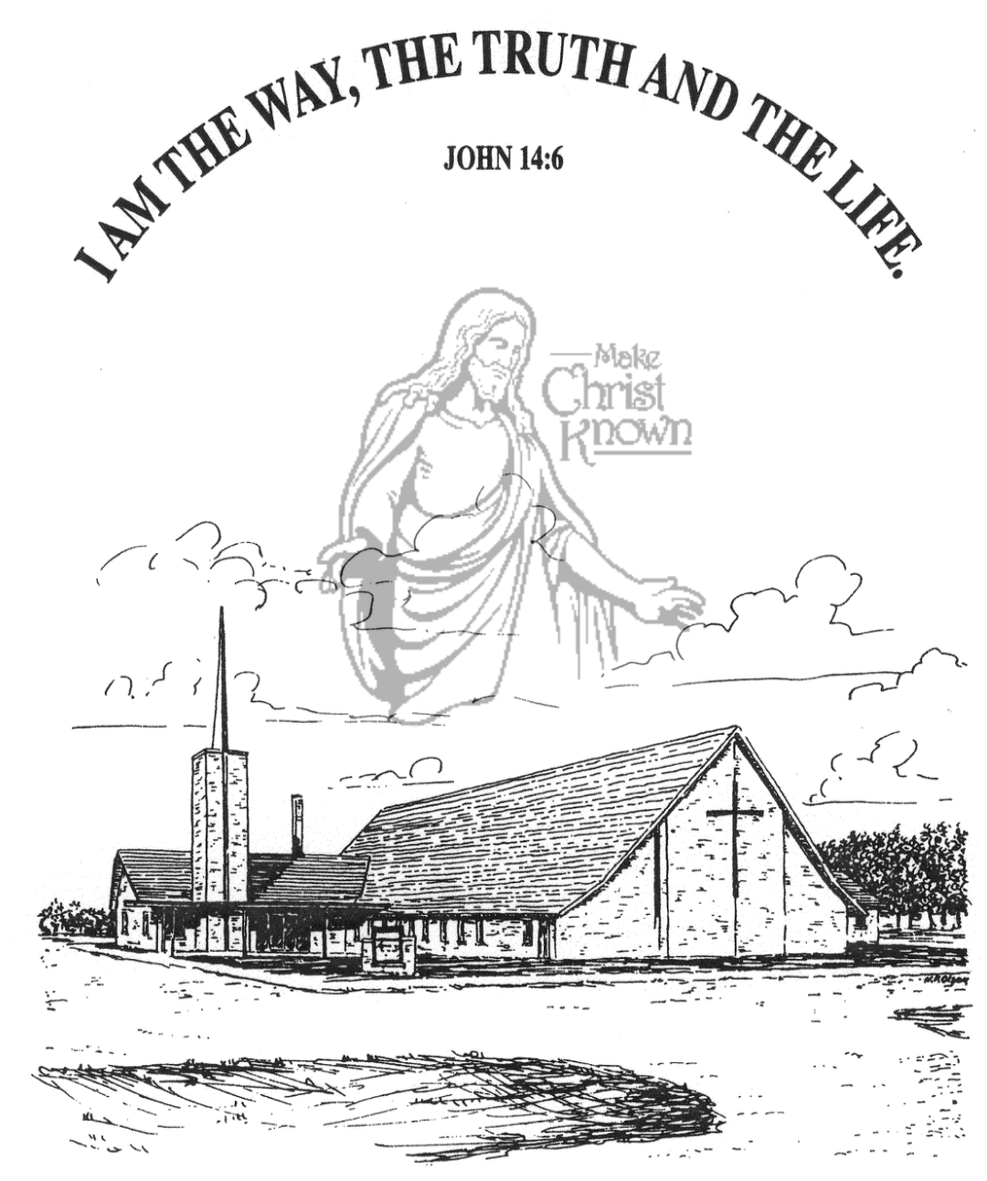

**Sunday, September 28, 2025**

**Salem Reformed Church**

**Menno, South Dakota**

..3

**SALEM REFORMED CHURCH**

Menno, South Dakota

Rev. Michael Hecht Pastor

Joan Nusz Pianist

10:30 AM – Worship Service September 28, 2025

Sixteenth Sunday after Pentecost

**Meditation:** *“I (Paul) persecuted the followers of this Way to their death, arresting both men and women and throwing them into prison, as also the high priest and all the Council can testify. I even obtained letters from them to their brothers in Damascus, and went there to bring these people as prisoners to Jerusalem to be punished. About noon as I came near Damascus, suddenly a bright light from heaven flashed around me. I fell to the ground and heard a voice say to me, ‘Saul! Saul! Why do you persecute Me?’ ‘Who are You, Lord?’ I asked. ‘I am Jesus of Nazareth, whom you are persecuting,’ He replied. My companions saw the light, but they did not understand the voice of Him who was speaking to me. ‘What shall I do, Lord?’ I asked. ‘Get up,’ the Lord said, ‘and go into Damascus. There you will be told all that you have been assigned to do.’*  Acts 22:4-10 NIV

**Praise Music:** #36, #13, #24, #110, #134

**Ringing of the Bell**

**Welcome / Announcements**

**Opening Prayer**

**\*Hymn:** #17 “Our Great Savior”

**Sharing of Joys and Concerns**

**Our Time of Offering**  Acts 26:18 NIV

**\*Doxology** sung on page #518

**\*Lord’s Prayer** debts and debtors

**Kingdom Kids:** “God’s Game Changers” by Johnny Woehl

**Hymn:** #354 “I Cannot Tell”

**The Holy Scriptures**

Galatians 1:11-24

Large Print NIV 1984 Edition, pg. 1810

**Sermon: “A Transformed Life!”**

**\*Hymn:** #526 “The Solid Rock”

**\*Benediction:**

**\*Prayer for Our Nation:** “God Bless America”

**Postlude** (*denotes standing for those able)

The congregation will be ushered out after the Benediction

Youth Ushers: Rylan Derby, Luke Plooster, Lee Kisely

**Office Hours for Pastor Hecht**

Tuesday – Friday: 8:00 AM to Noon (Church Office)

Afternoons: Visitation or Church Office

Church: (605) 387-5334 Parsonage: (605) 387-2855

Pastor Mike’s Cell #: (605) 660-1803

Church Web Page: ***salemreformedchurch.com***

**Opportunities**

Greeters Today: Harriet S. & Dianne K.

Greeters October 5th:

Sunday Prayer Time: 8:30 a.m.

Sunday School Classes: 9:15 a.m.

Praise Music: 10:15 a.m.

Worship Service: 10:30 a.m.

**Announcements**

**Welcome:** We extend a warm welcome to our visiting guests this morning. Please sign our guest book in the Narthex. We ask God’s blessing upon you and we pray that you will return and worship with us again soon.

**Coffee Hour:** Please join us in the Social Hall after church today for a time of fellowship, while enjoying coffee and desserts. This is a chance to get better acquainted!

**W.O.C. Fall Meeting:** TODAY is the Fall Meeting after church. You all play an important role in the life of our local church, and we give thanks to the Lord for each one of you!

**Mission Fest Service:** Mission Fest is on Sunday, October 19th. Our guest speaker will be Ali Farhadi. He will be sharing Sunday AM & PM! Ali was born into a Muslim family in the Islamic Republic of Iran. His family immigrated to the United States in 1989. Over the next two decades, Ali heard the witness of the Gospel from many believers, and was brightly saved in 2010. Ali and Veronika share the Good News of Jesus to Muslims in the USA and beyond! The offering has been designated as follows: 90% to the Ministry of Ali/Veronika, and 10% given to the FCA at Menno High School.

**\*NOTE:** The Consistory and Spouses will host a Pot Luck Dinner following the service. Please stay and enjoy the meal!

**Special Thanks:** Special Thanks to Ann Schultz for placing the flowers in the Sanctuary during the month of September.

**Cherub Choir:** The Cherub Choir (3 yrs. old – 3rd Grade) will be singing in church on Sunday, October 26th!

**Sunday Offerings:** Please note that we have an Offering Box/Pulpit at the back of the Sanctuary for people to place their tithes and offerings in during our worship services.