**Calendar of Events**

Sept 24 Women’s Bible Study @ 9:30 a.m. & 6:00 p.m.

4-O’s Women in the Social Hall @ 11:30 a.m.

Confirmation Classes @ 4:45 to 6:30 p.m.

Sept 25 Prayer Group @ 12 Noon

Sept 28 Prayer Time for Service @ 8:30 a.m.

Sunday School Classes @ 9:15 a.m.

Praise Music @ 10:15 a.m.

Worship Service @ 10:30 a.m.

w/Coffee Hour Following

w/W.O.C. Fall Meeting @ 11:45 a.m.

M/OCC Worship Service @ 2:00 p.m.

Oct 01 Women’s Bible Study @ 9:30 a.m. & 6:00 p.m.

Confirmation Classes @ 4:45 to 6:30 p.m.

FCA at Menno Gym @ 7:30 p.m.

Oct 02 Prayer Group @ 12 Noon

**Upcoming Special Music**

Sunday, Sept. 28 - Available

Sunday, Oct. 05 - Holy Communion

**Announcements**

**Meals-on-Wheels:** Our church will be delivering meals during the month of SEPTEMBER. Please remember the days that you signed up to deliver these meals. They should be picked up at M/OCC at 11:20 AM. Thanks for blessing others.

**Ark Encounter Bus Tour:** Please contact Cindy Herrboldt if you are interested in a bus tour going to the Ark & Creation Museums in Kentucky on July 21-25, 2026. **(See the Salem Spire for more details.)**

**Weekend to Remember:** Here is a wonderful way to invest in your marriage! This is a 2 ½ day getaway that equips couples with practical tools and resources. It is scheduled for Nov. 14-16, 2025 in Sioux Falls. Check out their website for more information: [*www.familylife.com*](http://www.familylife.com)

**Sound Crew Help:** We are looking for a few more people (High School and older) to help with running the Sound, the Projector, and the Video recording of our services. Please contact Joanie Handel, Ken Stepanek or the church office if interested.

**Salem Reformed Church – Who Are We?**

**We believe the Bible to be the inspired, inerrant, infallible Word of God in its original manuscripts. It is our supreme authority in all matters of doctrine and practice. We are affiliated with the Conservative Congregational Christian Conference.**

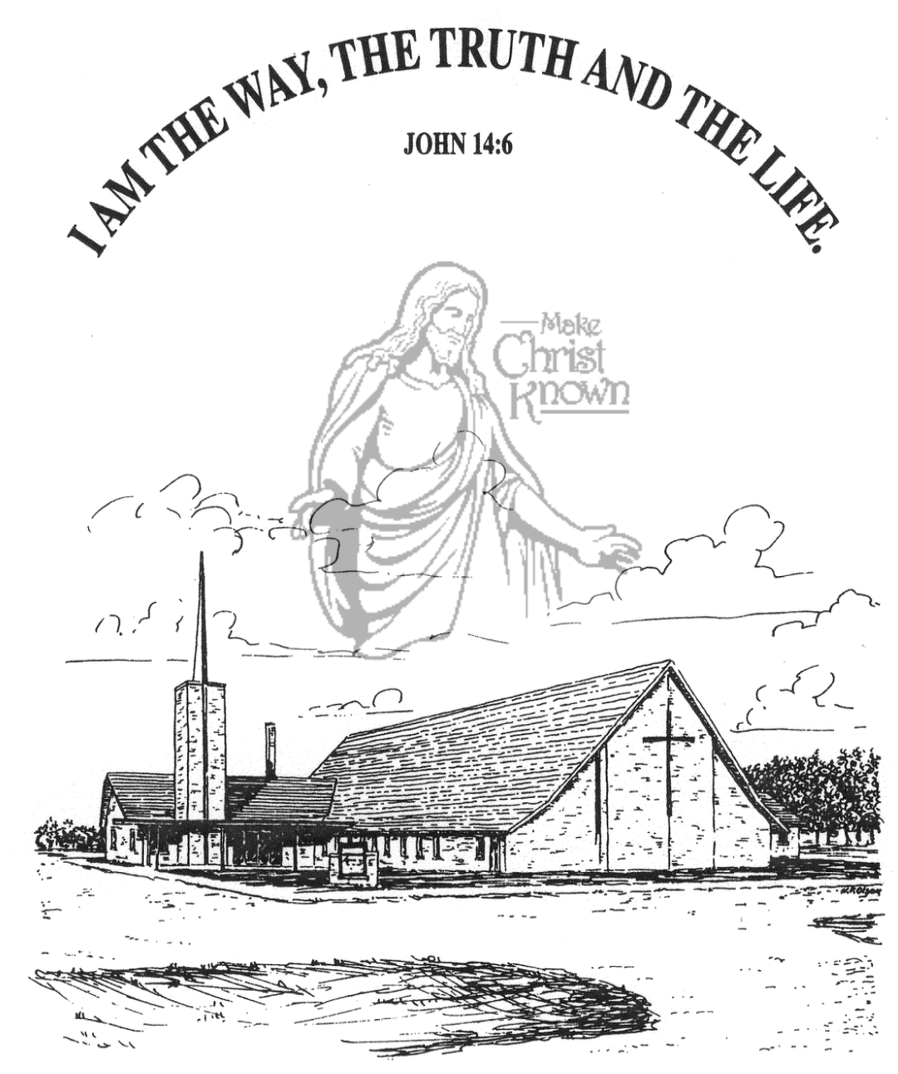

**Sunday, September 21, 2025**

**Salem Reformed Church**

**Menno, South Dakota**

..3

**SALEM REFORMED CHURCH**

Menno, South Dakota

Rev. Michael Hecht Pastor

Sharyl Herrboldt Pianist

10:30 AM – Worship Service September 21, 2025

Fifteenth Sunday after Pentecost

**Meditation:** *“Then some believers who belonged to the party of the Pharisees stood up and said, ‘The Gentiles must be circumcised and required to obey the law of Moses.’ The apostles and elders met to consider this question. After much discussion, Peter got up and addressed them: ‘Brothers, you know that some time ago God made a choice among you that the Gentiles might hear from my lips the message of the gospel and believe. God, who knows the heart, showed that He accepted them by giving the Holy Spirit to them, just as He did to us. He made no distinction between us and them, for He purified their hearts by faith. Now then, why do you try to test God by putting on the necks of the disciples a yoke that neither we nor our fathers have been able to bear? We believe it is through the grace of our Lord Jesus that we are saved, just as they are.’*  Acts 15:5-11 NIV

**Praise Music:** #52, #58, #59, #28, #1, #144

**Ringing of the Bell**

**Welcome / Announcements / Opening Prayer**

**\*Hymn:** #3 “Holy, Holy, Holy! Lord God Almighty”

**Sharing of Joys and Concerns**

**Our Time of Offering**  Acts 4:12 NIV

**\*Doxology** sung on page #518

**\*Apostles’ Creed** see words on screen

**Kingdom Kids:** “Caution! False Teachers Ahead“

**Hymn:** #436 “Freely, Freely”

**The Holy Scriptures**

Galatians 1:1-10

Large Print NIV 1984 Edition, pg. 445

**Sermon: “No Other Name!”**

**\*Hymn:** #571 “Trust and Obey”

**\*Benediction:**

**\*Prayer for Our Nation:** “God Bless America”

**Postlude** (*denotes standing for those able)

The congregation will be ushered out after the Benediction

Youth Ushers: Rylan Derby, Luke Plooster, Lee Kisely

**Office Hours for Pastor Hecht**

Tuesday – Friday: 8:00 AM to Noon (Church Office)

Afternoons: Visitation or Church Office

Church: (605) 387-5334 Parsonage: (605) 387-2855

Pastor Mike’s Cell #: (605) 660-1803

Church Web Page: ***salemreformedchurch.com***

**Opportunities**

Greeters Today: Johnny & Lori Woehl

Greeters September 28th: Harriet S. & Dianne K.

Sunday Prayer Time: 8:30 a.m.

Sunday School Classes: 9:15 a.m.

Praise Music: 10:15 a.m.

Worship Service: 10:30 a.m.

**Announcements**

**Welcome:** We extend a warm welcome to our visiting guests this morning. Please sign our guest book in the Narthex. We ask God’s blessing upon you and we pray that you will return and worship with us again soon.

**Pioneer Power Show Food Stand:** Our High School Youth Group will be hosting a Food Stand at the Power Show TODAY! They will be serving chislic, burgers, hot dogs, and kuchen. Thanks to everyone who has helped with this fundraiser!

**Coffee Hour:** We are looking for 1 more volunteer to bring two dozen goodies for Coffee Hour on Sunday, Sept. 28th. Please sign the sheet in the Narthex if you are able to help.

**W.O.C. Fall Meeting:** Ladies, please make plans to attend the Fall Meeting after church on Sunday, September 28th. You all play an important role in the life of our local church, and we give thanks to the Lord for each one of you!

**4-O’s Women:** Will meet on Wed., Sept. 24th at 11:30 a.m. in the Social Hall with lunch provided, followed by games and fellowship. Please sign the sheet in the Narthex if attending.

**Mission Fest Service:** Mark your calendars! We’re planning to have Mission Fest on Sunday, October 19th. Our guest speaker will be Ali Farhadi. Ali was born into a Muslim family in the Islamic Republic of Iran. His family immigrated to the United States in 1989. Over the next two decades, Ali heard the witness of the Gospel from many believers, and was brightly saved in 2010. Ali and Veronika share the Good News of Jesus to Muslims in the USA and beyond!

**Sunday Offerings:** Please note that we have an Offering Box/Pulpit at the back of the Sanctuary for people to place their tithes and offerings in during our worship services.