**Calendar of Events**

Sept 15 Men’s Christian Fellowship @ 7:30 p.m.

Sept 16 W.O.C. Program at M/OCC @ 2:00 p.m.

Sept 17 Women’s Bible Study @ 9:30 a.m. & 6:00 p.m.

Confirmation Classes @ 4:45 to 6:30 p.m.

FCA at Menno Gym @ 7:30 p.m.

Sept 18 Prayer Group @ 12 Noon

Sept 20/21 Menno Pioneer Power Show

Sept 21 Prayer Time for Service @ 8:30 a.m.

Sunday School Classes @ 9:15 a.m.

Praise Music @ 10:15 a.m.

Worship Service @ 10:30 a.m.

**Upcoming Special Music**

Sunday, Sept 21 - Available

Sunday, Sept 28 - Available

**Announcements**

**Potato Topper Supper:** You are invited to the Friedens Reformed Church, Tripp, SD, on Wed., Sept. 17th, for this event.

They serve from 5-8 p.m. Free-will donations are accepted.

**GO FISH in Concert:** The James Valley Christian School, Huron, SD, presents *“GO FISH”* in concert on Thursday, Sept. 18th @ 7 PM. There is FREE Admission and all seating in General Seating.

**Meals-on-Wheels:** Our church will be delivering meals during the month of SEPTEMBER. Please remember the days that you signed up to deliver these meals. They should be picked up at M/OCC at 11:20 AM. Thanks for blessing others.

**Ark Encounter Bus Tour:** We are taking names of people, from our congregation, who would have interest in a bus tour going to the Ark & Creation Museums on July 21-25, 2026. **(See the Salem Spire for more details.)**

**Weekend to Remember:** Here is a wonderful way to invest in your marriage! This is a 2 ½ day getaway that equips couples with practical tools and resources. It is scheduled for Nov. 14-16, 2025 in Sioux Falls. Check out their website for more information: [*www.familylife.com*](http://www.familylife.com)

**Sound Crew Help:** We are looking for a few more people (High School and older) to help with running the Sound, the Projector, and the Video recording of our services. Please contact Joanie Handel, Ken Stepanek or the church office if interested.

**Salem Reformed Church – Who Are We?**

**We believe the Bible to be the inspired, inerrant, infallible Word of God in its original manuscripts. It is our supreme authority in all matters of doctrine and practice. We are affiliated with the Conservative Congregational Christian Conference.**

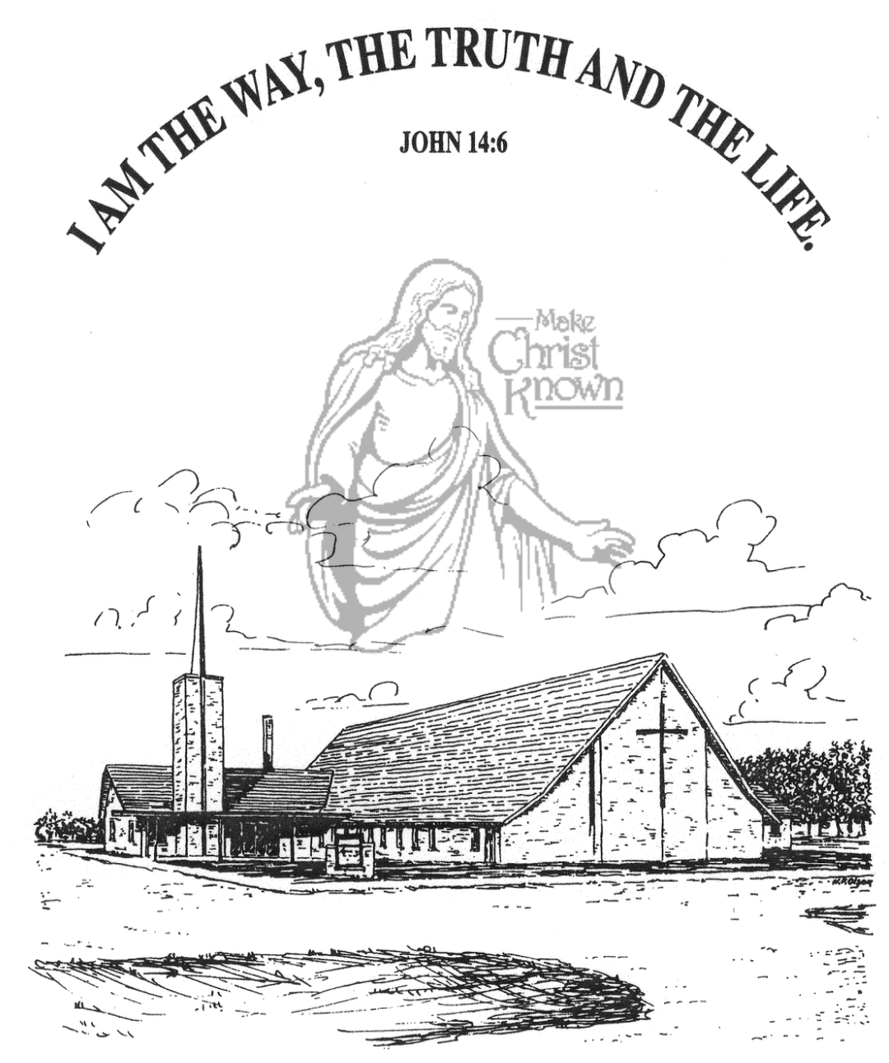

**Sunday, September 14, 2025**

**Salem Reformed Church**

**Menno, South Dakota**

..3

**SALEM REFORMED CHURCH**

Menno, South Dakota

Rev. Michael Hecht Pastor

Cindy Herrboldt Organist

10:30 AM – Worship Service September 14, 2025

Fourteenth Sunday after Pentecost

**Meditation:** *“Then I asked, ‘Who are You, Lord?’ ‘I am Jesus, whom you are persecuting,’ the Lord replied. ‘Now get up and stand on your feet. I have appeared to you to appoint you as a servant and as a witness of what you have seen of Me and what I will show you. I will rescue you from your own people and from the Gentiles. I am sending you to them to open their eyes and turn them from darkness to light, and from the power of Satan to God, so that they may receive forgiveness of sins and a place among those who are sanctified by faith in Me.’* Acts 26:15-18 NIV

**Praise Music:** #17, #7, #66, #46, #12, #762

**Ringing of the Bell**

**Welcome / Announcements**

**Opening Prayer**

**\*Hymn:** #562 “Be Thou My Vision”

**Sharing of Joys and Concerns**

**Our Time of Offering**  Galatians 5:1 NIV

**\*Doxology** sung on page #518

**\*Lord’s Prayer** debts and debtors

**Baptism: Nash Keith Miller**

**Questions of Candidates / Congregational Assent**

**Education Committee Pledge** Kevin Holzwarth

**Congregational Song:** “Jesus Loves You”

**Kingdom Kids:** “Jesus Rescued Us“

**Hymn:** #643 “O Lord, You’re Beautiful”

**The Holy Scriptures**

Galatians 1:1-10

Large Print NIV 1984 Edition, pg. 445

**Sermon: “RESCUED”**

**\*Hymn:** #358 “Because He Lives”

**\*Benediction:**

**\*Prayer for Our Nation:** “God Bless America”

**Postlude** (*denotes standing for those able)

The congregation will be ushered out after the Benediction

Youth Ushers: Rylan Derby, Luke Plooster, Lee Kisely

**Office Hours for Pastor Hecht**

Tuesday – Friday: 8:00 AM to Noon (Church Office)

Afternoons: Visitation or Church Office

Church: (605) 387-5334 Parsonage: (605) 387-2855

Pastor Mike’s Cell #: (605) 660-1803

Church Web Page: ***salemreformedchurch.com***

**Opportunities**

Greeters Today: Robert & Elaine Balogh

Greeters September 21st: Johnny & Lori Woehl

Sunday Prayer Time: 8:30 a.m.

Sunday School Classes: 9:15 a.m.

Praise Music: 10:15 a.m.

Worship Service: 10:30 a.m.

**Announcements**

**Welcome:** We extend a warm welcome to our visiting guests this morning. Please sign our guest book in the Narthex. We ask God’s blessing upon you and we pray that you will return and worship with us again soon.

**Congratulations:** We rejoice with the Family of Nash Keith Miller on his baptism today. Nash’s parents are Tyler and Jenna Miller, and he joins his older brother Myles, and his older sister Nora. We extend a warm welcome to all of their family and friends who may be present today!

**Pioneer Power Show Food Stand:** Our High School Youth Group will once again be hosting a Food Stand at the Power Show next weekend, Sept. 20/21. They will be serving chislic, burgers, hot dogs, and kuchen. Thanks to everyone who will be helping with this youth fundraiser!

**Coffee Hour:** We are looking for 4 volunteers to bring two dozen goodies for Coffee Hour on Sunday, September 28th. Please sign the sheet in the Narthex if you are able to help.

**W.O.C. Fall Meeting:** Ladies, please make plans to attend the Fall Meeting after church on Sunday, September 28th. You all play an important role in the life of our local church, and we give thanks to the Lord for each one of you!

**Kuchen Donations:** Please sign the sheet in the Narthex if you are willing to bake and donate some kuchen for the Youth Group Food Stand at the Power Show. The Menno Pioneer Power Show is the weekend of September 20/21.

**Sunday Offerings:** Please note that we have an Offering Box/Pulpit at the back of the Sanctuary for people to place their tithes and offerings in during our worship services.