**Calendar of Events**

Aug 13 S.S. Teachers Meeting @ 6:00 p.m.

Consistory Meeting @ 7:30 p.m.

Aug 14 Prayer Group @ 12 Noon

Serving at ‘The Banquet’ @ 5:30 p.m.

Aug 17 Prayer Time for Service @ 8:30 a.m.

Praise Music @ 9:15 a.m.

Worship Service @ 9:30 a.m.

Adult Sunday School @ 11:00 a.m.

M/OCC Care Center Service @ 2:00 p.m.

Youth Group Kick-Off @ 7:00 p.m.

Aug 18 Men’s Christian Fellowship @ 7:30 p.m.

**Upcoming Special Music**

Sunday, Aug 17 - Available

Sunday, Aug 24 - Available

**Announcements**

**CCCC Annual Gathering:** Pastor Mike & Ann will be returning this evening from the meetings in Orlando, FL.

**Flowers for Sanctuary/Social Hall Bulletin Board**: We are in need of volunteers to place the flowers in the sanctuary for Sunday worship during the months of Oct. and Nov. We are also looking for volunteers to do the Social Hall Bulletin Board for a month during Aug. and Sept. The sign-up sheet is posted in the Narthex.

**MOCC Program Coordinator:** The Women of the Church are scheduled to host the program at MOCC on Tuesday, Sept. 16 at 2:00 pm. We need 1 or 2 ladies to organize and coordinate a program. The sign-up sheet is posted in the narthex.

**Serving at the Banquet:** Our church is scheduled to serve at *‘The Banquet’* in Yankton on Thursday, August 14th.

If you signed up to bring ground beef and/or Rice Krispie bars please bring the donation to the church by noon on August 13.

If you signed up to help serve at The Banquet please be at the UCC Fellowship Hall, Yankton, SD, by 5:30 pm.

Any questions may be directed to Stephanie Wagner at (605) 660-4902.

**Salem Reformed Church – Who Are We?**

**We believe the Bible to be the inspired, inerrant, infallible Word of God in its original manuscripts. It is our supreme authority in all matters of doctrine and practice. We are affiliated with the Conservative Congregational Christian Conference.**

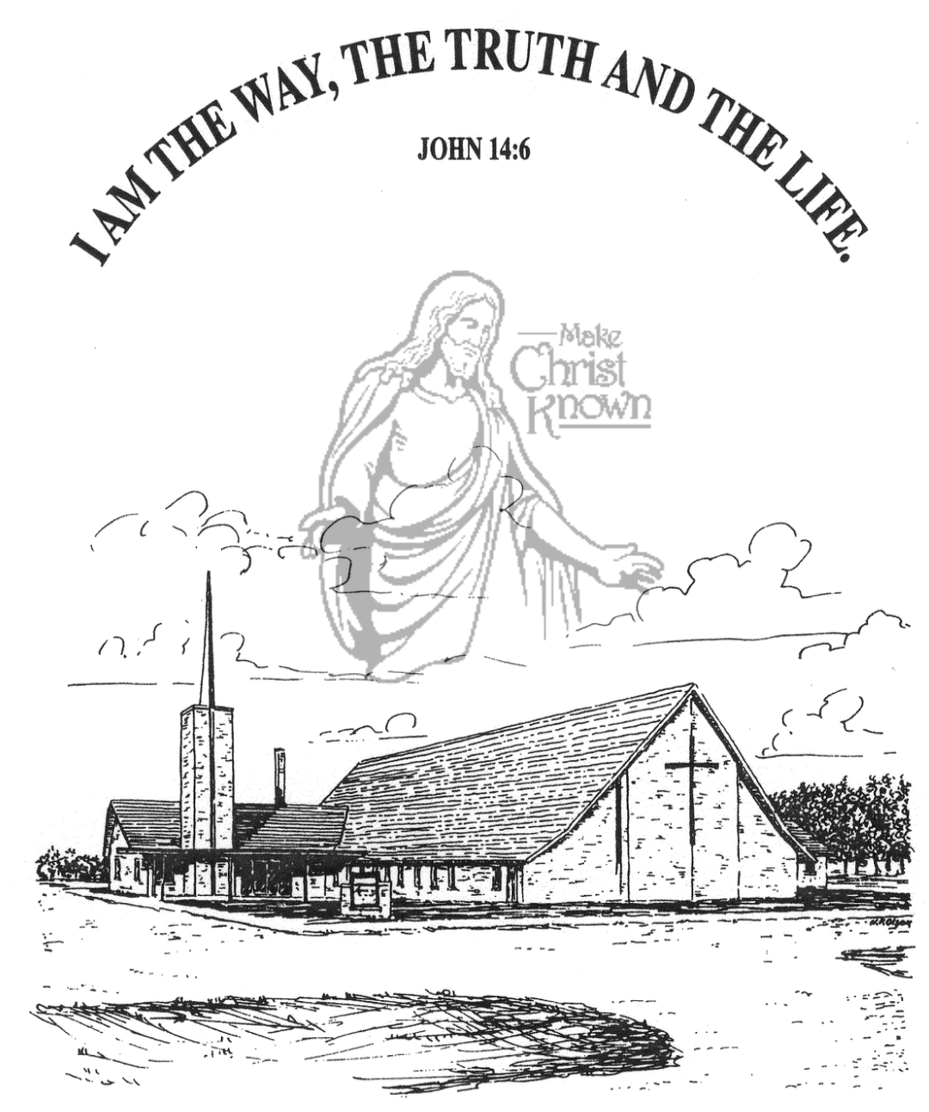

**Sunday, August 10, 2025**

**Salem Reformed Church**

**Menno, South Dakota**

..3

**Office Hours for Pastor Hecht**

Tuesday – Friday: 8:00 AM to Noon (Church Office)

Afternoons: Visitation or Church Office

Church: (605) 387-5334 Parsonage: (605) 387-2855

Pastor Mike’s Cell #: (605) 660-1803

Church Web Page: ***salemreformedchurch.com***

**Opportunities**

Greeters Today: Robert & Elaine Balogh

Greeters August 17th: Earl & Teresa Neuharth

Sunday Prayer Time: 8:30 a.m.

Praise Music: 9:15 a.m.

Worship Service: 9:30 a.m.

Adult Sunday School: 11:00 a.m.

**Announcements**

**Welcome:** We extend a warm welcome to our visiting guests this morning. Please sign our guest book in the Narthex. We ask God’s blessing upon you and we pray that you will return and worship with us again soon.

**Kevin & Karen Brasser:** Special Thanks to Kevin & Karen Brasser for sharing about their mission work in the country of Nepal! Karen is the daughter of the *‘late’* Calvin Hagge. They take a month each summer to do mission work in Nepal.

**SS Teachers Meeting:** The SS Teachers will plan to meet on Wed., August 13th at 6:00 p.m.

**Confirmation Parents Meeting:** Pastor Mike will meet briefly with the Parents of Confirmation Students (Grades 6-8) after church on Sun., Aug. 24th. Confirmation Classes are scheduled to begin on Wed., Aug. 27th @ 4:45 to 6:30 p.m.

**The Banquet:** Our congregation will be serving at ‘The Banquet’ in Yankton on Thursday, August 14th. There will be an offering plate placed at the rear of the Sanctuary today for those desiring to help with the expense of this meal. Big Thanks to those who will be donating hamburger, Rice Krispie bars, time and effort to this meal!

**Heidelberg League Kick-Off:** High School Youth – we will meet at 7 PM on Sunday, August 17th to begin our school year! Please watch for text messages to share more details!

**Coffee Hour:** Please join us in the Social Hall after church today for a time of fellowship, while enjoying coffee and desserts. This is a chance to get better acquainted!

**Sunday Offerings:** Please note that we have an Offering Box/Pulpit at the back of the Sanctuary for people to place their tithes and offerings in during our worship services.

**SALEM REFORMED CHURCH**

Menno, South Dakota

Rev. Michael Hecht Pastor

Cindy Herrboldt Organist

10:30 AM – Worship Service August 10, 2025

Ninth Sunday after Pentecost

**Meditation:** *“That if you confess with your mouth, ‘Jesus is Lord,’ and believe in your heart that God raised Him from the dead, you will be saved. For it is with your heart that you believe and are justified, and it is with your mouth that you confess and are saved. As the Scripture says, ‘Anyone who trusts in Him will never be put to shame.’ For there is no difference between Jew and Gentile – the same Lord is Lord of all and richly blesses all who call on Him, for ‘Everyone who calls on the name of the Lord will be saved.’ How, then, can they call on the One they have not believed in? And how can they believe in the One of whom they have not heard? And how can they hear without someone preaching to them? And how can they preach unless they are sent? As it is written, ‘How beautiful are the feet of those who bring good news!’*  Romans 10:9-15 NIV

**Praise Music:** #31, #19, #18, #12, #45, #32

**Ringing of the Bell**

**Welcome / Announcements**

**Opening Prayer**

**\*Hymn:** #143 “This Is My Father’s World”

**Sharing of Joys and Concerns**

**Our Time of Offering** Matthew 28:18-20 NIV

**\*Doxology** sung on page #815

**\*Apostles’ Creed** see words on screen

**Kingdom Kids:** “Evidence” shared by Kevin Brasser

**Hymn:** #630“What a Friend We Have in Jesus”

**The Holy Scriptures**

I Peter 4:7-11

Large Print NIV 1984 Edition, pg. 1891

**Sermon: “Above All Things”**

Shared by Kevin and Karen Brasser

**\*Hymn:** #406 “Wonderful Words of Life”

**\*Benediction:**

**\*Prayer for Our Nation:** “God Bless America”

**Postlude** (*denotes standing for those able)

The congregation will be ushered out after the Benediction