**Calendar of Events**

Sept 01 Men’s Christian Fellowship @ 7:30 p.m.

Sept 03 Confirmation Classes @ 4:45 to 6:30 p.m.

Menno FCA at Old Gym @ 7:30 p.m.

Sept 04 Prayer Group @ 12 Noon

Sept 07 **Sunday School Kick-Off!**

Prayer Time for Service @ 8:30 a.m.

Sunday School Classes @ 9:15 a.m.

Praise Music @ 10:15 a.m.

Worship Service @ 10:30 a.m.

w/Pot Luck Dinner & Games Following

Heidelberg League Youth @ 7:00 p.m.

Sept 10 Women’s Bible Study @ 9:30 a.m. & 6:00 p.m.

Confirmation Classes @ 4:45 to 6:30 p.m.

Consistory Meeting @ 7:30 p.m.

**Upcoming Special Music**

Sunday, Sept 07 - Sunday School Kick-Off

Sunday, Sept 14 - Available

**Announcements**

**Special Thanks:** Thanks to Linda Zeeb for placing the flowers in the sanctuary on Sundays, during the month of August!

**Meals-on-Wheels:** Our church will be delivering meals during the month of SEPTEMBER. Please remember the days that you signed up to deliver these meals. They should be picked up at M/OCC at 11:20 AM. Thanks for blessing others.

**S.S. Class Helpers Needed:** We are looking for 1 more helper in each of these classes: K/1st Class and 2/3rd Grade Class. We have found the lead teachers; we are looking for helpers. Contact Kevin Holzwarth or call the church office if you are interested. Thanks!

**Ark Encounter Bus Tour:** We are taking names of people, from our congregation, who would have interest in a bus tour going to the Ark & Creation Museums on July 21-25, 2026. **(See the Salem Spire for more details.)** Please sign the sheet in the Narthex if you are interested.

**MOCC Program Helpers Needed:** The Women of the Church are scheduled to host the program at MOCC on Tuesday, Sept. 16 at 2:00 pm. Please sign the sheet in the Narthex if you are willing to be a helper. Thanks!

**Salem Reformed Church – Who Are We?**

**We believe the Bible to be the inspired, inerrant, infallible Word of God in its original manuscripts. It is our supreme authority in all matters of doctrine and practice. We are affiliated with the Conservative Congregational Christian Conference.**

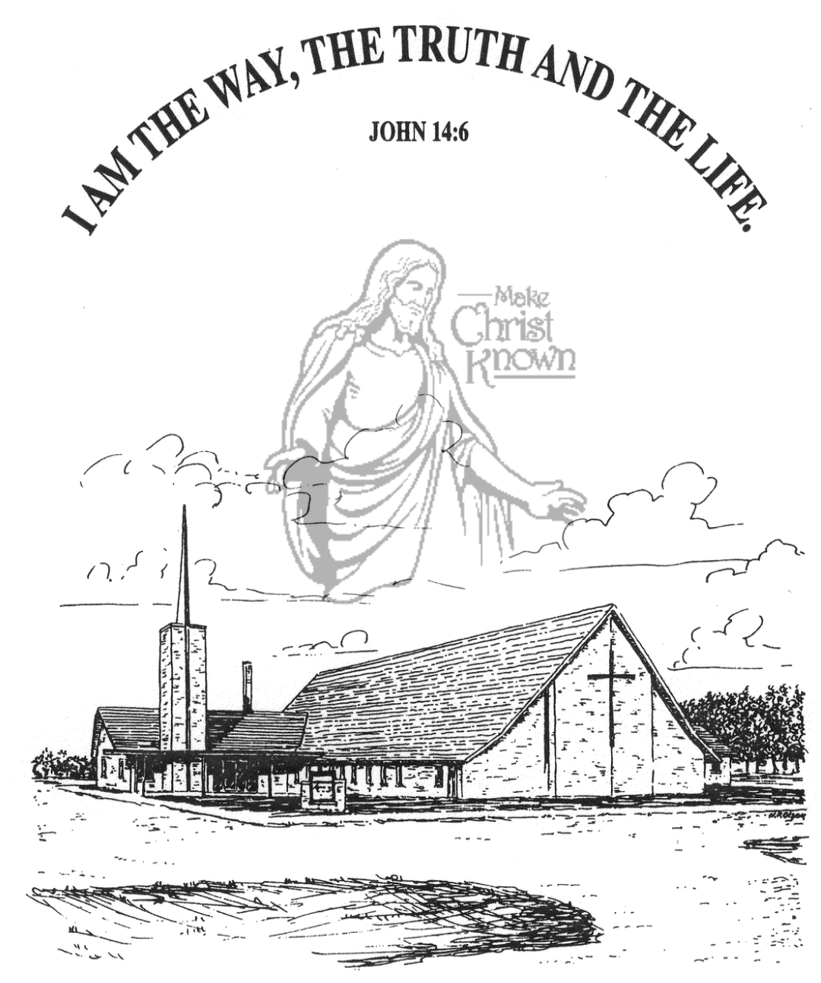

**Sunday, August 31, 2025**

**Salem Reformed Church**

**Menno, South Dakota**

..3

**SALEM REFORMED CHURCH**

Menno, South Dakota

Rev. Michael Hecht Pastor

Marina Schaeffer Pianist

10:30 AM – Worship Service August 31, 2025

Twelfth Sunday after Pentecost

**Meditation:** *“At the end of forty days they returned from exploring the land. They came back to Moses and Aaron and the whole Israelite community at Kadesh in the Desert of Paran. There they reported to them and to the whole assembly and showed them the fruit of the land. They gave Moses this account: ‘We went into the land to which you sent us, and it does flow with milk and honey! Here is the fruit. But the people who live there are powerful, and the cities are fortified and very large.’ . . . Then Caleb silenced the people before Moses and said, ‘We should go up and take possession of the land, for we CAN certainly do it.’ But the men who had gone up with him said, ‘We CAN’T attack those people; they are stronger than we are.’ And they spread among the Israelites a bad report about the land they had explored. . . . . That night all the people of the community raised their voices and wept aloud.”*

Numbers 13:25-28, 30-32; 14:1 NIV

**Praise Music:** #108, #51, #60, #96, #10

**Ringing of the Bell**

**Welcome / Announcements / Opening Prayer**

**\*Hymn:** #225 “Come, Christians Join to Sing”

**Sharing of Joys and Concerns**

**Our Time of Offering** Acts 1:13a,14 AMP

**\*Doxology** sung on page #815

**\*Lord’s Prayer** debts and debtors

**Kingdom Kids:** “Can Kids Be Revived?“

**Hymn:** “Refiner’s Fire”

**The Holy Scriptures**

Matthew 14:22-36

Large Print NIV 1984 Edition, pg. 1520

**Sermon: “Longing for Revival – Part 3”**

**\*Hymn:** #120 “10,000 Reasons” (praise book)

**\*Benediction:**

**\*Prayer for Our Nation:** “God Bless America”

**Postlude** (*denotes standing for those able)

The congregation will be ushered out after the Benediction

**Office Hours for Pastor Hecht**

Tuesday – Friday: 8:00 AM to Noon (Church Office)

Afternoons: Visitation or Church Office

Church: (605) 387-5334 Parsonage: (605) 387-2855

Pastor Mike’s Cell #: (605) 660-1803

Church Web Page: ***salemreformedchurch.com***

**Opportunities**

Greeters Today: Fred & Ann Schultz

Greeters September 7th:

Sunday Prayer Time: 8:30 a.m.

Praise Music: 9:15 a.m.

Worship Service: 9:30 a.m.

Adult Sunday School: 11:00 a.m.

**Announcements**

**Welcome:** We extend a warm welcome to our visiting guests this morning. Please sign our guest book in the Narthex. We ask God’s blessing upon you and we pray that you will return and worship with us again soon.

**CCCC Annual Gathering Report:** Pastor Mike & Ann, Greg & Melanie Wilcoxon, Johnny & Lori Woehl will plan to give a report on the Annual Gathering after church TODAY!

**Sunday School Kick-Off:** Sunday School Classes will resume on Sunday, Sept. 7th, starting at 9:15 a.m. Praise Music at 10:15 a.m., with Worship Service at 10:30 a.m. There will be a Pot Luck Dinner following for the Congregation! We also have SS Classes for the adults. Outside Games of volleyball, kickball, etc. will follow the dinner!

**Kuchen Donations:** Please sign the sheet in the Narthex if you are willing to bake and donate some kuchen for the Youth Group Food Stand at the Power Show. The Menno Pioneer Power Show is the weekend of September 20/21.

**Menno FCA:** The 1st Meeting of the Fellowship of Christian Athletes will be Wed., September 3rd @ 7:30 p.m. at the Menno Gym. This is open to students in 8th thru 12th Grade. Students from other schools are invited and welcome to attend!

**GO FISH in Concert:** The James Valley Christian School, Huron, SD, presents *“GO FISH”* in concert on Thursday, September 18th @ 7 PM. There is FREE Admission and all seating in General Seating.

**Sunday Offerings:** Please note that we have an Offering Box/Pulpit at the back of the Sanctuary for people to place their tithes and offerings in during our worship services.