**Calendar of Events**

Aug 4-9 4C’s Annual Gathering in Orlando, FL

Aug 10 Prayer Time for Service @ 8:30 a.m.

Praise Music @ 9:15 a.m.

Worship Service @ 9:30 a.m.

with Kevin & Karen Brasser sharing

Adult Sunday School @ 11:00 a.m.

Aug 13 S.S. Teachers Meeting @ 6:00 p.m.

Consistory Meeting @ 7:30 p.m.

Aug 14 Prayer Group @ 12 Noon

Serving at ‘The Banquet’ @ 5:30 p.m.

**Upcoming Special Music**

Sunday, Aug 10 - Available

Sunday, Aug 17 - Available

**Announcements**

**Guest Speakers:** Kevin & Karen Brasser will be sharing on Sun., morning, Aug. 10th, about their recent mission trip to Nepal. Karen is the daughter of *‘the late’* Calvin Hagge. The Brasser’s take a month each summer to do mission work in Nepal.

**Flowers for Sanctuary/Social Hall Bulletin Board**: We are in need of volunteers to place the flowers in the sanctuary for Sunday worship during the months of Oct. through December. We are also looking for volunteers to do the Social Hall Bulletin Board for a month during Aug. through December. The Sign-up sheet is posted in the Narthex.

**MOCC Program Coordinator:** The Women of the Church are scheduled to host the program at MOCC on Tuesday, Sept. 16 at 2:00 pm. We need 1 or 2 ladies to organize and coordinate a program. The sign-up sheet is posted in the narthex.

**Serving at the Banquet:** Our church is scheduled to serve at *‘The Banquet’* in Yankton on Thursday, August 14th. Help is needed as follows: Coordinator is Stephanie Wagner (605) 660-4902

1) 2 More Volunteers to prepare Lasagna at church on Wed., Aug. 13th @ 4:00 p.m.

2) 2 Volunteers to Load/Unload supplies for the meal on Thurs., Aug. 14th. Meet at Salem Church @ 2:00 p.m. You will also travel to Yankton to help unload supplies and prepare parts of the meal.

3) 5 More Volunteers needed at ‘The Banquet’ – 5:30 to 7:00 p.m.

**NOTE:** There is a special offering plate in back today and next Sunday for those wanting to help financially with the Banquet Meal!

**Salem Reformed Church – Who Are We?**

**We believe the Bible to be the inspired, inerrant, infallible Word of God in its original manuscripts. It is our supreme authority in all matters of doctrine and practice. We are affiliated with the Conservative Congregational Christian Conference.**

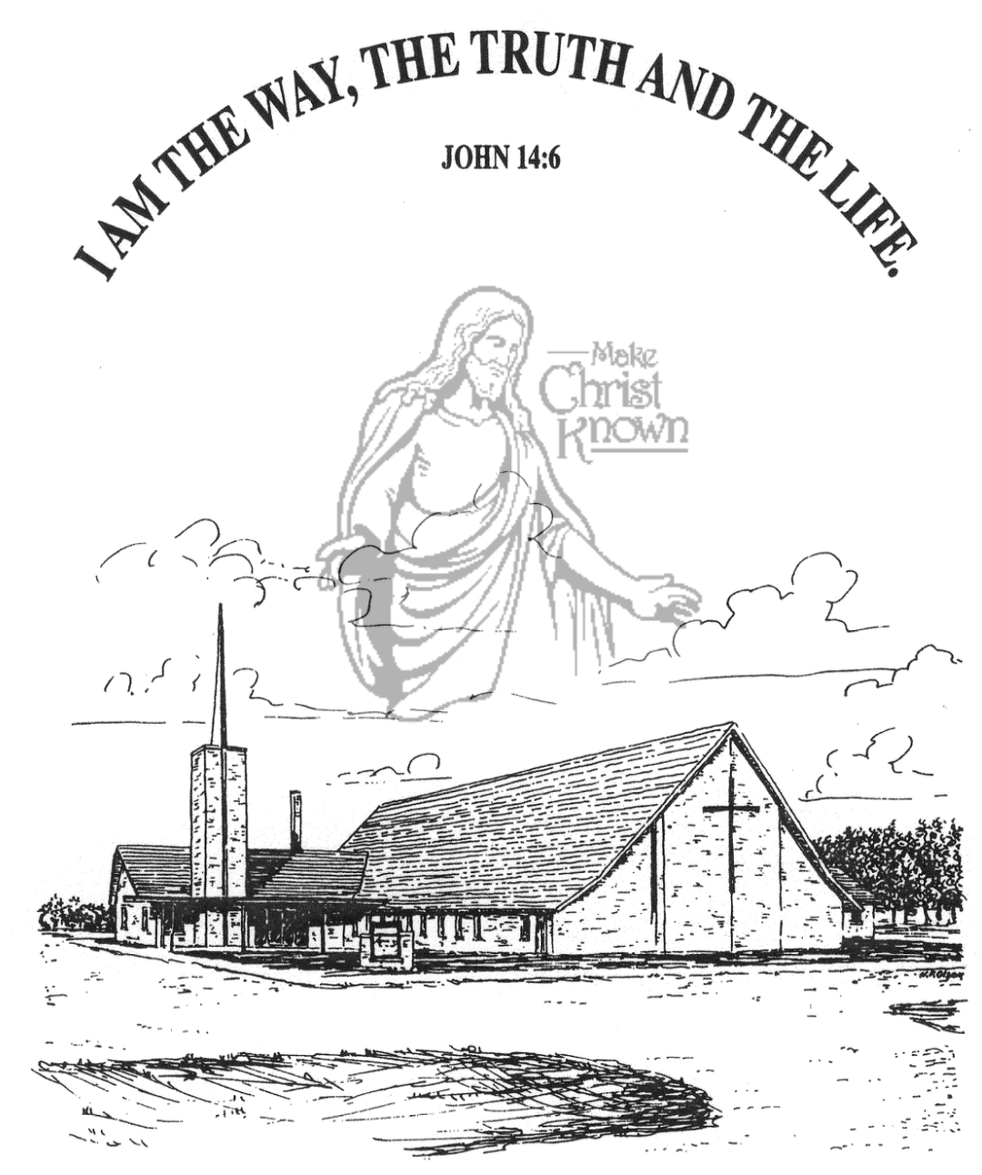

**Sunday, August 03, 2025**

**Salem Reformed Church**

**Menno, South Dakota**

..3

**SALEM REFORMED CHURCH**

Menno, South Dakota

Rev. Michael Hecht Pastor

Jennifer Herrboldt Pianist

10:30 AM – Worship Service August 03, 2025

Eighth Sunday after Pentecost

**Meditation:** *“I will sing of the LORD’s great love forever; with my mouth I will make Your faithfulness known through all generations. I will declare that Your love stands firm forever, that You established Your faithfulness in heaven itself. You said, ‘I have made a covenant with My chosen One, I have sworn to David My servant, I will establish your line forever and make your throne firm through all generations.’ The heavens praise Your wonders, O LORD, Your faithfulness too, in the assembly of the holy ones. For who in the skies above can compare with the LORD? Who is like the LORD among the heavenly beings?”*

Psalm 89:1-6 NIV

**Praise Music:** #126, #49, #96, #115, #63

**Ringing of the Bell**

**Welcome / Announcements**

**Opening Prayer**

**\*Hymn:** #348 “My Savior’s Love” (Vs. 1, 2, 4, 5)

**Sharing of Joys and Concerns**

**Our Time of Offering** Luke 22:14,15 NIV

**\*Doxology** sung on page #815

**\*Lord’s Prayer** debts and debtors

**Kingdom Kids:** “Fuel Our Spirits”

**Hymn:** #334“The Blood Will Never Lose Its Power”

**The Holy Scriptures**

Matthew 26:17-30

Large Print NIV 1984 Edition, pg. 1543

**Sermon: “If We Examine Ourselves”**

**Prayer of Confession**

#539 “My Faith Looks Up to Thee”

#63 “You Are My King” (praise book)

**Sacrament of Holy Communion**

**\*Hymn:** #318 “I Believe in a Hill Called Mt. Calvary”

**\*Benediction:**

**Postlude** (*denotes standing for those able)

The congregation will be ushered out after the Benediction

**Office Hours for Pastor Hecht**

Tuesday – Friday: 8:00 AM to Noon (Church Office)

Afternoons: Visitation or Church Office

Church: (605) 387-5334 Parsonage: (605) 387-2855

Pastor Mike’s Cell #: (605) 660-1803

Church Web Page: ***salemreformedchurch.com***

**Opportunities**

Greeter Today: Sally Sayler

Greeters August 10th: Robert & Elaine Balogh

Sunday Prayer Time: 8:30 a.m.

Praise Music: 9:15 a.m.

Worship Service: 9:30 a.m.

Adult Sunday School: 11:00 a.m.

**Announcements**

**Welcome:** We extend a warm welcome to our visiting guests this morning. Please sign our guest book in the Narthex. We ask God’s blessing upon you and we pray that you will return and worship with us again soon.

**Holy Communion:** We at Salem Reformed Church recognize an open communion table. All are welcome to partake of the bread and wine and accept the gift of grace that God offers to us through Jesus Christ, our Savior and Lord. **The inner most ring of the communion tray contains grape juice. All other rings contain wine.

**CE Committee Meeting:** The CE Committee will plan to meet TODAY, August 3rd, following our worship service.

**SS Teachers Meeting:** The SS Teachers will plan to meet on Wed., August 13th at 6:00 p.m.

**Confirmation Parents Meeting:** Pastor Mike will meet briefly with the Parents of Confirmation Students (Grades 6-8) after church on Sun., Aug. 24th. Confirmation Classes are scheduled to begin on Wed., Aug. 27th @ 4:45 to 6:30 p.m.

**The Banquet:** Our congregation will be serving at ‘The Banquet’ in Yankton on Thursday, August 14th. There will be an offering plate placed at the rear of the Sanctuary today and next Sunday, for those desiring to help with the expense of this meal. Big Thanks to those who will be donating hamburger, rice Krispie bars, time and effort to this meal!

**Special Thanks:** Thanks to Shirley Mettler for placing the flowers in the sanctuary during the month of July!

**Sunday Offerings:** Please note that we have an Offering Box/Pulpit at the back of the Sanctuary for people to place their tithes and offerings in during our worship services.