**Calendar of Events**

July 20 M/O Care Center Service @ 2:00 p.m.

July 21 Search Committee Meeting @ 7:00 p.m.

Men’s Christian Fellowship @ 7:30 p.m.

July 24 Prayer Group @ 12 Noon

July 27 Prayer Time for Service @ 8:30 a.m.

Praise Music @ 9:15 a.m.

Worship Service @ 9:30 a.m.

with baptism of Carter John Wiskur

Adult Sunday School @ 11:00 a.m.

**Upcoming Special Music**

Sunday, July 27 - Available

Sunday, Aug 03 - Available

**Announcements**

**M/OCC Bingo:** July is our turn to assist with BINGO at the M/OCC. Days to assist will be on Friday, July 25th at 2:00 p.m. Please sign the sheet in the Narthex.

**Flowers for Sanctuary**: We are in need of volunteers to place the flowers in the sanctuary for Sunday worship during the months of August through December. Sign up sheet is posted in the Narthex.

**Serving at the Banquet:** Our church is scheduled to serve at *‘The Banquet’* in Yankton on Thursday, August 14th. Help is needed as follows: Coordinator is Stephanie Wagner (605) 660-4902

1) 6 Volunteers to prepare Lasagna at church on Wed., Aug. 13th @ 4:00 p.m.

2) Donations of Ground Beef totaling 44 pounds.

3) 15 Volunteers to bring a 9x13 pan of Rice Krispie Bars. Please bring to the church by 12 Noon on Wed., Aug. 13th.

4) 3 Volunteers to Load/Unload supplies for the meal on Thurs., Aug. 14th. Meet at Salem Church @ 2:00 p.m. You will also travel to Yankton to help unload supplies and prepare parts of the meal.

5) 15-20 Volunteers needed at ‘The Banquet’ – 5:30 to 7:00 p.m.

**Salem Reformed Church – Who Are We?**

**We believe the Bible to be the inspired, inerrant, infallible Word of God in its original manuscripts. It is our supreme authority in all matters of doctrine and practice. We are affiliated with the Conservative Congregational Christian Conference.**

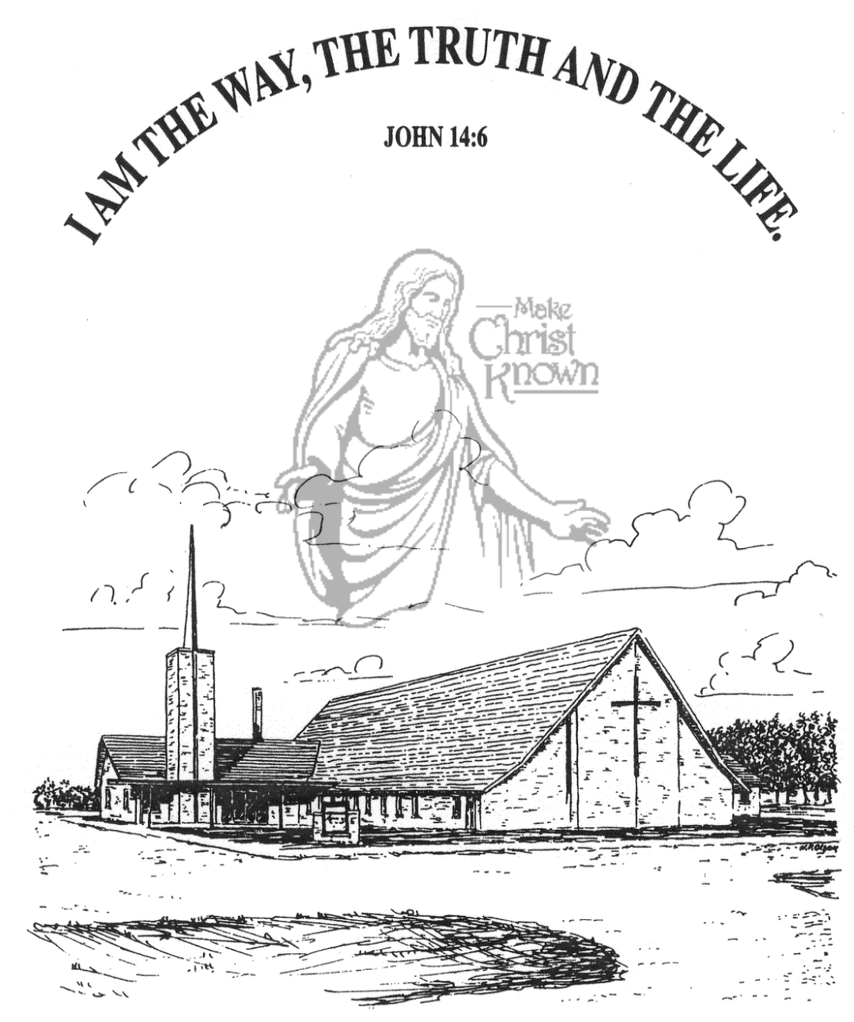

**Sunday, July 20, 2025**

**Salem Reformed Church**

**Menno, South Dakota**

..3

**SALEM REFORMED CHURCH**

Menno, South Dakota

Rev. Michael Hecht Pastor

Marina Schaeffer Pianist

10:30 AM – Worship Service July 20, 2025

Sixth Sunday after Pentecost

**Meditation:** *“You have not chosen Me, but I have chosen you and I have appointed and placed and purposefully planted you, so that you would go and bear fruit and keep on bearing, and that your fruit will remain and be lasting, so that whatever you ask of the Father in My name (as My representative) He may give to you. This (is what) I command you: that you love and unselfishly seek the best for one another.”* John 15: 16-17 (AMP)

**Praise Music:** #51, #99, #111, #150

**Ringing of the Bell**

**Welcome / Announcements**

**Opening Prayer**

**\*Hymn:** #8 “Come, Thou Almighty King”

**Sharing of Joys and Concerns**

**Our Time of Offering** Mark 16:15 NIV

**\*Doxology** sung on page #815

**\*The Lord’s Prayer**

**Kingdom Kids:** “God can use you anywhere in the world”

Shared by Devon Bush

**Hymn:** #91“Hope of the Nations” (praise book)

**The Holy Scriptures**

John 15: 1-8

Large Print NIV 1984 Edition, pg. 1676

**Sermon: “Kingdom Fruit”**

Shared by Jared & Devon Bush

**\*Hymn:** #133 “Whom Shall I Fear” (praise book)

**\*Benediction:**

**\*Prayer for Our Nation:** “God Bless America”

**Postlude** (*denotes standing for those able)

The congregation will be ushered out after the Benediction

**Office Hours for Pastor Hecht**

Tuesday – Friday: 8:00 AM to Noon (Church Office)

Afternoons: Visitation or Church Office

Church: (605) 387-5334 Parsonage: (605) 387-2855

Pastor Mike’s Cell #: (605) 660-1803

Church Web Page: ***salemreformedchurch.com***

**Opportunities**

Greeters Today: Bruce and Mary Handel

Greeters July 27th:

Sunday Prayer Time: 8:30 a.m.

Praise Music: 9:15 a.m.

Worship Service: 9:30 a.m.

Adult Sunday School: 11:00 a.m.

**Announcements**

**Welcome:** We extend a warm welcome to our visiting guests this morning. Please sign our guest book in the Narthex. We ask God’s blessing upon you and we pray that you will return and worship with us again soon.

**Jared & Devon Bush:** *Special thanks* to Jared & Devon Bush for sharing about their mission work in the country of Nepal. An offering plate has been placed at the back of the sanctuary for those desiring to give to their ministry!

**Community Patriotic Worship Service:** The offering received Sun, July 6, for the flooring project at M/OCC was $4,239.00. The Ministerial added to this amount from their funds, and gave a check of $5,000 to the M/OCC for this project.

**Sunday School Teachers Needed:** We are in search of teachers for the upcoming SS year. Open positions are:

1. Co-Teacher for 2nd & 3rd grade class
2. 1 or 2 Teachers for the 6th & 7th grade class

Questions may be directed to Kevin Holzwarth or by calling the church office.

**MOCC Program Coordinator:** The Women of the Church are scheduled to host the program at MOCC on Tuesday, Sept. 16 at 2:00 pm. We need 1 or 2 ladies to organize and coordinate a program. The sign-up sheet is posted in the narthex.

**Special Thanks:** Special thanks to Linda Zeeb for placing the flowers in the Sanctuary during the month of June!

**Sunday Offerings:** Please note that we have an Offering Box/Pulpit at the back of the Sanctuary for people to place their tithes and offerings in during our worship services.