**Calendar of Events**

June 08 M/OCC Worship Service @ 2:00 p.m.

June 11 Consistory Meeting @ 7:30 p.m.

June 12 Prayer Group @ 12 Noon

June 15 **Happy Father’s Day!**

Prayer Time for Service @ 8:30 a.m.

Praise Music @ 9:15 a.m.

Worship Service @ 9:30 a.m.

Adult Sunday School @ 11:00 a.m.

June 16 Men’s Christian Fellowship @ 7:30 p.m.

**Upcoming Special Music**

Sunday, June 15 - Available

Sunday, June 22 - Available

**Announcements**

**Congratulations:** Congratulations to Weston and Bella (Clark) Freier, as they were married yesterday in our sanctuary!

**Blood Drive:** The Women of the Church are hosting a blood drive on Thurs, June 26, from 12:30-5:30. Amanda Rames is coordinating the event as her senior project. If you are willing to donate please contact Amanda at 605.760.9602 or you can go online to register at [www.donors.vitalant.org](http://www.donors.vitalant.org).

**Special Thanks:** We would like to thank all of the volunteers who helped to make this year’s VBS a great success! Your time, effort and energy did not go unnoticed!

**Zoe Care Fundraiser:** You are invited to attend this event on Thursday, July 17th, starting at 6:00 p.m. This will be held at the Riverfront Event Center in Yankton. Would you like to be a table host? If so, please contact Zoe Care at (605) 655-4967.

**Summer Christian Camps:** Please see the Information Cabinet for summer camp dates. The W.O.C. are willing to pay for some of the expense for our children to attend a Christian Camp this summer, up to $200/child.

**Give Where You Live:** The High School Youth Group is planning a *‘Give Where You Live’* work day in the community on Wed., June 25th, from 9AM to 3PM. The youth should plan to meet at the church at 9AM. Lunch will be provided. Please contact Ben/Julie Crick or Ryan/Cassie Wielenga for more information. (Please wear clothing appropriate for painting.)

**Salem Reformed Church – Who Are We?**

**We believe the Bible to be the inspired, inerrant, infallible Word of God in its original manuscripts. It is our supreme authority in all matters doctrine and practice. We are affiliated with the Conservative Congregational Christian Conference.**

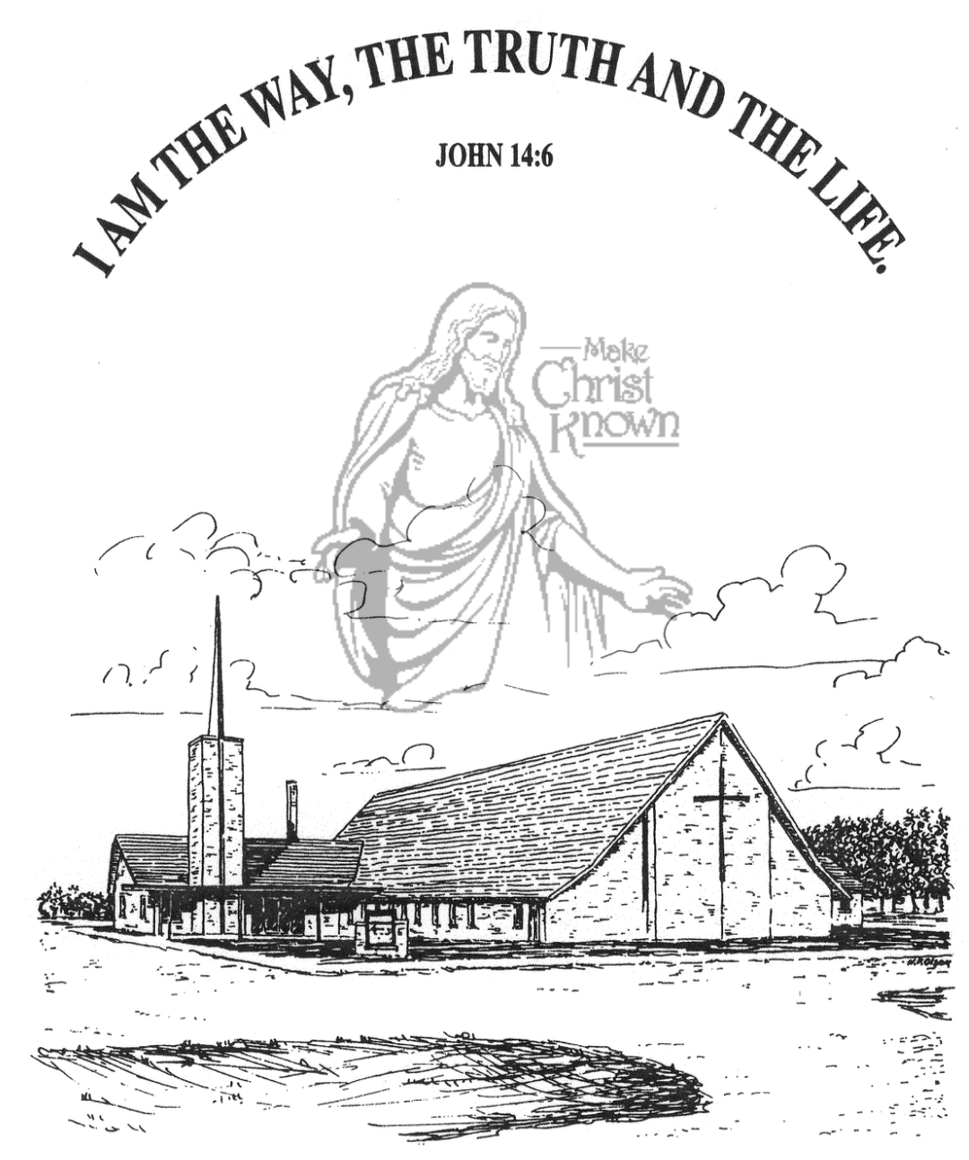

**Sunday, June 08, 2025**

**Salem Reformed Church**

**Menno, South Dakota**

..3

**SALEM REFORMED CHURCH**

Menno, South Dakota

Rev. Michael Hecht Pastor

Sharyl Herrboldt Pianist

10:30 AM – Worship Service June 08, 2025

Pentecost Sunday

**Meditation:** *“When the day of Pentecost came, they were all together in one place. Suddenly a sound like the blowing of a violent wind came from heaven and filled the whole house where they were sitting. They saw what seemed to be tongues of fire that separated and came to rest on each of them. All of them were filled with the Holy Spirit and began to speak in other tongues as the Spirit enabled them. Now there were staying in Jerusalem God-fearing Jews from every nation under heaven. When they heard this sound, a crowd came together in bewilderment, because each one heard them speaking in his own language. Utterly amazed, they asked: ‘Are not all these men who are speaking Galileans? Then how is it that each of us hears them in his own language?’* Acts 2:1-8 NIV

**Praise Music:** #55, #49, #67, #96, #762

**Ringing of the Bell**

**Welcome / Announcements**

**Opening Prayer**

**\*Hymn:** #43 “All Hail the Power of Jesus’ Name”

**Sharing of Joys and Concerns**

**Our Time of Offering** I John 1:8,9 NIV

**\*Doxology** sung on page #815

**\*Lord’s Prayer** debts and debtors

**Kingdom Kids:** “Let’s Encourage Each Other”

**Hymn:** #88“More Precious Than Silver”

**The Holy Scriptures**

Hebrews 10:19-25

Large Print NIV 1984 Edition, pg. 1873

**Sermon: “Confidence to Enter“**

**Prayer of Confession**

#115 “The Wonderful Cross” (praise book)

#319 “Near the Cross”

**Sacrament of Holy Communion**

**\*Hymn:** #56 “To God Be the Glory”

**\*Benediction:**

**Postlude** (*denotes standing for those able)

The congregation will be ushered out after the Benediction

**Office Hours for Pastor Hecht**

Tuesday – Friday: 8:00 AM to Noon (Church Office)

Afternoons: Visitation or Church Office

Church: (605) 387-5334 Parsonage: (605) 387-2855

Pastor Mike’s Cell #: (605) 660-1803

Church Web Page: ***salemreformedchurch.com***

**Opportunities**

Greeters Today: Ryan/Cassie Wielenga & Family

Greeters June 15th: Billy & Jennifer Masterson

Sunday Prayer Time: 8:30 a.m.

Praise Music: 9:15 a.m.

Worship Service: 9:30 a.m.

Adult Sunday School: 11:00 a.m.

**Announcements**

**Welcome:** We extend a warm welcome to our visiting guests this morning. Please sign our guest book in the Narthex. We ask God’s blessing upon you and we pray that you will return and worship with us again soon.

**Holy Communion:** We at Salem Reformed Church recognize an open communion table. All are welcome to partake of the bread and wine and accept the gift of grace that God offers to us through Jesus Christ, our Savior and Lord. **The inner most ring of the communion tray contains grape juice. All other rings contain wine.

**VBS Offerings:** The **Evening Offerings** came to $2,400, and will be divided in three ways: Tiffany/Jeff Pommerville Family; The Sack Pack Programs at Menno, Freeman, and Scotland Public Schools. The **Sunday Morning Offering** was $4,884, and will be divided between Jerad & Devon Bush and Kevin & Karen Brasser – who all serve as missionaries to Nepal.

**Annual Church Cleaning:** **THANKS** to all who helped this past week during our annual church cleaning. As we all work together, we endeavor to keep this building looking beautiful for the glory of God! Your labor is not in vain! **I Cor. 15:58**

**Sunday School:** The Adult S.S. Class will continue meeting through the summer months after church. They are currently working through the Gospel of John. Please consider joining this class as they study God’s Word.

**Sunday Offerings:** Please note that we have an Offering Box/Pulpit at the back of the Sanctuary for people to place their tithes and offerings in during our worship services.