**Calendar of Events**

July 01 M/O Ministerial Mtg at Roosters @ 11:30 a.m.

July 03 Prayer Group @ 12 Noon

July 04 **Happy 249th Birthday America!!**

July 06 Patriotic Worship Service @ 10:00 a.m.

at the Menno City Park (weather permitting)

July 07 Men’s Christian Fellowship @ 7:30 p.m.

July 09 Consistory Meeting @ 7:30 p.m.

July 10 Prayer Group @ 12 Noon

July 13 Prayer Time for Service @ 8:30 a.m.

Praise Music @ 9:15 a.m.

Worship Service @ 9:30 a.m.

with Coffee Hour Following

Adult Sunday School @ 11:00 a.m.

July 14-18 Pastor Mike & Ann on Vacation

July 15 W.O.C. Program at M/OCC @ 2:00 p.m.

**Upcoming Special Music**

Sunday, June 29 - Available

Sunday, July 13 - Available

**Announcements**

**Zoe Care Fundraiser:** You are invited to attend this event on Thursday, July 17th, starting at 6:00 p.m. This will be held at the Riverfront Event Center in Yankton. Would you like to be a table host? If so, please contact Zoe Care at (605) 655-4967.

**Program Coordinator for M/OCC:** We are looking for someone to coordinate the program at M/OCC on Tuesday, July 15th at 2:00 p.m. Please sign the sheet in the Narthex if you are able to coordinate. We will also need people willing to be present to help and visit with the residents.

**Painting at M/OCC:** Please contact Kay Smidt at (605) 387- 5688 if you would like to help with some inside painting at the care center. This will be in the hallways and some of the resident’s rooms. (We are looking for experienced painters.)

**Save the Date:** Jared & Devon Bush will plan to be present in our worship service on Sunday, July 20th, to share about their mission work in the country of Nepal.

**Serving at the Banquet:** Our church is scheduled to serve at *‘The Banquet’* in Yankton on Thursday, August 14th. Please save the date and watch the bulletin for more information.

**Salem Reformed Church – Who Are We?**

**We believe the Bible to be the inspired, inerrant, infallible Word of God in its original manuscripts. It is our supreme authority in all matters of doctrine and practice. We are affiliated with the Conservative Congregational Christian Conference.**

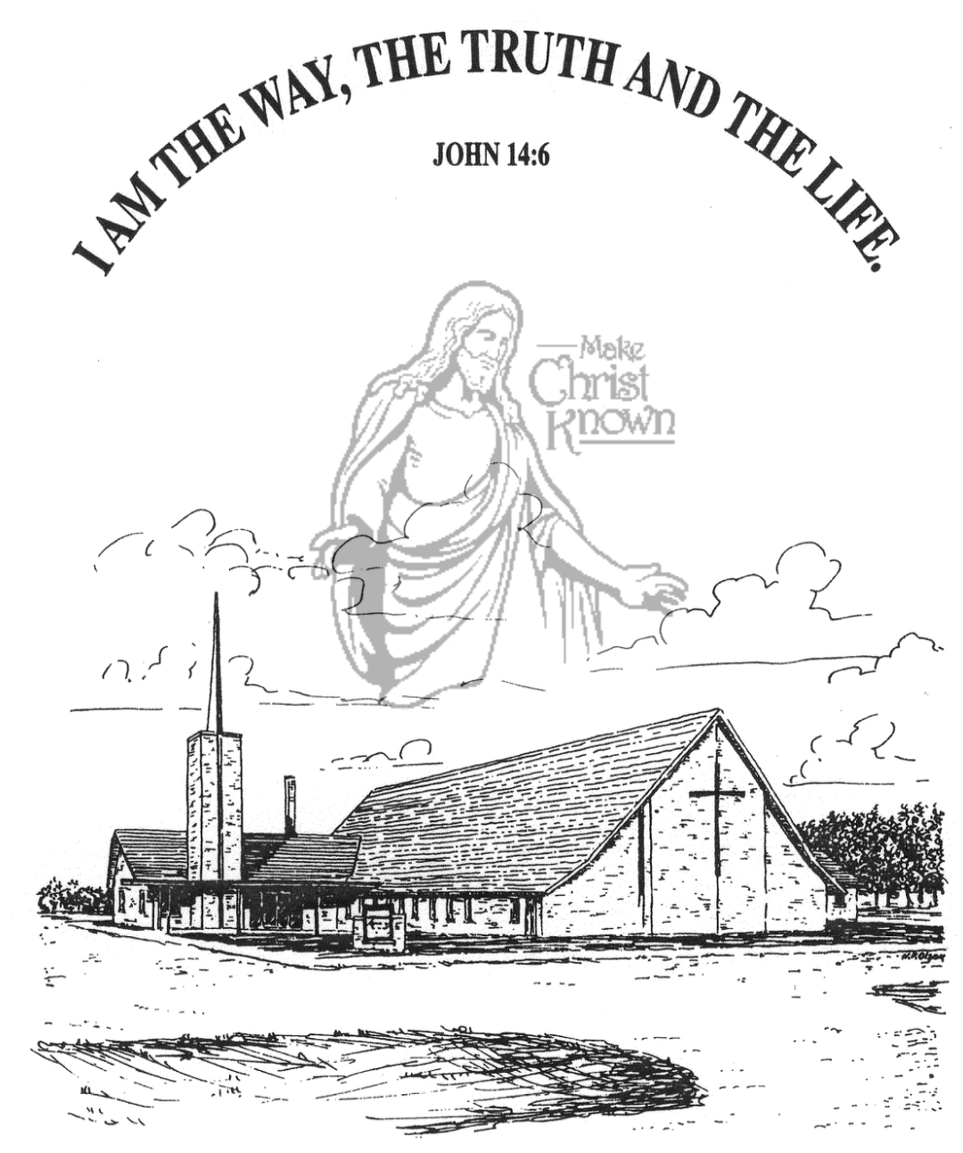

**Sunday, June 29, 2025**

**Salem Reformed Church**

**Menno, South Dakota**

..3

**SALEM REFORMED CHURCH**

Menno, South Dakota

Rev. Michael Hecht Pastor

Sharyl Herrboldt Pianist

10:30 AM – Worship Service June 29, 2025

Third Sunday after Pentecost

**Meditation:** *“I pray also that the eyes of your heart may be enlightened in order that you may know the hope to which He has called you, the riches of His glorious inheritance in the saints, and His incomparably great power for us who believe. That power is like the working of His mighty strength, which He exerted in Christ when He raised Him from the dead and seated Him at His right hand in the heavenly realms, far above all rule and authority, power and dominion, and every title that can be given, not only in the present age but also in the one to come.”* Ephesians 1:18-21 NIV

**Praise Music:** #28, #17, #58, #5, #1, #144

**Ringing of the Bell**

**Welcome / Announcements**

**Opening Prayer**

**\*Hymn:** #90 “Joyful, Joyful, We Adore Thee”

**Sharing of Joys and Concerns**

**Our Time of Offering** Psalm 127:3-5 NLT

**\*Doxology** sung on page #815

**\*Lord’s Prayer** debts and debtors

**Baptism: Carson Cory Heckenlaible**

**Questions of Candidates / Congregational Assent**

**Education Committee Pledge**  Kristin Heckenlaible

**Congregational Song:** “Jesus Loves You!”

**Kingdom Kids:** “Does the Holy Spirit Give Us Strength?”

**Hymn:** #640“Sweet Hour of Prayer”

**The Holy Scriptures**

Colossians 1:9-14

Large Print NIV 1984 Edition, pg. 1832

**Sermon: “Strengthened With All Power!”**

**\*Hymn:** #43 “I Stand in Awe” (praise book)

**\*Benediction:**

**\*Prayer for Our Nation:** “God Bless America”

**Postlude**

(*denotes standing for those able)

The congregation will be ushered out after the Benediction

**Office Hours for Pastor Hecht**

Tuesday – Friday: 8:00 AM to Noon (Church Office)

Afternoons: Visitation or Church Office

Church: (605) 387-5334 Parsonage: (605) 387-2855

Pastor Mike’s Cell #: (605) 660-1803

Church Web Page: ***salemreformedchurch.com***

**Opportunities**

Greeters Today: Robert & Elaine Balogh

Greeters July 13th: Brian & Steph Mehlhaf

Sunday Prayer Time: 8:30 a.m.

Praise Music: 9:15 a.m.

Worship Service: 9:30 a.m.

Adult Sunday School: 11:00 a.m.

**Announcements**

**Welcome:** We extend a warm welcome to our visiting guests this morning. Please sign our guest book in the Narthex. We ask God’s blessing upon you and we pray that you will return and worship with us again soon.

**Congratulations:** We rejoice with the Family of Carson Cory Heckenlaible on his baptism today. Carson’s parents are Cory and Cindy Heckenlaible, and he joins his two older brothers, Connor and Camden. We extend a warm welcome to all of their family and friends who may be present today!

**Congratulations:** Congratulations to Derek & Ashton (Vaith) Wortman, as they were married yesterday in our sanctuary!

**Community Patriotic Worship Service:** The M/O Ministerial Association will host this Worship Service in the Menno City Park on Sunday, July 6th at 10:00 a.m. Please bring your lawn chairs to the park. The Offering will be designated to the M/O Care Center to help with replacing the original floor tiles in the resident’s rooms. Olivet Christian Church is the host church this year. NOTE: In case of inclement weather, the service will be held in the Menno/City Auditorium.

**Coffee Hour:** We are looking for 5 volunteers to bring two dozen goodies for Coffee Hour on Sunday, July 13th.

**M/OCC Bingo:** July is our turn to assist with BINGO at the M/OCC. Thurs., July 3rd is the first time. The other times will be on Fridays, July 11,18, 25 – all starting at 2:00 p.m. Please sign the sheet in the Narthex if you are able to help.

**Sunday Offerings:** Please note that we have an Offering Box/Pulpit at the back of the Sanctuary for people to place their tithes and offerings in during our worship services.