**Calendar of Events**

June 15 **Happy Father’s Day!**

June 16 Men’s Christian Fellowship @ 7:30 p.m.

June 19 Prayer Group @ 12 Noon

June 22 Prayer Time for Service @ 8:30 a.m.

Praise Music @ 9:15 a.m.

Worship Service @ 9:30 a.m.

Adult Sunday School @ 11:00 a.m.

June 25 Youth Give Where You Live @ 9AM to 3PM

June 26 Blood Drive in Social Hall 12:30 to 5:30 p.m.

**Upcoming Special Music**

Sunday, June 22 - Available

Sunday, June 29 - Available

**Announcements**

**Zoe Care Fundraiser:** You are invited to attend this event on Thursday, July 17th, starting at 6:00 p.m. This will be held at the Riverfront Event Center in Yankton. Would you like to be a table host? If so, please contact Zoe Care at (605) 655-4967.

**Program Coordinator for M/OCC:** We are looking for someone to coordinate the program at M/OCC on Tuesday, July 15th at 2:00 p.m. Please sign the sheet in the Narthex if you are able to coordinate. We will also need people willing to be present to help and visit with the residents.

**Give Where You Live:** The High School Youth Group is planning a *‘Give Where You Live’* work day in the community on Wed., June 25th, from 9AM to 3PM. The youth should plan to meet at the church at 9AM. Lunch will be provided. Please contact Ben/Julie Crick or Ryan/Cassie Wielenga for more information. (Please wear clothing appropriate for painting.)

**Community Patriotic Worship Service:** The M/O Ministerial Association will host this Worship Service in the Menno City Park on Sunday, July 6th at 10:00 a.m. Please bring your lawn chairs to the park. The Offering will be designated to the M/O Care Center to help with replacing the original floor tiles in the resident’s rooms. Olivet Christian Church is the host church this year. NOTE: In case of inclement weather, the service will be held in the Menno/City Auditorium.

**Coffee Hour:** We are looking for 7 volunteers to bring two dozen goodies for Coffee Hour on Sunday, July 13th.

**Salem Reformed Church – Who Are We?**

**We believe the Bible to be the inspired, inerrant, infallible Word of God in its original manuscripts. It is our supreme authority in all matters of doctrine and practice. We are affiliated with the Conservative Congregational Christian Conference.**

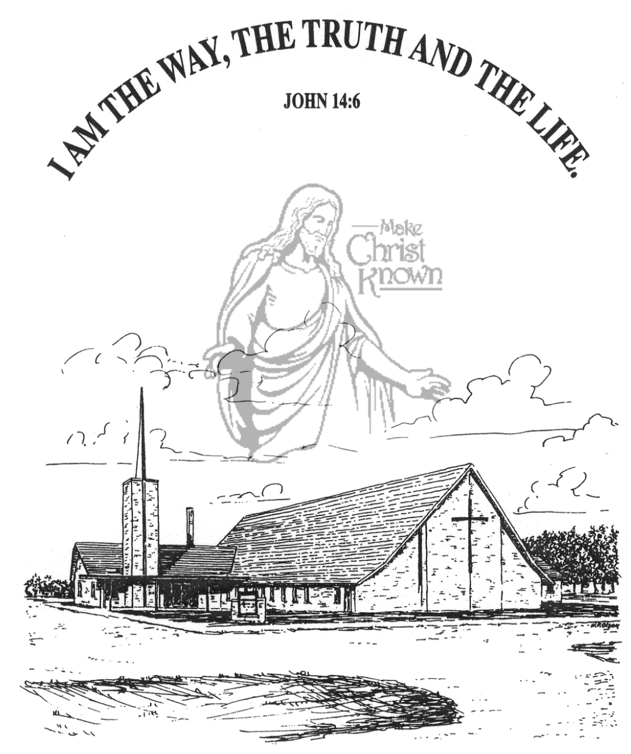

**Sunday, June 15, 2025**

**Salem Reformed Church**

**Menno, South Dakota**

..3

**SALEM REFORMED CHURCH**

Menno, South Dakota

Rev. Michael Hecht Pastor

Joan Nusz Pianist

10:30 AM – Worship Service June 15, 2025

First Sunday after Pentecost

**Meditation:** *“Only be careful, and watch yourselves closely so that you do not forget the things your eyes have seen or let them slip from your heart as long as you live. Teach them to your children and to their children after them. Remember the day you stood before the LORD your God at Horeb, when He said to me, ‘Assemble the people before Me to hear My Words so that they may learn to revere Me as long as they live in the land and may teach them to their children.’ You came near and stood at the foot of the mountain while it blazed with fire to the very heavens, with black clouds and deep darkness. Then the LORD spoke to you out of the fire. You heard the sound of words but saw no form; there was only a voice. He declared to you His covenant, the Ten Commandments, which He commanded you to follow and then wrote them on two stone tablets.”* Deuteronomy 4:9-13 NIV

**Praise Music:** #61, #57, #110, #69, #134

**Ringing of the Bell**

**Welcome / Announcements**

**Opening Prayer**

**\*Hymn:** #139 “Great Is Thy Faithfulness”

**Sharing of Joys and Concerns**

**Our Time of Offering** Genesis 18:19 NIV

**\*Doxology** sung on page #815

**\*Apostles’ Creed** words on screen

**Kingdom Kids:** “We All Have a Father” by Joanie Handel

**Hymn:** #404“Faith of Our Fathers”

**The Holy Scriptures**

Philippians 2:19-30

Large Print NIV 1984 Edition, pg. 1828

**Sermon: “Honor Men Like Him”**

**\*Hymn:** #24 “Shine, Jesus, Shine” (praise book)

**\*Benediction:**

**\*Prayer for Our Nation:** “God Bless America”

**Postlude**

(*denotes standing for those able)

The congregation will be ushered out after the Benediction

**Office Hours for Pastor Hecht**

Tuesday – Friday: 8:00 AM to Noon (Church Office)

Afternoons: Visitation or Church Office

Church: (605) 387-5334 Parsonage: (605) 387-2855

Pastor Mike’s Cell #: (605) 660-1803

Church Web Page: ***salemreformedchurch.com***

**Opportunities**

Greeters Today: Billy & Jennifer Masterson

Greeters June 22nd: Tim & Sherry Freier Family

Sunday Prayer Time: 8:30 a.m.

Praise Music: 9:15 a.m.

Worship Service: 9:30 a.m.

Adult Sunday School: 11:00 a.m.

**Announcements**

**Welcome:** We extend a warm welcome to our visiting guests this morning. Please sign our guest book in the Narthex. We ask God’s blessing upon you and we pray that you will return and worship with us again soon.

**Happy Father’s Day:** Fathers, Grandfathers, Uncles, and Men of the Church – please pick up your bottle of Dad’s Root Beer following our worship service today! This is a gift from the Christian Education Committee! We thank the Lord for you!

**Blood Drive:** The Women of the Church are hosting a blood drive on Thurs, June 26, from 12:30-5:30. Amanda Rames is coordinating the event as her senior project. If you are willing to donate, please contact Amanda at 605.760.9602 or you can go online to register at [www.donors.vitalant.org](http://www.donors.vitalant.org).

**M/OCC Bingo:** July is our turn to assist with BINGO at the M/OCC. Thurs., July 3rd is the first time. The others times will be on Fridays, July 11,18, 25 – all starting at 2:00 p.m. Please sign the sheet in the Narthex if you are able to help.

**Sunday School:** The Adult S.S. Class will continue meeting through the summer months after church. They are currently working through the Gospel of John. Please consider joining this class as they study God’s Word.

**Painting at M/OCC:** Please contact Kay Smidt at (605) 387- 5688 if you would like to help with some inside painting at the care center. This will be in the hallways and some of the resident’s rooms. Let’s keep our care center looking beautiful!

**Sunday Offerings:** Please note that we have an Offering Box/Pulpit at the back of the Sanctuary for people to place their tithes and offerings in during our worship services.