**Calendar of Events**

May 05 Men’s Christian Fellowship @ 7:30 p.m.

May 06 M/O Ministerial Mtg at Roosters @ 11:30 a.m.

May 07 FCA at Menno Park @ 7:30 p.m.

May 08 Prayer Group @ 12 Noon

May 11 **Happy Mother’s Day!**

Prayer Time for Service @ 8:30 a.m.

Sunday School Classes @ 9:15 a.m.

Praise Music @ 10:15 a.m.

Worship Service @ 10:30 a.m.

May 14 Consistory Meeting @ 7:30 p.m.

**Upcoming Special Music**

Sunday, May 11 - Cherub Choir

Sunday, May 18 - Junior Choir

**Announcements**

**Cherub & Junior Choirs:** The Cherub Choir (Age 3yrs. to 3rd Grade) will sing on Sun., May 11th and the Junior Choir (Grades 4 through 8) will sing on Sun., May 18th.

**Coffee Hour:** We are looking for 2 individuals to bring 2 dozen goodies for Coffee Hour on Sunday, May 18th. Please sign the sheet in the Narthex if you are able to help.

**VBS T-Shirts & Helpers:** The T-Shirt Orders will be placed on Monday, May 12th. Please have your registration completed by Sunday, May 11th. Please get Children & Helpers Registered ASAP. We can still use Adult and High School Helpers in various areas. Contact Carrie Dyk or Ann Hecht with questions.

**Swan Lake Christian Camps:** Please see the Information Cabinet for summer camp dates. The W.O.C. are willing to pay for some of the expense for our children to attend.

**Meals-on-Wheels:** Special Thanks to all who have helped deliver meals during the month of April! You have been a blessing to many others in our community!

**VBS Food sign-Up Sheets:** Please see the sign-up sheets in the Social Hall for food items needed for the VBS Suppers. This year we will again be serving supper to those attending, beginning at 5:45 to 6:15 p.m. each evening.

**2025 VBS Dates:** Mark your Calendars – The Dates for VBS will be May 26-30, 2025, with the Program on Sunday, June 1st.

**Salem Reformed Church – Who Are We?**

**We believe the Bible to be the inspired, inerrant, infallible Word of God in its original manuscripts. It is our supreme authority in all matters doctrine and practice. We are affiliated with the Conservative Congregational Christian Conference.**

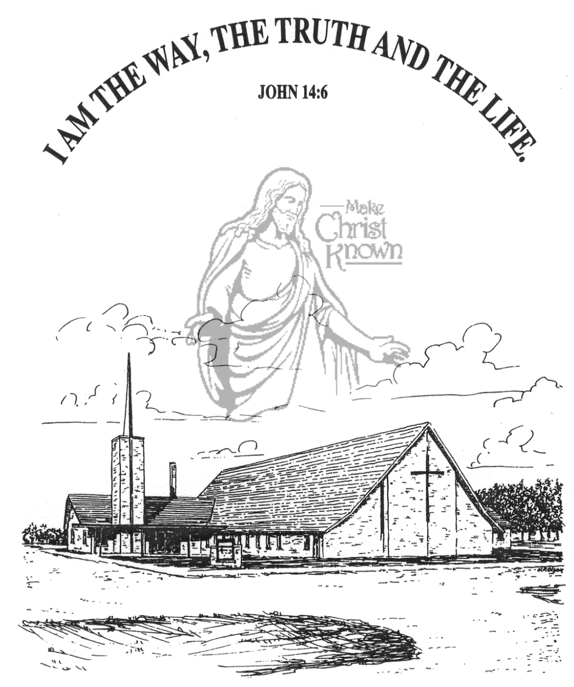

**Sunday, May 04, 2025**

**Salem Reformed Church**

**Menno, South Dakota**

..3

**SALEM REFORMED CHURCH**

Menno, South Dakota

Rev. Michael Hecht Pastor

Jennifer Herrboldt Pianist

10:30 AM – Worship Service May 04, 2025

Second Sunday after Easter

**Meditation:** *“In my former book, Theophilus, I wrote about all that Jesus began to do and to teach until the day He was taken up to heaven, after giving instructions through the Holy Spirit to the apostles He had chosen. After His suffering, He showed Himself to these men and gave many convincing proofs that He was alive. He appeared to them over a period of forty days and spoke about the kingdom of* *God.”* Acts 1:1-3 NIV

**Praise Music:** #6, #82, #116, #131, #23

**Ringing of the Bell**

**Welcome / Announcements**

**Opening Prayer**

**\*Hymn:** #372 “Our God Reigns”

**Sharing of Joys and Concerns**

**Honoring Our Graduates**

**Our Time of Offering** Phil. 4:19,20 AMP

**\*Doxology** sung on page #815

**\*Lord’s Prayer** debts and debtors

**Baptism: Leo Amos Schultz**

**Questions of Candidates / Congregational Assent**

**Education Committee Pledge** Kevin Holzwarth

**Congregational Song:** “Jesus Loves You!”

**Kingdom Kids:** “Who Did Jesus See?”

**Hymn:** #365 “Alleluia! Alleluia!”

**The Holy Scriptures**

I Corinthians 15:1-12

Large Print NIV 1984 Edition, pg. 1789

**Sermon: “The FACT IS . . . . .”** (part 2)

**\*Hymn:** #444 “I Love to Tell the Story”

**\*Benediction:**

**\*Prayer for Our Nation:** “God Bless America”

**Postlude**

(*denotes standing for those able)

The congregation will be ushered out after the Benediction

Youth Ushers: Micah Goehring and Luke Plooster

**Office Hours for Pastor Hecht**

Tuesday – Friday: 8:00 AM to Noon (Church Office)

Afternoons: Visitation or Church Office

Church: (605) 387-5334 Parsonage: (605) 387-2855

Pastor Mike’s Cell #: (605) 660-1803

Church Web Page: ***salemreformedchurch.com***

**Opportunities**

Greeters Today: Johnny & Lori Woehl

Greeters May 11th: Robert & Elaine Balogh

Sunday Prayer Time: 8:30 a.m.

Sunday School Classes: 9:15 a.m.

Praise Music: 10:15 a.m.

Worship Service: 10:30 a.m.

**Announcements**

**Welcome:** We extend a warm welcome to our visiting guests this morning. Please sign our guest book in the Narthex. We ask God’s blessing upon you and we pray that you will return and worship with us again soon.

**Congratulations:** We rejoice with the Family of Leo Amos Schultz on his baptism today. Leo’s parents are Spencer and Shaylee Schultz. We extend a warm welcome to all of their family and friends who may be present in our worship service.

**Conference Sunday:** TODAY has been designated by the CCCC as Conference Sunday. Our regular offering will be given to the work and ministry of the Conservative Congregational Christian Conference. Also note that 25% of this offering will be designated to help fund the position of our North Central Regional Pastor, Rev. Ray DeLaurier.

**Women’s Salad Supper:** This is scheduled for Wednesday, May 21st at 6PM! The guest speaker is Eileen Peacock. She will be singing songs and sharing her testimony. Please sign the sheet in the Narthex if you plan to attend and how many guests you are bringing. Also bring a salad to share with those in attendance.

**MHS Baccalaureate Service:** The M/O Ministerial Association will host the Baccalaureate Service in the New Gym on Saturday, May 10th @ 1:45 p.m.

The Commencement Ceremony will be held in the New Gym @ 2:30 p.m. Congrats to our Graduates!

**Sunday Offerings:** Please note that we have an Offering Box/Pulpit at the back of the Sanctuary for people to place their tithes and offerings in during our worship services.