**Calendar of Events**

May 26-30 VBS Nightly from 6:30 to 9:00 p.m.

(Supper will be served from 5:45 to 6:15 PM)

May 29 Prayer Group @ 12 Noon

June 01 Prayer Time for Service @ 8:30 a.m.

VBS Program Practice @ 9:15 a.m.

VBS Program @ 10:30 a.m.

**With Pot Luck Dinner Following**

June 2-4 All Church Cleaning! Everyone Help!

June 05 Prayer Group @ 12 Noon

June 08 **Summer Worship Service Begins**

Prayer Time for Service @ 8:30 a.m.

Praise Music @ 9:15 a.m.

Worship Service @ 9:30 a.m.

With Holy Communion

Adult Sunday School @ 11:00 a.m.

M/OCC Worship Service @ 2:00 p.m.

June 11 Consistory Meeting @ 7:30 p.m.

**Upcoming Special Music**

Sunday, June 01 - VBS Program

Sunday, June 08 - Holy Communion

**Announcements**

**Summer Christian Camps:** Please see the Information Cabinet for summer camp dates. The W.O.C. are willing to pay for some of the expense for our children to attend a Christian Camp this summer, up to $200/child.

**VBS Food sign-Up Sheets and Other Information:** Please see the sign-up sheets in the Social Hall for food items needed for the VBS Suppers. This year we will again be serving Supper to those attending, beginning at 5:45 to 6:15 p.m. each evening.

(Parents, Grandparents are also welcome to come for supper!) VBS will go from 6:30 to 9:00 p.m. each evening, M-F, May 26-30. The VBS Program will be Sunday, June 1st. Program Practice will be at 9:15 a.m., and the VBS Program will be at 10:30 a.m.

(Please have your child wear their VBS T-Shirt to the Program on Sunday, June 1st.) There will be a Pot Luck Dinner following the Program! Please contact Carrie Dyk or Ann Hecht with any questions. **Suggested T-Shirt Donation is $8/shirt.**

**Salem Reformed Church – Who Are We?**

**We believe the Bible to be the inspired, inerrant, infallible Word of God in its original manuscripts. It is our supreme authority in all matters doctrine and practice. We are affiliated with the Conservative Congregational Christian Conference.**

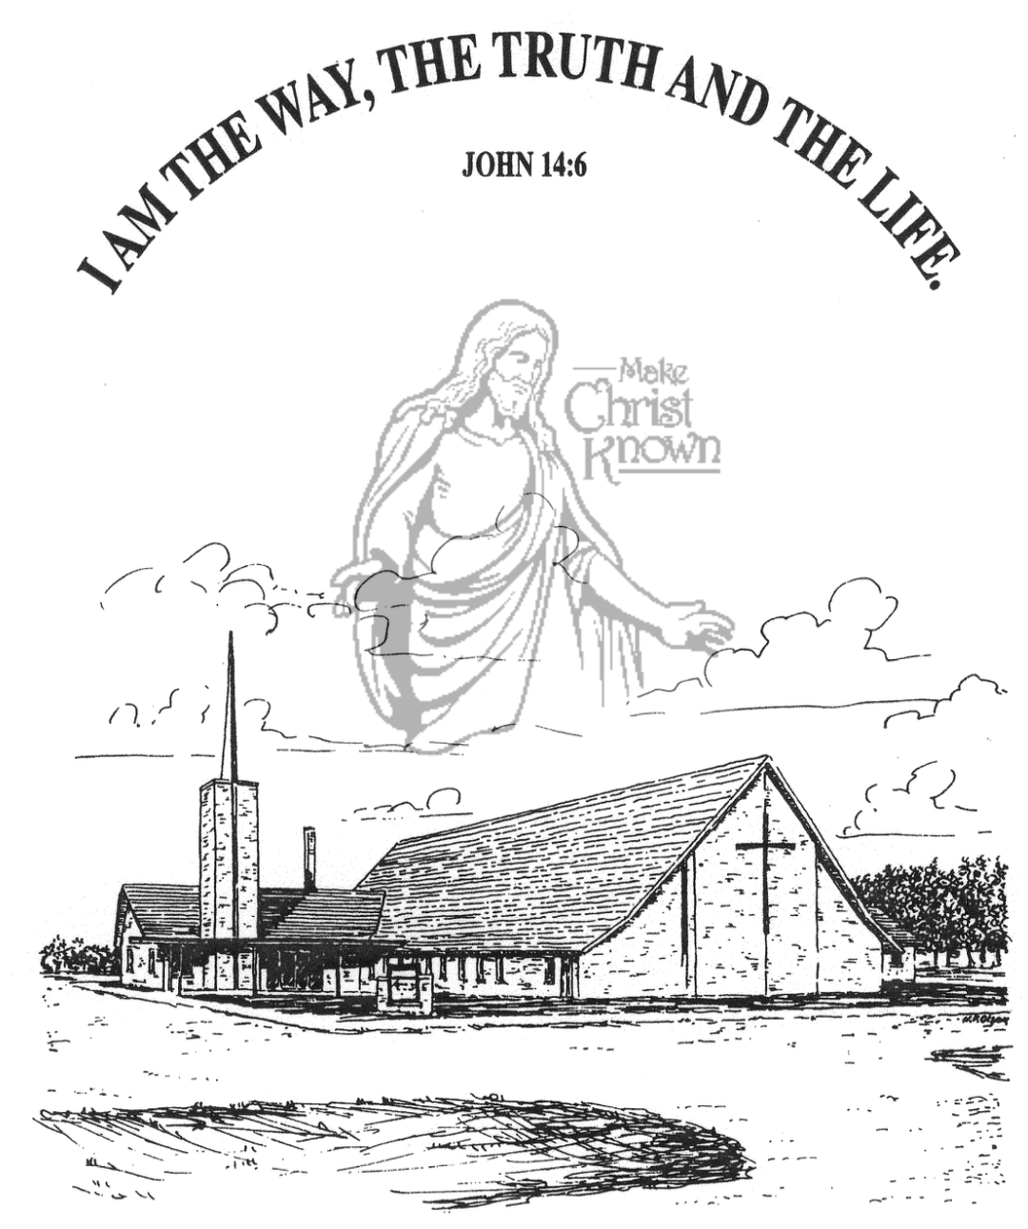

**Sunday, May 25, 2025**

**Salem Reformed Church**

**Menno, South Dakota**

..3

**SALEM REFORMED CHURCH**

Menno, South Dakota

Rev. Michael Hecht Pastor

Cindy Herrboldt Organist

10:30 AM – Worship Service May 25, 2025

Fifth Sunday after Easter

**Meditation:** *“Finally, be strong in the Lord and in His mighty power. Put on the full armor of God so that you can take your stand against the devil’s schemes. For our struggle is not against flesh and blood, but against the rulers, against the authorities, against the powers of this dark world and against the spiritual forces of evil in the heavenly realms. Therefore put on the full armor of God, so that when the day of evil comes, you may be able to stand your ground, and after you have done everything, to stand. Stand firm then, with the belt of truth buckled around your waist, with the breastplate of righteousness in place, and with your feet fitted with the readiness that comes from the gospel of peace. In addition to all this take up the shield of faith, with which you can extinguish all the flaming arrows of the evil one. Take the helmet of salvation and the sword of the Spirit, which is the Word of God.”*  Ephesians 6:10-17 NIV

**Praise Music:** #31, #19, #18, #45, #12, #32

**Ringing of the Bell**

**Welcome / Announcements / Opening Prayer**

**\*Hymn:** #809 “God of Our Fathers”

**Sharing of Joys and Concerns**

**Our Time of Offering** Galatians 5:1 NIV

**\*Doxology** sung on page #815

**\*Apostles’ Creed** see words on screen

**Kingdom Kids:** “VBS . . . Here We Come!”

**Hymn:** #800“Heal Our Land”

**The Holy Scriptures**

II Timothy 2:1-13

Large Print NIV 1984 Edition, pg. 1853

**Sermon: “Soldiers of Christ Arise!“**

**\*Hymn:** #731 “Onward, Christian Soldiers”

**\*Benediction:**

**\*Prayer for Our Nation:** “God Bless America”

**Postlude** (*denotes standing for those able)

The congregation will be ushered out after the Benediction

Youth Ushers: Micah Goehring and Luke Plooster

**Office Hours for Pastor Hecht**

Tuesday – Friday: 8:00 AM to Noon (Church Office)

Afternoons: Visitation or Church Office

Church: (605) 387-5334 Parsonage: (605) 387-2855

Pastor Mike’s Cell #: (605) 660-1803

Church Web Page: ***salemreformedchurch.com***

**Opportunities**

Greeters Today: Ken & Ramona Bittner

Greeters June 1st:

Sunday Prayer Time: 8:30 a.m.

Sunday School Classes: 9:15 a.m.

Praise Music: 10:15 a.m.

Worship Service: 10:30 a.m.

**Announcements**

**Welcome:** We extend a warm welcome to our visiting guests this morning. Please sign our guest book in the Narthex. We ask God’s blessing upon you and we pray that you will return and worship with us again soon.

**VBS Offerings:** The **Evening Offerings** will be divided in three ways: 1) Tiffany/Jeff Pommerville to help with her medical expenses, as she continues to battle cancer.

2) Bethany Food Pantry to help with the Sack Pack Program at Menno & Freeman Schools.

3) Scotland Food Pantry to help with the Sack Pack Program at the Scotland School. The **Sunday Morning Program Offering** will be divided between Jerad & Devon Bush and Kevin & Karen Brasser – who all serve as missionaries to Nepal.

**Summer Worship Schedule:** Our Summer Schedule will begin on **Sunday, June 8th,** with Praise Music @ 9:15; Worship Service @ 9:30; Adult Sunday School @ 11:00. We will have Holy Communion during the Worship Service on June 8th!

**Special Thanks:** Special Thanks to all of our S.S. Teachers, Helpers, Choir Directors/Accompanists for all of your work throughout this past school year! We appreciate your work in teaching our children about God’s Love and His Word!

**Annual Church Cleaning:** The annual church cleaning is set for Mon. thru Wed., June 2-4, 2025. Cleaning assignments have been mailed out. **Men** are welcome and encouraged to help in this effort! Many hands make light work!

**Sunday Offerings:** Please note that we have an Offering Box/Pulpit at the back of the Sanctuary for people to place their tithes and offerings in during our worship services.