**Calendar of Events**

April 30 4-0’s Women at Church @ 11:30 a.m.

Search Committee Meeting @ 7:00 p.m.

May 01 Prayer Group @ 12 Noon

May 04 Prayer Time for Service @ 8:30 a.m.

Sunday School Classes @ 9:15 a.m.

Praise Music @ 10:15 a.m.

Worship Service @ 10:30 a.m.

**w/Baptism of Leo Amos Schultz**

May 05 Men’s Christian Fellowship @ 7:30 p.m.

May 06 M/O Ministerial Mtg at Roosters @ 11:30 a.m.

May 07 FCA at Menno Park @ 7:30 p.m.

May 08 Prayer Group @ 12 Noon

**Upcoming Special Music**

Sunday, May 04 - Available

Sunday, May 11 - Cherub Choir

Sunday, May 18 - Junior Choir

**Announcements**

**Cherub & Junior Choirs:** The Cherub Choir (Age 3yrs. to 3rd Grade) will sing on Sun., May 11th and the Junior Choir (Grades 4 through 8) will sing on Sun., May 18th.

**Search Committee:** The Search Committee for the Assistant Pastor will plan to meet on Wed., April 30th @ 7:00 p.m.

**Meals-on-Wheels:** Special Thanks to all who have helped deliver meals during the month of April! You have been a blessing to many others in our community!

**Special Thanks:** Thanks to Jennifer Herrboldt for placing the flowers & lilies in the sanctuary during the month of April.

**VBS Food sign-Up Sheets:** Please see the sign-up sheets in the Social Hall for food items needed for the VBS Suppers. This year we will again be serving supper to those attending, beginning at 5:45 to 6:15 p.m. each evening.

**2025 VBS Dates:** Mark your Calendars – The Dates for VBS will be May 26-30, 2025, with the Program on Sunday, June 1st.

**MHS Baccalaureate Service:** The M/O Ministerial Association will host the Baccalaureate Service in the New Gym on Saturday, May 10th @ 1:45 p.m. The Commencement Ceremony will be held in the New Gym @ 2:30 p.m. Congrats to our Graduates!

**Salem Reformed Church – Who Are We?**

**We believe the Bible to be the inspired, inerrant, infallible Word of God in its original manuscripts. It is our supreme authority in all matters doctrine and practice. We are affiliated with the Conservative Congregational Christian Conference.**

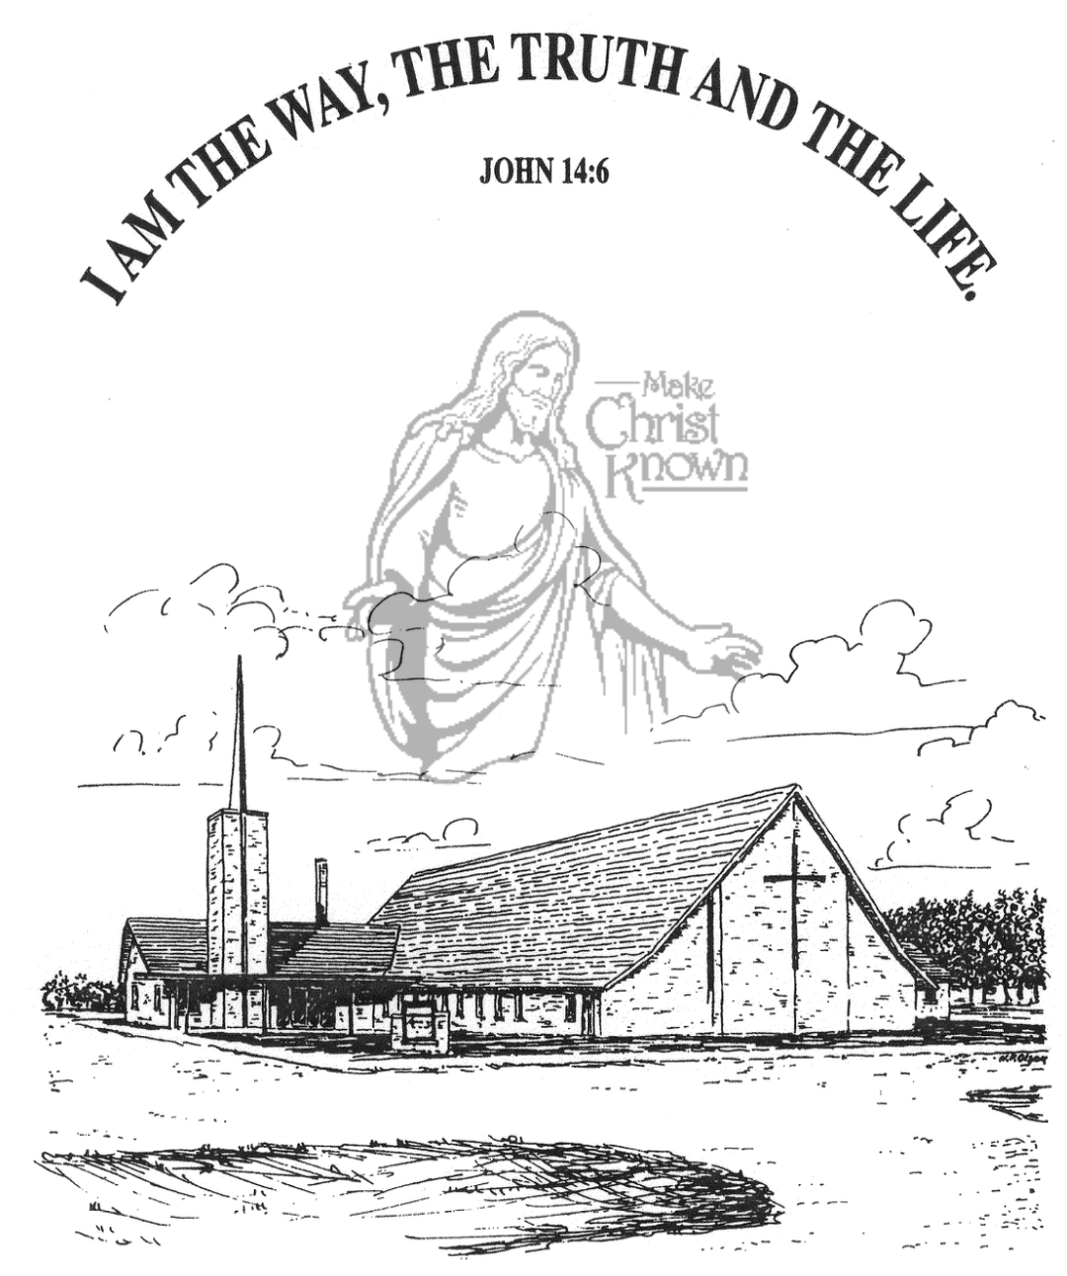

**Sunday, April 27, 2025**

**Salem Reformed Church**

**Menno, South Dakota**

..3

**SALEM REFORMED CHURCH**

Menno, South Dakota

Rev. Michael Hecht Pastor

Sharyl Herrboldt Pianist

10:30 AM – Worship Service April 27, 2025

First Sunday after Easter

**Meditation:** *“But if it is preached that Christ has been raised from the dead, how can some of you say that there is no resurrection of the dead? If there is no resurrection of the dead, then not even Christ has been raised. And if Christ has not been raised, our preaching is useless and so is your faith. More than that, we are then found to be false witnesses about God, for we have testified about God that He raised Christ from the dead. But He did not raise Him if in fact the dead are not raised. For if the dead are not raised, then Christ has not been raised either. And if Christ has not been raised, your faith is futile; you are still in your sins. Then those also who have fallen asleep in Christ are lost. If only for this life we have hope in Christ, we are to be pitied more than all men. But Christ has indeed been raised from the dead!”* I Corinthians 15:12-20a NIV

**Praise Music:** #38, #28, #56, #54, #17, #43

**Ringing of the Bell**

**Welcome / Announcements / Opening Prayer**

**\*Hymn:** #358 “Because He Lives”

**Sharing of Joys and Concerns**

**Our Time of Offering** I Peter 2:24,25 NIV

**\*Doxology** sung on page #815

**\*Apostles’ Creed** words on screen

**Kingdom Kids:** “He Is Alive!”

**Hymn:** #366 “I Live”

**The Holy Scriptures**

I Corinthians 15:1-11

Large Print NIV 1984 Edition, pg. 1789

**Sermon: “The FACT IS . . . . .”**

**\*Hymn:** #144 “Amazing Grace, My Chains Are Gone”

**\*Benediction:**

**\*Prayer for Our Nation:** “God Bless America”

**Postlude** (*denotes standing for those able)

The congregation will be ushered out after the Benediction

Youth Ushers: Taylor Freier, Ashlyn Derby, Hannah Masterson

**Office Hours for Pastor Hecht**

Tuesday – Friday: 8:00 AM to Noon (Church Office)

Afternoons: Visitation or Church Office

Church: (605) 387-5334 Parsonage: (605) 387-2855

Pastor Mike’s Cell #: (605) 660-1803

Church Web Page: ***salemreformedchurch.com***

**Opportunities**

Greeters April 27th: Lee & Dianne Herrboldt

Greeters May 04th:

Sunday Prayer Time: 8:30 a.m.

Sunday School Classes: 9:15 a.m.

Praise Music: 10:15 a.m.

Worship Service: 10:30 a.m.

**Announcements**

**Welcome:** We extend a warm welcome to our visiting guests this morning. Please sign our guest book in the Narthex. We ask God’s blessing upon you and we pray that you will return and worship with us again soon.

**Conference Sunday:** Next Sunday, May 4th, has been designated by the CCCC as Conference Sunday. Our regular offering will be given to the work and ministry of the Conservative Congregational Christian Conference. Also note that 25% of this offering will be designated to help fund the position of our North Central Regional Pastor, Rev. Ray DeLaurier.

**College Graduates:** We will be honoring our High School, College & 8th Grade Grads on Sun., May 4th. Contact the church office with information on your College Graduates.

**Women’s Salad Supper:** This is scheduled for Wednesday, May 21st at 6PM! The guest speaker is Eileen Peacock. She will be singing songs and sharing her testimony. Please sign the sheet in the Narthex if you plan to attend and how many guests you are bringing. Also bring a salad to share with those in attendance.

**4-O’s Women:**  The Women will have a Spring Brunch in the Social Hall on Wed., April 30th @ 11:30 a.m. Please sign the sheet in the Narthex if you plan to attend and also make a note of what you plan to bring for the Brunch.

**Sunday Offerings:** Please note that we have an Offering Box/Pulpit at the back of the Sanctuary for people to place their tithes and offerings in during our worship services.