**Calendar of Events**

April 06 M/O Care Center Service @ 2:00 p.m.

Caden Fischer in Concert @ 3:00 p.m.

April 07 Cantata Practice at Salem Reformed @ 7:00 p.m.

Men’s Christian Fellowship @ 7:30 p.m.

April 09 Women’s Bible Study @ 9:30 a.m. & 6:00 p.m.

8th Grade Confirmation @ 5:30-7:00 p.m.

Consistory Meeting @ 7:30 p.m.

April 10 Prayer Group @ 12 Noon

April 12 Cantata Practice at Salem Reformed @ 7:00 p.m.

April 13 **Palm Sunday & Confirmation Sunday**

Prayer Time for Service @ 8:30 a.m.

No Sunday School Classes Today

Praise Music @ 9:45 a.m.

Worship Service @ 10:00 a.m.

M/O Community Easter Cantata @ 7:00 p.m.

**Upcoming Special Music**

Sunday, April 13 - Chanda Bender

Thursday, April 17 - Cantata Group from Salem

**Announcements**

**Meals-on-Wheels:** Please remember the days that you signed up for in April to deliver these meals. They should be picked up at M/OCC at 11:20 a.m. Thanks for blessing others!

**M/O Community Easter Cantata:** This will be held in our Sanctuary on Palm Sunday, April 13th @ 7:00 p.m. A free-will offering will be received for cantata expenses and the on-going ministry of the M/O Ministerial Association.

**Alpha Center Banquet:** Mark your calendars! The Alpha Center Friends & Fellowship Dinner will be Friday, April 25th, 2025 at the Sioux Falls Convention Center. Please contact Lee/Dianne Herrboldt if you are interested in attending this Banquet.

**College Graduates:** We will be honoring our High School, College & 8th Grade Grads in May. Please contact the church office ASAP with information on your College Graduates.

**M/OCC Volunteer Appreciation:** The Care Center will be hosting a volunteer appreciation on Tues., April 22nd @ 2 PM in their dining room. Please sign your name to the sheet on the Information Cabinet in the Narthex if you are able to attend.

**2025 VBS Dates:** Mark your Calendars – The Dates for VBS will be May 26-30, 2025, with the Program on Sunday, June 1st.

**Salem Reformed Church – Who Are We?**

**We believe the Bible to be the inspired, inerrant, infallible Word of God in its original manuscripts. It is our supreme authority in all matters doctrine and practice. We are affiliated with the Conservative Congregational Christian Conference.**

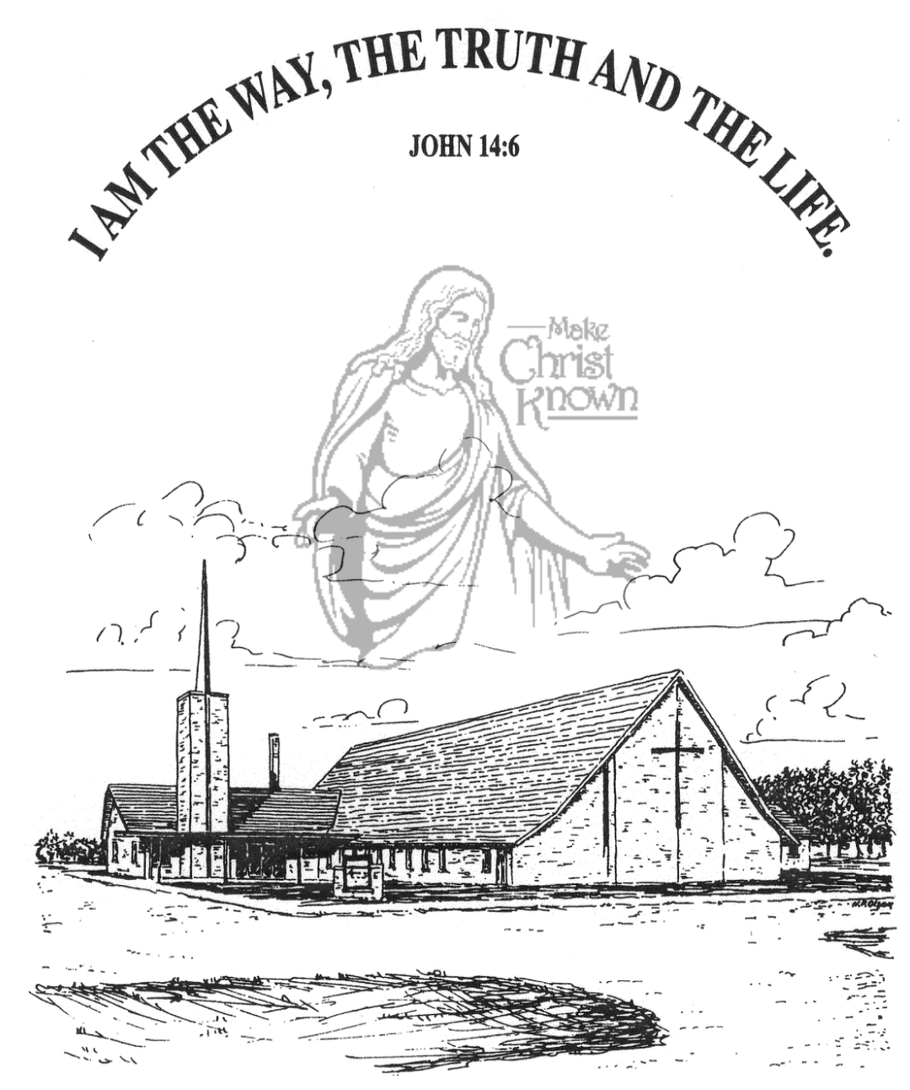

**Sunday, April 06, 2025**

**Salem Reformed Church**

**Menno, South Dakota**

..3

**SALEM REFORMED CHURCH**

Menno, South Dakota

Rev. Michael Hecht Pastor

Marina Schaeffer Pianist

10:30 AM – Worship Service April 06, 2025

5th Sunday in the Lenten Season

**Meditation:** *“As a prisoner for the Lord, then, I urge you to live a life worthy of the calling you have received. Be completely humble and gentle; be patient, bearing with one another in love. Make every effort to keep the unity of the Spirit through the bond of peace. There is one body and one Spirit – just as you were called to one hope when you were called – one Lord, one faith, one baptism; one God and Father of all, who is over all and through all and in all. But to each one of us grace has been given as Christ apportioned it. This is why it says: ‘When He ascended on high, He led captives in His train and gave gifts to men.”*

Ephesians 4:1-8 NIV

**Praise Music:** #50, #63, #115, #49

**Ringing of the Bell**

**Welcome / Announcements**

**Opening Prayer**

**\*Hymn:** #311 “Hallelujah, What a Savior!”

**Sharing of Joys and Concerns**

**Our Time of Offering** Ephesians 3:17-19 NIV

**\*Doxology** sung on page #815

**\*Lord’s Prayer** debts and debtors

**Kingdom Kids:** “In the World – Not Of the World”

**Hymn:** #349 “O How He Loves You and Me”

**The Holy Scriptures**

John 17:11-19

Large Print NIV 1984 Edition, pg. 1680

**Sermon: “That They May Be One As We Are One”**

**\*Hymn:** #150 “Goodness of God” (praise book)

**\*Benediction:**

**\*Prayer for Our Nation:** “God Bless America”

**Postlude**

(*denotes standing for those able)

The congregation will be ushered out after the Benediction

Youth Ushers: Taylor Freier, Ashlyn Derby, Hannah Masterson

**Office Hours for Pastor Hecht**

Tuesday – Friday: 8:00 AM to Noon (Church Office)

Afternoons: Visitation or Church Office

Church: (605) 387-5334 Parsonage: (605) 387-2855

Pastor Mike’s Cell #: (605) 660-1803

Church Web Page: ***salemreformedchurch.com***

**Opportunities**

Greeters April 6th: Ray and Beverly Gossen

Greeters April 13th:

Greeters April 17th:

Sunday Prayer Time: 8:30 a.m.

Sunday School Classes: 9:15 a.m.

Praise Music: 10:15 a.m.

Worship Service: 10:30 a.m.

**Announcements**

**Welcome:** We extend a warm welcome to our visiting guests this morning. Please sign our guest book in the Narthex. We ask God’s blessing upon you and we pray that you will return and worship with us again soon.

**Caden Fischer In Concert:** Caden Fischer, a senior at SDSU, will present a concert in our sanctuary TODAY @ 3PM. Please invite your friends and make plans to attend!

**Christian Ed. Committee:** The CE Committee will plan to meet after church TODAY in the High School S.S. Room.

**Easter Lilies in Memory of Loved Ones:** On Easter Sunday, April 20th, we have the opportunity to place Easter Lilies in the sanctuary in memory of departed loved ones. Please contact the florist of your choice if you desire to give a plant this year, and let the church office know who it is in memory of.

**Confirmation Sunday:** Confirmation will be held on Sunday, April 13th at 10:00 a.m. This is also Palm Sunday! There are no SS Classes, but we will still have the children bringing in the palm branches on that day! There will be 8 Eighth Graders Confirmed next week! Let’s support this important day!

**Easter Breakfast:** The High School Youth Group will host an Easter Breakfast in the Social Hall from 8:30-10:00 a.m. on Sunday, April 20th. Breakfast includes Egg Bake, Muffins, and Fresh Fruit. Free-will donations are accepted.

**Sunday Offerings:** Please note that we have an Offering Box/Pulpit at the back of the Sanctuary for people to place their tithes and offerings in during our worship services.