**Calendar of Events**

April 13 M/O Community Easter Cantata @ 7:00 p.m.

April 16 8th Grade Confirmands to Dairy Bar @ 3:30pm

FCA at Menno Gym @ 7:30 p.m.

April 17 **Maundy Thursday Service @ 7:00 p.m.**

April 19 Easter Breakfast Prep @ 10:00 a.m.

April 20 **Resurrection Day! Happy Easter!**

Easter Breakfast from 8:30-10:00 a.m.

Children’s DVD @ 9:30 a.m.

Praise Music @ 10:15 a.m.

Worship Service @ 10:30 a.m.

April 21 Men’s Christian Fellowship @ 7:30 p.m.

**Upcoming Special Music**

Sunday, April 20 - Available

Sunday, April 27 - Available

**Announcements**

**Sunday Offerings:** Please note that we have an Offering Box/Pulpit at the back of the Sanctuary for people to place their tithes and offerings in during our worship services.

**M/O Community Easter Cantata:** This will be held in our Sanctuary THIS EVENING @ 7:00 p.m. A free-will offering will be received for cantata expenses and the on-going ministry of the M/O Ministerial Association.

**College Graduates:** We will be honoring our High School, College & 8th Grade Grads on Sunday, May 4th. Please contact the church office ASAP with information on your College Graduates.

**M/OCC Volunteer Appreciation:** The Care Center will be hosting a volunteer appreciation on Tues., April 22nd @ 2 PM in their dining room. Please sign your name to the sheet on the Information Cabinet in the Narthex if you are able to attend.

**Conference Sunday:** Sunday, May 4th, has been designated by the CCCC as Conference Sunday. Our regular offering will be given to the work and ministry of the Conservative Congregational Christian Conference. Also note that 25% of this offering will be designated to help fund the position of our North Central Regional Pastor, Rev. Ray DeLaurier.

**VBS Registration:** Mark your Calendars! Our VBS is scheduled for May 26th-30th! The VBS Program will be on Sunday, June 1st. Helpers and Students can begin to register **NOW**, at the following website: ***salem.myanswers.com***

**Salem Reformed Church – Who Are We?**

**We believe the Bible to be the inspired, inerrant, infallible Word of God in its original manuscripts. It is our supreme authority in all matters doctrine and practice. We are affiliated with the Conservative Congregational Christian Conference.**

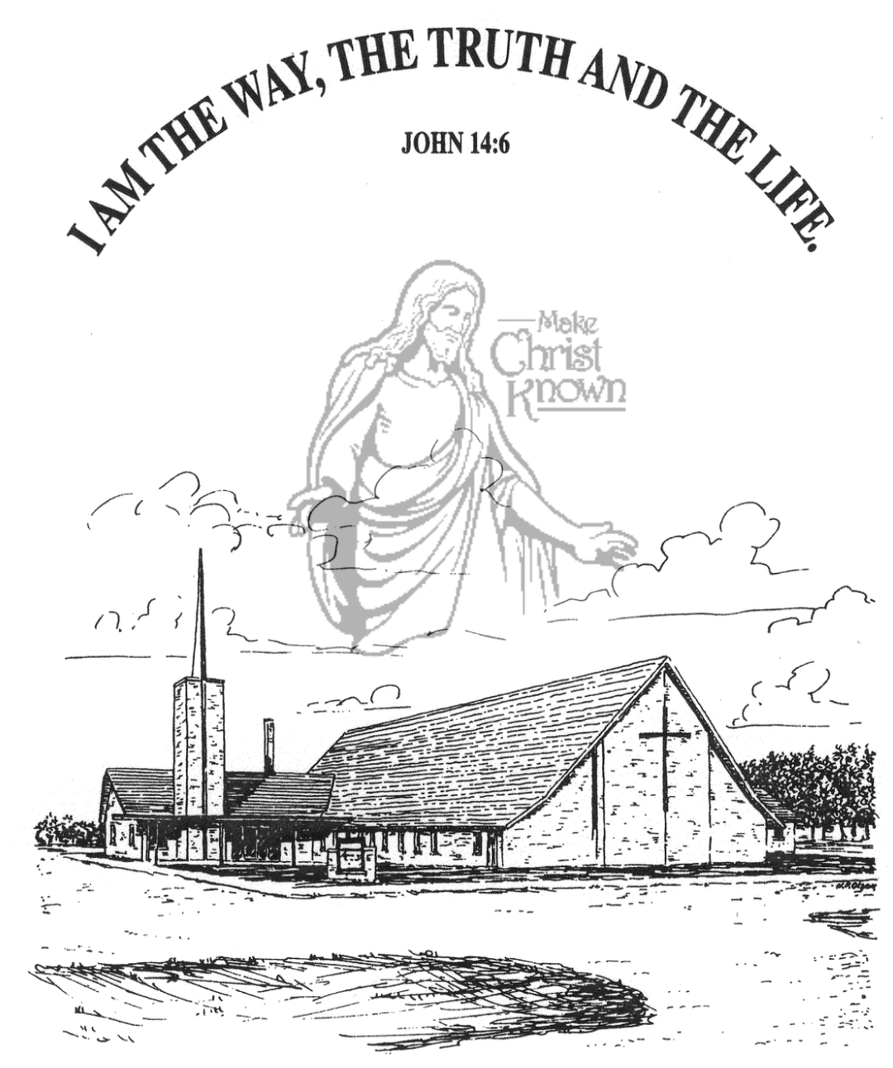

**Sunday, April 13, 2025**

**Salem Reformed Church**

**Menno, South Dakota**

**Prayer: (unison – pastor & candidates)**

“O God, my God, known to me in Jesus Christ, I am not my own, but Yours. I give myself to You, as Your own, to love and serve You faithfully, all the days of my life. Thank You for saving me and making me a new creation in Jesus Christ. Amen.”

**Prayer of Congregation: (unison)**

“Almighty God, who in Jesus Christ has made salvation a free gift of grace to all who will believe, empower by Your Spirit these young adults to continue to grow and develop their daily walk with You. Give to them the gift of power to love others, have joy in serving You, seek peace above dissension, and show patience in suffering. Help them to display kindness toward all people, goodness in evil times, faithfulness in temptation, gentleness in the face of opposition, and self-control in all things. This we ask in the name of Jesus Christ, our Lord and Savior. Amen.”

**Act of Confirmation:** (laying on of hands)

**Prayer of Confirmation:**

**Welcome:** by Ken Stepanek, Consistory Chairman

“In the name of Jesus Christ and on behalf of Salem Reformed Church, I extend the hand of Christian love, welcoming you into the company of this congregation.”

**Presentation of Bibles:** by Ken Stepanek

**Sacrament of the Lord’s Supper:**

(For the Confirmands and their Parents)

**\*Hymn:** #300 “All Glory, Laud and Honor”

**Benediction:**

**Postlude** (*denotes standing for those able)

The congregation will be ushered out after the Benediction.

**Opportunities**

Greeters April 13th: Ryan & Cassie Wielenga

Greeters April 17th: Carl & Linda Zeeb

Sunday Prayer Time: 8:30 a.m.

Sunday School Classes: 9:15 a.m.

Praise Music: 10:15 a.m.

Worship Service: 10:30 a.m.

**Welcome:** We extend a warm welcome to our visiting guests this morning. Please sign our guest book in the Narthex. We ask God’s blessing upon you and we pray that you will return and worship with us again soon.

**SALEM REFORMED CHURCH**

Menno, South Dakota

Rev. Michael Hecht Pastor

Joan Nusz Pianist

10:00 AM – Worship Service April 13, 2025

Palm Sunday and Confirmation Sunday

**Meditation:** *“As He approached Jerusalem and saw the city, He wept over it and said, ‘If you, even you, had only known on this day what would bring you peace – but now it is hidden from your eyes. The days will come upon you when your enemies will build an embankment against you and encircle you and hem you in on every side. They will dash you to the ground, you and the children within your walls. They will not leave one stone on another, because you did not recognize the time of God’s coming to you.’ Then He entered the temple area and began driving out those who were selling. ‘It is written,’ He said to them, ‘My house will be a house of prayer’; but you have made it a den of robbers.’* Luke 19:41-46 NIV

**Praise Music:** #110, #29, #32, #90, #134

**Ringing of the Bell**

**Announcements / Opening Prayer**

**\*Hymn:** #297 “Hosanna, Loud Hosanna”

**Reading of Faith Statements by:**

Ava Wyldes, Vincent Kludt, Daniel Schaeffer

**Kingdom Kids:** “Palm Sunday”

**Reading of Faith Statements by;**

Briley Cross, Lee Kisely, Jeremiah Mudder

**Our Time of Offering** Proverbs 22:6 AMP

**Special Music:** “Goodness of God” by Chanda Bender

**\*Doxology and Lord’s Prayer** (debts and debtors)

**Reading of Faith Statements by:**

Corwin Schaeffer and Leah Crick

**The Holy Scriptures**

Mark 11:1-11 pg. 1572

**Exhortation: “The Lord Needs You!”**

**ORDER OF CONFIRMATION**

**Preliminary Questions to Candidates**

**Recitation of the Heidelberg Catechism**

**Address:** by Pastor

**Questions:** to Candidates