**Calendar of Events**

April 03 Prayer Group @ 12 Noon

April 06 Prayer Time for Service @ 8:30 a.m.

Sunday School Classes @ 9:15 a.m.

Praise Music @ 10:15 a.m.

Worship Service @ 10:30 a.m.

CE Comm. Meeting @ 11:45 a.m.

M/O Care Center Service @ 2:00 p.m.

Caden Fischer Concert @ 3:00 p.m.

April 07 Cantata Practice at Salem @ 7:00 p.m.

Men’s Christian Fellowship @ 7:30 p.m.

April 09 Women’s Bible Study @ 9:30 a.m. & 6:00 p.m.

8th Grade Confirmation @ 5:30 – 7:00 p.m.

Consistory Meeting @ 7:30 p.m.

April 10 Prayer Group @ 12 Noon

April 12 Cantata Practice at Salem @ 7:00 p.m.

**Upcoming Special Music**

Sunday, April 06 - Available

Sunday, April 13 - Chanda Bender

**Announcements**

**Caden Fischer In Concert:** Caden Fischer, a senior at SDSU, will present a concert in our sanctuary on Sunday, April 6th @ 3PM. Please mark your calendars and make plans to attend!

**Christian Ed. Committee:** The CE Committee will plan to meet after church this coming Sunday, April 6th.

**Meals-on-Wheels:** Please remember the days that you signed up for in April to deliver these meals. They should be picked up at M/OCC at 11:20 a.m. Thanks for blessing others!

**Easter Breakfast:** The High School Youth Group will host an Easter Breakfast in the Social Hall from 8:30-10:00 a.m. on Sunday, April 20th. Breakfast includes Egg Bake, Muffins, and Fresh Fruit. Free-will donations are accepted.

**2025 VBS Dates:** Mark your Calendars – The Dates for VBS will be May 26-30, 2025, with the Program on Sunday, June 1st.

**Alpha Center Banquet:** Mark your Calendars! The Alpha Center Friends & Fellowship Dinner will be Friday, April 25, 2025 at the Sioux Falls Convention Center. The deadline to register is April 11th. Please contact Lee Herrboldt if you are interested in attending this Banquet.

**Salem Reformed Church – Who Are We?**

**We believe the Bible to be the inspired, inerrant, infallible Word of God in its original manuscripts. It is our supreme authority in all matters doctrine and practice. We are affiliated with the Conservative Congregational Christian Conference.**

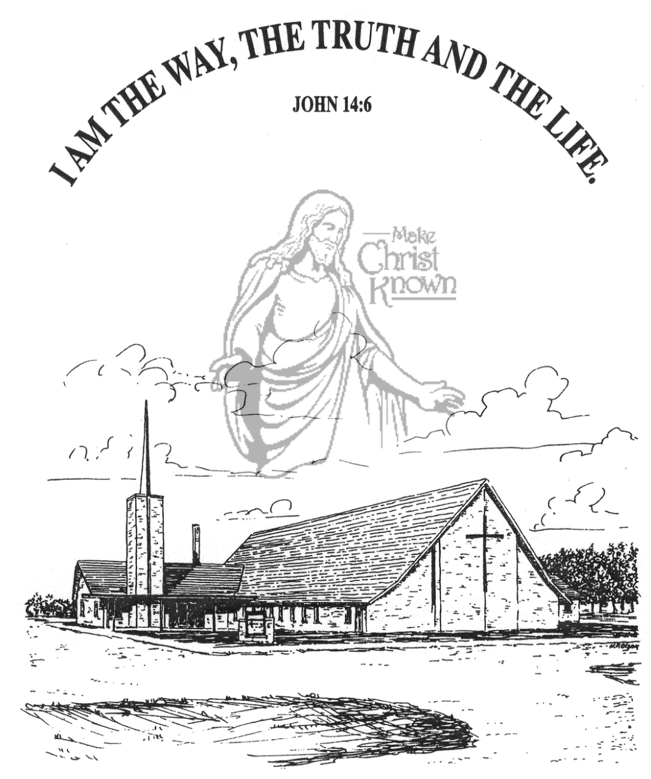

**Wednesday, April 02, 2025**

**Salem Reformed Church**

**Menno, South Dakota**

**Office Hours for Pastor Hecht**

Tuesday – Friday: 8:00 AM to Noon (Church Office)

Afternoons: Visitation or Church Office

Church: (605) 387-5334 Parsonage: (605) 387-2855

Pastor Mike’s Cell #: (605) 660-1803

Church Web Page: ***salemreformedchurch.com***

**Opportunities**

Greeter Tonight: Shirley Mettler

Greeters April 06:

Sunday Prayer Time: 8:30 a.m.

Sunday School Classes: 9:15 a.m.

Praise Music: 10:15 a.m.

Worship Service: 10:30 a.m.

**Announcements**

**Welcome:** We extend a warm welcome to our visiting guests this evening. Please sign our guest book in the Narthex. We ask God’s blessing upon you and we pray that you will return and worship with us again soon.

**Special Thanks:** THANKS to our High School Youth Group for helping lead in our worship service this evening! Thanks to our Youth Advisors – Scott & Amy Nusz and Matt & Trishia Fischer for all that they do throughout the year in working with our youth!

**Confirmation Sunday:** Confirmation will be held on Sunday, April 13th at 10:00 a.m. This is also Palm Sunday! Please mark your calendars and plan to attend. There are no SS Classes, but we will still have the children bringing in the palm branches on that day!

**M/O Community Easter Cantata:** This will be held in our Sanctuary on Palm Sunday, April 13th @ 7:00 p.m. A free- will offering will be received for cantata expenses and the on-going ministry of the M/O Ministerial Association.

**Easter Lilies in Memory of Loved Ones:** On Easter Sunday, April 20th, we have the opportunity to place Easter Lilies in the sanctuary in memory of departed loved ones. Please contact the florist of your choice if you desire to give a plant this year, and let the church office know who it is in memory of. Thanks!

**Sunday Offerings:** Please note that we have an Offering Box/Pulpit at the back of the Sanctuary for people to place their tithes and offerings.

***“God loves a cheerful giver.”* II Corinthians 9:7**

**SALEM REFORMED CHURCH**

Menno, South Dakota

Rev. Michael Hecht Pastor

Joan Nusz Pianist

7:00 PM – Worship Service April 02, 2025

Mid-Week Lenten Service

**Meditation:** *“Then Jesus said to His disciples, ‘If anyone would come after Me, he must deny himself and take up his cross and follow Me. For whoever wants to save his life will lose it, but whoever loses his life for Me will find it. What good will it be for a man if he gains the whole world, yet forfeits his soul? Or what can a man give in exchange for his soul? For the Son of Man is going to come in His Father’s glory with His angels, and then He will reward each person according to what he has done.”* Matthew 16:24-27 NIV

**Prelude Music:**  Joan Nusz

**Praise Song:** #52 “You Are My All In All”

**Ringing of the Bell / Welcome / Announcements**

**Opening Prayer**  Zoe Schaeffer

**Responsive Reading:** #645Hannah Masterson & Autumn Rames

**\*Hymn:** #323 “At The Cross”

**Scripture Readings: Galatians 2:20,21** Luke Plooster

**I Corinthians 1:18,19, 22-24** Emmalyn Heckenlaible

**Heidelberg Catechism #18:** Elly Fischer

**Kingdom Kids:** “Take Up Your Cross”

Ashlyn Derby & Emmarie Rames

**Responsive Reading – The Cross** All High School Youth

**Hymn:** #324 “When I Survey the Wondrous Cross”

**Scripture Readings:** Ashlynn Fergen & Austen Soukup

Galatians 6:14-18 (AMP)

Large Print NIV 1984 Edition, pg. 1816

**Sermon: “Crucified With Christ”**

**Special Prayer Offered:**  Ethan McCoy

**Our Time of Offering:** Jefrey Poma Gal. 3:13,14 NIV

**\*Doxology** sung on page #815

**\*Apostles’ Creed** Jaxon Stoebner (words on screen)

**\*Hymn:** #343 “Amazing Grace”

**\*Benediction:** Micah Goehring

**Postlude** (*denotes standing for those able)

The congregation will be ushered out after the Benediction

Youth Ushers: Taylor Freier, Ashlyn Derby, Hannah Masterson