**Calendar of Events**

Mar 09 Contemporary Service @ 7:00 p.m.

Mar 12 Women’s Bible Study @ 9:30 a.m. & 6:00 p.m.

No Confirmation Classes Today (Spring Break)

Consistory Meeting @ 7:00 p.m.

Mar 13 Prayer Group @ 12 Noon

Cantata Practice at Grace Lutheran @ 7:00 p.m.

Mar 16 Prayer Time for Service @ 8:30 a.m.

Sunday School Classes @ 9:15 a.m.

Praise Music @ 10:15 a.m.

Worship Service @ 10:30 a.m.

Mar 17 Men’s Christian Fellowship @ 7:30 p.m.

Mar 19 Women’s Bible Study @ 9:30 a.m.

4-O’s Women at Roosters @ 11:30 a.m.

8th Grade Confirmation @ 3:30-5:00 p.m.

6/7th Grade Confirmation @ 5:00-6:20 p.m.

**Lenten Service @ 7:00 p.m.**

**Upcoming Special Music**

Sunday, March 16 - Available

Wednesday, March 19 - Available

**Announcements**

**Program at M/OCC:** Helpers are needed for the Program at M/OCC on Tues., March 18th @ 2:00 p.m. Please sign the sheet in the Narthex if you are able to come and help. Thanks!

**2025 VBS Dates:** Mark your Calendars – The Dates for VBS will be May 26-30, 2025, with the Program on Sunday, June 1st.

**FCA Spring Banquet:** This will be held on Sunday, March 30th at 6PM at the Menno/City School Auditorium. Our guest speaker will be Coach Jerry Olszewski, Head Coach of the Augustana Vikings Football Team. Everyone is invited to attend!

**Coffee Hour:** We are looking for 6 volunteers to bring 2 dozen goodies for Coffee Hour on Sun., March 30th. Please sign the sheet in the Narthex if you are able to help.

**Alpha Center Banquet:** Mark your calendars! The Alpha Center Friends & Fellowship Dinner will be Friday, April 25th, 2025 at the Sioux Falls Convention Center. Please contact Lee Herrboldt if you are interested in attending this Banquet.

**Caden Fischer In Concert:** Caden Fischer, a senior at SDSU, will present a concert in our sanctuary on Sunday, April 6th @ 3PM. Please mark your calendars and make plans to attend!

**Salem Reformed Church – Who Are We?**

**We believe the Bible to be the inspired, inerrant, infallible Word of God in its original manuscripts. It is our supreme authority in all matters doctrine and practice. We are affiliated with the Conservative Congregational Christian Conference.**

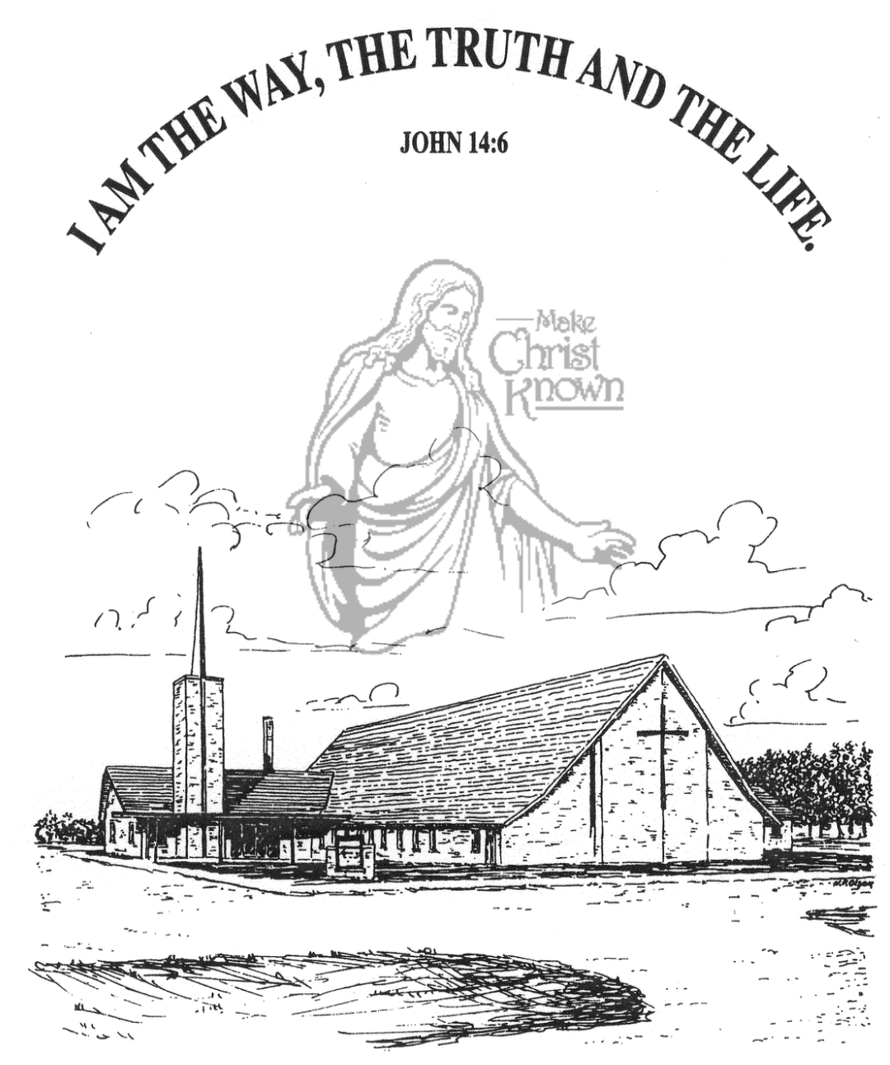

**Sunday, March 09, 2025**

**Salem Reformed Church**

**Menno, South Dakota**

..3

**SALEM REFORMED CHURCH**

Menno, South Dakota

Rev. Michael Hecht Pastor

Joan Nusz Pianist

10:30 AM – Worship Service March 09, 2025

1st Sunday in the Lenten Season

**Meditation:** *“I am the True Vine, and My Father is the gardener. He cuts off every branch in Me that bears fruit, while every branch that does not bear fruit He prunes so that it will be even more fruitful. You are already clean because of the word I have spoken to you. Remain in Me, and I will remain in you. No branch can bear fruit by itself; it must remain in the vine. Neither can you bear fruit unless you remain in Me. I am the Vine; you are the branches. If a man remains in Me and I in him, he will bear much fruit; apart from Me you can do nothing. If anyone does not remain in Me, he is like a branch that is thrown away and withers; such branches are picked up, thrown into the fire and burned. If you remain in Me and My words remain in you, ask whatever you wish, and it will be given you.”* John 15:1-7 NIV

**Praise Music:** #53, #88, #104, #13, #24

**Ringing of the Bell**

**Welcome / Announcements / Opening Prayer**

**\*Hymn:** #87 “Fairest Lord Jesus”

**Sharing of Joys and Concerns**

**Our Time of Offering** John 16:7 NIV

**\*Doxology** sung on page #815

**\*Apostles’ Creed** words on screen

**Kingdom Kids:** “The True Vine”

**Hymn:** #319 “Near the Cross”

**The Holy Scriptures**

I John 2:26-3:1

Large Print NIV 1984 Edition, pg. 1900

**Sermon: “Abiding in the Vine”**

**\*Hymn:** #638 “I Need Thee Every Hour”

**\*Benediction:**

**\*Prayer for Our Nation:** “God Bless America”

**Postlude** (*denotes standing for those able)

The congregation will be ushered out after the Benediction

Youth Ushers: Lexie McNinch, Amanda Rames, Madison Schaeffer

**Office Hours for Pastor Hecht**

Tuesday – Friday: 8:00 AM to Noon (Church Office)

Afternoons: Visitation or Church Office

Church: (605) 387-5334 Parsonage: (605) 387-2855

Pastor Mike’s Cell #: (605) 660-1803

Church Web Page: ***salemreformedchurch.com***

**Opportunities**

Greeters Today: Greg and Melanie Wilcoxon

Greeters March 16th: Robert and Elaine Balogh

Greeters March 19th: Ben and Julie Crick and Family

Sunday Prayer Time: 8:30 a.m.

Sunday School Classes: 9:15 a.m.

Praise Music: 10:15 a.m.

Worship Service: 10:30 a.m.

**Announcements**

**Welcome:** We extend a warm welcome to our visiting guests this morning. Please sign our guest book in the Narthex. We ask God’s blessing upon you and we pray that you will return and worship with us again soon.

**Contemporary Service:** We will plan to have a Contemporary Service TONIGHT at 7:00 p.m. Contact Pastor Mike/Ann if you have a testimony that you would like to share!

**Cherub Choir:** The Cherub Choir will be singing in church on Sunday, March 30th. This includes children who are 3 years old through 3rd Grade. Please have your children here for Practice and Sunday School by 9:15 a.m.

**Women of the Church Salad Supper:** We are looking for 4 ladies who are willing to be on the planning committee for the Spring Salad Supper. Please sign the sheet in the Narthex.

**Women of the Church:** The W.O.C. will hold their next meeting on Sunday, March 30th, following the worship service.

**Marriage Seminar:** Sunday, March 23rd, from 4 to 8 PM – meal included. If you’re single, engaged or married, this is for you! We will be watching a DVD Series titled, ‘From This Day Forward’ by Craig & Amy Groeschel. We will also be giving away a gift certificate to attend a Weekend to Remember Conference. This will be a door-prize for one couple who attends the marriage seminar at our church. Please sign the sheet in the Narthex if you are planning to attend!

**Sunday Offerings:** Please note that we have an Offering Box/Pulpit at the back of the Sanctuary for people to place their tithes and offerings in during our worship services.