**Calendar of Events**

Mar 30 FCA Spring Banquet at Menno Gym @ 6:00 p.m.

Mar 31 Cantata Practice at Salem Reformed @ 7:00 p.m.

April 01 M/O Ministerial at Roosters @ 11:30 a.m.

April 02 Women’s Bible Study @ 9:30 a.m.

8th Grade Confirmation @ 3:30-5:00 p.m.

6/7th Grade Confirmation @ 5:00-6:00 p.m.

**Lenten Service @ 7:00 p.m.**

April 03 Prayer Group @ 12 Noon

April 06 Prayer Time for Service @ 8:30 a.m.

Sunday School Classes @ 9:15 a.m.

Praise Music @ 10:15 a.m.

Worship Service @ 10:30 a.m.

M/O Care Center Service @ 2:00 p.m.

Caden Fischer in Concert @ 3:00 p.m. in our

Church Sanctuary

April 07 Men’s Christian Fellowship @ 7:30 p.m.

**Upcoming Special Music**

Wednesday, April 02 - High School Youth Helping

Sunday, April 06 - Available

**Announcements**

**Easter Lilies in Memory of Loved Ones:** On Easter Sunday, April 20th, we have the opportunity to place Easter Lilies in the sanctuary in memory of departed loved ones. Please contact the florist of your choice if you desire to give a plant this year, and let the church office know who it is in memory of. Thanks!

**Confirmation Sunday:** Confirmation will be held on Sunday, April 13th at 10:00 a.m. This is also Palm Sunday! Please mark your calendars and plan to attend. There are no SS Classes, but we will still have the children bringing in the palm branches on that day!

**Alpha Center Banquet:** Mark your calendars! The Alpha Center Friends & Fellowship Dinner will be Friday, April 25th, 2025 at the Sioux Falls Convention Center. Please contact Lee/Dianne Herrboldt if you are interested in attending this Banquet.

**Meals-on-Wheels:** Our church will be delivering meals during the month of APRIL. Drivers are needed for delivering lunches on Mon.- Friday. They should be picked up at M/OCC at 11:20 a.m. Please sign the sheet in the Narthex if you can help.

**2025 VBS Dates:** Mark your Calendars – The Dates for VBS will be May 26-30, 2025, with the Program on Sunday, June 1st.

**Salem Reformed Church – Who Are We?**

**We believe the Bible to be the inspired, inerrant, infallible Word of God in its original manuscripts. It is our supreme authority in all matters doctrine and practice. We are affiliated with the Conservative Congregational Christian Conference.**

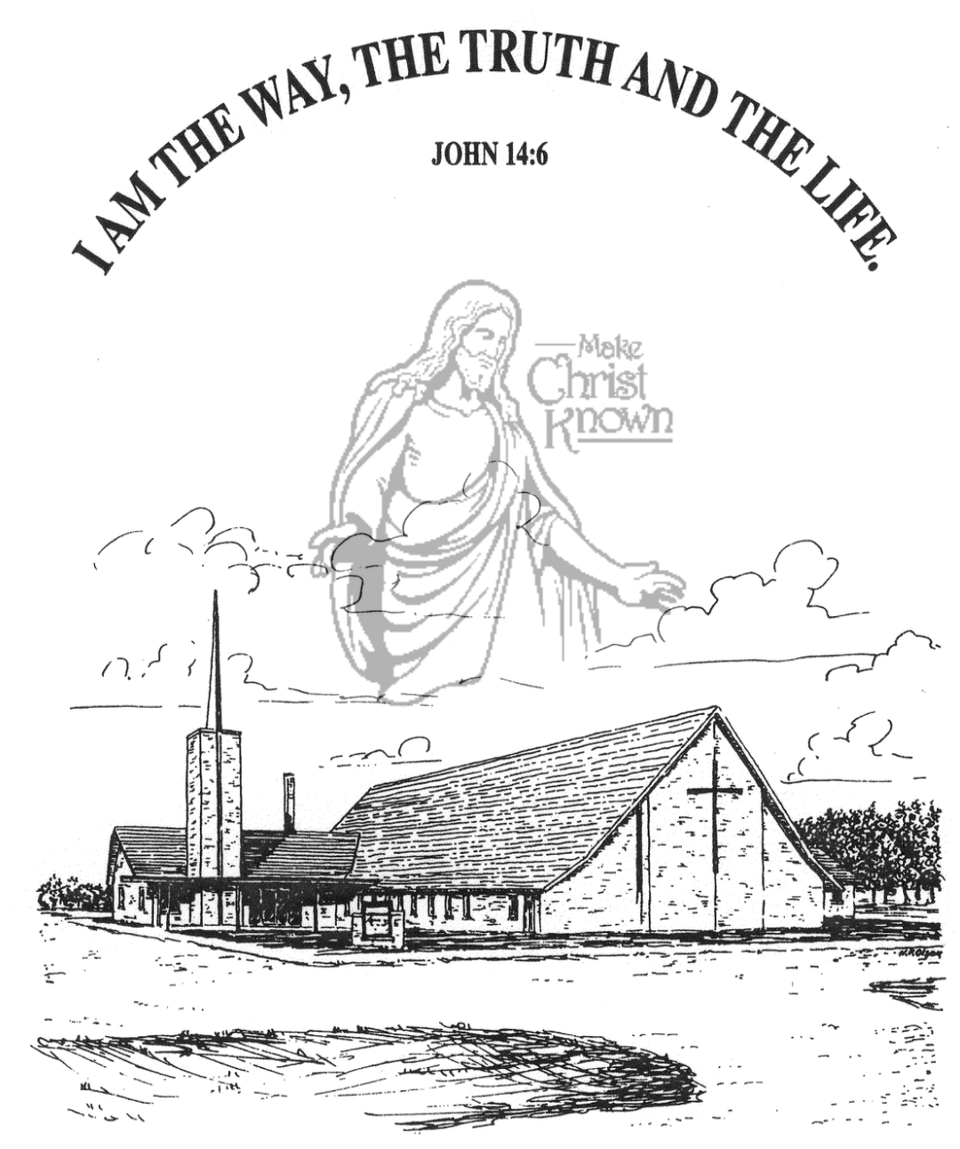

**Sunday, March 30, 2025**

**Salem Reformed Church**

**Menno, South Dakota**

..3

**SALEM REFORMED CHURCH**

Menno, South Dakota

Rev. Michael Hecht Pastor

Jennifer Herrboldt Pianist

10:30 AM – Worship Service March 30, 2025

4th Sunday in the Lenten Season

**Meditation:** *“Teach your children to choose the right path, and when they are older, they will remain upon it. . . . A youngster’s heart is filled with foolishness, but discipline will drive it away.”* Proverbs 22:6,15 NLT

*“If you refuse to discipline your children, it proves you don’t love them; if you love your children, you will be prompt to discipline them.”*  Proverbs 13:24 NLT

*“Discipline your children, and they will give you happiness and peace of mind.”* Proverbs 29:17 NLT

**Praise Music:** #83, #72, #140, #16

**Ringing of the Bell**

**Welcome / Announcements**

**Opening Prayer**

**\*Hymn:** #104 “O Worship the King”

**Sharing of Joys and Concerns**

**Our Time of Offering** Psalm 8:1,2a NIV

**\*Lord’s Prayer** sung on page #631

**\*Apostles’ Creed** (see words on screen)

**Baptism: Sienna Elizabeth Preszler**

**Questions of Candidates / Congregational Assent**

**Education Committee Pledge** Kevin Holzwarth

**Congregational Song:** “Jesus Loves You!”

**Special Music:** “Only a Boy Named David” and

“10 Commandment Boogie” sung by the Cherub Choir

**Kingdom Kids:** “Jesus Loves the Children”

**The Holy Scriptures**

Psalm 127:1-5

Large Print NIV 1984 Edition, pg. 968

**Sermon: “The LORD Builds the House”**

**\*Hymn:** #318 “I Believe in a Hill Called Mt. Calvary”

**\*Benediction:**

**\*Prayer for Our Nation:** “God Bless America”

**Postlude** (*denotes standing for those able)

The congregation will be ushered out after the Benediction

Youth Ushers: Lexie McNinch, Amanda Rames, Madison Schaeffer

**Office Hours for Pastor Hecht**

Tuesday – Friday: 8:00 AM to Noon (Church Office)

Afternoons: Visitation or Church Office

Church: (605) 387-5334 Parsonage: (605) 387-2855

Pastor Mike’s Cell #: (605) 660-1803

Church Web Page: ***salemreformedchurch.com***

**Opportunities**

Greeters March 30th: Robert and Elaine Balogh

Greeters April 2nd:

Greeters April 6th:

Sunday Prayer Time: 8:30 a.m.

Sunday School Classes: 9:15 a.m.

Praise Music: 10:15 a.m.

Worship Service: 10:30 a.m.

**Announcements**

**Welcome:** We extend a warm welcome to our visiting guests this morning. Please sign our guest book in the Narthex. We ask God’s blessing upon you and we pray that you will return and worship with us again soon.

**Congratulations:** We rejoice with the Family of Sienna Elizabeth Preszler on her baptism day. Sienna’s parents are Caleb and Abby Preszler. We extend a warm welcome to all of their family and friends who may be present in our worship service today.

**Coffee Hour:** Please join us after church today for a time of fellowship, while enjoying coffee and desserts.

**Women of the Church:** The W.O.C. will meet TODAY, following the worship service, in the High School Room.

**FCA Spring Banquet:** This will be held THIS EVENING at 6PM at the Menno/City School Auditorium. Our guest speaker will be Coach Jerry Olszewski, Head Coach of the Augustana Vikings Football Team. Everyone is invited to attend! A free-will offering will be received for the meal.

**Caden Fischer In Concert:** Caden Fischer, a senior at SDSU, will present a concert in our sanctuary on Sunday, April 6th @ 3PM. Please mark your calendars and make plans to attend!

**Special Thanks:** Special Thanks to Stephanie & Michael Wagner for placing flowers in the sanctuary during the month of March.

**Sunday Offerings:** Please note that we have an Offering Box/Pulpit at the back of the Sanctuary for people to place their tithes and offerings in during our worship services.