**Calendar of Events**

Mar 17 Men’s Christian Fellowship @ 7:30 p.m.

Mar 19 Women’s Bible Study @ 9:30 a.m.

4-O’s Women at Roosters @ 11:30 a.m.

8th Grade Confirmation @ 3:30-5:00 p.m.

6/7th Grade Confirmation @ 5:00-6:20 p.m.

**Lenten Service @ 7:00 p.m.**

Mar 20 Prayer Group @ 12 Noon

Mar 21 Cantata Practice at Salem Reformed @ 7:00 p.m.

Mar 23 Prayer Time for Service @ 8:30 a.m.

Sunday School Classes @ 9:15 a.m.

Praise Music @ 10:15 a.m.

Worship Service @ 10:30 a.m.

Marriage Event at Church @ 4-8 p.m.

**Upcoming Special Music**

Wednesday, March 19 - Available

Sunday, March 23 - Available

**Announcements**

**FCA Spring Banquet:** This will be held on Sunday, March 30th at 6PM at the Menno/City School Auditorium. Our guest speaker will be Coach Jerry Olszewski, Head Coach of the Augustana Vikings Football Team. Everyone is invited to attend!

**Coffee Hour:** We are looking for 1 volunteer to bring 2 dozen goodies for Coffee Hour on Sun., March 30th. Please sign the sheet in the Narthex if you are able to help.

**Women of the Church Salad Supper:** We are looking for 2 more ladies who are willing to be on the planning committee for the Spring Salad Supper. Please sign the sheet in the Narthex.

**Alpha Center Banquet:** Mark your calendars! The Alpha Center Friends & Fellowship Dinner will be Friday, April 25th, 2025 at the Sioux Falls Convention Center. Please contact Lee Herrboldt if you are interested in attending this Banquet.

**Caden Fischer In Concert:** Caden Fischer, a senior at SDSU, will present a concert in our sanctuary on Sunday, April 6th @ 3PM. Please mark your calendars and make plans to attend!

**Easter Lilies in Memory of Loved Ones:** On Easter Sunday, April 20th, we have the opportunity to place Easter Lilies in the sanctuary in memory of departed loved ones. Please contact the florist of your choice if you desire to give a plant this year, and let the church office know who it is in memory of. Thanks!

**Salem Reformed Church – Who Are We?**

**We believe the Bible to be the inspired, inerrant, infallible Word of God in its original manuscripts. It is our supreme authority in all matters doctrine and practice. We are affiliated with the Conservative Congregational Christian Conference.**

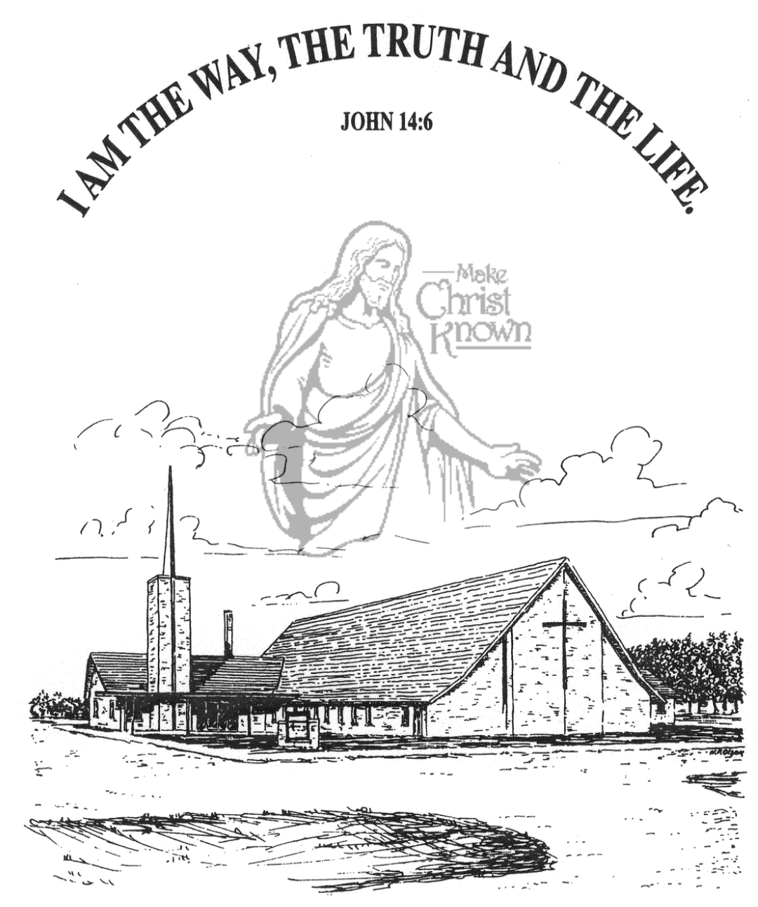

**Sunday, March 16, 2025**

**Salem Reformed Church**

**Menno, South Dakota**

..3

**SALEM REFORMED CHURCH**

Menno, South Dakota

Rev. Michael Hecht Pastor

Sharyl Herrboldt Pianist

10:30 AM – Worship Service March 16, 2025

2nd Sunday in the Lenten Season

**Meditation:** *“Very early in the morning, while it was still dark, Jesus got up, left the house and went off to a solitary place, where He* ***PRAYED****.”*  Mark 1:35 NIV

*“One of those days Jesus went out to a mountainside to PRAY, and spent the night* ***PRAYING*** *to God. When morning came, He called His disciples to Him and chose twelve of them, whom He designated apostles.”* Luke 6:12,13 NIV

*“About eight days after Jesus said this, He took Peter, John and James with Him and went up onto a mountain to* ***PRAY****. As He was PRAYING, the appearance of His face changed, and His clothes became as bright as a flash of lightning.”*

Luke 9:28,29 NIV

*“Be joyful always;* ***PRAY*** *continually; give thanks in all circumstances, for this is God’s will for you in Christ Jesus.”*

I Thessalonians 5:16-18 NIV

**Praise Music:** #49, #5, #1, #58, #144

**Ringing of the Bell**

**Welcome / Announcements / Opening Prayer**

**\*Hymn:** #309 “I Will Sing of My Redeemer”

**Sharing of Joys and Concerns**

**Our Time of Offering** Philippians 3:7,8 NIV

**\*Doxology** sung on page #815

**\*Lord’s Prayer** debts and debtors

**Kingdom Kids:** “Listening For God”

**Hymn:** #9 “Glorify Thy Name”

**The Holy Scriptures**

John 17:1-5

Large Print NIV 1984 Edition, pg. 1679

**Sermon: “The Greatest Prayer”**

**\*Hymn:** #493 “Glory to His Name”

**\*Benediction:**

**\*Prayer for Our Nation:** “God Bless America”

**Postlude** (*denotes standing for those able)

The congregation will be ushered out after the Benediction

Youth Ushers: Lexie McNinch, Amanda Rames, Madison Schaeffer

**Office Hours for Pastor Hecht**

Tuesday – Friday: 8:00 AM to Noon (Church Office)

Afternoons: Visitation or Church Office

Church: (605) 387-5334 Parsonage: (605) 387-2855

Pastor Mike’s Cell #: (605) 660-1803

Church Web Page: ***salemreformedchurch.com***

**Opportunities**

Greeters Today: Robert and Elaine Balogh

Greeters March 19th: Ben and Julie Crick and Family

Greeters March 23rd: David and Peg Walloch

Sunday Prayer Time: 8:30 a.m.

Sunday School Classes: 9:15 a.m.

Praise Music: 10:15 a.m.

Worship Service: 10:30 a.m.

**Announcements**

**Welcome:** We extend a warm welcome to our visiting guests this morning. Please sign our guest book in the Narthex. We ask God’s blessing upon you and we pray that you will return and worship with us again soon.

**Cherub Choir:** The Cherub Choir will be singing in church on Sunday, March 30th. This includes children who are 3 years old through 3rd Grade. Please have your children here for Practice and Sunday School by 9:15 a.m.

**Program at M/OCC:** Helpers are needed for the Program at M/OCC on Tues., March 18th @ 2:00 p.m. Please sign the sheet in the Narthex if you are able to come and help. Thanks!

**4-O’s Women:** We will plan to meet at Roosters on Wed., March 19th at 11:30 a.m. for lunch together. Then we will go to the church social hall for a time of fellowship and games. Please sign the sheet in the Narthex if you plan to attend.

**Women of the Church:** The W.O.C. will hold their next meeting on Sunday, March 30th, following the worship service.

**Marriage Seminar:** Sunday, March 23rd, from 4 to 8 PM – meal included. If you’re single, engaged or married, this is for you! We will be watching a DVD Series titled, ‘From This Day Forward’ by Craig & Amy Groeschel. We will also be giving away a gift certificate to attend a Weekend to Remember Conference. This will be a door-prize for one couple who attends the marriage seminar at our church. Please sign the sheet in the Narthex if you are planning to attend!

**Sunday Offerings:** Please note that we have an Offering Box/Pulpit at the back of the Sanctuary for people to place their tithes and offerings in during our worship services.