**Calendar of Events**

Mar 06 Prayer Group @ 12 Noon

Mar 07 Cantata Practice at Peace CRC @ 7:00 p.m.

Mar 08 **Daylight Savings Time – Set Clocks Ahead 1 Hour**

Mar 09 Prayer Time for Service @ 8:30 a.m.

Sunday School Classes @ 9:15 a.m.

Praise Music @ 10:15 a.m.

Worship Service @ 10:30 a.m.

Contemporary Service @ 7:00 p.m.

Mar 12 Women’s Bible Study @ 9:30 a.m. & 6:00 p.m.

No Confirmation Classes Today

Consistory Meeting @ 7:00 p.m.

FCA at Menno Gym @ 7:30 p.m.

Mar 13 Prayer Group @ 12 Noon

Cantata Practice at Grace Lutheran @ 7:00 p.m.

**Upcoming Special Music**

Sunday, March 09 - Available

Sunday, March 16 - Available

**Announcements**

**Women of the Church Salad Supper:** We are looking for 4 ladies who are willing to be on the planning committee for the Spring Salad Supper. Please sign the sheet in the Narthex.

**FCA Spring Banquet:** This will be held on Sunday, March 30th at 6PM at the Menno/City School Auditorium. Our guest speaker will be Coach Jerry Olszewski, Head Coach of the Augustana Vikings Football Team. Everyone is invited!

**Program at M/OCC:** Helpers are needed for the Program at M/OCC on Tues., March 18th @ 2:00 p.m. Please sign the sheet in the Narthex if you are able to come and help this ministry.

**Coffee Hour:** We are looking for 7 volunteers to bring 2 dozen goodies for Coffee Hour on Sun., March 30th. Please sign the sheet in the Narthex if you are able to help.

**Women of the Church:** The W.O.C. will hold their next meeting on Sunday, March 30th, following the worship service.

**Alpha Center Banquet:** Mark your Calendars! The Alpha Center Friends & Fellowship Dinner will be Friday, April 25, 2025 at the Sioux Falls Convention Center. Please contact Lee Herrboldt if you are interested in attending this Banquet.

**Salem Reformed Church – Who Are We?**

**We believe the Bible to be the inspired, inerrant, infallible Word of God in its original manuscripts. It is our supreme authority in all matters doctrine and practice. We are affiliated with the Conservative Congregational Christian Conference.**

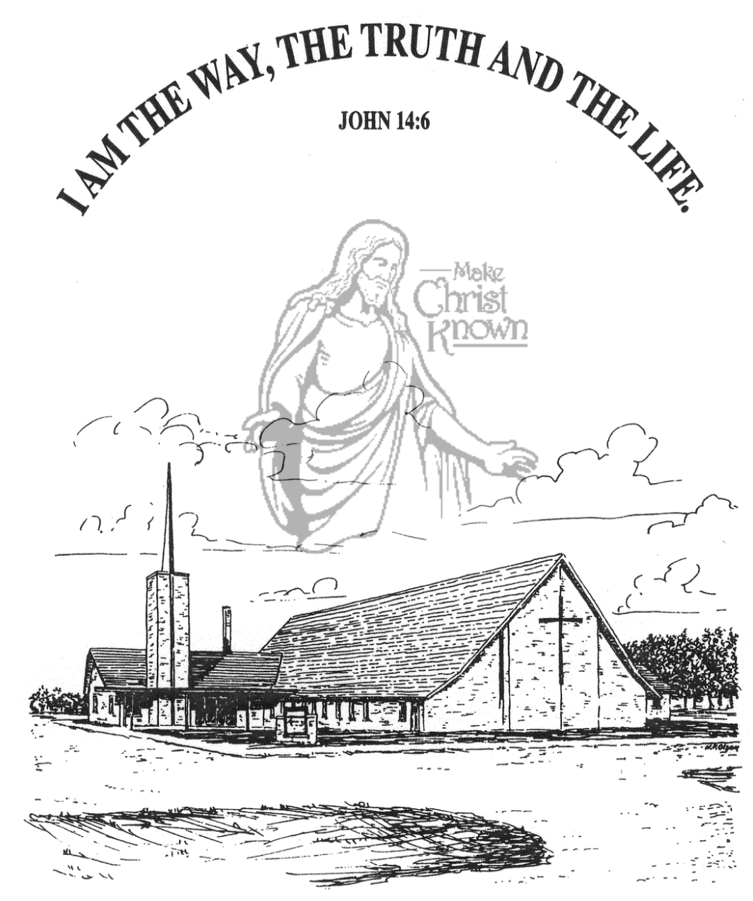

**Wednesday, March 05, 2025**

**Salem Reformed Church**

**Menno, South Dakota**

**Office Hours for Pastor Hecht**

Tuesday – Friday: 8:00 AM to Noon (Church Office)

Afternoons: Visitation or Church Office

Church: (605) 387-5334 Parsonage: (605) 387-2855

Pastor Mike’s Cell #: (605) 660-1803

Church Web Page: ***salemreformedchurch.com***

**Opportunities**

Greeter Tonight: Shirley Mettler

Greeters March 09: Greg and Melanie Wilcoxon

Sunday Prayer Time: 8:30 a.m.

Sunday School Classes: 9:15 a.m.

Praise Music: 10:15 a.m.

Worship Service: 10:30 a.m.

**Announcements**

**Welcome:** We extend a warm welcome to our visiting guests this evening. Please sign our guest book in the Narthex. We ask God’s blessing upon you and we pray that you will return and worship with us again soon.

**Special Thanks:** THANKS to our High School Youth Group for helping lead in our worship service this evening! Thanks to Mick Huber and Marina Schaeffer for working with them to sing the special music during our service! Thanks to our Youth Advisors – Scott & Amy Nusz and Matt & Trishia Fischer for all that they do throughout the year in working with our youth!

**Contemporary Service:** We will plan to have a Contemporary Service this coming Sunday, March 9th at 7:00 p.m. Please contact Pastor Mike/Ann if you have a testimony that you would like to share!

**Easter Lilies in Memory of Loved Ones:** On Easter Sunday, April 20th, we have the opportunity to place Easter Lilies in the sanctuary in memory of departed loved ones. Please contact the florist of your choice if you desire to give a plant this year, and let the church office know who it is in memory of. Thanks!

**Cherub Choir:** Parents of the Cherub Choir (3yrs. - 3rd Grade), please note that your children will be singing in church on Sunday, March 30th.

**Sunday Offerings:** Please note that we have an Offering Box/Pulpit at the back of the Sanctuary for people to place their tithes and offerings.

***“God loves a cheerful giver.”* II Corinthians 9:7**

**SALEM REFORMED CHURCH**

Menno, South Dakota

Rev. Michael Hecht Pastor

Cindy Herrboldt Organist

7:00 PM – Worship Service March 05, 2025

Ash Wednesday Service

**Meditation:** *“One day Peter and John were going up to the temple at the time of prayer – at three in the afternoon. Now a man crippled from birth was being carried to the temple gate called Beautiful, where he was put every day to beg from those going into the temple courts. When he saw Peter and John about to enter, he asked them for money. Peter looked straight at him, as did John. Then Peter said, ‘Look at us!’ So the man gave them his attention, expecting to get something from them. Then Peter said, ‘Silver or gold I do not have, but what I have I give you. In the Name of Jesus Christ of Nazareth, walk.’*  Acts 3:1-6 NIV

**Prelude Music:**  Cindy Herrboldt

**Praise Song:** #10 “Majesty”

**Ringing of the Bell / Welcome / Announcements**

**Opening Prayer**  Addisyn Friesen

**Responsive Reading – Rev. 5:11-13**  Joslynn Fischer

**\*Hymn:** #340 “Turn Your Eyes Upon Jesus” (see insert)

**Scripture Readings: Philippians 2:8-11**  Eli Soukup

**Acts 4:8-12** Michael Nusz

**Kingdom Kids:** “Amazing Faith” Taylor Freier & Amanda Rames

**Special Music:** “I Speak Jesus” Sung by the High School Youth

**Scripture Readings:** Lexie McNinch & Madison Schaeffer

Matthew 8:5-13

Large Print NIV 1984 Edition, pg. 1507

**Sermon: “Only Speak the Word”**

**Hymn:** “I Speak Jesus” (Congregation & High School Youth)

**Special Prayer Offered:**  Carter Fischer

**Our Time of Offering:** Bryce Sattler II Cor. 9:6,7 NIV

**\*Doxology** sung on page #815

**\*Lord’s Prayer** Brockton Kocourek(debts and debtors)

**\*Hymn:** #45 “Crown Him with Many Crowns”

**\*Benediction:** Rylan Derby

**Postlude** (*denotes standing for those able)

The congregation will be ushered out after the Benediction

Youth Ushers: Lexie McNinch, Amanda Rames, Madison Schaeffer