**Calendar of Events**

Feb 23 M/OCC Worship Service @ 2:00 p.m.

Feb 26 Women’s Bible Study @ 9:30 a.m. & 6:00 p.m.

8th Grade Confirmation @ 3:30-5:00 p.m.

6/7th Grade Confirmation @ 5:00-6:20 p.m.

Pastor/Spouse Supper at Roosters @ 6:30 p.m.

Feb 27 Prayer Group @ 12 Noon

Mar 02 Prayer Time for Service @ 8:30 a.m.

Sunday School Classes @ 9:15 a.m.

Praise Music @ 10:15 a.m.

Worship Service @ 10:30 a.m.

VBS Helper Meeting @ 11:45 a.m.

High School Youth Group @ 11:45 a.m.

Family Fun Event in Yankton @ 3:00 p.m.

Mar 03 Men’s Christian Fellowship @ 7:00 p.m.

Mar 05 Women’s Bible Study @ 9:30 a.m.

8th Grade Confirmation @ 3:30-5:00 p.m.

NO 6/7th Grade Confirmation Classes

**Ash Wednesday Service @ 7:00 p.m.**

**Upcoming Special Music**

Sunday, March 02 - Available

Wednesday, March 05 - High School Youth

**Announcements**

**Card Ministry:** Please sign the sheet in the Narthex if you are willing to take over the ‘Card Ministry’ for the W.O.C. Special thanks to Donna Friesen for doing this the last several years!

**Flower Committee:** Please sign the sheet in the Narthex if you are willing to place flowers in the Sanctuary for a month or two in 2025. There are still several months available.

**Bulletin Board:** Please sign the sheet in the Narthex if you are willing to do the bulletin board in the Social Hall for a month.

**Women of the Church Salad Supper:** We are looking for 4 ladies who are willing to be on the planning committee for the Spring Salad Supper. Please sign the sheet in the Narthex.

**FCA Spring Banquet:** This will be held on Sunday, March 30th at 6PM at the Menno/City School Auditorium. Our guest speaker will be Coach Jerry Olszewski, Head Coach of the Augustana Vikings Football Team. Everyone is invited to attend!

**Annual Report:** Church Members may pick up a copy of the Annual Report from the Information Cabinet in the Narthex.

**Salem Reformed Church – Who Are We?**

**We believe the Bible to be the inspired, inerrant, infallible Word of God in its original manuscripts. It is our supreme authority in all matters doctrine and practice. We are affiliated with the Conservative Congregational Christian Conference.**

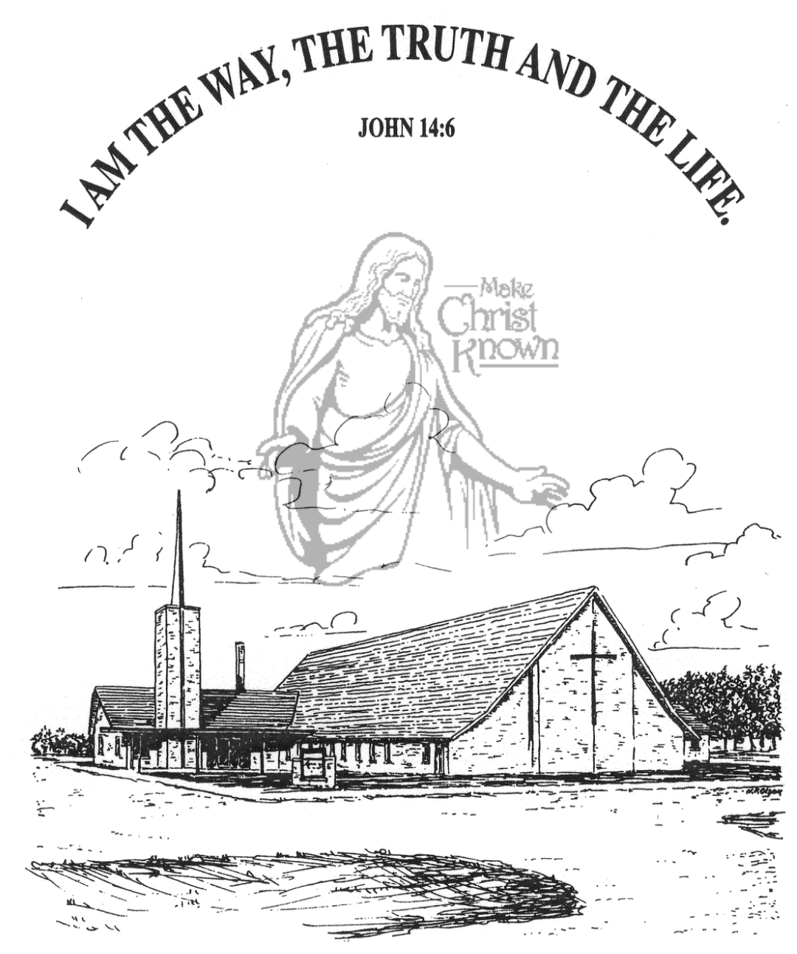

**Sunday, February 23, 2025**

**Salem Reformed Church**

**Menno, South Dakota**

..3

**Office Hours for Pastor Hecht**

Tuesday – Friday: 8:00 AM to Noon (Church Office)

Afternoons: Visitation or Church Office

Church: (605) 387-5334 Parsonage: (605) 387-2855

Pastor Mike’s Cell #: (605) 660-1803

Church Web Page: ***salemreformedchurch.com***

**Opportunities**

Greeters Today: Jim and Deb Christensen

Greeters March 02nd: Michael and Stephanie Wagner

Sunday Prayer Time: 8:30 a.m.

Sunday School Classes: 9:15 a.m.

Praise Music: 10:15 a.m.

Worship Service: 10:30 a.m.

**Announcements**

**Welcome:** We extend a warm welcome to our visiting guests this morning. Please sign our guest book in the Narthex. We ask God’s blessing upon you and we pray that you will return and worship with us again soon.

**Coffee Hour:** Please join us TODAY after church for a time of fellowship, while enjoying coffee and desserts.

**VBS Helper Meeting:** VBS is fast approaching! We will have a meeting with those interested in helping on Sunday, March 2nd, following our worship service. Please make plans to attend this important meeting.

**Family Fun Event:** This is scheduled for Sunday, March 2nd, at the Bowling Alley in Yankton @ 3:00 p.m. Bring the whole family and we’ll have a great time! Supper will follow at the Pizza Ranch for those wanting to go there. Please sign the sheet in the Narthex if you are planning to attend. **NOTE:** Bowling is $4.50 per game; Shoe Rental is $3.00.

**Marriage Seminar:** Save the Date! Sunday, March 23rd, from 4 to 8 PM – meal included. If you’re single, engaged or married, this is for you! Watch for more details coming in the bulletin.

**2025 VBS Dates:** Mark your Calendars – The Dates for VBS will be May 26-30, 2025, with the Program on Sunday, June 1st. **We are looking for VBS Directors!**  **Please contact the church office if you are interested.** The VBS Kit for 2025 has already arrived and it’s time to begin making plans.

**Sunday Offerings:** Please note that we have an Offering Box/Pulpit at the back of the Sanctuary for people to place their tithes and offerings in during our worship services.

**SALEM REFORMED CHURCH**

Menno, South Dakota

Rev. Michael Hecht Pastor

Jennifer Herrboldt Pianist

10:30 AM – Worship Service February 23, 2025

Seventh Sunday after Epiphany

**Meditation:** *“Now the works of the flesh are evident, which are: adultery, fornication, uncleanness, lewdness, idolatry, sorcery, hatred, contentions, jealousies, outbursts of wrath, selfish ambitions, dissensions, heresies, envy, murders, drunkenness, revelries, and the like; of which I tell you beforehand, just as I also told you in time past, that those who practice such things will not inherit the kingdom of God. But the fruit of the Spirit is love, joy, peace, long-suffering, kindness, goodness, faithfulness, gentleness, self-control. Against such things there is no law. And those who are Christ’s have crucified the flesh with its passions and desires. If we live in the Spirit, let us also walk in the Spirit.”* Galatians 5:19-25 NKJ

**Praise Music:** #48, #70, #143, #23

**Ringing of the Bell**

**Welcome / Announcements / Opening Prayer**

**\*Hymn:** #139 “Great Is Thy Faithfulness”

**Sharing of Joys and Concerns**

**Our Time of Offering** Luke 6:38 NIV

**\*Lord’s Prayer** sung on page #631

**\*Apostles’ Creed** see words on screen

**Kingdom Kids:** “Big Sin, Little Sin”

**Hymn:** #149 “Ah, Lord God”

**The Holy Scriptures**

I John 2:12-17

Large Print NIV 1984 Edition, pg. 1899

**Sermon: “Loving the World?”**

**\*Hymn:** #353 “Victory In Jesus”

**\*Benediction:**

**\*Prayer for Our Nation:** “God Bless America”

**Postlude**

(*denotes standing for those able)

The congregation will be ushered out after the Benediction

Youth Ushers: Jaxon Stoebner, Austen Soukup, Ethan McCoy