**Calendar of Events**

Feb 12 Women’s Bible Study @ 9:30 a.m. & 6:00 p.m.

8th Grade Confirmation @ 3:30-5:15 p.m.

6/7th Grade Confirmation @ 5:20-7:00 p.m.

Consistory Meeting @ 7:00 p.m.

Feb 13 Prayer Group @ 12 Noon

Feb 16 Prayer Time for Service @ 8:30 a.m.

Sunday School Classes @ 9:15 a.m.

Praise Music @ 10:15 a.m.

Worship Service @ 10:30 a.m.

Feb 17 Men’s Christian Fellowship @ 7:00 p.m.

Feb 19 Women’s Bible Study @ 9:30 a.m. & 6:00 p.m.

8th Grade Confirmation @ 3:30-5:15 p.m.

6/7th Grade Confirmation @ 5:20-7:00 p.m.

FCA at Menno Gym @ 7:30 p.m.

**Upcoming Special Music**

Sunday, Feb. 16 - Available

Sunday, Feb. 23 - Available

**Announcements**

**Painting Volunteers:** We are in need of several helpers to paint the basement walls at the parsonage. This probably won’t happen until closer to the end of the month. If you are willing to help, please sign the sheet in the Narthex. Please contact Steve Preszler if you have further questions. Thanks!

**Card Ministry:** Please sign the sheet in the Narthex if you are willing to take over the ‘Card Ministry’ for the W.O.C. Special thanks to Donna Friesen for doing this the last several years!

**Flower Committee:** Please sign the sheet in the Narthex if you are willing to place flowers in the Sanctuary for a month or two in 2025. There are still several months available.

**Bulletin Board:** Please sign the sheet in the Narthex if you are willing to do the bulletin board in the Social Hall for a month.

**Women of the Church Salad Supper:** We are looking for 4 ladies who are willing to be on the planning committee for the Spring Salad Supper. Please sign the sheet in the Narthex.

**FCA Spring Banquet:** Save the Date! This will be held on Sunday, March 30th at 6PM at the Menno/City School Auditorium. Our guest speaker will be Coach Jerry Olszewski, Head Coach of the Augustana Vikings Football Team. Coach OJ took over the position of head coach for the 2013 season. Everyone is invited to attend!

**Salem Reformed Church – Who Are We?**

**We believe the Bible to be the inspired, inerrant, infallible Word of God in its original manuscripts. It is our supreme authority in all matters doctrine and practice. We are affiliated with the Conservative Congregational Christian Conference.**

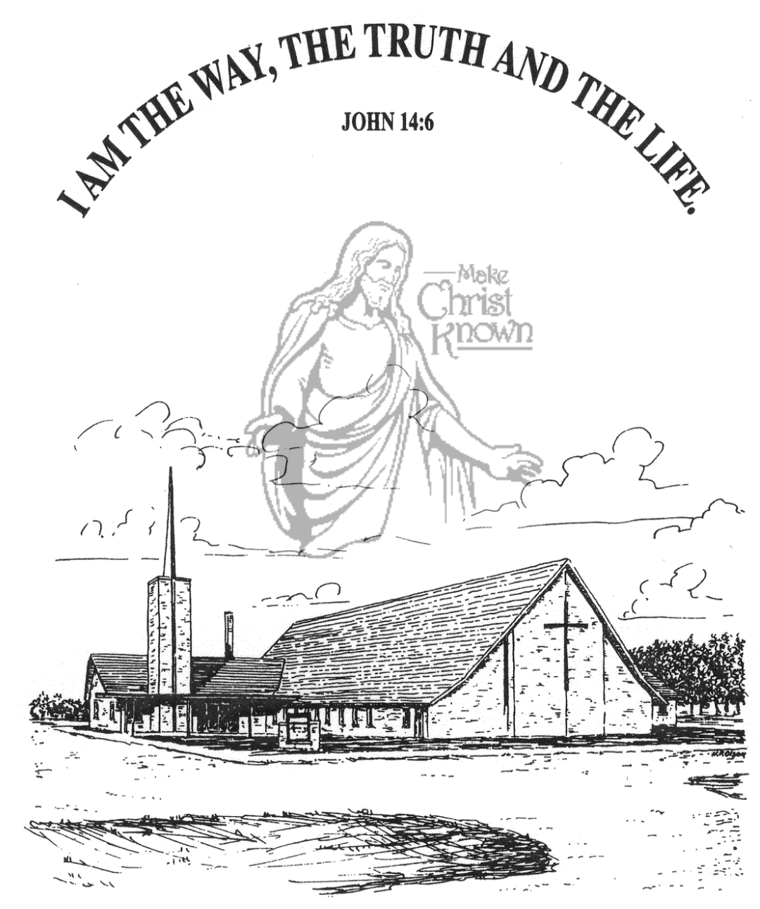

**Sunday, February 09, 2025**

**Salem Reformed Church**

**Menno, South Dakota**

..3

**Office Hours for Pastor Hecht**

Tuesday – Friday: 8:00 AM to Noon (Church Office)

Afternoons: Visitation or Church Office

Church: (605) 387-5334 Parsonage: (605) 387-2855

Pastor Mike’s Cell #: (605) 660-1803

Church Web Page: ***salemreformedchurch.com***

**Opportunities**

Greeters Today: Brian and Steph Mehlhaf

Greeters February 16th: Robert and Elaine Balogh

Sunday Prayer Time: 8:30 a.m.

Sunday School Classes: 9:15 a.m.

Praise Music: 10:15 a.m.

Worship Service: 10:30 a.m.

**Announcements**

**Welcome:** We extend a warm welcome to our visiting guests this morning. Please sign our guest book in the Narthex. We ask God’s blessing upon you and we pray that you will return and worship with us again soon.

**CE Committee Meeting:** The Christian Education Committee will plan to meet **TODAY** after church in the H.S. Classroom.

**Coffee Hour:** We are looking for 8 volunteers to bring 2 dozen goodies for Coffee Hour on Sun., Feb. 23rd. Please sign the sheet in the Narthex if you are able to help.

**Annual Report:** Church Members may pick up a copy of the Annual Report from the Information Cabinet in the Narthex.

**Family Fun Event:** This is scheduled for Sunday, March 2nd, at the Bowling Alley in Yankton @ 3:00 p.m. Bring the whole family and we’ll have a great time! Please sign the sheet in the Narthex if you are planning to attend. **NOTE:** Bowling is $4.50 per game; Shoe Rental is $3.00.

**2025 VBS Dates:** Mark your Calendars – The Dates for VBS will be May 26-30, 2025, with the Program on Sunday, June 1st. **We are looking for VBS Directors!**  **Please contact the church office if you are interested.** The VBS Kit for 2025 has already arrived and it’s time to begin making plans.

**Pastor Installation at Parkston Congregational:** Pastor Cole Pleggenkuhle will be installed as the new pastor at the Parkston Congregational Church on Sunday, February 16th at 6:00 p.m. You are welcome to attend this exciting event in the life of one of our sister churches in the CCCC!

**Sunday Offerings:** Please note that we have an Offering Box/Pulpit at the back of the Sanctuary for people to place their tithes and offerings in during our worship services.

**SALEM REFORMED CHURCH**

Menno, South Dakota

Rev. Michael Hecht Pastor

Joan Nusz Pianist

10:30 AM – Worship Service February 09, 2025

Fifth Sunday after Epiphany

**Meditation:** *“Watch out for false prophets. The come to you in sheep’s clothing, but inwardly they are ferocious wolves. By their fruit you will recognize them. Do people pick grapes from thornbushes, or figs from thistles? Likewise every good tree bears good fruit, but a bad tree bears bad fruit. A good tree cannot bear bad fruit, and a bad tree cannot bear good fruit. Every tree that does not bear good fruit is cut down and thrown into the fire. Thus, by their fruit you will recognize them. Not everyone who says to Me, ‘Lord, Lord,’ will enter the kingdom of heaven, but only he who does the will of My Father who is in heaven. Many will say to Me on that day, ‘Lord, Lord, did we not prophesy in Your Name, and in Your Name drive out demons and perform many miracles?’ Then I will tell them plainly, ‘I never knew you. Away from Me, you evildoers!’* Matthew 7:15-23 NIV

**Praise Music:** #36, #41, #60, #110, #134

**Ringing of the Bell**

**Welcome / Announcements**

**Opening Prayer**

**\*Hymn:** #21 “O For a Thousand Tongues to Sing”

**Sharing of Joys and Concerns**

**Our Time of Offering** John 13:1 NIV

**\*Doxology** sung on page #518

**\*Apostles’ Creed** see words on screen

**Kingdom Kids:** “Fans or Followers?”

**Hymn:** #354 “I Cannot Tell”

**The Holy Scriptures**

I John 2:3-11

Large Print NIV 1984 Edition, pg. 1899

**Sermon: “Walking as Jesus Walked”**

**\*Hymn:** #552 “I Am Thine, O Lord”

**\*Benediction:**

**Postlude**

(*denotes standing for those able)

The congregation will be ushered out after the Benediction

Youth Ushers: Jaxon Stoebner, Austen Soukup, Ethan McCoy