**Calendar of Events**

Dec 31 to Jan 07 Pastor Mike/Ann on Vacation

Jan 06 Men’s Christian Fellowship @ 7:00 p.m.

Jan 08 8th Grade Confirmation @ 3:30-5:15 p.m.

6/7th Grade Confirmation @ 5:20-7:00 p.m.

Consistory Meeting @ 7:00 p.m.

Jan 09 Prayer Group @ 12 Noon

Jan 12 Prayer Time for Service @ 8:30 a.m.

Sunday School Classes @ 9:15 a.m.

Praise Music @ 10:15 a.m.

Worship Service @ 10:30 a.m.

**Upcoming Special Music**

Sunday, Jan. 05 - Available

Sunday, Jan. 12 - Available

**Announcements**

**Annual Meeting:** The Annual Meeting of the Congregation is scheduled for Sunday, January 26, 2025 at 12:45 p.m. The snow date is set for Sun., Feb. 2nd at the same time.

**Annual Reports:** If you are responsible for completing a report for our Annual Meeting, please have it turned into the church office by Friday, January 10, 2025. You may also email your report to the office at: ***salemref2@goldenwest.net***

**Youth Trip to Great Bear:** The Heidelberg League and Confirmation will be tubing at Great Bear in Sioux Falls on Sunday, January 12. We plan to leave right after church. Parents must go onto the Great Bear link that was sent out to complete the waiver and “purchase a ticket”. This must be done by January 9. If you have any questions please contact Julie Crick.

**Women of the Church Business Meeting:** The W.O.C. Annual Business Meeting will be held after church, Sun., Jan. 19th.

**Coffee Hour:** We are looking for 4 volunteers to bring 2 dozen goodies for Coffee Hour on Sunday, January 19th. Please sign the sheet in the Narthex if you are able to help.

**Pastor’s Vacation:** Pastor Mike/Ann will be on Vacation from December 31st through January 7th. Please contact the church office or one of the Consistory Members for special needs.

**Salem Reformed Church – Who Are We?**

**We believe the Bible to be the inspired, inerrant, infallible Word of God in its original manuscripts. It is our supreme authority in all matters doctrine and practice. We are affiliated with the Conservative Congregational Christian Conference.**

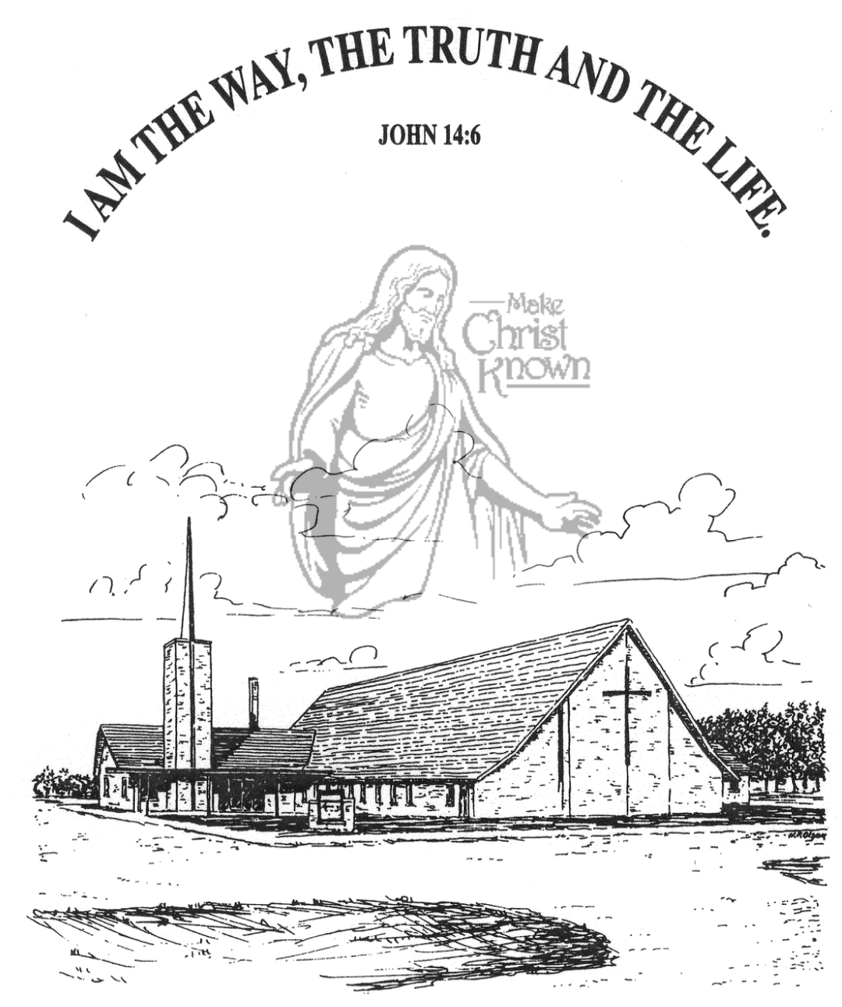

**Sunday, January 05, 2025**

**Salem Reformed Church**

**Menno, South Dakota**

..3

**Office Hours for Pastor Hecht**

Tuesday – Friday: 8:00 AM to Noon (Church Office)

Afternoons: Visitation or Church Office

Church: (605) 387-5334 Parsonage: (605) 387-2855

Pastor Mike’s Cell #: (605) 660-1803

Church Web Page: ***salemreformedchurch.com***

**Opportunities**

Greeters Today: Brian & Jessica Goehring

Greeters January 12th:

Sunday Prayer Time: 8:30 a.m.

Sunday School Classes: 9:15 a.m.

Praise Music: 10:15 a.m.

Worship Service: 10:30 a.m.

**Announcements**

**Welcome:** We extend a warm welcome to our visiting guests this morning. Please sign our guest book in the Narthex. We ask God’s blessing upon you and we pray that you will return and worship with us again soon.

**Special Welcome:** We extend a special welcome to Rachel Jones, from Zoe Care in Yankton, SD. Our offering received today will be for the ministry of Zoe Care.

**Poinsettias:** Special Thanks to all who have shared poinsettias and flowers with us in Memory of Loved Ones. You may take your plant home today if you desire to do so.

**Christmas Eve Offering:** The offering received on Christmas Eve was $6,696.00. The Abbott House received $3,348.00; Swan Lake Christian Camp received $2,008.80; and Healing Hope Ministries received $1,339.20. We praise the Lord for such generous giving to these ministries!

**Christmas Day Offering:** The offering received on Christmas Day was $4,380.00, and was given to the M/O Care Center to assist with on-going needs and upgrades as determined by the Board of Directors and the Administration.

**Women of the Church**: The Women of the Church are in charge of the afternoon program at M/OCC on Tues, Jan. 21 at 2:00 pm. We are in need of someone to coordinate the program and ladies to help. Sign-up sheets are posted in the narthex.

**Legion Baseball Spaghetti Meal:** This Fundraising Meal will be at the Menno Gym **TODAY,** from 10:30 to 1:00 p.m. Free will donations are accepted. Sponsored by Legion Post 152 members and baseball players.

**Sunday Offerings:** Please note that we have an Offering Box/Pulpit at the back of the Sanctuary for people to place their tithes and offerings in during our worship services.

**SALEM REFORMED CHURCH**

Menno, South Dakota

Rev. Michael Hecht Pastor

Cindy Herrboldt Organist

10:30 AM – Worship Service January 05, 2025

Sanctity of Human Life Sunday

**Meditation:** *“These six things the LORD hates; indeed, seven are repulsive to Him: A proud look [the attitude that makes one overestimate oneself and discount others], a lying tongue, and hands that shed innocent blood, a heart that creates wicked plans, feet that run swiftly to evil, a false witness who breathes out lies [even half-truths], and one who spreads discord (rumors) among brothers. My son, be guided by your father’s [God-given] commandment (instruction) and do not reject the teaching of your mother; bind them continually upon your heart (in your thoughts), and tie them around your neck.”*

Proverbs 6:16-21 AMP

**Praise Music:** #31, #18, #19, #45, #12, #32

**Ringing of the Bell**

**Welcome / Announcements / Opening Prayer**

**\*Hymn:** #3 “Holy, Holy, Holy! Lord God Almighty”

**Sharing of Joys and Concerns**

**Our Time of Offering** Jeremiah 1:4,5 NIV

**\*Doxology** sung on page #815

**\*Lord’s Prayer** debts and debtors

**Kingdom Kids:** by Rachel Jones

**Hymn:** #447 “Jesus Loves the Little Children”

**The Holy Scriptures**

Ephesians 3:20

Large Print NIV 1984 Edition, pg. 1820

**Sermon: “ The Sanctity of Human Life ”**

Shared by Rachel Jones, Zoe Care

**\*Hymn:** #406 “Wonderful Words of Life”

**\*Benediction:**

**\*Prayer for Our Nation:** “God Bless America”

**Postlude** (*denotes standing for those able)

The congregation will be ushered out after the Benediction

Youth Ushers: Michael Nusz, Eli Soukup, Rylan Derby