**Calendar of Events**

Jan 26 **Annual Meeting of the Congregation @ 12:45 p.m.**

Jan 28 Search Committee Meeting @ 3:30 p.m.

Jan 29 Women’s Bible Study @ 9:30 a.m. & 6:00 p.m.

8th Grade Confirmation @ 3:30-5:15 p.m.

6/7th Grade Confirmation @ 5:20-7:00 p.m.

FCA at Menno Gym @ 7:30 p.m.

Jan 30 Prayer Group @ 12 Noon

Feb 02 Prayer Time for Service @ 8:30 a.m.

Sunday School Classes @ 9:15 a.m.

Praise Music @ 10:15 a.m.

Worship Service @ 10:30 a.m.

**w/Holy Communion**

High School Youth Group @ 11:45 a.m.

8th Grade Parent Meeting @ 11:45 a.m.

Feb 03 Men’s Christian Fellowship @ 7:00 p.m.

**Upcoming Special Music**

Sunday, Feb. 02 - Holy Communion

Sunday, Feb. 09 - Available

**Announcements**

**High School Youth:** The High School Youth will plan to meet after church next Sunday, February 2nd. Lunch is provided!

**Search Committee Meeting:** The Search Committee for the Assistant Pastor position will plan to meet on Tuesday, Jan. 28th @ 3:30 p.m.

**CE Committee Meeting:** The Christian Education Committee will plan to meet after church on Sunday, February 9th.

**Women’s Bible Study:** “Heaven” by Jennifer Rothschild. This is a 7-Session Video based study that explores the subject of Heaven from a Biblical perspective. Please sign the sheet in the Narthex if you would like to attend either on Wed. @ 6 PM, or Sunday @ 9:15 AM. Also, please indicate if you would like to order a workbook or not on the sheet. These studies began on Wed. PM, Jan. 22nd and Sunday morning, Jan. 26th.

**Wed. AM Women’s Bible Study:** This group is doing a book study called, “Twelve Extraordinary Women” by John MacArthur. They meet on Wed. mornings at 9:30 a.m.

**Special Thanks:** Special Thanks to Jane & Gary Gramkow for placing the flowers in the Sanctuary during January!

**Salem Reformed Church – Who Are We?**

**We believe the Bible to be the inspired, inerrant, infallible Word of God in its original manuscripts. It is our supreme authority in all matters doctrine and practice. We are affiliated with the Conservative Congregational Christian Conference.**

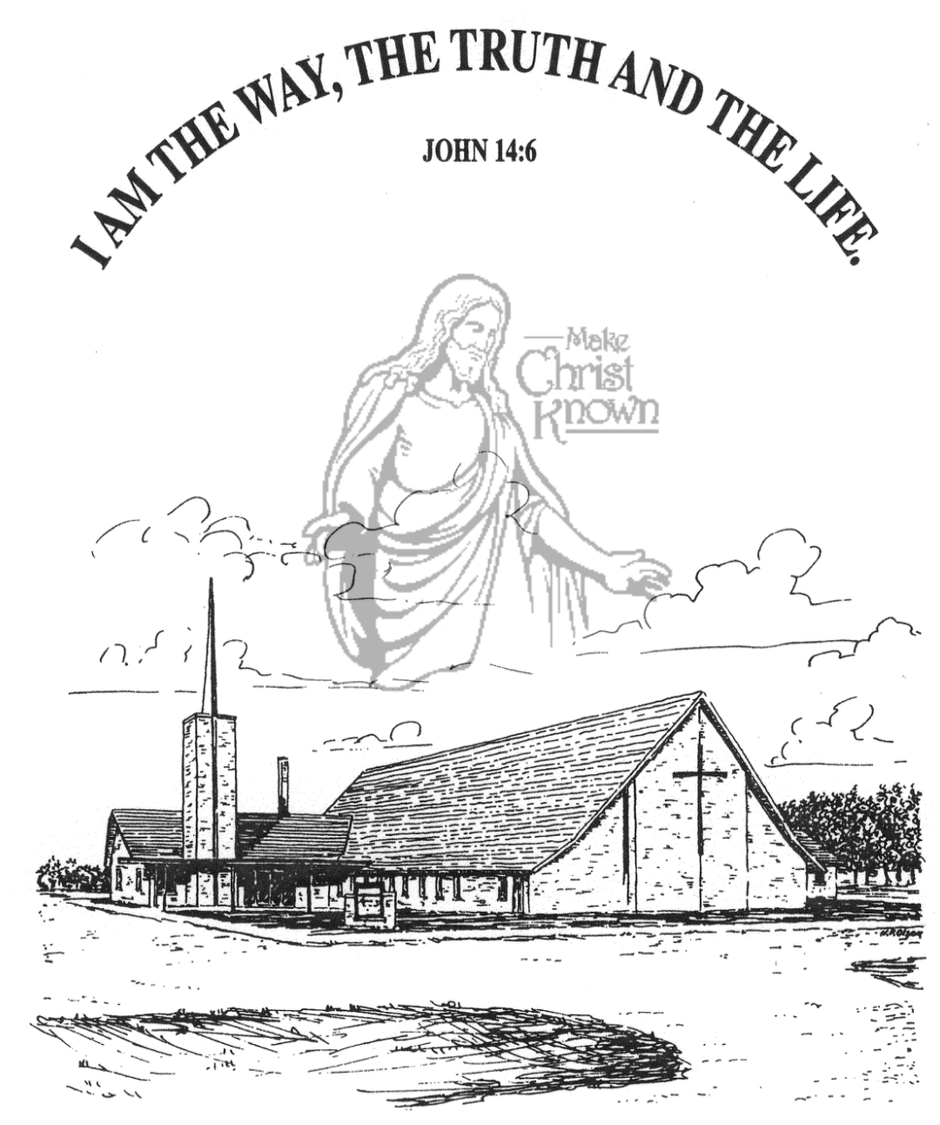

**Sunday, January 26, 2025**

**Salem Reformed Church**

**Menno, South Dakota**

..3

**Office Hours for Pastor Hecht**

Tuesday – Friday: 8:00 AM to Noon (Church Office)

Afternoons: Visitation or Church Office

Church: (605) 387-5334 Parsonage: (605) 387-2855

Pastor Mike’s Cell #: (605) 660-1803

Church Web Page: ***salemreformedchurch.com***

**Opportunities**

Greeters Today: Jim and Donna Sattler

Greeters February 2nd: Jerry and Joan Nusz

Sunday Prayer Time: 8:30 a.m.

Sunday School Classes: 9:15 a.m.

Praise Music: 10:15 a.m.

Worship Service: 10:30 a.m.

**Announcements**

**Welcome:** We extend a warm welcome to our visiting guests this morning. Please sign our guest book in the Narthex. We ask God’s blessing upon you and we pray that you will return and worship with us again soon.

**8th Grade Parent Meeting:** Pastor Mike would like to meet with the Parents of the 8th Grade Confirmation Students after church on Sunday, February 2nd.

**Annual Meeting:** The Annual Meeting of the Congregation is TODAY at 12:45 p.m. *The Women of the Church will host a lunch for the congregation immediately following our worship service. Everyone is welcome to stay and enjoy the lunch, and you are also encouraged to stay for the Annual Meeting.

**Nominations to Consistory:** The Consistory has voted to nominate the following individuals for office:

Tim Freier Elder 2nd Term

Ron Schaeffer Elder 2nd Term

Daniel Schaeffer Deacon 2nd Term

Ryan Wielenga Deacon 1st Term

Also to be voted on are the positions for the CE Committee:

Kevin Holzwarth S.S. Superintendent

Katie Huber Assistant S.S. Superintendent

The Consistory would like to remind the voting membership that they may bring nominations from the floor at the Annual Meeting. We are thankful for the many volunteers who work so hard in the life of this local church throughout the year!

**Sunday Offerings:** Please note that we have an Offering Box/Pulpit at the back of the Sanctuary for people to place their tithes and offerings in during our worship services.

**SALEM REFORMED CHURCH**

Menno, South Dakota

Rev. Michael Hecht Pastor

Cindy Herrboldt Organist

10:30 AM – Worship Service January 26, 2025

Third Sunday after Epiphany

**Meditation:** *“For we know that our old self was crucified with Him so that the body of sin might be done away with, that we should no longer be slaves to sin – because anyone who has died has been freed from sin. Now if we died with Christ, we believe that we will also live with Him. For we know that since Christ was raised from the dead, He cannot die again; death no longer has mastery over Him. The death He died, He died to sin once for all; but the life He lives, He lives to God. In the same way, count yourselves dead to sin but alive to God in Christ Jesus. Therefore do not let sin reign in your mortal body so that you obey its evil desires. . . . For sin shall not be your master, because you are not under law, but under grace.”*  Romans 6:6-12, 14 NIV

**Praise Music:** #57, #59, #19, #18, #45, #12

**Ringing of the Bell**

**Welcome / Announcements**

**Opening Prayer**

**\*Hymn:** #90 “Joyful, Joyful, We Adore Thee”

**Sharing of Joys and Concerns**

**Our Time of Offering** Romans 3:23,24 NIV

**\*Doxology** sung on page #518

**\*Apostles’ Creed** see words on screen

**Kingdom Kids:** “Dirty Shoes“

**Hymn:** #83 “There’s Something About That Name”

**The Holy Scriptures**

I John 1:5-2:2

Large Print NIV 1984 Edition, pg. 1898

**Sermon: “All Have Sinned”**

**\*Hymn:** #56 “To God Be the Glory”

**\*Benediction:**

**\*Prayer for Our Nation:** “God Bless America”

**Postlude**

(*denotes standing for those able)

The congregation will be ushered out after the Benediction

Youth Ushers: Michael Nusz, Eli Soukup, Rylan Derby