**Calendar of Events**

Jan 19 M/O Care Center Service @ 2:00 p.m.

Jan 20 Men’s Christian Fellowship @ 7:00 p.m.

Jan 21 W.O.C. Program at M/OCC @ 2:00 p.m.

Jan 22 Women’s Bible Study @ 9:30 a.m. & 6:00 p.m.

8th Grade Confirmation @ 3:30-5:15 p.m.

6/7th Grade Confirmation @ 5:20-7:00 p.m.

Jan 23 Prayer Group @ 12 Noon

Jan 26 Prayer Time for Service @ 8:30 a.m.

Sunday School Classes @ 9:15 a.m.

Praise Music @ 10:15 a.m.

Worship Service @ 10:30 a.m.

w/Lunch for the Congregation Following!

**Annual Meeting of the Congregation @ 12:45 p.m.**

**Upcoming Special Music**

Sunday, Jan. 26 - Available

Sunday, Feb. 02 - Holy Communion

**Announcements**

**Annual Meeting:** The Annual Meeting of the Congregation is scheduled for Sunday, January 26, 2025 at 12:45 p.m. The snow date is set for Sun., Feb. 2nd at the same time. *The Women of the Church will host a lunch for the congregation immediately following our worship service on the day of the Annual Meeting. Everyone is welcome to stay and enjoy the lunch, and you are also encouraged to stay for the Annual Meeting.

**Nominations to Consistory:** The Consistory has voted to nominate the following individuals for office:

Tim Freier Elder 2nd Term

Ron Schaeffer Elder 2nd Term

Daniel Schaeffer Deacon 2nd Term

Ryan Wielenga Deacon 1st Term

Also to be voted on are the positions for the CE Committee:

Kevin Holzwarth S.S. Superintendent

Katie Huber Assistant S.S. Superintendent

The Consistory would like to remind the voting membership that they may bring nominations from the floor at the Annual Meeting.

We are thankful for the many volunteers who work so hard in the life of this local church throughout the year!

**Salem Reformed Church – Who Are We?**

**We believe the Bible to be the inspired, inerrant, infallible Word of God in its original manuscripts. It is our supreme authority in all matters doctrine and practice. We are affiliated with the Conservative Congregational Christian Conference.**

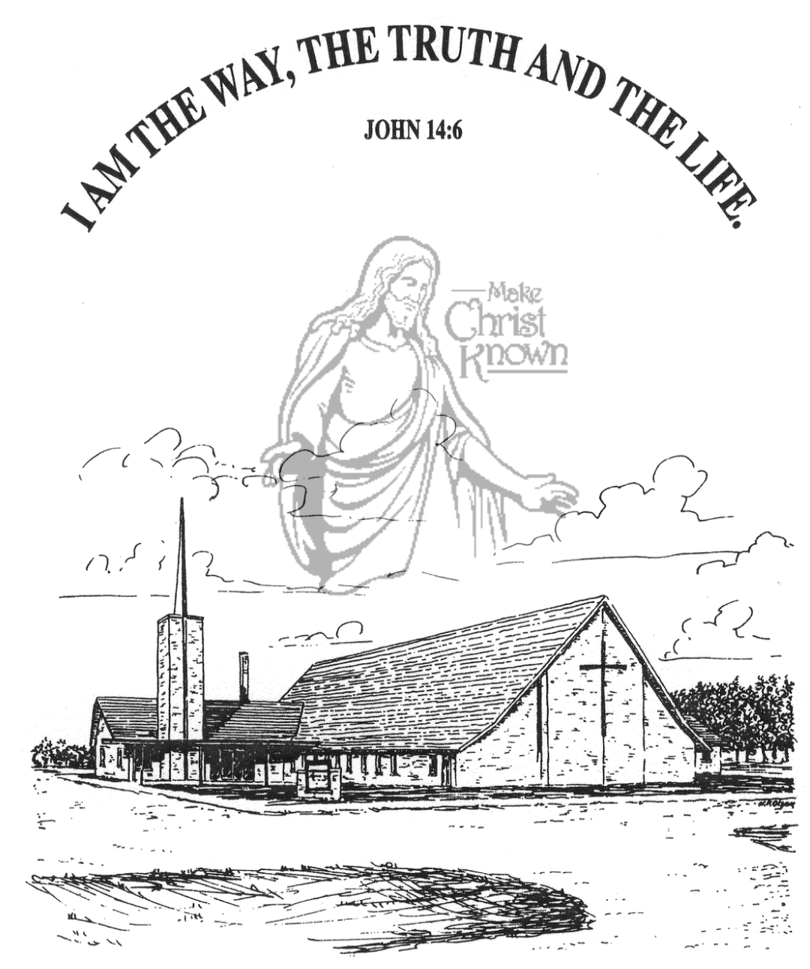

**Sunday, January 19, 2025**

**Salem Reformed Church**

**Menno, South Dakota**

..3

**Office Hours for Pastor Hecht**

Tuesday – Friday: 8:00 AM to Noon (Church Office)

Afternoons: Visitation or Church Office

Church: (605) 387-5334 Parsonage: (605) 387-2855

Pastor Mike’s Cell #: (605) 660-1803

Church Web Page: ***salemreformedchurch.com***

**Opportunities**

Greeters Today: Robert and Elaine Balogh

Greeters January 26th: Jim and Donna Sattler

Sunday Prayer Time: 8:30 a.m.

Sunday School Classes: 9:15 a.m.

Praise Music: 10:15 a.m.

Worship Service: 10:30 a.m.

**Announcements**

**Welcome:** We extend a warm welcome to our visiting guests this morning. Please sign our guest book in the Narthex. We ask God’s blessing upon you and we pray that you will return and worship with us again soon.

**Women of the Church Business Meeting:** The W.O.C. Annual Business Meeting will be held after church TODAY in the High School Class Room.

**Coffee Hour:** Please join us TODAY after church in the Social Hall for a time of fellowship, while enjoying coffee and desserts. Special Thanks to Allen and Carrie Dyk for coordinating this event throughout the year!

**Zoe Care Offering:** The offering received on Jan. 5th, for Zoe Care Ministries, Yankton, SD, was $5,638.00! Thank you for giving to the Lord and supporting this ministry. Their mission statement is simple: *“Leading women to Choose Life and Choose Christ!”* This is a matter of LIFE or Death! John 10:10

**Women of the Church**: The W.O.C. are in charge of the afternoon program at M/OCC on Tues, Jan. 21 at 2:00 pm. Ladies and Men are welcome to come and help. Please sign the sheet in the Narthex if you are able to attend.

**8th Grade Parent Meeting:** Pastor Mike would like to meet with the Parents of the 8th Grade Confirmation Students after church on Sunday, February 2nd.

**CE Committee Meeting:** The Christian Education Committee will plan to meet after church on Sunday, February 9th.

**Sunday Offerings:** Please note that we have an Offering Box/Pulpit at the back of the Sanctuary for people to place their tithes and offerings in during our worship services.

**SALEM REFORMED CHURCH**

Menno, South Dakota

Rev. Michael Hecht Pastor

Sharyl Herrboldt Pianist

10:30 AM – Worship Service January 19, 2025

Second Sunday after Epiphany

**Meditation:** *“Remember your leaders, who spoke the Word of God to you. Consider the outcome of their way of life and imitate their faith. Jesus Christ is the same yesterday and today and forever. Do not be carried away by all kinds of strange teachings. It is good for our hearts to be strengthened by grace, not by ceremonial foods, which are of no value to those who eat them. We have an altar from which those who minister at the tabernacle have no right to eat. . . Through Jesus, therefore, let us continually offer to God a sacrifice of praise – the fruit of lips that confess His Name. And do not forget to do good and to share with others, for with such sacrifices God is pleased.”*

Hebrews 13:7-10, 15,16 NIV

**Praise Music:** #1, #5, #52, #49, #144

**Ringing of the Bell**

**Welcome / Announcements**

**Opening Prayer**

**\*Hymn:** #572 “Blessed Assurance”

**Sharing of Joys and Concerns**

**Our Time of Offering** I Corinthians 1:8,9 NIV

**\*Doxology** sung on page #518

**\*Lord’s Prayer** debts and debtors

**Kingdom Kids:** “Jesus is the Real Thing!“

**Hymn:** #630 “What a Friend We Have in Jesus”

**The Holy Scriptures**

I John 1:1-4

Large Print NIV 1984 Edition, pg. 1898

**Sermon: “The Word of Life”**

**\*Hymn:** #575 “Leaning on the Everlasting Arms”

**\*Benediction:**

**\*Prayer for Our Nation:** “God Bless America”

**Postlude**

(*denotes standing for those able)

The congregation will be ushered out after the Benediction

Youth Ushers: Michael Nusz, Eli Soukup, Rylan Derby