**Calendar of Events**

Jan 15 4-O’s Women at Roosters @ 11:30 a.m.

8th Grade Confirmation @ 3:30-5:15 p.m.

6/7th Grade Confirmation @ 5:20-7:00 p.m.

FCA at Menno Gym @ 7:30 p.m.

Jan 16 Prayer Group @ 12 Noon

Search Committee Meeting @ 7:00 p.m.

Jan 19 Prayer Time for Service @ 8:30 a.m.

Sunday School Classes @ 9:15 a.m.

Praise Music @ 10:15 a.m.

Worship Service @ 10:30 a.m.

W.O.C. Meeting @ 11:45 a.m.

M/O Care Center Service @ 2:00 p.m.

**Upcoming Special Music**

Sunday, Jan. 12 - Available

Sunday, Jan. 19 - Available

**Announcements**

**Annual Meeting:** The Annual Meeting of the Congregation is scheduled for Sunday, January 26, 2025 at 12:45 p.m. The snow date is set for Sun., Feb. 2nd at the same time. *The Women of the Church will host a lunch for the congregation immediately following our worship service on the day of the Annual Meeting. Everyone is welcome to stay and enjoy the lunch, and your are also encouraged to stay for the Annual Meeting.

**Nominations to Consistory:** The Consistory has voted to nominate the following individuals for office:

Tim Freier Elder 2nd Term

Ron Schaeffer Elder 2nd Term

Daniel Schaeffer Deacon 2nd Term

Ryan Wielenga Deacon 1st Term

Also to be voted on are the positions for the CE Committee:

Kevin Holzwarth S.S. Superintendent

Katie Huber Assistant S.S. Superintendent

The Consistory would like to remind the voting membership that they may bring nominations from the floor at the Annual Meeting.

We are thankful for the many volunteers who work so hard in the life of this local church throughout the year!

**Poinsettias:** Special Thanks to all who have shared poinsettias and flowers with us in Memory of Loved Ones. You may take your plant home today if you desire to do so.

**Salem Reformed Church – Who Are We?**

**We believe the Bible to be the inspired, inerrant, infallible Word of God in its original manuscripts. It is our supreme authority in all matters doctrine and practice. We are affiliated with the Conservative Congregational Christian Conference.**

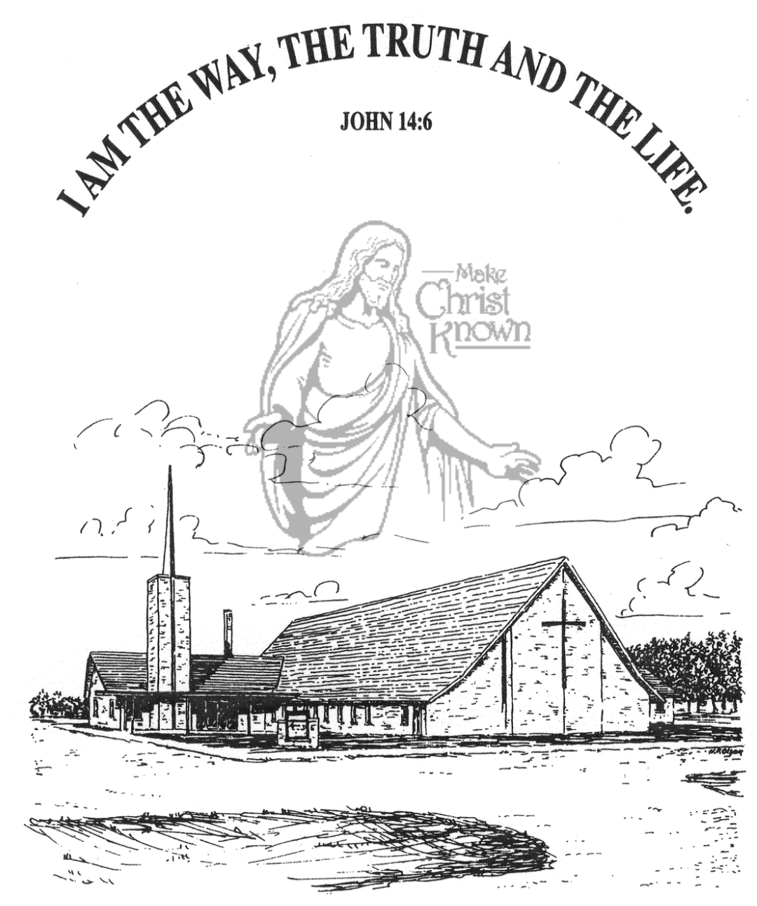

**Sunday, January 12, 2025**

**Salem Reformed Church**

**Menno, South Dakota**

..3

**Office Hours for Pastor Hecht**

Tuesday – Friday: 8:00 AM to Noon (Church Office)

Afternoons: Visitation or Church Office

Church: (605) 387-5334 Parsonage: (605) 387-2855

Pastor Mike’s Cell #: (605) 660-1803

Church Web Page: ***salemreformedchurch.com***

**Opportunities**

Greeters Today: Mike and Stephanie Wagner

Greeters January 19th: Robert and Elaine Balogh

Sunday Prayer Time: 8:30 a.m.

Sunday School Classes: 9:15 a.m.

Praise Music: 10:15 a.m.

Worship Service: 10:30 a.m.

**Announcements**

**Welcome:** We extend a warm welcome to our visiting guests this morning. Please sign our guest book in the Narthex. We ask God’s blessing upon you and we pray that you will return and worship with us again soon.

**Women of the Church Business Meeting:** The W.O.C. Annual Business Meeting will be held after church, Sun., Jan. 19th.

**Coffee Hour:** We are looking for 4 volunteers to bring 2 dozen goodies for Coffee Hour on Sunday, January 19th. Please sign the sheet in the Narthex if you are able to help.

**Zoe Care Offering:** The offering received last Sunday for Zoe Care Ministries, Yankton, SD, was $5,388.00! Thank you for giving to the Lord and supporting this ministry. Their mission statement is simple: *“Leading women to Choose Life and Choose Christ!”* This is a matter of LIFE or Death! John 10:10

**Women of the Church**: The W.O.C. are in charge of the afternoon program at M/OCC on Tues, Jan. 21 at 2:00 pm. We need volunteers, women or men, to help. Sign-up sheets are posted in the narthex.

**Youth Trip to Great Bear:** The Heidelberg League and Confirmation will be tubing at Great Bear in Sioux Falls **TODAY!** We plan to leave right after church, have lunch at Pizza Ranch in Tea, and then go on to Great Bear. We should be home near 6 p.m. this evening.

**4-O’s Women:** The 4-O’s Women’s Group will plan to gather at Roosters at 11:30 a.m. for lunch on Wed., Jan. 15th. Please sign the sheet in the Narthex if you plan to attend.

**Sunday Offerings:** Please note that we have an Offering Box/Pulpit at the back of the Sanctuary for people to place their tithes and offerings in during our worship services.

**SALEM REFORMED CHURCH**

Menno, South Dakota

Rev. Michael Hecht Pastor

Jennifer Herrboldt Pianist

10:30 AM – Worship Service January 12, 2025

First Sunday after Epiphany

**Meditation:** *“Since, then, we know what it is to fear the Lord, we try to persuade men. What we are is plain to God, and I hope it is also plain to your conscience. We are not trying to commend ourselves to you again, but are giving you an opportunity to take pride in us, so that you can answer those who take pride in what is seen rather than in what is in the heart. If we are out of our mind, it is for the sake of God; if we are in our right mind, it is for you. For Christ’s love compels us, because we are convinced that one died for all, and therefore all died. And He died for all, that those who live should no longer live for themselves but for Him who died for them and was raised again.”*

II Corinthians 5:11-15 NIV

**Praise Music:** #70, #82, #91, #140

**Ringing of the Bell**

**Welcome / Announcements**

**Opening Prayer**

**\*Hymn:** #43 “All Hail the Power of Jesus Name”

**Sharing of Joys and Concerns**

**Our Time of Offering** I Corinthians 3:16,17 NIV

**\*Lord’s Prayer** sung on page #631

**\*Apostles’ Creed** words on screen

**Kingdom Kids:** “Jesus – Our Life Savior!“

**Hymn:** #520 “The Longer I Serve Him”

**The Holy Scriptures**

II Corinthians 5:16-6:2

Large Print NIV 1984 Edition, pg. 1799

**Sermon: “Ambassadors For Christ”**

**\*Hymn:** #358 “Because He Lives”

**\*Benediction:**

**\*Prayer for Our Nation:** “God Bless America”

**Postlude**

(*denotes standing for those able)

The congregation will be ushered out after the Benediction

Youth Ushers: Michael Nusz, Eli Soukup, Rylan Derby