**Calendar of Events**

Dec 31 to Jan 07 Pastor Mike/Ann on Vacation

Jan 05 Prayer Time for Service @ 8:30 a.m.

Sunday School Classes @ 9:15 a.m.

Praise Music @ 10:15 a.m.

Worship Service @ 10:30 a.m.

with Rachel Jones from Zoe Care, Yankton

Jan 06 Men’s Christian Fellowship @ 7:00 p.m.

Jan 08 8th Grade Confirmation @ 3:30-5:15 p.m.

6/7th Grade Confirmation @ 5:20-7:00 p.m.

Consistory Meeting @ 7:00 p.m.

Jan 09 Prayer Group @ 12 Noon

**Upcoming Special Music**

Sunday, Jan. 05 - Available

Sunday, Jan. 12 - Available

**Announcements**

**Sanctity of Human Life Sunday:** Rachel Jones, from Zoe Care in Yankton will be sharing on Sun., January 5th, with the Elders assisting with other parts of the worship service. The Offering received on January 5th will be given to Zoe Care for their Pro-Life Ministry in South Eastern South Dakota!

**Annual Meeting:** The Annual Meeting of the Congregation is scheduled for Sunday, January 26, 2025 at 12:45 p.m. The snow date is set for Sun., Feb. 2nd at the same time.

**Annual Reports:** If you are responsible for completing a report for our Annual Meeting, please have it turned into the church office by Friday, January 10, 2025. You may also email your report to the office at: ***salemref2@goldenwest.net***

**Youth Trip to Great Bear:** We are planning a trip to Great Bear for Tubing on Sunday, January 12th after church. This will be for the Confirmation Classes and the High School Youth. More details will be coming!

**Women of the Church Business Meeting:** The W.O.C. Annual Business Meeting will be held after church, Sun., Jan. 19th.

**Coffee Hour:** We are looking for 7 volunteers to bring 2 dozen goodies for Coffee Hour on Sunday, January 19th. Please sign the sheet in the Narthex if you are able to help.

**Pastor’s Vacation:** Pastor Mike/Ann will be on Vacation from December 31st through January 7th. Please contact the church office or one of the Consistory Members for special needs.

**Salem Reformed Church – Who Are We?**

**We believe the Bible to be the inspired, inerrant, infallible Word of God in its original manuscripts. It is our supreme authority in all matters doctrine and practice. We are affiliated with the Conservative Congregational Christian Conference.**

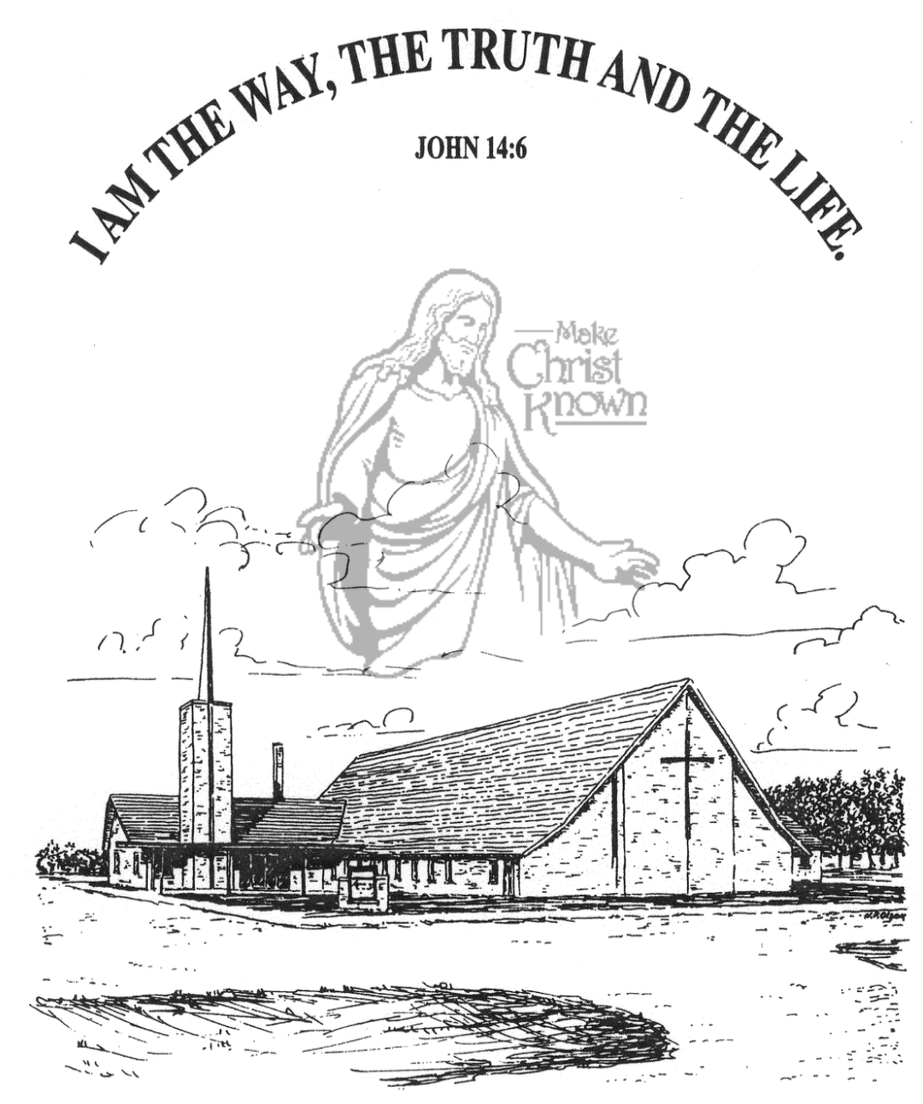

**Sunday, December 29, 2024**

**Salem Reformed Church**

**Menno, South Dakota**

..3

**Office Hours for Pastor Hecht**

Tuesday – Friday: 8:00 AM to Noon (Church Office)

Afternoons: Visitation or Church Office

Church: (605) 387-5334 Parsonage: (605) 387-2855

Pastor Mike’s Cell #: (605) 660-1803

Church Web Page: ***salemreformedchurch.com***

**Opportunities**

Greeters Today: David and Jennifer Herrboldt

Greeters January 5th:

Sunday Prayer Time: 8:30 a.m.

Sunday School Classes: 9:15 a.m.

Praise Music: 10:15 a.m.

Worship Service: 10:30 a.m.

**Announcements**

**Welcome:** We extend a warm welcome to our visiting guests this morning. Please sign our guest book in the Narthex. We ask God’s blessing upon you and we pray that you will return and worship with us again soon.

**Sunday School Classes:** Sunday School Classes will **RESUME** next Sun., January 5th at the regular time of 9:15 a.m.

**Taking Down of the Greens:** The CE Committee will be taking down the Christmas Tree and Greens TODAY after our worship service. Others are welcome to help!

**Poinsettias:** Special Thanks to all who have shared poinsettias and flowers with us in Memory of Loved Ones. You may take your plant home today if you desire to do so.

**Christmas Eve Offering:** The offering received on Christmas Eve was $6,696.00. The Abbott House received $3,348.00; Swan Lake Christian Camp received $2,008.80; and Healing Hope Ministries received $1,339.20. We praise the Lord for such generous giving to these ministries!

**Christmas Day Offering:** The offering received on Christmas Day was $4,380.00, and was given to the M/O Care Center to assist with on-going needs and upgrades as determined by the Board of Directors and the Administration.

**Legion Baseball Spaghetti Meal:** This Fundraising Meal will be at the Menno Gym on Sunday, January 5th at the Menno Old Gym from 10:30 to 1:00 p.m. Free will donations are accepted. Sponsored by Legion Post 152 members and baseball players.

**Special Thanks:** Big Thanks to Jennifer Herrboldt for taking care of the poinsettias during the Advent/Christmas Season!

**Sunday Offerings:** Please note that we have an Offering Box/Pulpit at the back of the Sanctuary for people to place their tithes and offerings in during our worship services.

**SALEM REFORMED CHURCH**

Menno, South Dakota

Rev. Michael Hecht Pastor

Joan Nusz Pianist

10:30 AM – Worship Service December 29, 2024

First Sunday after Christmas

**Meditation:** *“After Jesus was born in Bethlehem in Judea, during the time of King Herod, Magi from the east came to Jerusalem and asked, ‘Where is the One who has been born King of the Jews? We saw His star in the east and have come to worship Him. When King Herod heard this he was disturbed, and all Jerusalem with him. When he had called together all the people’s chief priests and teachers of the law, he asked them where the Christ was to be born.*

Matthew 2:1-4 NIV

*“On coming to the house, they saw the child with His mother Mary, and they bowed down and worshiped Him. Then they opened their treasures and presented Him with gifts of gold and of incense and of myrrh. And having been warned in a dream not to go back to Herod, they returned to their country by another route.”* Matthew 2:11,12 NIV

**Prelude Music:**  Joan Nusz

**Ringing of the Bell**

**Welcome / Announcements / Opening Prayer**

**\*Hymn:** #288 “We Three Kings”

**Sharing of Joys and Concerns**

**Our Time of Offering** John 1:18 NIV

**\*Doxology** sung on page #815

**\*Apostles’ Creed** see words on screen

**Kingdom Kids:** “Crown Him King”

**Hymn:** #284 “The Birthday of a King”

**The Holy Scriptures**

John 18:36-40

Large Print NIV 1984 Edition, pg. 1683

**Sermon: “Born to Be King”**

**\*Hymn:** #762 “What a Day That Will Be”

#763 “The King Is Coming!”

**\*Benediction:**

**Postlude** (*denotes standing for those able)

The congregation will be ushered out after the Benediction

Youth Ushers: Bryce Sattler, Brockton Kocourek, Carter Fischer