**Calendar of Events**

Dec 24 Christmas Eve Program @ 7:00 p.m.

Dec 25 Christmas Day Worship @ 10:00 a.m.

Dec 29 Prayer Time for Service @ 9:30 a.m.

No Sunday School Classes Today

Prelude Music @ 10:15 a.m.

Worship Service @ 10:30 a.m.

Dec 31 to Jan 07 Pastor Mike/Ann on Vacation

Jan 05 Prayer Time for Service @ 8:30 a.m.

Sunday School Classes @ 9:15 a.m.

Praise Music @ 10:15 a.m.

Worship Service @ 10:30 a.m.

Jan 06 Men’s Christian Fellowship @ 7:00 p.m.

Jan 08 8th Grade Confirmation @ 3:30-5:15 p.m.

6/7th Grade Confirmation @ 5:20-7:00 p.m.

Consistory Meeting @ 7:00 p.m.

**Upcoming Special Music**

Wednesday, Dec. 25 - Available

Sunday, Dec. 29 - Available

**Announcements**

**Special Thanks:** Thanks to Chandra van Zyl, Katie Huber, Stephanie Wagner, and Jenna Miller for coordinating and serving the lunches for the Christmas Program Practices!

**Annual Reports:** If you are responsible for completing a report for our Annual Meeting, please have it turned into the church office by Friday, January 10, 2025. You may also email your report to the office at: ***salemref2@goldenwest.net***

**M/OCC Bingo:** The Care Center is looking for volunteers to help with Friday Bingo during December. Please sign the sheet in the Narthex if you are able to help.

**Youth Trip to Great Bear:** We are planning a trip to Great Bear for Tubing on Sunday, January 12th after church. This will be for the Confirmation Classes and the High School Youth. More details will be coming!

**Women of the Church Business Meeting:** The W.O.C. Annual Business Meeting will be held after church, Sun., Jan. 19th.

**Christmas Eve Program @ 7 PM**

**Christmas Day Worship @ 10 AM**

**Salem Reformed Church – Who Are We?**

**We believe the Bible to be the inspired, inerrant, infallible Word of God in its original manuscripts. It is our supreme authority in all matters doctrine and practice. We are affiliated with the Conservative Congregational Christian Conference.**

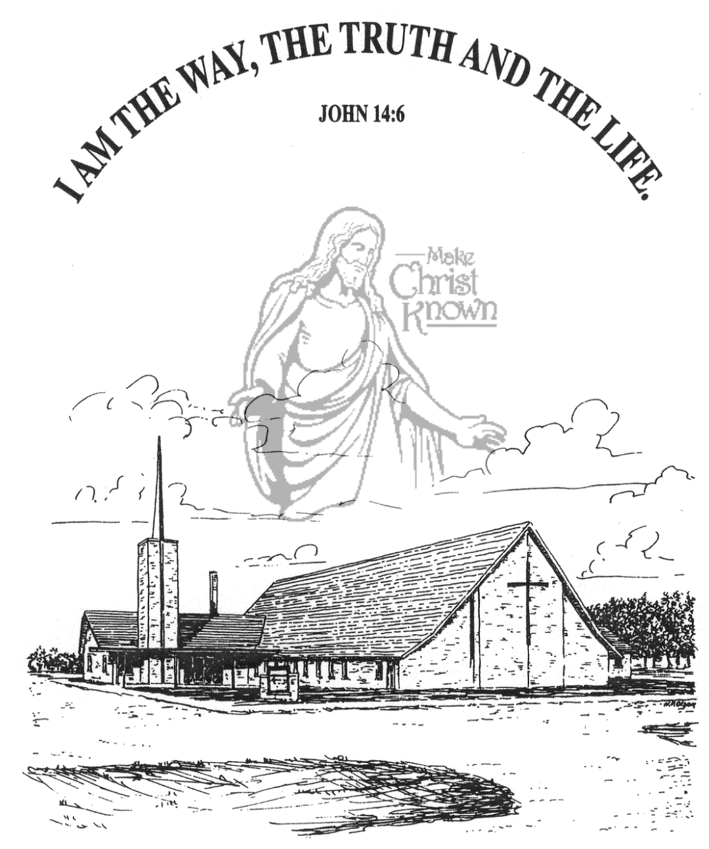

**Sunday, December 22, 2024**

**Salem Reformed Church**

**Menno, South Dakota**

..3

**Office Hours for Pastor Hecht**

Tuesday – Friday: 8:00 AM to Noon (Church Office)

Afternoons: Visitation or Church Office

Church: (605) 387-5334 Parsonage: (605) 387-2855

Pastor Mike’s Cell #: (605) 660-1803

Church Web Page: ***salemreformedchurch.com***

**Opportunities**

Greeters Today: Gary and Jane Gramkow

Greeters December 24th: Tim and Sherry Freier

Greeters December 25th: Carl and Linda Zeeb

Sunday Prayer Time: 8:30 a.m.

Sunday School Classes: 9:15 a.m.

Praise Music: 10:15 a.m.

Worship Service: 10:30 a.m.

**Announcements**

**Welcome:** We extend a warm welcome to our visiting guests this morning. Please sign our guest book in the Narthex. We ask God’s blessing upon you and we pray that you will return and worship with us again soon.

**Sunday School Classes:** We will **NOT** be having Sunday School Classes on Sun., Dec. 29th. Church will be at the regular time of 10:30 a.m. Sunday School Classes will **RESUME** on Sun., January 5th at the regular time of 9:15 a.m.

**Christmas Eve Program:** The Children should be at church by 6:30-6:40 p.m. on Christmas Eve. The High School Youth should be at church by 6:30 p.m. Special Thanks to Ashley Holzwarth and Mary Heckenlaible for directing!

**Prelude Music:** During the Advent Season the pianists and organist will be playing prelude music before the services. This is to be used as a time to prepare your hearts and minds for the worship service. Please keep the visiting to a minimum.

**Christmas Eve Offering:** Our Christmas Eve Program and Candle Light Service is at 7 PM. The offering received will be divided as follows: 50% to the Abbott House in Mitchell; 30% to the Swan Lake Christian Camp; 20% to Healing Hope Ministries.

**Christmas Day Offering:** Our Christmas Day Offering will be given to the M/O Care Center to assist with on-going needs and upgrades as determined by the Board and Administration. Our Worship Service starts at 10:00 a.m. on Christmas Day!

**Special Thanks:** Big Thanks to Jennifer Herrboldt for taking care of the poinsettias during the Advent/Christmas Season!

**Sunday Offerings:** Please note that we have an Offering Box/Pulpit at the back of the Sanctuary for people to place their tithes and offerings in during our worship services.

**SALEM REFORMED CHURCH**

Menno, South Dakota

Rev. Michael Hecht Pastor

Cindy Herrboldt Organist

10:30 AM – Worship Service December 22, 2024

Fourth Sunday of Advent

**Meditation:** *“Your attitude should be the same as that of Christ Jesus: Who, being in very nature God, did not consider equality with God something to be grasped, but made Himself NOTHING, taking the very nature of a servant, being made in human likeness. And being found in appearance as a man, He humbled Himself and became obedient to death – even death on a cross! Therefore God exalted Him to the highest place and gave Him the NAME that is above every name, that at the name of JESUS every knee should bow, and every tongue confess that Jesus Christ is Lord, to the glory of God the Father.”*

Philippians 2:5-11 NIV

**Prelude Music:**  Cindy Herrboldt

**Ringing of the Bell**

**Welcome / Announcements**

**Opening Prayer**

**Lighting of the Advent Wreath**

Trent Crick and Andrew Nusz

**\*Hymn:** #249 “O Come, All Ye Faithful”

**Sharing of Joys and Concerns**

**Our Time of Offering** Galatians 4:4,5 NIV

**\*Doxology** sung on page #815

**\*Lord’s Prayer** debts and debtors

**Kingdom Kids:** “The Best Gift is You“ by Emily Guthmiller

**Special Music:** “The Manger” by Jay & Sharyl Herrboldt

**The Holy Scriptures**

Luke 2:1-7

Large Print NIV 1984 Edition, pg. 1590

**Sermon: “From the Highest High to the Lowest Low”**

**\*Hymn:** #262 “Away in a Manger”

**\*Benediction:**

**Postlude**

(*denotes standing for those able)

The congregation will be ushered out after the Benediction

Youth Ushers: Bryce Sattler, Brockton Kocourek, Carter Fischer