**Calendar of Events**

Dec 15 Christmas Caroling @ 4:00 p.m.

Dec 16 Men’s Christian Fellowship @ 7:00 p.m.

Dec 18 No Confirmation Classes Today

FCA at Menno Gym @ 7:30 p.m.

Dec 19 Prayer Group @ 12 Noon

Search Committee Meeting @ 7:30 p.m.

Dec 22 Prayer Time for Service @ 8:30 a.m.

Christmas Program Practice @ 9:00 a.m.

Prelude Music @ 10:15 a.m.

Worship Service @ 10:30 a.m.

CE Comm. Fill Christmas Sacks @ 12 Noon

Dec 24 Christmas Eve Program @ 7:00 p.m.

Dec 25 Christmas Day Worship @ 10:00 a.m.

Dec 29 Prayer Time for Service @ 9:30 a.m.

No Sunday School Classes Today

Prelude Music @ 10:15 a.m.

Worship Service @ 10:30 a.m.

**Upcoming Special Music**

Sunday, Dec. 22 - Jay Herrboldt

Sunday, Dec. 25 - Available

**Announcements**

**Christmas Caroling:** We will plan to meet at the church TODAY @ 4PM to go caroling in Menno. We’ll come back to the church afterwards for some chili soup, other goodies and fellowship!

**Special Thanks:** Thanks to Chandra van Zyl, Katie Huber, Stephanie Wagner, and Jenna Miller for coordinating and serving the lunches for the Christmas Program Practices!

**Annual Reports:** If you are responsible for completing a report for our Annual Meeting, please have it turned into the church office by Friday, January 10, 2025. You may also email your report to the office at: ***salemref2@goldenwest.net***

**M/OCC Bingo:** The Care Center is looking for volunteers to help with Friday Bingo during December. Please sign the sheet in the Narthex if you are able to help.

**Youth Trip to Great Bear:** We are planning a trip to Great Bear for Tubing on Sunday, January 12th after church. This will be for the Confirmation Classes and the High School Youth. More details will be coming!

**Christmas Eve Program @ 7 PM**

**Salem Reformed Church – Who Are We?**

**We believe the Bible to be the inspired, inerrant, infallible Word of God in its original manuscripts. It is our supreme authority in all matters doctrine and practice. We are affiliated with the Conservative Congregational Christian Conference.**

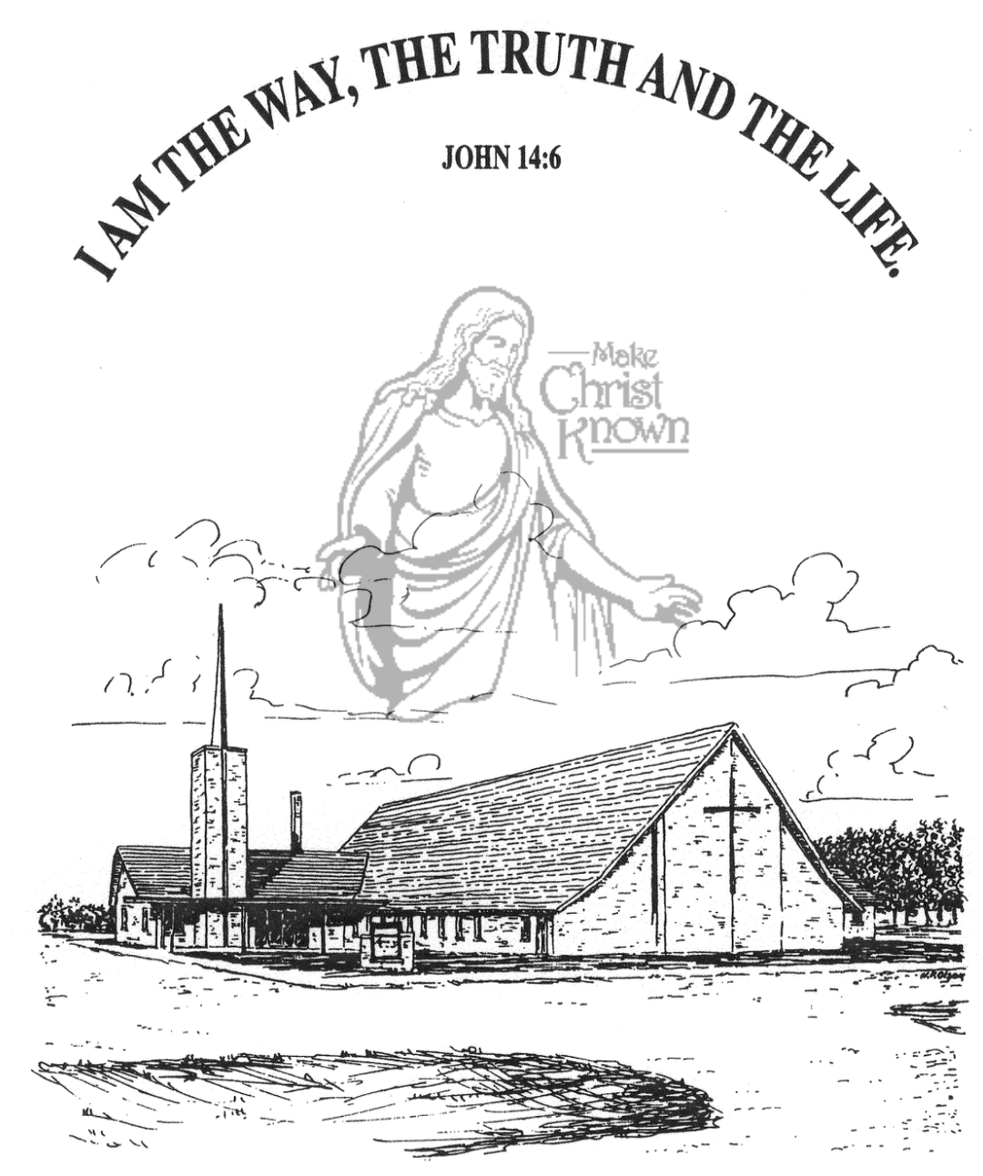

**Sunday, December 15, 2024**

**Salem Reformed Church**

**Menno, South Dakota**

..3

**Office Hours for Pastor Hecht**

Tuesday – Friday: 8:00 AM to Noon (Church Office)

Afternoons: Visitation or Church Office

Church: (605) 387-5334 Parsonage: (605) 387-2855

Pastor Mike’s Cell #: (605) 660-1803

Church Web Page: ***salemreformedchurch.com***

**Opportunities**

Greeters Today: Robert and Elaine Balogh

Greeters December 22nd: Gary and Jane Gramkow

Greeters December 24th: Tim and Sherry Freier

Sunday Prayer Time: 8:30 a.m.

Sunday School Classes: 9:15 a.m.

Praise Music: 10:15 a.m.

Worship Service: 10:30 a.m.

**Announcements**

**Welcome:** We extend a warm welcome to our visiting guests this morning. Please sign our guest book in the Narthex. We ask God’s blessing upon you and we pray that you will return and worship with us again soon.

**Soup Kitchen:** We would like to thank everyone for attending the Annual Soup Kitchen. The committee would like to express their heartfelt appreciation for your gift of time, food donations and financial support. We thank you for making the event a success! If you would like to serve on the committee next year, please contact a committee member: Melanie Wilcoxon, Michelle Friesen, Deb Schmidt or Mick Huber.

**Christmas Eve Program Practice:** The last practice will be Sun., Dec. 22nd at 9:00 AM, during the Sunday School Hour. This practice will also include the Pre-School Class. Special Thanks to Ashley Holzwarth and Mary Heckenlaible for directing!

**Prelude Music:** During the Advent Season the pianists and organist will be playing prelude music before the services. This is to be used as a time to prepare your hearts and minds for the worship service. Please keep the visiting to a minimum.

**Christmas Eve Offering:** Our Christmas Eve Program and Candle Light Service is at 7 PM. The offering received will be divided as follows: 50% to the Abbott House in Mitchell; 30% to the Swan Lake Christian Camp; 20% to Healing Hope Ministries.

**Christmas Day Offering:** Our Christmas Day Offering will be given to the M/O Care Center to assist with on-going needs and upgrades as determined by the Board and Administration.

**Sunday Offerings:** Please note that we have an Offering Box/Pulpit at the back of the Sanctuary for people to place their tithes and offerings in during our worship services.

**SALEM REFORMED CHURCH**

Menno, South Dakota

Rev. Michael Hecht Pastor

Marina Schaeffer Pianist

10:30 AM – Worship Service December 15, 2024

Third Sunday of Advent

**Meditation:** *“And we know that in all things God works for the good of those who love Him, who have been called according to His purpose. For those God foreknew He also predestined to be conformed to the likeness of His Son, that He might be the firstborn among many brothers. And those He predestined, He also called; those He called, He also justified; those He justified, He also glorified. What, then, shall we say in response to all this? If God is for us, who can be against us? He who did not spare His own Son, but gave Him up for us all – how will He not also, along with Him graciously give us all things?*

Romans 8:28-32 NIV

**Praise Music:** #51, #50, #135, #150

**Ringing of the Bell**

**Welcome / Announcements**

**Opening Prayer**

**Lighting of the Advent Wreath**

Lee Kisely and Corwin Schaeffer

**\*Hymn:** #277 “Hark! the Herald Angels Sing”

**Sharing of Joys and Concerns**

**Our Time of Offering**  John 18:37 NIV

**\*Doxology** sung on page #815

**\*Apostles’ Creed** see words on screen

**Kingdom Kids:** “The Joy of Christmas“

**Hymn:** #254 “Isn’t He?”

**The Holy Scriptures**

Matthew 1:18-25

Large Print NIV 1984 Edition, pg. 1497

**Sermon: “Joseph’s Much Needed Verification”**

**\*Hymn:** #251 “It Came Upon a Midnight Clear”

**\*Benediction:**

**Postlude**

(*denotes standing for those able)

The congregation will be ushered out after the Benediction

Youth Ushers: Bryce Sattler, Brockton Kocourek, Carter Fischer