**Calendar of Events**

Dec 09 Search Committee Meeting @ 5:30 p.m.

Dec 11 Women’s Bible Study @ 9:30 a.m.

8th Grade Confirmation @ 3:30-5:15 p.m.

6/7th Grade Confirmation @ 5:20-7:00 p.m.

Consistory Meeting @ 7:00 p.m.

Dec 12 Prayer Group @ 12 Noon

Dec 15 Prayer Time for Service @ 8:30 a.m.

Sunday School Classes @ 9:15 a.m.

Praise Music @ 10:15 a.m.

Worship Service @ 10:30 a.m.

Program Practice @ 12 Noon to 2:00 p.m.

Dec 16 Men’s Christian Fellowship @ 7:00 p.m.

Dec 18 No Confirmation Classes Today

FCA at Menno Gym @ 7:30 p.m.

**Upcoming Special Music**

Sunday, Dec. 15 - Available

Sunday, Dec. 22 - Jay Herrboldt

**Announcements**

**Advent Season:** During the Advent Season the pianists/organist will be playing prelude music before the services. This is to be used as a time to prepare hearts/minds for the Worship Service.

**Poinsettias in Memory of Loved Ones:** During the Advent Season we have the opportunity to place poinsettias in the sanctuary in memory of loved ones. Please contact the florist of your choice if you desire to place a plant this year.

**M/OCC Bingo:** The Care Center is looking for volunteers to help with Friday Bingo during December. Please sign the sheet in the Narthex if you are able to help.

**Christmas Concert:** The Scotland Community Church will be hosting Amanda Ellison in concert on Monday, Dec. 9th @ 6:30 p.m. She will be singing Christmas Classics and Carols. A free-will offering will be received. (Amanda was a member of the Preacher’s Daughters).

**Christmas Eve Offering:** Our Christmas Eve Program and Candle Light Service is at 7 PM. The offering received will be divided as follows: 50% to the Abbott House in Mitchell; 30% to the Swan Lake Christian Camp; 20% to Healing Hope Ministries.

**Christmas Day Offering:** Our Christmas Day Offering will be given to the M/O Care Center to assist with on-going needs and upgrades as determined by the Board and Administration.

**Salem Reformed Church – Who Are We?**

**We believe the Bible to be the inspired, inerrant, infallible Word of God in its original manuscripts. It is our supreme authority in all matters doctrine and practice. We are affiliated with the Conservative Congregational Christian Conference.**

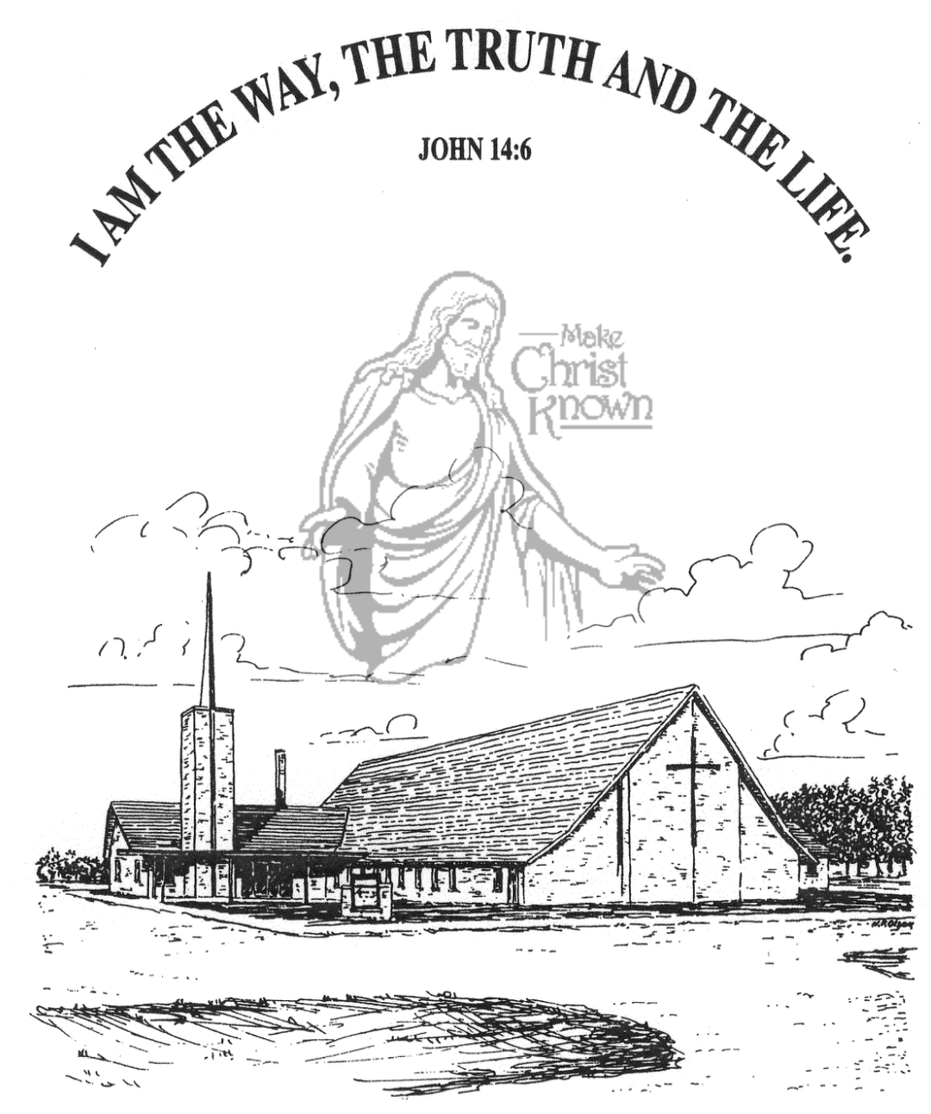

**Sunday, December 08, 2024**

**Salem Reformed Church**

**Menno, South Dakota**

..3

**Office Hours for Pastor Hecht**

Tuesday – Friday: 8:00 AM to Noon (Church Office)

Afternoons: Visitation or Church Office

Church: (605) 387-5334 Parsonage: (605) 387-2855

Pastor Mike’s Cell #: (605) 660-1803

Church Web Page: ***salemreformedchurch.com***

**Opportunities**

Greeters Today: Johnny and Lori Woehl

Greeters December 15th: Robert and Elaine Balogh

Sunday Prayer Time: 8:30 a.m.

Sunday School Classes: 9:15 a.m.

Praise Music: 10:15 a.m.

Worship Service: 10:30 a.m.

**Announcements**

**Welcome:** We extend a warm welcome to our visiting guests this morning. Please sign our guest book in the Narthex. We ask God’s blessing upon you and we pray that you will return and worship with us again soon.

**Holy Communion:** We at Salem Reformed Church recognize an open communion table. All are welcome to partake of the bread and wine and accept the gift of grace that God offers to us through Jesus Christ, our Savior and Lord. **The inner most ring of the communion tray contains grape juice. All other rings contain wine.

**Soup Kitchen:** We would like to thank everyone for attending the Annual Soup Kitchen. The committee would like to express their heartfelt appreciation for your gift of time, food donations and financial support. We thank you for making the event a success! If you would like to serve on the committee next year, please contact a committee member: Melanie Wilcoxon, Michelle Friesen, Deb Schmidt or Mick Huber.

**Christmas Program Lunches:** Please remember to bring what you signed up for! Thanks for your help. Lunch coordinators are Chandra van Zyl, Katie Huber, Jenna Miller and Stephanie Wagner.

**Christmas Eve Program Practices:** Program practices for grades K-8 are **TODAY,** and next Sun., Dec. 15, following the worship service. A lunch for the children/teachers will be served prior to practice. The last practice will be Sun., Dec. 22nd during the Sunday School Hour. This practice will also include the Pre-School Class. Ashley Holzwarth/Mary Heckenlaible are Directors.

**Sunday Offerings:** Please note that we have an Offering Box/Pulpit at the back of the Sanctuary for people to place their tithes and offerings in during our worship services.

**SALEM REFORMED CHURCH**

Menno, South Dakota

Rev. Michael Hecht Pastor

Sharyl Herrboldt Pianist

10:30 AM – Worship Service December 08, 2024

Second Sunday of Advent

**Meditation:** *“But the angel said to him: ‘Do not be afraid, Zechariah; your prayer has been heard. Your wife Elizabeth will bear you a son, and you are to give him the name John. He will be a joy and delight to you, and many will rejoice because of his birth, for he will be great in the sight of the Lord. He is never to take wine or other fermented drink, and he will be filled with the Holy Spirit even from birth.”*

Luke 1:13-15 NIV

**Prelude Music:** by Sharyl Herrboldt

**Ringing of the Bell**

**Welcome / Announcements**

**Opening Prayer**

**Lighting of the Advent Wreath**

Leah Crick and Briley Cross

**\*Hymn:** #259 “Angels, from the Realms of Glory”

**Sharing of Joys and Concerns**

**Our Time of Offering** Luke 1:68,69NIV

**\*Doxology** sung on page #815

**\*Lord’s Prayer** debts and debtors

**Kingdom Kids:** “Fanfare for a King“

**Hymn:** #243 “Emmanuel”

**The Holy Scriptures**

Luke 1:34-45

Large Print NIV 1984 Edition, pg. 1588

**Sermon: “Mary’s Much Needed Verification”**

**Prayer of Confession**

#281 “What Child Is This?”

#287 “A Communion Hymn for Christmas”

**Sacrament of Holy Communion**

**\*Hymn:** #278 “Angels We Have Heard on High”

**\*Benediction:**

**Postlude**

(*denotes standing for those able)

The congregation will be ushered out after the Benediction

Youth Ushers: Bryce Sattler, Brockton Kocourek, Carter Fischer