**Calendar of Events**

Dec 02 Men’s Christian Fellowship @ 7:00 p.m.

Dec 03 M/O Ministerial Mtg at Roosters @ 11:30 a.m.

Dec 04 Women’s Bible Study @ 9:30 a.m.

8th Grade Confirmation @ 3:30-5:15 p.m.

6/7th Grade Confirmation @ 5:20-7:00 p.m.

FCA at Menno Gym @ 7:30 p.m.

Dec 05 Prayer Group @ 12 Noon

Dec 07 Soup Kitchen/Bake Sale @ 11 a.m. to 7 p.m.

Dec 08  **Second Sunday of Advent**

Prayer Time for Service @ 8:30 a.m.

Sunday School Classes @ 9:15 a.m.

Praise Music @ 10:15 a.m.

Worship Service @ 10:30 a.m.

Program Practice @ 12 Noon to 2:00 p.m.

**Upcoming Special Music**

Sunday, Dec. 01 - Available

Sunday, Dec. 08 - Available

**Announcements**

**Meals-on-Wheels:** Special Thanks to all who have helped deliver meals during the month of November! You have been a blessing to many others in our community!

**Christmas Eve Program Practices:** Program practices for grades K-8 start **TODAY**, and continue on Dec. 8, 15, following the worship service. A lunch for the children/teachers will be served prior to practice. The last practice will be Sun., Dec. 22nd during the Sunday School Hour. This practice will also include the Pre-School Class. Ashley Holzwarth/Mary Heckenlaible are Directors.

**Poinsettias in Memory of Loved Ones:** During the Advent Season we have the opportunity to place poinsettias in the sanctuary in memory of loved ones. Please contact the florist of your choice if you desire to place a plant this year. The first Sunday of Advent is December 1st.

**M/OCC Bingo:** The Care Center is looking for volunteers to help with Friday Bingo during December. Please sign the sheet in the Narthex if you are able to help.

**Salem Reformed Church – Who Are We?**

**We believe the Bible to be the inspired, inerrant, infallible Word of God in its original manuscripts. It is our supreme authority in all matters doctrine and practice. We are affiliated with the Conservative Congregational Christian Conference.**

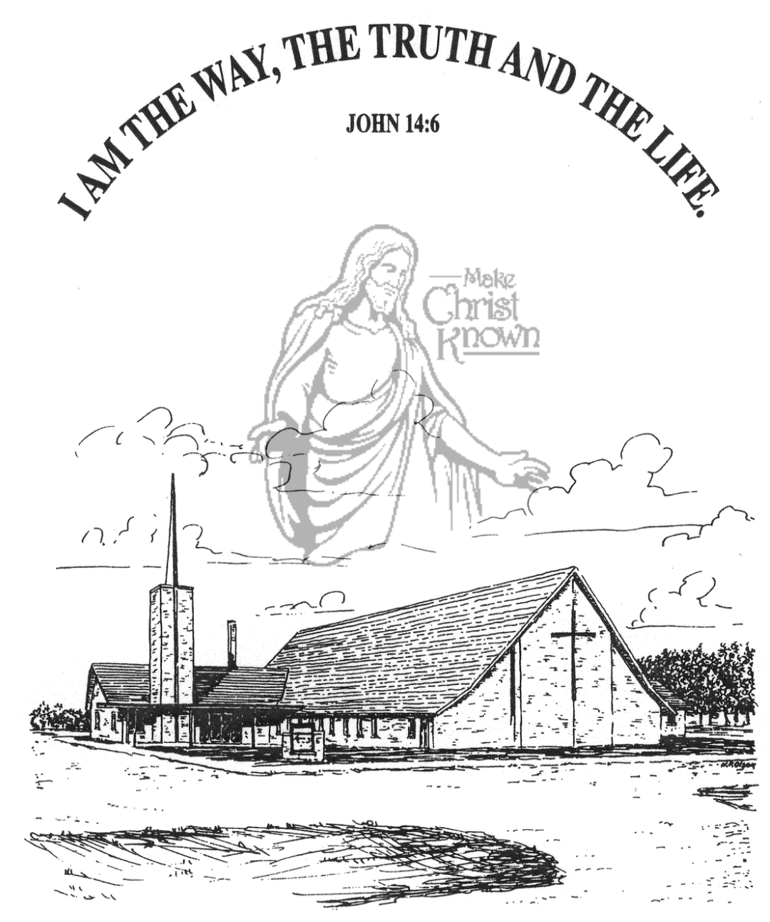

**Sunday, December 01, 2024**

**Salem Reformed Church**

**Menno, South Dakota**

..3

**Office Hours for Pastor Hecht**

Tuesday – Friday: 8:00 AM to Noon (Church Office)

Afternoons: Visitation or Church Office

Church: (605) 387-5334 Parsonage: (605) 387-2855

Pastor Mike’s Cell #: (605) 660-1803

Church Web Page: ***salemreformedchurch.com***

**Opportunities**

Greeters Today: Ken and Ramona Bittner

Greeters December 08th: Johnny and Lori Woehl

Sunday Prayer Time: 8:30 a.m.

Sunday School Classes: 9:15 a.m.

Praise Music: 10:15 a.m.

Worship Service: 10:30 a.m.

**Announcements**

**Welcome:** We extend a warm welcome to our visiting guests this morning. Please sign our guest book in the Narthex. We ask God’s blessing upon you and we pray that you will return and worship with us again soon.

**Thanksgiving Eve Service:** The offering received for the M.O.R.E. Committee on Thanksgiving Eve was $0,000.00! We Praise the Lord for such generous gifts to share!

**Soup Kitchen:** Please stop by the Social Hall today after the service to pick up your work assignment. We appreciate your donations of food and time to assist with the event. If you have any questions, the committee members can assist you. The Soup Kitchen is scheduled for Sat., Dec. 7th in the Social Hall from 11AM to 7PM. Please remember to invite your friends and family to this fundraiser. It is also a wonderful time of fellowship!

**Christmas Program Lunches:** Please remember to bring what you signed up for! Thanks for your help. Lunch coordinators are Chandra van Zyl, Katie Huber, Jenna Miller and Stephanie Wagner.

**Hanging of the Greens:** Special Thanks to the CE Comm. and their Families, and others who helped with putting up the Christmas Tree and Decorations last Wednesday evening! It is Beautiful! Jesus is the Light of the World!

**Christmas Eve Program Practices:** Program practices for grades K-8 start TODAY, and continue on Dec. 8, 15, following the worship service. A lunch for the children/teachers will be served prior to practice. The last practice will be Sun., Dec. 22nd during the Sunday School Hour. This practice will also include the Pre-School Class. Ashley Holzwarth/Mary Heckenlaible are Directors.

**Sunday Offerings:** Please note that we have an Offering Box/Pulpit at the back of the Sanctuary for people to place their tithes and offerings in during our worship services.

**SALEM REFORMED CHURCH**

Menno, South Dakota

Rev. Michael Hecht Pastor

Joan Nusz Pianist

10:30 AM – Worship Service December 01, 2024

First Sunday of Advent

**Meditation:** *“But you are a chosen people, a royal priest- hood, a holy nation, a people belonging to God, that you may declare the praises of Him who called you out of darkness into His wonderful light. Once you were not a people, but now you are the people of God; once you had not received mercy, but now you have received mercy. Dear friends, I urge you, as aliens and strangers in the world, to abstain from sinful desires, which war against your soul. Live such good lives among the pagans that, though they accuse you of doing wrong, they may see your good deeds and glorify God on the day He visits us.”*

I Peter 2:9-12 NIV

**Praise Music:** #61, #46, #3, #10, #43

**Ringing of the Bell**

**Welcome / Announcements**

**Opening Prayer**

**Lighting of the Advent Wreath**

Vincent Kludt and Daniel Schaeffer

**\*Hymn:** #245 “O Come, O Come, Emmanuel”

**Sharing of Joys and Concerns**

**Our Time of Offering** Isaiah 7:14 NIV

**\*Doxology** sung on page #815

**\*Apostles’ Creed** see words on screen

**Kingdom Kids:** “Ring of Promise“

**Hymn:** #247 “Let’s Worship and Adore Him”

**The Holy Scriptures**

Luke 1:26-38

Large Print NIV 1984 Edition, pg. 1588

**Sermon: “I Am the Lord’s Servant”**

**\*Hymn:** #244 “Come, Thou Long-Expected Jesus”

**\*Benediction:**

**Postlude**

(*denotes standing for those able)

The congregation will be ushered out after the Benediction

Youth Ushers: Bryce Sattler, Brockton Kocourek, Carter Fischer