**Calendar of Events**

Nov 11 Veteran’s Day Program at School @ 2:00 p.m.

Nov 13 Women’s Bible Study @ 9:30 a.m.

8th Grade Confirmation @ 3:30-5:15 p.m.

6/7th Grade Confirmation @ 5:20-7:00 p.m.

Consistory Meeting @ 7:00 p.m.

Nov 14 Prayer Group @ 12 Noon

Nov 17Prayer Time for Service @ 8:30 a.m.

Sunday School Classes @ 9:15 a.m.

Praise Music @ 10:15 a.m.

Worship Service @ 10:30 a.m.

with New Members being Received

with Coffee Hour Following the Service

Nov 18 Men’s Christian Fellowship @ 7:00 p.m.

Nov 19 W.O.C. Program at M/O Care Center @ 2 PM

**Upcoming Special Music**

Sunday, Nov. 17 - Available

Sunday, Nov. 24 - Jay and Sharyl Herrboldt

**Announcements**

**Thanksgiving Eve Service:** This Service will be on Wed., Nov. 27th at 7:00 p.m. The offering received will be given to the M.O.R.E. Committee (Menno/Olivet Resources for the Elderly) to purchase gift certificates for those in need of a holiday meal.

**Meals-on-Wheels:** Please remember the dates in November that you have signed up to deliver these meals. They should be picked up at the M/OCC at 11:20 a.m. Thanks for helping in this way!

**Christmas Eve Program Practices:** Program practices for grades K-8 will be on Sundays, Dec. 1, 8, 15, following the worship service. A lunch for the children/teachers will be served prior to practice. The last practice will be Sun., Dec. 22nd during the Sunday School Hour. This practice will also include the Pre-School Class. Ashley Holzwarth and Mary Heckenlaible are the Directors.

**Veterans Day Program:** The National Honor Society will present a Veterans Day Celebration on Mon., Nov. 11th at 2 PM in the Menno New Gym. All are invited to attend as we honor those who have served!

**Bethany Food Pantry:** Thanks to everyone who donated items for the Bethany Food Pantry! You are a blessing to so many others!

**Salem Reformed Church – Who Are We?**

**We believe the Bible to be the inspired, inerrant, infallible Word of God in its original manuscripts. It is our supreme authority in all matters doctrine and practice. We are affiliated with the Conservative Congregational Christian Conference.**

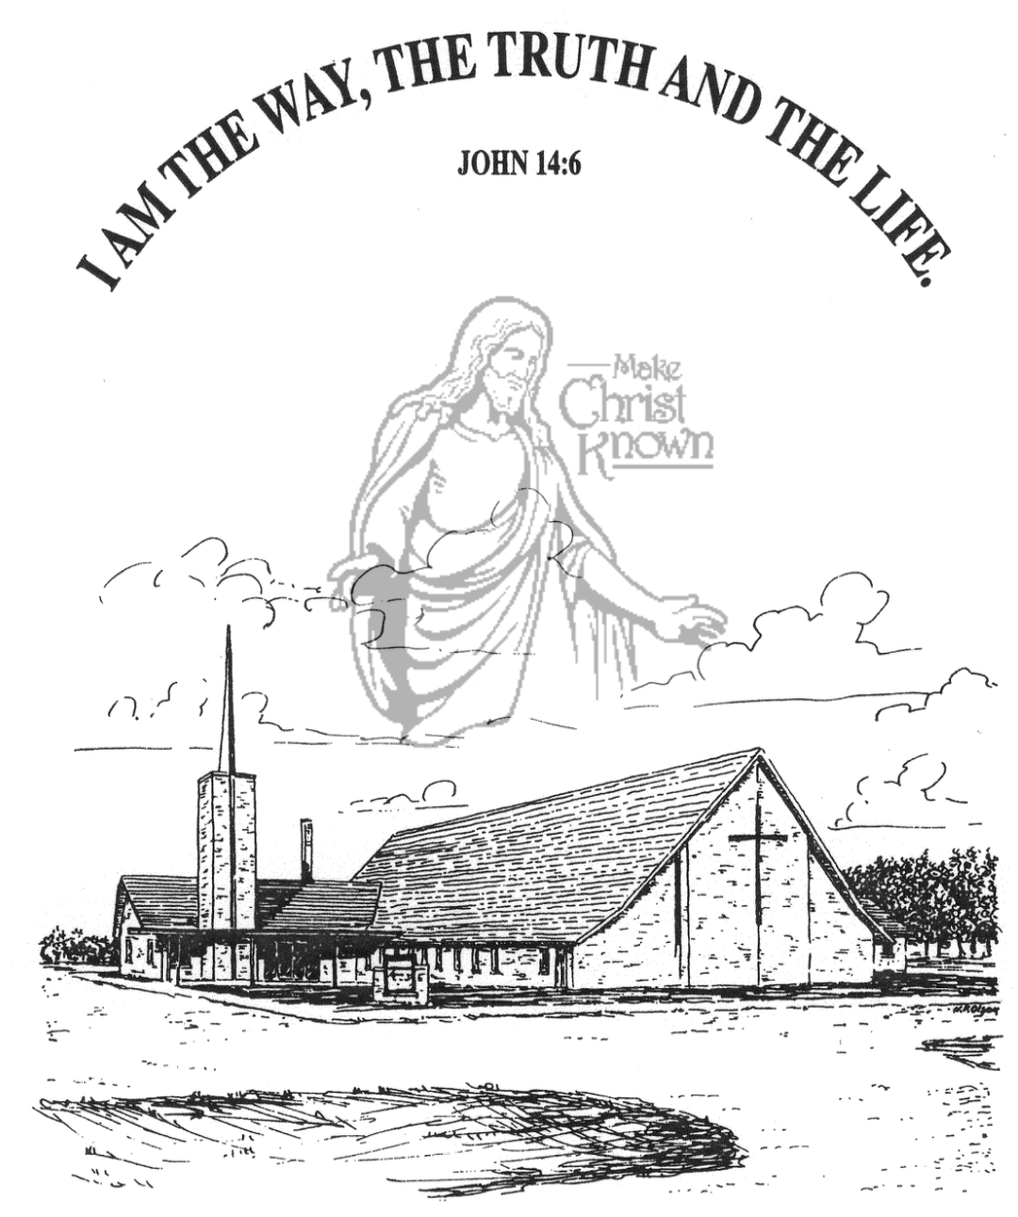

**Sunday, November 10, 2024**

**Salem Reformed Church**

**Menno, South Dakota**

..3

**Office Hours for Pastor Hecht**

Tuesday – Friday: 8:00 AM to Noon (Church Office)

Afternoons: Visitation or Church Office

Church: (605) 387-5334 Parsonage: (605) 387-2855

Pastor Mike’s Cell #: (605) 660-1803

Church Web Page: ***salemreformedchurch.com***

**Opportunities**

Greeters Today: Jim and Deb Christensen

Greeters November 17th:

Sunday Prayer Time: 8:30 a.m.

Sunday School Classes: 9:15 a.m.

Praise Music: 10:15 a.m.

Worship Service: 10:30 a.m.

**Announcements**

**Welcome:** We extend a warm welcome to our visiting guests this morning. Please sign our guest book in the Narthex. We ask God’s blessing upon you and we pray that you will return and worship with us again soon.

**Congratulations:** We rejoice with the Family of Quinn Stacy Roth at her baptism! Quinn’s parents are Joshua and Becca Roth. We extend a warm welcome to all of their family and friends who may be present in our worship service today.

**W.O.C. Program:** The Women will be hosting the program at the M/OCC on Tues., Nov. 19th @ 2PM. Please sign the sheet in the Narthex of you are able to come and help. Thanks!

**Soup Kitchen:** The annual Soup Kitchen is scheduled for Sat., Dec. 7th in the Social Hall from 11AM to 7PM. The committee will have the work schedule and donation sheets available in the Social Hall today and next week. This is a great time to participate and enjoy a time of serving and fellowship. Work sign-up sheets are also available for grades 4th-8th. We appreciate your generous gifts of time and food donations. Contact committee members: Melanie Wilcoxon, Michelle Friesen, Deb Schmidt or Mick Huber with questions.

**Christmas Program Lunches:** Sign the list in the Social Hall for food items or monetary donations needed for the lunches served before our Christmas Program Practices. Lunches will be served on Sundays, December 1st, 8th, and 15th. Lunch coordinators are Chandra van Zyl, Katie Huber, Jenna Miller and Stephanie Wagner.

**Sunday Offerings:** Please note that we have an Offering Box/Pulpit at the back of the Sanctuary for people to place their tithes and offerings in during our worship services.

**SALEM REFORMED CHURCH**

Menno, South Dakota

Rev. Michael Hecht Pastor

Sharyl Herrboldt Pianist

10:30 AM – Worship Service November 10, 2024

Twenty-fifth Sunday after Pentecost

**Meditation:** *“Hear, O Israel: The LORD our God, the LORD is one. Love the LORD your God with all your heart and with all your soul and with all your strength. These commandments that I give you today are to be upon your hearts. Impress them on your children. Talk about them when you sit at home and when you walk along the road, when you lie down and when you get up. Tie them as symbols on your hands and bind them on your foreheads. Write them on the doorframes of your houses and on your gates.* Deuteronomy 6:4-9 NIV

**Praise Music:** #38, #56, #28, #21, #144

**Ringing of the Bell**

**Welcome / Announcements / Opening Prayer**

**\*Hymn:** #147 “How Great Thou Art”

**Sharing of Joys and Concerns**

**Our Time of Offering**  Psalm 127:3-5 NLT

**\*Doxology** sung on page #815

**\*Lord’s Prayer** debts and debtors

**Baptism: Quinn Stacy Roth**

**Questions of Candidates / Congregational Assent**

**Education Committee Pledge** Lee Heckenlaible

**Act of Baptism**

**Congregational Song:** “Yes, Jesus Loves You!”

**Kingdom Kids:** “Another Boy King ? ?”

**Hymn:** #88 “More Precious Than Silver”

**The Holy Scriptures**

II Chronicles 24:1-19

Large Print NIV 1984 Edition, pg. 707

**Sermon: “The Power of Influence”**

**\*Hymn:** #571 “Trust and Obey”

**\*Benediction:**

**\*Prayer for Our Nation:** “God Bless America”

**Postlude**

(*denotes standing for those able)

The congregation will be ushered out after the Benediction

Youth Ushers: Ashlynn Fergen and Elly Fischer