**Calendar of Events**

Oct 06 Contemporary Service @ 7:00 p.m.

Oct 07 Men’s Christian Fellowship @ 7:30 p.m.

Oct 09 Women’s Bible Study @ 9:30 a.m. & 6:00 p.m.

8th Grade Confirmation @ 3:30-5:15 p.m.

6/7th Grade Confirmation @ 5:20-7:00 p.m.

Consistory Meeting @ 7:30 p.m.

Oct 10 Prayer Group @ 12 Noon

Oct 13Prayer Time for Service @ 8:30 a.m.

Sunday School Classes @ 9:15 a.m.

Praise Music @ 10:15 a.m.

Worship Service @ 10:30 a.m.

Nathan/Katrina Hecht Open House 2-4 p.m.

Oct 16 4-O’s Women to Jamesville @ 10:50 a.m.

Women’s Bible Study @ 9:30 a.m. & 6:00 p.m.

**Upcoming Special Music**

Sunday, Oct 13 - Available

Sunday, Oct 20 - Cherub Choir

**Announcements**

**Mission Fest Service:** Mission Fest is scheduled for Sunday, October 20th. Our guest speaker will be Dr. Jeff Johnson, from the Servant Hearts Clinic in Yankton. Servant Hearts Clinic is a FREE health care clinic dedicated to providing health care to all we serve. The offering has been designated as follows: 90% given to Servant Hearts Clinic and 10% given to the FCA at Menno High School. **The Consistory and Spouses will host a Pot Luck Dinner following the service.

**Christmas Eve Program Directors:** BIG THANKS to Mary Heckenlaible and Ashley Holzwarth, who will be directing our Christmas Eve Program this year! If your children will not be present for the program this year, please let Mary, Ashley or the Church Office know as soon as possible.

**Contemporary Service:** We will have a Contemporary Service **TONIGHT** at 7 PM, with guest speaker, Ali Farhadi. Ali was born and raised in Iran, and then moved to the USA. In his young adult years he became a Christian, and now has a powerful ministry leading others to Christ! A special offering will be received for their ministry.

**Salem Reformed Church – Who Are We?**

**We believe the Bible to be the inspired, inerrant, infallible Word of God in its original manuscripts. It is our supreme authority in all matters doctrine and practice. We are affiliated with the Conservative Congregational Christian Conference.**

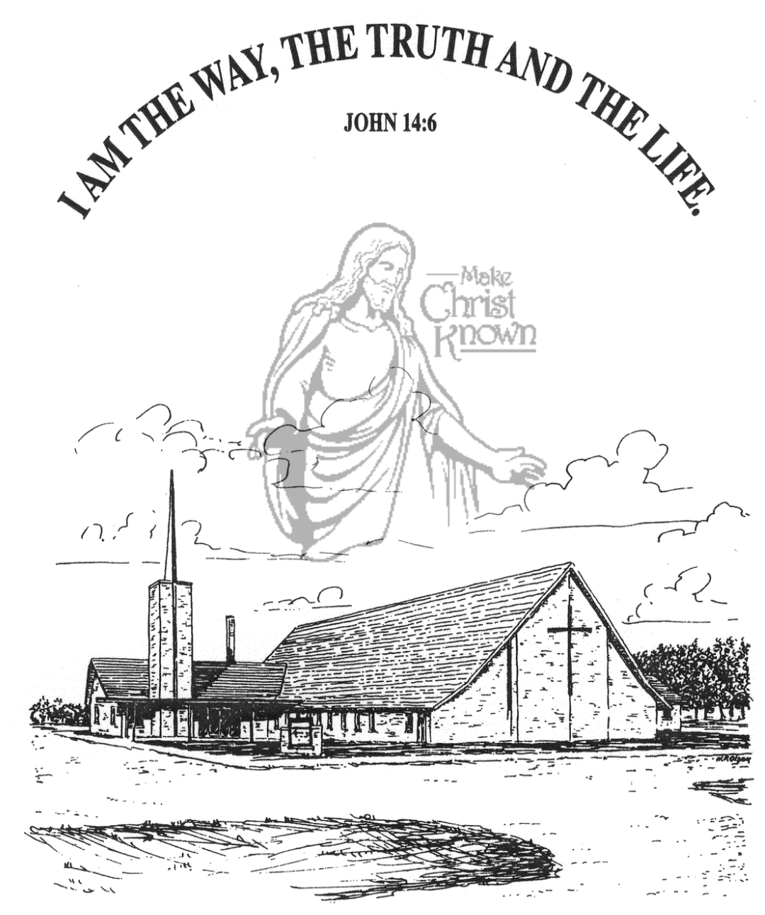

**Sunday, October 06, 2024**

**Salem Reformed Church**

**Menno, South Dakota**

..3

**Office Hours for Pastor Hecht**

Tuesday – Friday: 8:00 AM to Noon (Church Office)

Afternoons: Visitation or Church Office

Church: (605) 387-5334 Parsonage: (605) 387-2855

Pastor Mike’s Cell #: (605) 660-1803

Church Web Page: ***salemreformedchurch.com***

**Opportunities**

Greeters Today: Ken and Ramona Bittner

Greeters October 13th:

Sunday Prayer Time: 8:30 a.m.

Sunday School Classes: 9:15 a.m.

Praise Music: 10:15 a.m.

Worship Service: 10:30 a.m.

**Announcements**

**Welcome:** We extend a warm welcome to our visiting guests this morning. Please sign our guest book in the Narthex. We ask God’s blessing upon you and we pray that you will return and worship with us again soon.

**Holy Communion:** We at Salem Reformed Church recognize an open communion table. All are welcome to partake of the bread and wine and accept the gift of grace that God offers to us through Jesus Christ, our Savior and Lord. **The inner most ring of the communion tray contains grape juice. All other rings contain wine.

**4-O’s Women:** This group will be taking a tour of the Jamesville Colony on Wed., Oct. 16th. Please meet at the church @ 10:50 a.m. The cost is $10/person, which includes a noon meal and tour. Sign the sheet in the Narthex if you are planning to attend.

**Young Adults:** Parents of Sunday School Children – if you are not attending a S.S. Class, please consider sitting at the Table in the Social Hall during that time. Have a cup of coffee and get to know each other. You’ll be glad that you did!

**Cherub Choir:** The Cherub Choir (ages 3 yrs. thru 3rd Grade) will plan to sing in church on Sunday, Oct. 20th! This is also our Mission Fest Sunday.

**Men Standing Together:** Sun., Nov. 3rd @ 5 PM in our Social Hall. Brad Magness, owner of Magness Livestock Market, Huron, SD, will be our guest speaker. Supper will be provided. Invite your friends! Middle School/High School age young men are welcome! Please sign the sheet in the Narthex if you plan to attend.

**Sunday Offerings:** Please note that we have an Offering Box/Pulpit at the back of the Sanctuary for people to place their tithes and offerings in during our worship services.

**SALEM REFORMED CHURCH**

Menno, South Dakota

Rev. Michael Hecht Pastor

Sharyl Herrboldt Pianist

10:30 AM – Worship Service October 06, 2024

Twentieth Sunday after Pentecost

**Meditation:** *“For I received from the Lord that which I also delivered to you: that the Lord Jesus on the same night in which He was betrayed took bread; and when He had given thanks, He broke it and said, ‘Take, eat; this is My body which is for you; do this in remembrance of Me.’ In the same manner He also took the cup after supper, saying, ‘This cup is the new covenant in My blood. This do, as often as you drink it, in remembrance of Me.’ For as often as you eat this bread and drink this cup, you proclaim the Lord’s death till He comes. Therefore whoever eats this bread or drinks this cup of the Lord in an unworthy manner will be guilty of the body and blood of the Lord.”*  I Corinthians 11:23-27 NIV

**Praise Music:** #67, #52, #55, #49, #43

**Ringing of the Bell**

**Welcome / Announcements / Opening Prayer**

**\*Hymn:** #793 “For the Beauty of the Earth”

**Sharing of Joys and Concerns**

**Our Time of Offering**  Ephesians 2:4,5 NIV

**\*Doxology** sung on page #815

**\*Apostles’ Creed** see words on screen

**Kingdom Kids:** “Nailed to the Cross”

**Hymn:** #333 “O the Blood of Jesus”

**The Holy Scriptures**

Colossians 2:9-15

Large Print NIV 1984 Edition, pg. 1833

**Sermon: “Alive With Christ”**

**Prayer of Confession**

#323 “At the Cross” (Verses 1,2,3,5)

#327 “The Old Rugged Cross”

**Sacrament of Holy Communion**

**\*Hymn:** #144 “Amazing Grace – Chains Are Gone”(praise book)

**\*Benediction:**

**Postlude** (*denotes standing for those able)

The congregation will be ushered out after the Benediction

Youth Ushers: Joslynn Fischer, Zoe Schaeffer, and Autumn Rames