**Calendar of Events**

Oct 30 Women’s Bible Study @ 9:30 a.m.

8th Grade Confirmation @ 3:30-5:15 p.m.

6/7th Grade Confirmation @ 5:20-7:00 p.m.

Search Committee Meeting @ 7:15 p.m.

Oct 31 Prayer Group @ 12 Noon

Nov 02 **Daylight Savings Time Ends/Set Clocks Back!**

Nov 03Prayer Time for Service @ 8:30 a.m.

Sunday School Classes @ 9:15 a.m.

Praise Music @ 10:15 a.m.

Worship Service @ 10:30 a.m.

Men Standing Together Event @ 5:00 p.m.

**Upcoming Special Music**

Sunday, Nov. 03 - Junior Choir

Sunday, Nov. 10 - Available

**Announcements**

**Meals-on-Wheels:** Our church will be delivering meals during the month of NOVEMBER. Drivers are needed for delivering lunches on Mon. – Friday. They should be picked up at the M/OCC at 11:20 a.m. Please sign the sheet in the Narthex if you can help.

**Operation Christmas Child:** If you are interested in participating please have your shoebox filled and at the church by November 17th. Please include $10/box for shipping and handling. Thanks!

**Christmas Eve Program Directors:** BIG THANKS to Mary Heckenlaible and Ashley Holzwarth, who will be directing our Christmas Eve Program this year! If your children will not be present for the program this year, please let Mary, Ashley or the Church Office know as soon as possible.

**Bethany Food Pantry:** Our church youth group will be sponsoring this Food Drive. Bring items to church by Sun., Nov. 3rd. In addition to non-perishable food items, you may also bring personal care items such as tooth paste, shampoo, deodorant, tooth brushes, laundry detergent. Winter caps, gloves and scarves are also welcome. Place items in the Box in the Social Hall.

**Christmas Program Lunches:** We are looking for 2 more people to coordinate the Christmas Program lunches after church on Sundays, December 1st, 8th, and 15th. And a quick snack after program practice the morning of Sunday, December 22nd.

**Special Thanks:** Thanks to Kayleen Aisenbrey for placing the flowers in the Sanctuary during the month of October.

**Salem Reformed Church – Who Are We?**

**We believe the Bible to be the inspired, inerrant, infallible Word of God in its original manuscripts. It is our supreme authority in all matters doctrine and practice. We are affiliated with the Conservative Congregational Christian Conference.**

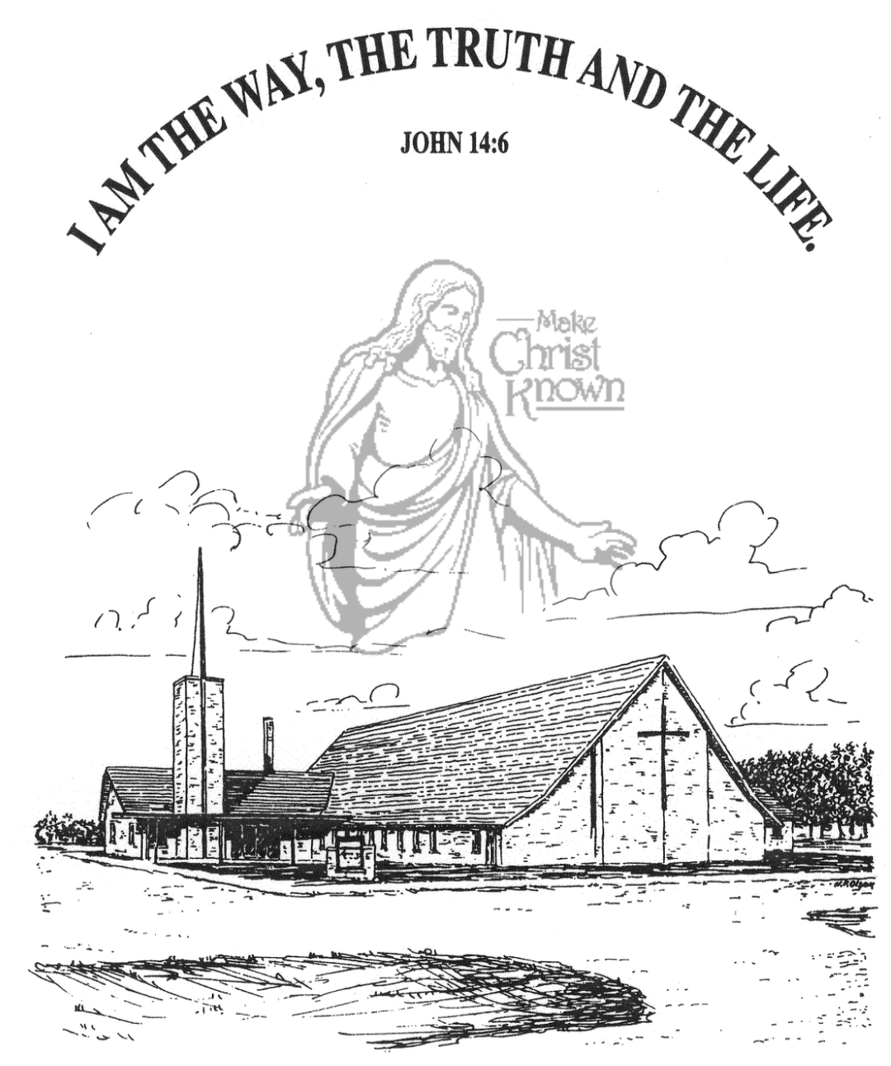

**Sunday, October 27, 2024**

**Salem Reformed Church**

**Menno, South Dakota**

..3

**Office Hours for Pastor Hecht**

Tuesday – Friday: 8:00 AM to Noon (Church Office)

Afternoons: Visitation or Church Office

Church: (605) 387-5334 Parsonage: (605) 387-2855

Pastor Mike’s Cell #: (605) 660-1803

Church Web Page: ***salemreformedchurch.com***

**Opportunities**

Greeters Today: Michael and Stephanie Wagner

Greeters November 3rd:

Sunday Prayer Time: 8:30 a.m.

Sunday School Classes: 9:15 a.m.

Praise Music: 10:15 a.m.

Worship Service: 10:30 a.m.

**Announcements**

**Welcome:** We extend a warm welcome to our visiting guests this morning. Please sign our guest book in the Narthex. We ask God’s blessing upon you and we pray that you will return and worship with us again soon.

**CE Committee Meeting:** The CE Comm. will meet to TODAY, following our worship service in the H.S. Sunday School Room.

**Search Committee Meeting:** The Search Comm. for the Assistant Pastor position will meet on Wed., Oct. 30th at 7:15 p.m.

**Young Adults:** Parents of Sunday School Children – if you are not attending a S.S. Class, please consider sitting at the Table in the Social Hall during that time. Have a cup of coffee and get to know each other. You’ll be glad that you did!

**Junior Choir:** The Junior Choir (Grades 4-8) will plan to sing in church on Sunday, November 3rd.

**Mission Fest Offering:** The total amount given for the Mission Fest Offering last Sunday was $12,008.00. 90% ($10,807.20) will be given to Servant Hearts Clinic and 10% ($1,200.80) will be given to the Menno FCA Huddle! We Praise the Lord for such generous giving to these mission works!

**Men Standing Together:** Sun., Nov. 3rd @ 5 PM in our Social Hall. Brad Magness, owner of Magness Livestock Market, Huron, SD, will be our guest speaker. Supper will be provided. Invite your friends! Middle School/High School age young men are welcome! Please sign the sheet in the Narthex if you plan to attend.

**Daylight Savings Time Ends:** Remember to set your clocks **BACK** 1 Hour this coming Saturday evening, November 2nd!

**Sunday Offerings:** Please note that we have an Offering Box/Pulpit at the back of the Sanctuary for people to place their tithes and offerings in during our worship services.

**SALEM REFORMED CHURCH**

Menno, South Dakota

Rev. Michael Hecht Pastor

Cindy Herrboldt Organist

10:30 AM – Worship Service October 27, 2024

Reformation Sunday

**Meditation:** *“And what more shall I say? I do not have time to tell about Gideon, Barak, Samson, Jephthah, David, Samuel and the prophets, who through faith conquered kingdoms, administered justice, and gained what was promised; who shut the mouths of lions, quenched the fury of the flames, and escaped the edge of the sword; whose weakness was turned to strength; and who became powerful in battle and routed foreign armies. Women received back their dead, raised to life again. Others were tortured and refused to be released, so that they might gain a better resurrection. Some faced jeers and flogging, while still others were chained and put in prison. They were stoned; they were sawed in two; they were put to death by the sword. They went about in sheepskins and goatskins, destitute, persecuted and mistreated – the world was not worthy of them. . .”*  Hebrews 11:32-38a NIV

**Praise Music:** #7, #44, #57, #59, #762, #12

**Ringing of the Bell**

**Welcome / Announcements / Opening Prayer**

**\*Hymn:** #151 “A Mighty Fortress Is Our God”

**Sharing of Joys and Concerns**

**Our Time of Offering**  Galatians 2:15,16 NIV

**\*Doxology** sung on page #815

**\*Apostles’ Creed** see words on screen

**Kingdom Kids:** “Who Was Deborah?”

**Hymn:** #22 “Praise the Name of Jesus”

**The Holy Scriptures**

Judges 4:1-24

Large Print NIV 1984 Edition, pg. 377

**Sermon: “Life’s Dangerous Cycle”**

**\*Hymn:** #730 “Stand Up, Stand Up for Jesus”

**\*Benediction:**

**\*Prayer for Our Nation:** “God Bless America”

**Postlude** (*denotes standing for those able)

The congregation will be ushered out after the Benediction

Youth Ushers: Joslynn Fischer, Zoe Schaeffer, Autumn Rames