**Calendar of Events**

Oct 13 Nathan/Katrina Hecht Open House 2-4 p.m.

Oct 16 4-O’s Women to Jamesville @ 10:50 a.m.

Women’s Bible Study @ 9:30 a.m. & 6:00 p.m.

8th Grade Confirmation @ 3:30-5:15 p.m.

6/7th Grade Confirmation @ 5:20-7:00 p.m.

FCA at Menno Gym @ 7:30 p.m.

Oct 17 Prayer Group @ 12 Noon

Oct 20 **Mission Fest Sunday!**

Prayer Time for Service @ 8:30 a.m.

Sunday School Classes @ 9:15 a.m.

Praise Music @ 10:15 a.m.

Worship Service @ 10:30 a.m.

With Dr. Jeff Johnson speaking

Pot Luck Dinner Following the Service

M/O Care Center Service @ 2:00 p.m.

Oct 21 Men’s Christian Fellowship @ 7:30 p.m.

**Upcoming Special Music**

Sunday, Oct 20 - Cherub Choir

Sunday, Oct 27 - Tyler Ulmer

**Announcements**

**CE Committee Meeting:** The CE Comm. will plan to meet after church on Sunday, October 27th.

**Wedding Reception:** The congregation is invited to an *‘After the Wedding’* reception for Nathan & Katrina Hecht TODAY, from 2-4 PM in our church Social Hall. They were united in marriage Aug. 31st, at Grace Baptist Church in Waverly, IA.

**Meals-on-Wheels:** Our church will be delivering meals during the month of NOVEMBER. Drivers are needed for delivering lunches on Mon. – Friday. They should be picked up at the M/OCC at 11:20 a.m. Please sign the sheet in the Narthex if you can help.

**Operation Christmas Child:** If you are interested in participating please have your shoebox filled and at the church by November 17th. Please include $10/box for shipping and handling. Thanks!

**Christmas Eve Program Directors:** BIG THANKS to Mary Heckenlaible and Ashley Holzwarth, who will be directing our Christmas Eve Program this year! If your children will not be present for the program this year, please let Mary, Ashley or the Church Office know as soon as possible.

**Salem Reformed Church – Who Are We?**

**We believe the Bible to be the inspired, inerrant, infallible Word of God in its original manuscripts. It is our supreme authority in all matters doctrine and practice. We are affiliated with the Conservative Congregational Christian Conference.**

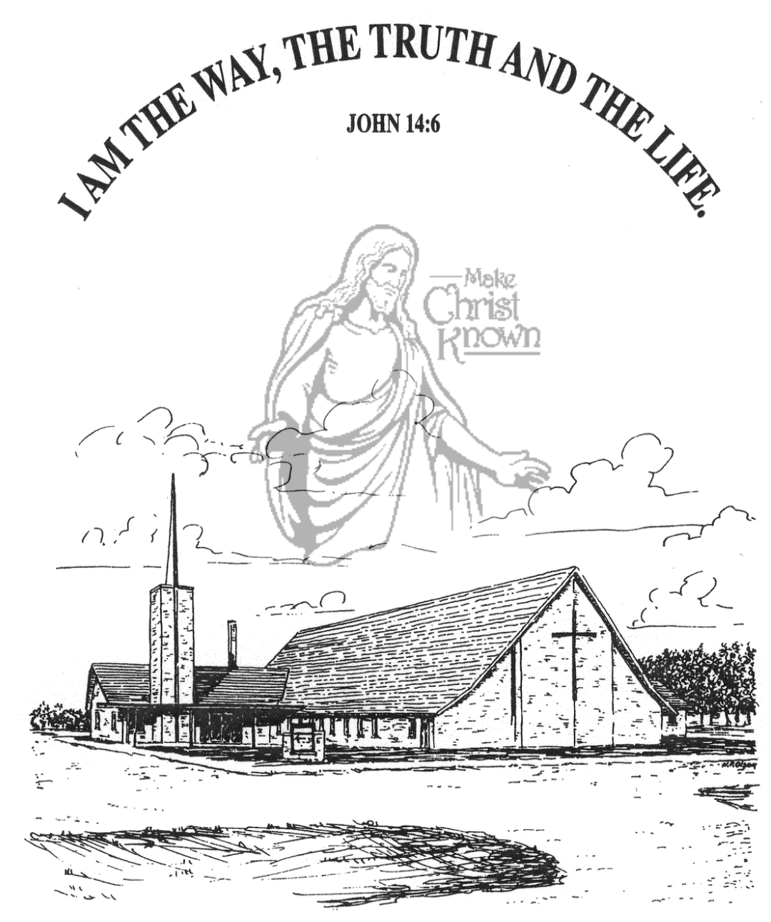

**Sunday, October 13, 2024**

**Salem Reformed Church**

**Menno, South Dakota**

..3

**Office Hours for Pastor Hecht**

Tuesday – Friday: 8:00 AM to Noon (Church Office)

Afternoons: Visitation or Church Office

Church: (605) 387-5334 Parsonage: (605) 387-2855

Pastor Mike’s Cell #: (605) 660-1803

Church Web Page: ***salemreformedchurch.com***

**Opportunities**

Greeters Today: Jim and Donna Sattler

Greeters October 20th: David and Peg Walloch

Sunday Prayer Time: 8:30 a.m.

Sunday School Classes: 9:15 a.m.

Praise Music: 10:15 a.m.

Worship Service: 10:30 a.m.

**Announcements**

**Welcome:** We extend a warm welcome to our visiting guests this morning. Please sign our guest book in the Narthex. We ask God’s blessing upon you and we pray that you will return and worship with us again soon.

**4-O’s Women:** This group will be taking a tour of the Jamesville Colony on Wed., Oct. 16th. Please meet at the church @ 10:50 a.m. The cost is $10/person, which includes a noon meal and tour. Sign the sheet in the Narthex if you are planning to attend.

**Young Adults:** Parents of Sunday School Children – if you are not attending a S.S. Class, please consider sitting at the Table in the Social Hall during that time. Have a cup of coffee and get to know each other. You’ll be glad that you did!

**Cherub Choir:** The Cherub Choir (ages 3 yrs. thru 3rd Grade) will plan to sing in church on Sunday, Oct. 20th!

**Mission Fest Service:** Mission Fest is scheduled for Sun., Oct. 20th. Our guest speaker will be Dr. Jeff Johnson. Servant Hearts Clinic is a FREE health care clinic dedicated to providing health care to all we serve. The offering has been designated as follows: 90% given to Servant Hearts Clinic and 10% given to the FCA at Menno High School. **The Consistory and Spouses will host a Pot Luck Dinner following the service.

**Men Standing Together:** Sun., Nov. 3rd @ 5 PM in our Social Hall. Brad Magness, owner of Magness Livestock Market, Huron, SD, will be our guest speaker. Supper will be provided. Invite your friends! Middle School/High School age young men are welcome! Please sign the sheet in the Narthex if you plan to attend.

**Sunday Offerings:** Please note that we have an Offering Box/Pulpit at the back of the Sanctuary for people to place their tithes and offerings in during our worship services.

**SALEM REFORMED CHURCH**

Menno, South Dakota

Rev. Michael Hecht Pastor

Jennifer Herrboldt Pianist

10:30 AM – Worship Service October 13, 2024

Twenty-first Sunday after Pentecost

**Meditation:** *“Standing up, Paul motioned with his hand and said: ‘Men of Israel and you Gentiles who worship God, listen to me! The God of the people of Israel chose our fathers; He made the people prosper during their stay in Egypt, with mighty power He led them out of that country, He endured their conduct for about forty years in the desert, He overthrew seven nations in Canaan and gave their land to His people as their inheritance. All this took about 450 years. After this, God gave them judges until the time of Samuel the prophet. Then the people asked for a king, and He gave them Saul son of Kish, of the tribe of Benjamin, who ruled forty years. After removing Saul, He made David their king. He testified concerning him: ‘I have found David son of Jesse a man after My own heart; he will do everything I want him to do.’ From this man’s descendants God has brought to Israel the Savior Jesus, as He promised.’ “* Acts 13:16-23 NIV

**Praise Music:** #72, #91, #143, #16

**Ringing of the Bell**

**Welcome / Announcements / Opening Prayer**

**\*Hymn:** #104 “O Worship the King”

**Sharing of Joys and Concerns**

**Our Time of Offering**  I John 5:4,5 NIV

**\*Lord’s Prayer** sung on page #631

**\*Apostles’ Creed** see words on screen

**Kingdom Kids:** “One Stone – David vs. Goliath”

**Hymn:** #219/220 “Surely the Presence” & “He Is Here”

**The Holy Scriptures**

I Samuel 17:32-51

Large Print NIV 1984 Edition, pg. 447

**Sermon: “The Battle Is the Lord’s”**

**\*Hymn:** #353 “Victory In Jesus”

**\*Benediction:**

**Postlude** (*denotes standing for those able)

The congregation will be ushered out after the Benediction

Youth Ushers: Joslynn Fischer, Zoe Schaeffer, Autumn Rames