**Calendar of Events**

Sept 02 Men’s Christian Fellowship @ 7:30 p.m.

Sept 03 M/O Ministerial Meeting @ 11:30 a.m.

Sept 04 8th Grade Confirmation @ 3:30-5:15 p.m.

6/7th Grade Confirmation @ 5:30-7:00 p.m.

FCA at Menno Gym @ 7:30 p.m.

Sept 05 Prayer Group @ 12 Noon

Sept 08 **Sunday School Kick-Off**

Prayer Time for Service @ 8:30 a.m.

Sunday School Classes @ 9:15 a.m.

Praise Music @ 10:15 a.m.

Worship Service @ 10:30 a.m.

w/Pot Luck Dinner & Games Following

High School Youth Supper/Games @ 6:00 pm

**Upcoming Special Music**

Sunday, Sept 08 - Available

Sunday, Sept 15 - Available

**Announcements**

**Coffee Hour:** We are looking for 7 volunteers to bring 2 dozen goodies for the Coffee Hour on Sunday, Sept. 15th. Please sign the sheet in the Narthex if you are able to help.

**Women of the Church:** The W.O.C. will plan to meet on Sunday, Sept. 15th, following the morning worship service.

**High School Youth:** The High School Youth will meet Sun., Sept. 8th @ 6 p.m. in the Social Hall for supper and games.

**Kuchen Donations:** Please sign the sheet in the Narthex if you are willing to bake and donate some kuchen for the Youth Group Food Stand at the Power Show. The Menno Pioneer Power Show is the weekend of September 21/22.

**SD Right to Life Convention:** You are invited to attend this convention at the Calvary Baptist Church, Yankton, SD on September 20th & 21st. Please see the brochures on the Information Cabinet in the Narthex on how to register.

**W.O.C. Program Date Change:** The date for the W.O.C. Program has been changed to Tues., Sept. 17th. Please sign the sheet in the Narthex if you are able to attend. Jan Torres will be in charge of coordinating the program in September.

**Salem Reformed Church – Who Are We?**

**We believe the Bible to be the inspired, inerrant, infallible Word of God in its original manuscripts. It is our supreme authority in all matters doctrine and practice. We are affiliated with the Conservative Congregational Christian Conference.**

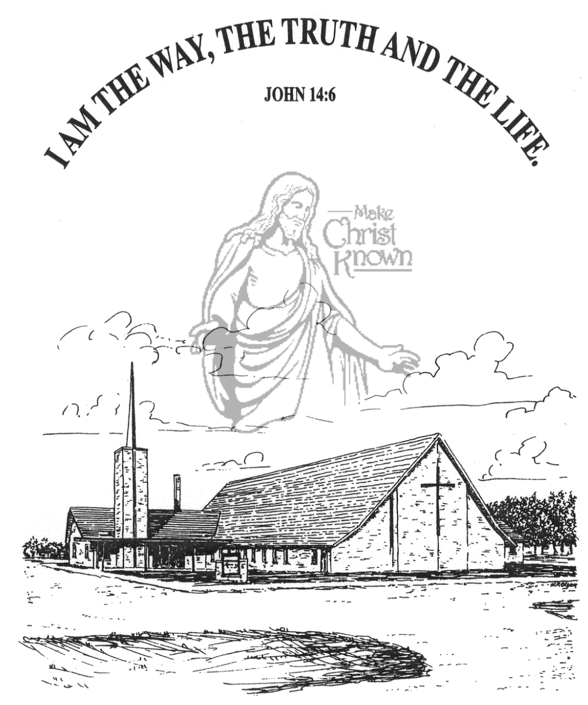

**Sunday, September 01, 2024**

**Salem Reformed Church**

**Menno, South Dakota**

**Office Hours for Pastor Hecht**

Tuesday – Friday: 8:00 AM to Noon (Church Office)

Afternoons: Visitation or Church Office

Church: (605) 387-5334 Parsonage: (605) 387-2855

Pastor Mike’s Cell #: (605) 660-1803

Church Web Page: ***salemreformedchurch.com***

**Opportunities**

Greeters Today: Carl and Linda Zeeb

Greeters September 8th: Robert and Elaine Balogh

Sunday Prayer Time: 8:30 a.m.

Sunday School Classes: 9:15 a.m.

Praise Music: 10:15 a.m.

Worship Service: 10:30 a.m.

**Announcements**

**Welcome:** We extend a warm welcome to our visiting guests this morning. Please sign our guest book in the Narthex. We ask God’s blessing upon you and we pray that you will return and worship with us again soon.

**Guest Speaker:** We are excited to welcome Rev. Ray DeLaurier, as our guest speaker this morning! Ray serves as our North Central Regional Pastor in the CCCC. Ray and his wife live in Edgeley, North Dakota.

**Sunday School Kick-Off:** Sunday School Classes will resume on **Sunday, September 8th**, starting at 9:15 a.m. Praise Music at 10:15 a.m., with Worship Service at 10:30 a.m. There will be a Pot Luck Dinner following for the Congregation! We also have Sunday School Classes for the adults! Outside Games of volleyball, kickball, etc. will follow the dinner!

**Pastor’s Vacation:** Pastor Mike/Ann are in Waverly, IA, for Nathan’s wedding this weekend. We plan to have a wedding reception for Nathan/Katrina here in the Social Hall on Sun., Oct. 13th from 2-4 p.m. The congregation is invited to that reception.

**Menno FCA:** The 1st Meeting of the Fellowship of Christian Athletes will be Wed., September 4th @ 7:30 p.m. at the Menno Gym. This is open to students in 8th thru 12th Grade.

**4-O’s Women:** We will plan to meet at Roosters this Wed., Sept. 4th @ 11:30 a.m. for lunch. Please sign the sheet in the Narthex if you are planning to join us!

**Sunday Offerings:** Please note that we have an Offering Box/Pulpit at the back of the Sanctuary for people to place their tithes and offerings in during our worship services.

**SALEM REFORMED CHURCH**

Menno, South Dakota

Rev. Michael Hecht Pastor

Sharyl Herrboldt Pianist

9:30 AM – Worship Service September 01, 2024

Fifteenth Sunday after Pentecost

**Meditation:** *“For this reason I kneel* *before the Father, from whom His whole family in heaven and on earth derives its name. I pray that out of His glorious riches He may strengthen you with power through His Spirit in your inner being, so that Christ may dwell in your hearts through faith. And I pray that you, being rooted and established in love, may have power, together with all the saints, to grasp how wide and long and high and deep is the love of Christ, and to know this love that surpasses knowledge – that you may be filled to the measure of all the fullness of God. Now unto Him who is able to do immeasurably more than all we ask or imagine, according to His power that is at work within us, to Him be glory in the church and in Christ Jesus throughout all generations, for ever and ever! Amen.”*

Ephesians 3:14-21 NIV

**Praise Music:** #38, #1, #5, #54, #52, #144

**Ringing of the Bell**

**Welcome / Announcements / Opening Prayer**

**\*Hymn:** #8 “Come, Thou Almighty King”

**Sharing of Joys and Concerns**

**Our Time of Offering** James 5:16 NIV

**\*Doxology** sung on page #815

**\*Lord’s Prayer** debts and debtors

**Kingdom Kids:** “The Five Finger Prayer“

**Hymn:** #640 “Sweet Hour of Prayer”

**The Holy Scriptures**

Various Selected Texts

Large Print NIV 1984 Edition, pg.

**Sermon: “Why Should a Church Pray?”**

Shared by Rev. Ray DeLaurier

**\*Hymn:** #549 “Higher Ground”

**\*Benediction:**

**\*Prayer for Our Nation:** “God Bless America”

**Postlude** (*denotes standing for those able)

The congregation will be ushered out after the Benediction